Contents
- Case Study 23: Timetable Conflict Detection
- Case Study 28: Suspicious Transaction Detection
- Case Study 35: Run-Length Text Encoding
- Case Study 42: Student Marks Analysis
- Case Study 48: Employee Shift Conflict Detection
- Case Study 55: Bank Transaction Validation
- Case Study 61: Seating Arrangement Validation
- Case Study 66: Student Academic Risk Classification
- Case Study 75: Student Record Validation
- Case Study 87: Multiple-Choice Question Difficulty Analysis
Note: Output screenshots are generated from running the supplied Python scripts. Test cases other than the supplied input are described as expected results.

Case Study 23: Timetable Conflict Detection

1. Problem Statement
A timetable may contain classes scheduled at overlapping times. This program checks every pair of scheduled classes on the same day and reports overlaps. If overlapping classes use the same room, it also reports a room conflict.

2. Objectives
- Represent class schedules using course, day, start time, end time, and room.
- Compare each pair of classes to detect time overlap on the same day.
- Report overlapping classes and any shared-room conflict.
- Report that the timetable is valid when no overlap is found.

3. Assumptions
- Time values are numeric and use a consistent unit, such as hours.
- A class occupies the interval from its start time up to, but not including, its end time.
- The supplied schedule records are complete and correctly formatted.
- An overlap is considered only when two classes occur on the same day.

4. Algorithm
- Store the timetable entries in a list of tuples.
- Set a conflict flag to False.
- For each entry, compare it with every later entry.
- Check whether both entries have the same day and their time intervals overlap.
- If they overlap, print the course names and day, set the conflict flag, and check whether the rooms match.
- After all comparisons, print that the timetable is valid if no conflict was found.

5. Flowchart
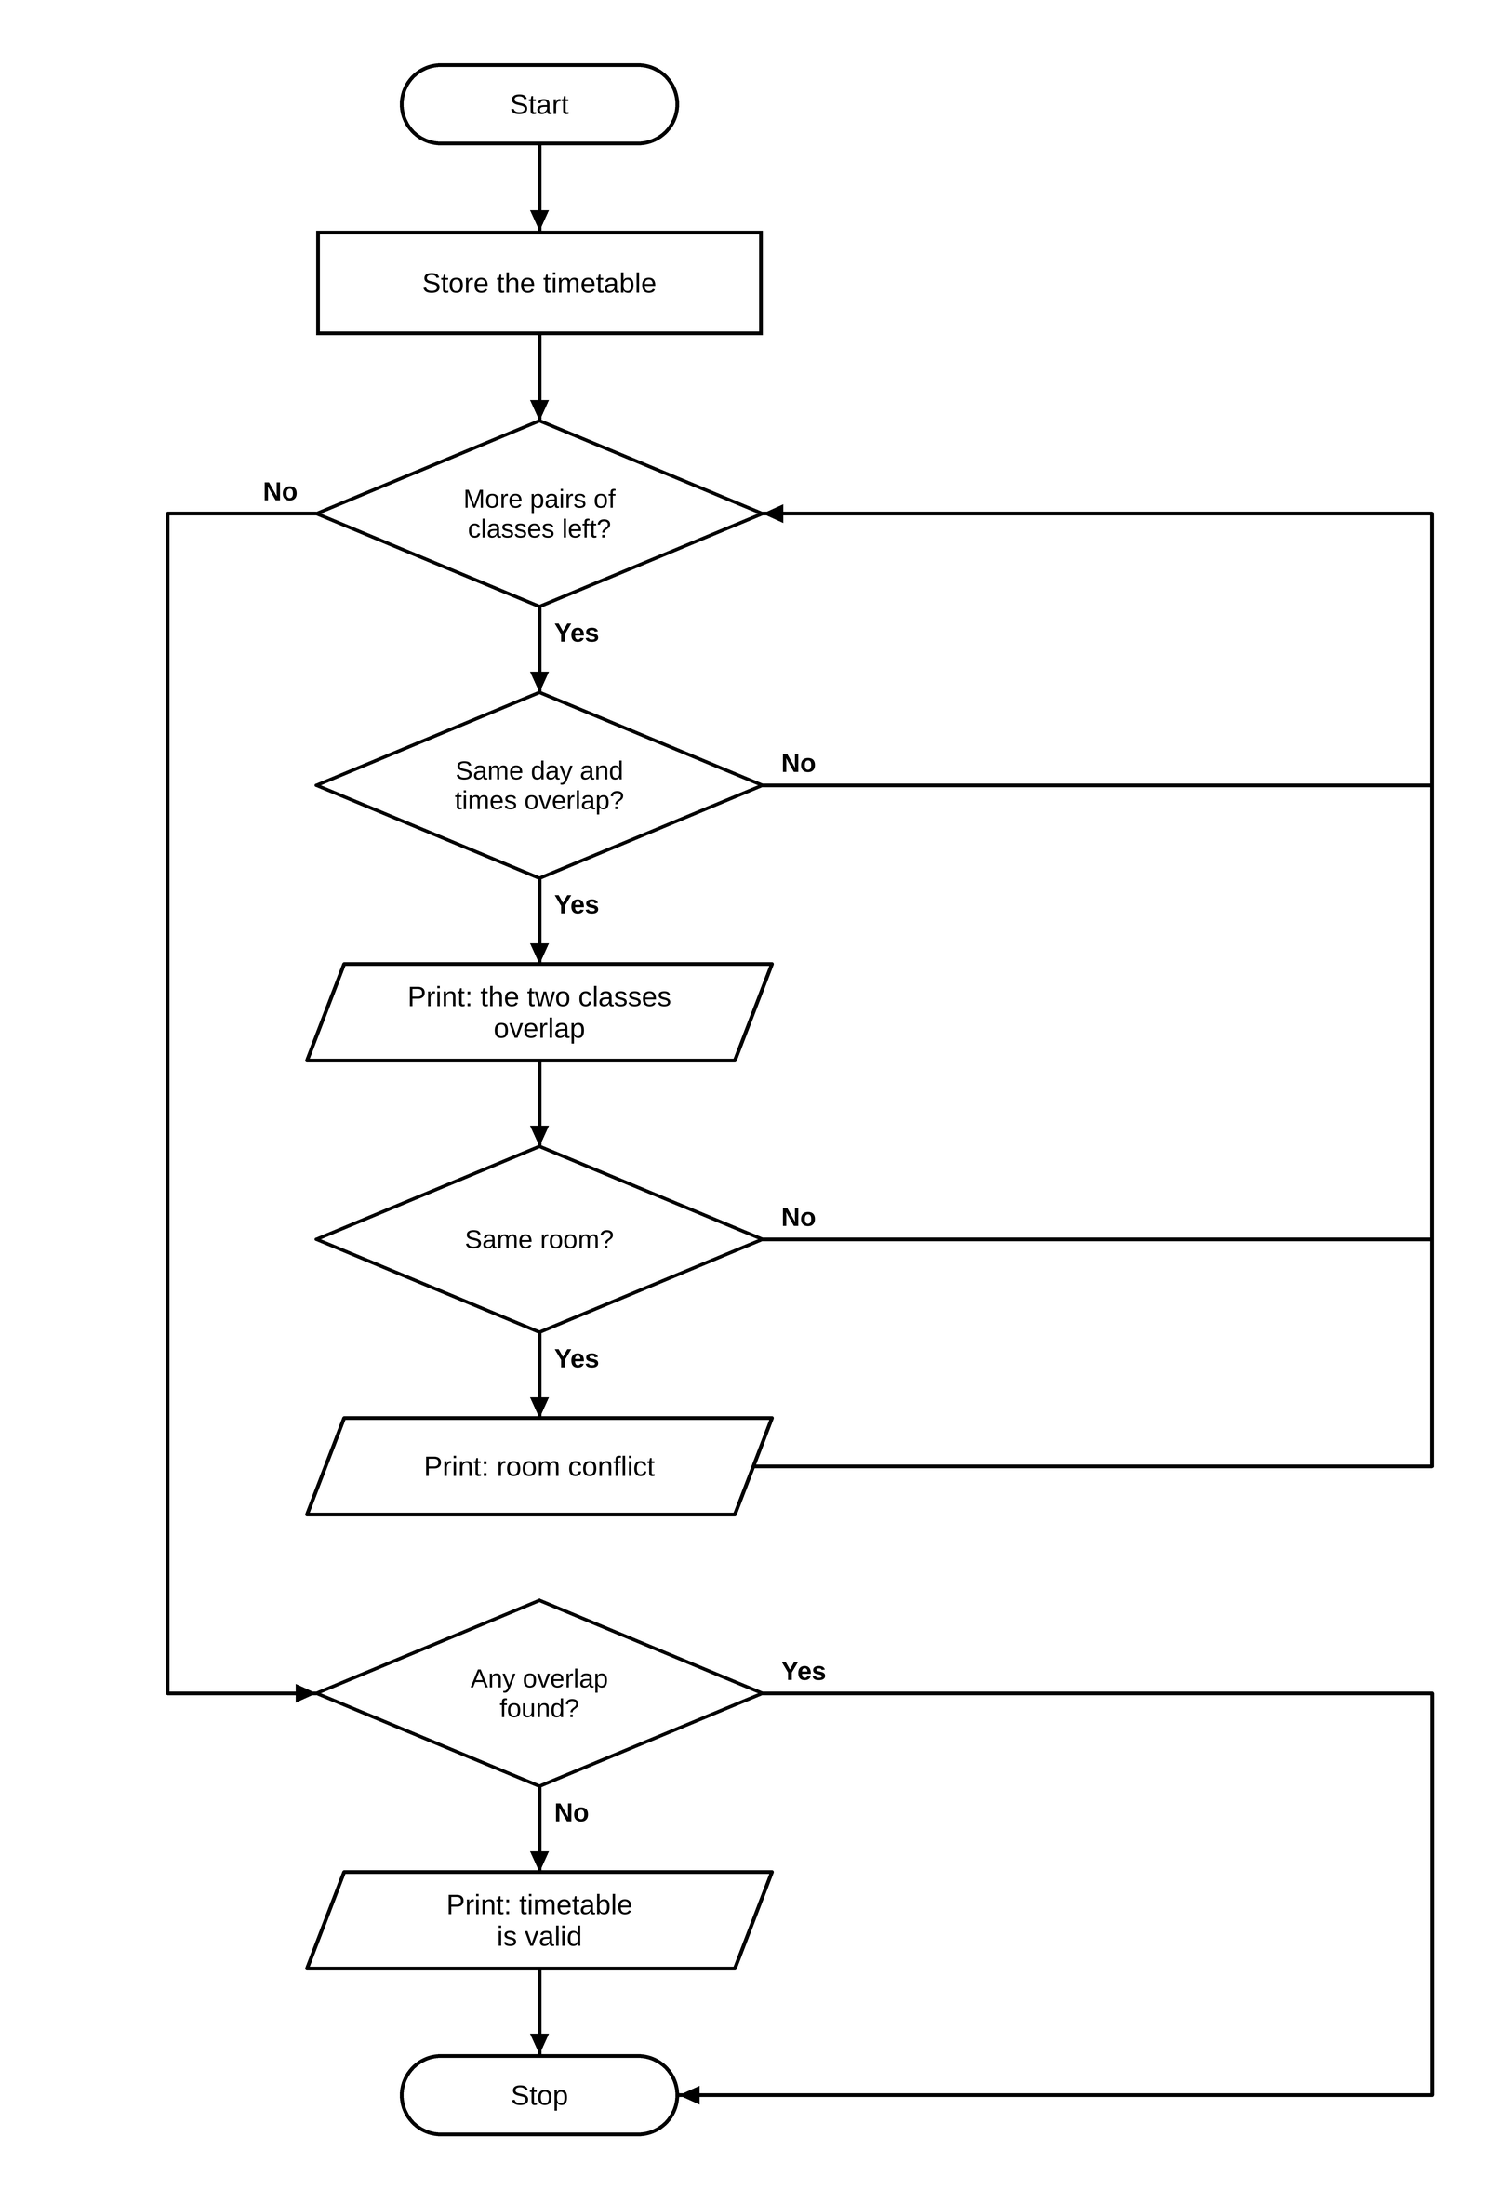

6. Pseudocode
BEGIN
schedule ← list of class records
conflict_found ← FALSE
FOR i from 0 to length(schedule) − 1
FOR j from i + 1 to length(schedule) − 1
IF day[i] = day[j] AND start[i] < end[j] AND start[j] < end[i]
PRINT overlapping courses and day
conflict_found ← TRUE
IF room[i] = room[j], PRINT room conflict
IF conflict_found = FALSE, PRINT timetable is valid
END

7. Python Source Code
schedule = [
("Python", "Mon", 9, 10, "R1"),
("Maths", "Mon", 9, 11, "R2"),
("Physics", "Mon", 11, 12, "R1"),
("English", "Tue", 10, 11, "R1")
]
conflict_found = False
for i in range(len(schedule)):
course1, day1, start1, end1, room1 = schedule[i]
for j in range(i + 1, len(schedule)):
course2, day2, start2, end2, room2 = schedule[j]
overlap = (day1 == day2 and start1 < end2 and start2 < end1)
if overlap:
print(course1, "and", course2, "overlap on", day1)
conflict_found = True
if room1 == room2:
print("Room conflict:", room1)
if not conflict_found:
print("Timetable is valid.")

8. Test Cases
Test Case 1
Input: Given schedule (Python, Maths, Physics, English)
Expected result: Python and Maths overlap on Mon

Test Case 2
Input: Python Mon 9-10 R1, Maths Mon 10-11 R1
Expected result: Timetable is valid.

Test Case 3
Input: Python Mon 9-11 R1, Maths Mon 10-12 R1
Expected result: Python and Maths overlap on Mon; Room conflict: R1

9. Output Screenshot
The following screenshot-style terminal capture shows the output produced by the supplied script.
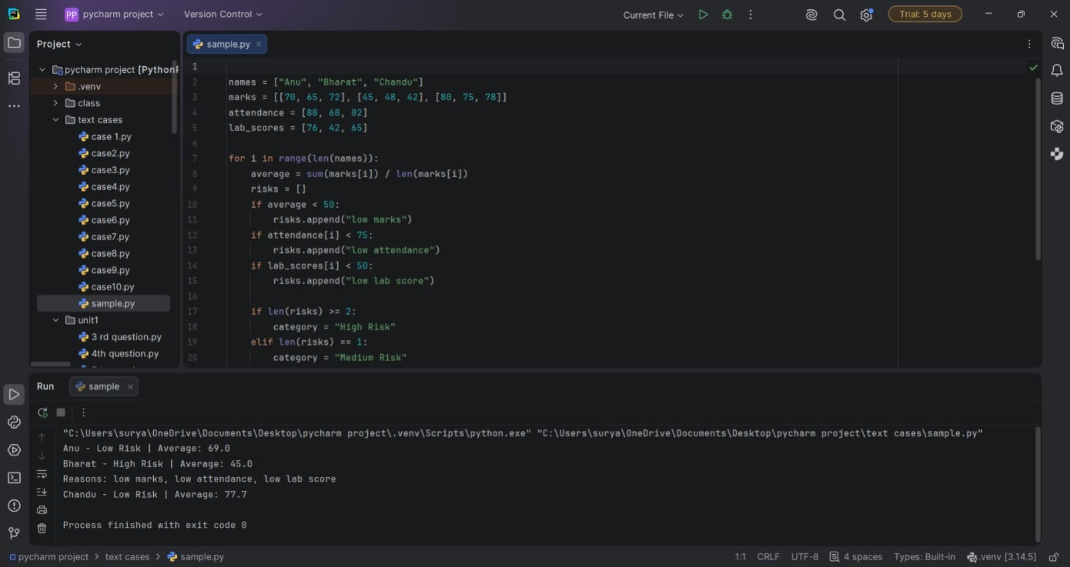

10. Conclusion
The program uses pairwise comparison to identify timetable clashes. It helps detect scheduling errors and room conflicts before a timetable is finalized.

Case Study 28: Suspicious Transaction Detection

1. Problem Statement
A list of financial transactions is checked for repeated transaction IDs and amounts above a configured threshold. A transaction is marked suspicious if its ID occurs more than once or its amount exceeds the threshold.

2. Objectives
- Store transaction IDs and amounts.
- Count occurrences of each transaction ID.
- Detect repeated transactions and unusually large amounts.
- Display the suspicious transactions without listing the same tuple repeatedly.

3. Assumptions
- Transaction IDs are intended to uniquely identify transactions.
- The threshold is expressed in rupees and is set to Rs. 5,000 in the program.
- The provided transaction list is the complete input for this demonstration.
- A repeated ID is treated as suspicious even if its amount is the same.

4. Algorithm
- Create a list of transaction ID and amount pairs.
- Set the suspicious threshold to 5,000 and initialize an empty result list.
- For each transaction, count how many records have the same ID.
- If the ID is repeated or the amount exceeds the threshold, add the transaction if it is not already in the result list.
- Print the heading and each suspicious transaction.

5. Flowchart
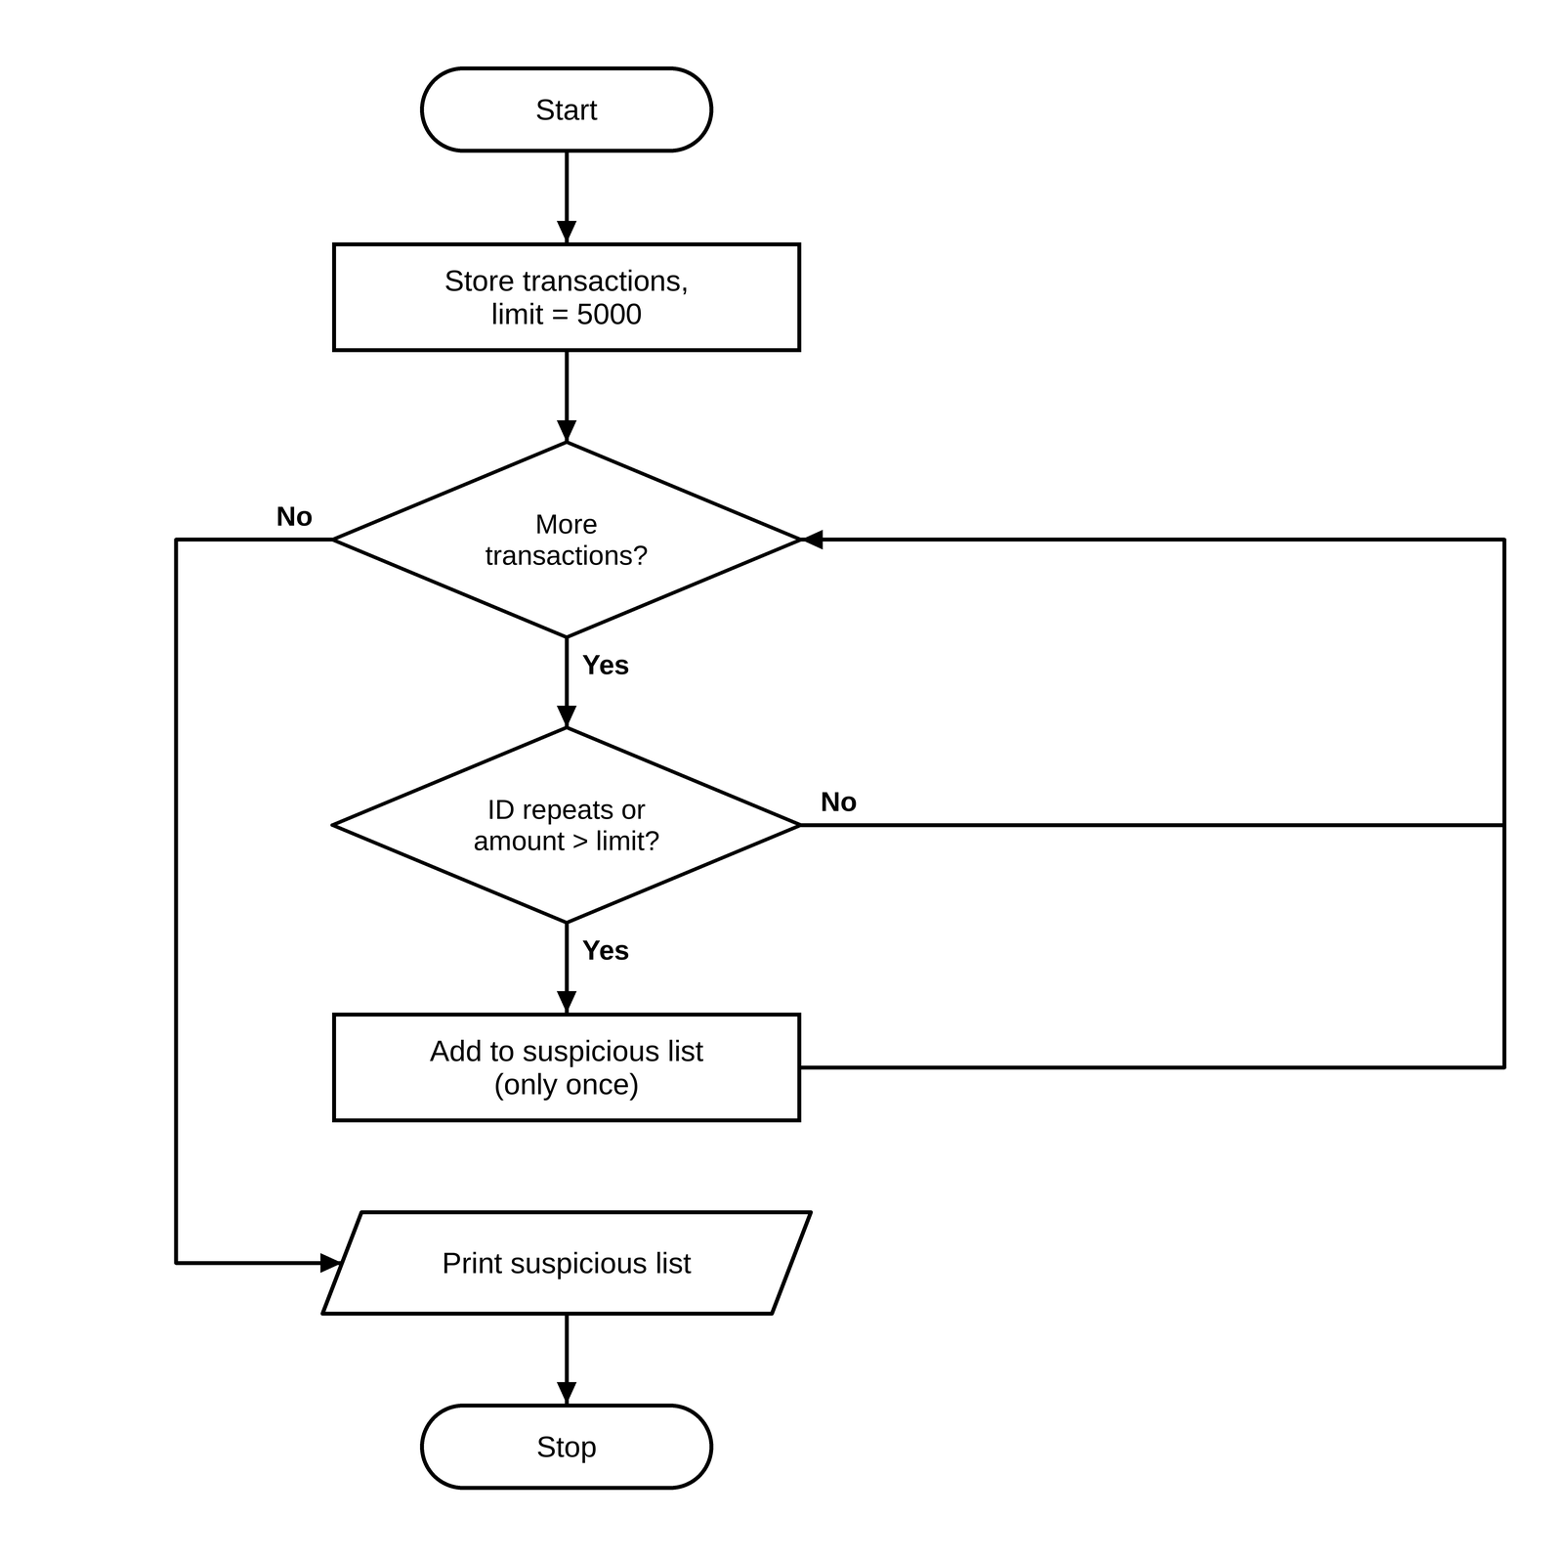

6. Pseudocode
BEGIN
transactions ← list of (ID, amount)
threshold ← 5000
suspicious ← empty list
FOR each transaction in transactions
count records whose ID equals transaction.ID
IF count > 1 OR transaction.amount > threshold
IF transaction not in suspicious, append transaction
PRINT each suspicious transaction
END

7. Python Source Code
transactions = [
("T101", 1200),
("T102", 6500),
("T103", 800),
("T101", 1200),
("T104", 7200)
]
threshold = 5000
suspicious = []
for transaction in transactions:
transaction_id, amount = transaction
count = 0
for item in transactions:
if item[0] == transaction_id:
count += 1
if (count > 1 or amount > threshold) and transaction not in suspicious:
suspicious.append(transaction)
print("Suspicious transactions:")
for transaction_id, amount in suspicious:
print(transaction_id, "- Rs.", amount)

8. Test Cases
Test Case 1
Input: Given transactions
Expected result: T101 - Rs. 1200; T102 - Rs. 6500; T104 - Rs. 7200

Test Case 2
Input: (“T1”, 3000), (“T2”, 800)
Expected result: No suspicious transactions

Test Case 3
Input: (“T1”, 5000), (“T2”, 5001)
Expected result: T2 - Rs. 5001 (5000 is not above the threshold)

9. Output Screenshot
The following screenshot-style terminal capture shows the output produced by the supplied script.
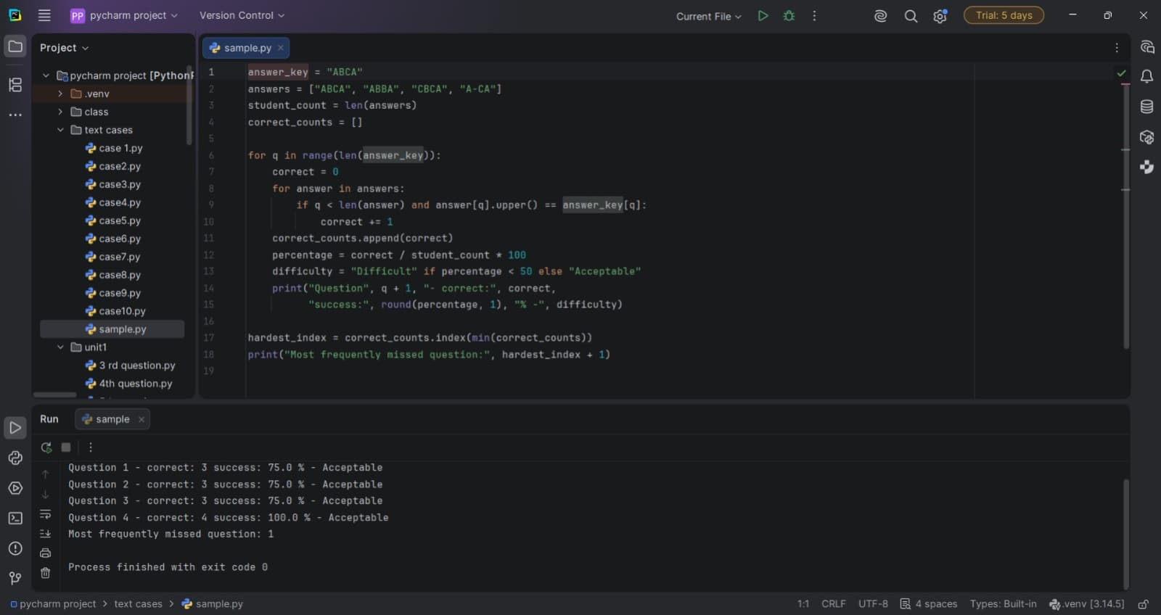

10. Conclusion
The program demonstrates basic rule-based transaction screening using duplicate-ID and high-value checks. Real financial monitoring would require stronger validation and additional risk rules.

Case Study 35: Run-Length Text Encoding

1. Problem Statement
The program compresses a string by replacing each consecutive run of identical characters with the character followed by its count. It compares the encoded string length with the original and recommends the encoded version only if it is shorter.

2. Objectives
- Identify consecutive repeated characters.
- Encode each run as a character and a count.
- Measure original and encoded string lengths.
- Avoid recommending compression when the encoded text is not shorter.

3. Assumptions
- The input is a Python string.
- Runs are encoded in the form character followed by decimal count.
- This is a simple demonstration and does not include an escape scheme for digits or special characters.
- Compression is beneficial only when encoded length is strictly less than original length.

4. Algorithm
- Initialize the input text and an empty encoded string.
- If the input is not empty, start a run counter at one.
- Scan the string from the second character onward.
- Increase the counter when the current character matches the previous character.
- Otherwise append the previous character and its count, then reset the counter.
- Append the final run after the loop.
- Print both strings and their lengths, then compare lengths.

5. Flowchart
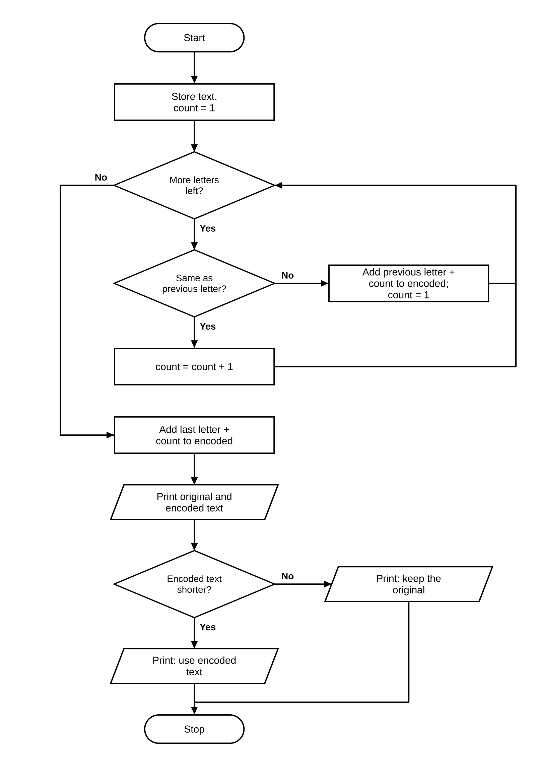

6. Pseudocode
BEGIN
text ← input string; encoded ← empty string
IF text is not empty
count ← 1
FOR i from 1 to length(text) − 1
IF text[i] = text[i−1], count ← count + 1
ELSE append text[i−1] and count; count ← 1
append final character and count
PRINT original and encoded strings and lengths
IF encoded length < original length, recommend encoded text
ELSE keep original text
END

7. Python Source Code
text = "aaabbccccd"
encoded = ""
if text != "":
count = 1
for i in range(1, len(text)):
if text[i] == text[i - 1]:
count += 1
else:
encoded += text[i - 1] + str(count)
count = 1
encoded += text[-1] + str(count)
print("Original:", text)
print("Encoded:", encoded)
print("Original length:", len(text))
print("Encoded length:", len(encoded))
if len(encoded) < len(text):
print("Use encoded text:", encoded)
else:
print("Compression is not beneficial; keep original.")

8. Test Cases
Test Case 1
Input: aaabbccccd
Expected result: Encoded: a3b2c4d1; Lengths: 10 and 8; Use encoded text

Test Case 2
Input: abc
Expected result: Encoded: a1b1c1; Lengths: 3 and 6; Compression is not beneficial; keep original.

Test Case 3
Input: aaaa
Expected result: Encoded: a4; Lengths: 4 and 2; Use encoded text

9. Output Screenshot
The following screenshot-style terminal capture shows the output produced by the supplied script.
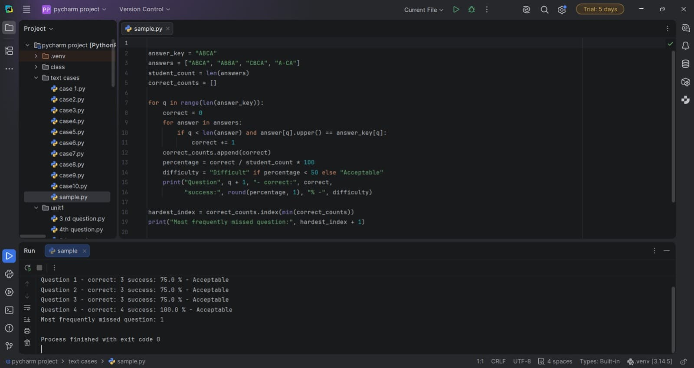

10. Conclusion
Run-length encoding is easy to implement and can reduce strings with long repeated runs. The length check prevents using the encoded result when it would increase storage.

Case Study 42: Student Marks Analysis

1. Problem Statement
The program calculates each student's total and average marks, calculates the average mark for each subject, identifies subjects with averages below 50, and finds the top performer by total marks.

2. Objectives
- Store student names, subject names, and marks in a nested list.
- Calculate each student's total and average.
- Calculate the average for every subject.
- Flag subject averages below 50.
- Identify the student with the highest total.

3. Assumptions
- Each student's marks list has one mark per subject.
- Marks are numeric and use the same scale.
- The provided data is representative and contains no missing marks.
- The top performer is the student with the largest total; ties are resolved by the first maximum in the list.

4. Algorithm
- Store names, subjects, and marks.
- For each student, sum their marks, calculate the average, and store the total.
- For each subject column, sum marks across students and calculate the subject average.
- Print any subject whose average is below 50.
- Find the index of the maximum student total and print that student's name.

5. Flowchart
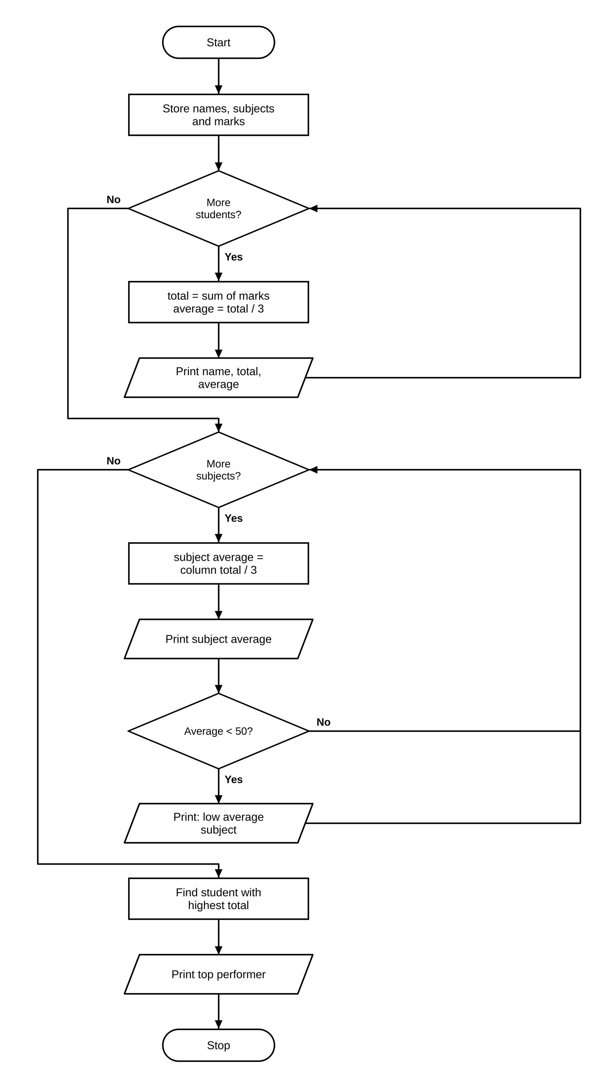

6. Pseudocode
BEGIN
FOR each student i
total[i] ← sum of marks[i]
average ← total[i] / number of subjects
PRINT student, total, average
FOR each subject j
subject average ← sum of marks[i][j] / number of students
PRINT subject and average
IF subject average < 50, PRINT low-average warning
top_index ← index of maximum total
PRINT student[top_index] as top performer
END

7. Python Source Code
names = ["Asha", "Bala", "Charan"]
subjects = ["Python", "Maths", "Physics"]
marks = [
[85, 78, 91],
[60, 55, 58],
[42, 48, 45]
]
totals = []
for i in range(len(marks)):
total = sum(marks[i])
average = total / len(subjects)
totals.append(total)
print(names[i], "total =", total, "average =", round(average, 2))
print("\nSubject averages:")
for j in range(len(subjects)):
total = 0
for i in range(len(marks)):
total += marks[i][j]
average = total / len(marks)
print(subjects[j], "=", round(average, 2))
if average < 50:
print("Low average subject:", subjects[j])
top_index = totals.index(max(totals))
print("\nTop performer:", names[top_index])

8. Test Cases
Test Case 1
Input: Given marks (Asha, Bala, Charan)
Expected result: Asha: total 254, average 84.67; Bala: total 173, average 57.67; Charan: total 135, average 45.0; Subject averages: Python 62.33, Maths 60.33, Physics 64.67; Top performer: Asha

Test Case 2
Input: One student, marks [80, 70, 90]
Expected result: Total 240, average 80.0; Top performer is that student

Test Case 3
Input: 3 students, one subject (Maths), marks 30, 40, 45
Expected result: Maths average = 38.33; Low average subject: Maths; Top performer: the student with 45

9. Output Screenshot
The following screenshot-style terminal capture shows the output produced by the supplied script.
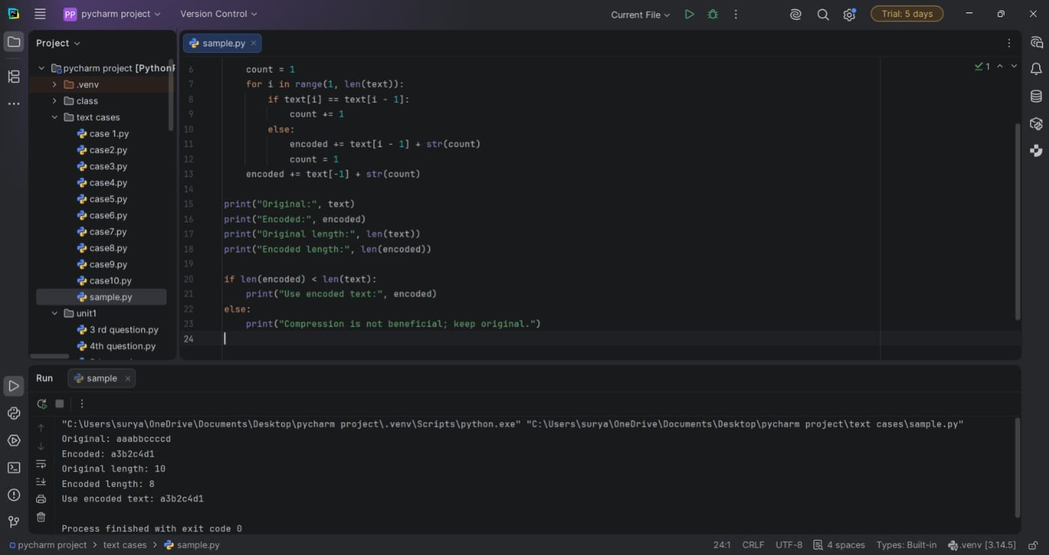

10. Conclusion
The program summarizes student performance at both individual and subject levels. It can help identify the strongest overall performer and subjects that may need attention.

Case Study 48: Employee Shift Conflict Detection

1. Problem Statement
Employee work shifts are represented by employee, day, start time, and end time. The program detects when the same employee has two overlapping shifts on the same day.

2. Objectives
- Store employee shift records.
- Compare pairs of shifts.
- Check employee identity, day, and time overlap.
- Report conflicting shift intervals or confirm that none exist.

3. Assumptions
- Start and end times are numeric and consistently represented.
- A shift's end time is not part of the occupied interval.
- Only shifts belonging to the same employee on the same day can conflict.
- The input shift list is complete for the period being checked.

4. Algorithm
- Create the list of shifts and initialize a found flag to False.
- Compare every shift with each later shift.
- If employee and day match, test whether the time intervals overlap.
- Print the employee and both intervals and set found to True when a conflict is found.
- If no conflict is found, print the no-conflicts message.

5. Flowchart
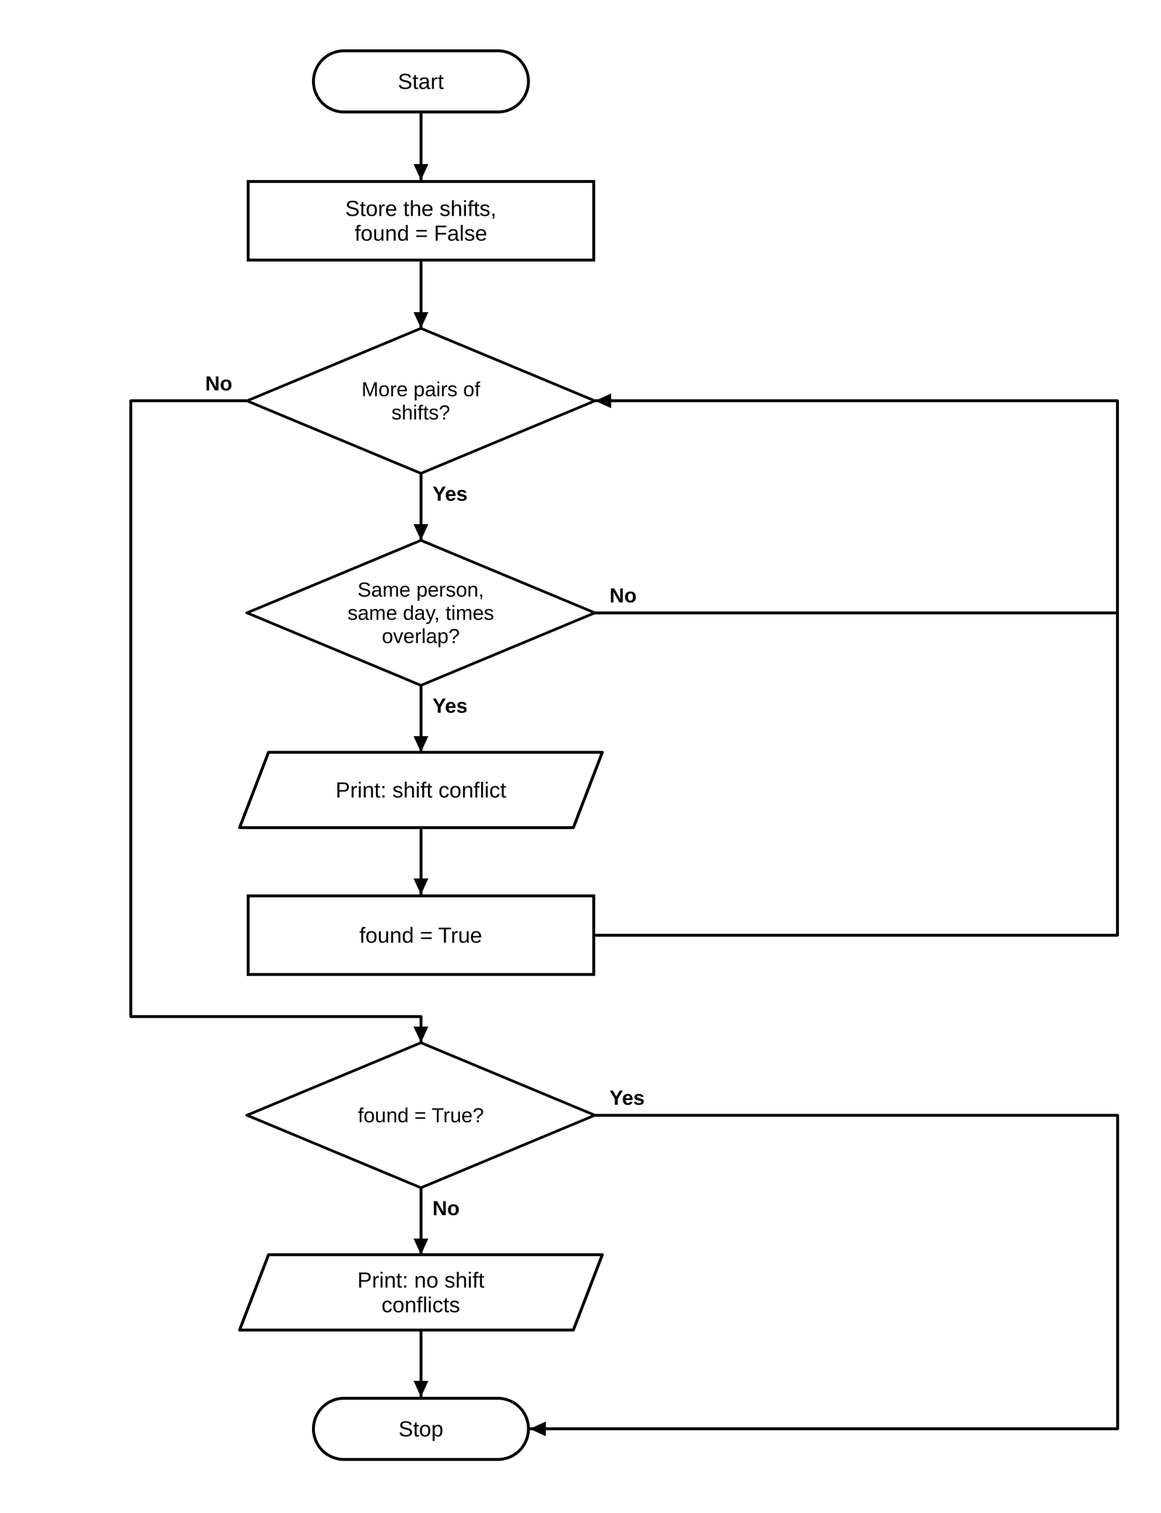

6. Pseudocode
BEGIN
shifts ← list of shift records
found ← FALSE
FOR i from 0 to length(shifts) − 1
FOR j from i + 1 to length(shifts) − 1
IF employee[i] = employee[j] AND day[i] = day[j]
AND start[i] < end[j] AND start[j] < end[i]
PRINT shift conflict and both intervals
found ← TRUE
IF found = FALSE, PRINT no shift conflicts
END

7. Python Source Code
shifts = [
("Ravi", "Mon", 9, 13),
("Ravi", "Mon", 12, 16),
("Meena", "Mon", 9, 12),
("Ravi", "Tue", 10, 12)
]
found = False
for i in range(len(shifts)):
employee1, day1, start1, end1 = shifts[i]
for j in range(i + 1, len(shifts)):
employee2, day2, start2, end2 = shifts[j]
if (employee1 == employee2 and day1 == day2
and start1 < end2 and start2 < end1):
print("Shift conflict:", employee1, day1,
str(start1) + "-" + str(end1), "and",
str(start2) + "-" + str(end2))
found = True
if not found:
print("No shift conflicts.")

8. Test Cases
Test Case 1
Input: Given shifts
Expected result: Shift conflict: Ravi Mon 9-13 and 12-16

Test Case 2
Input: Ravi Mon 9-12 and Ravi Mon 12-15
Expected result: No shift conflicts.

Test Case 3
Input: Ravi Mon 9-12 and Meena Mon 9-12
Expected result: No shift conflicts.

9. Output Screenshot
The following screenshot-style terminal capture shows the output produced by the supplied script.
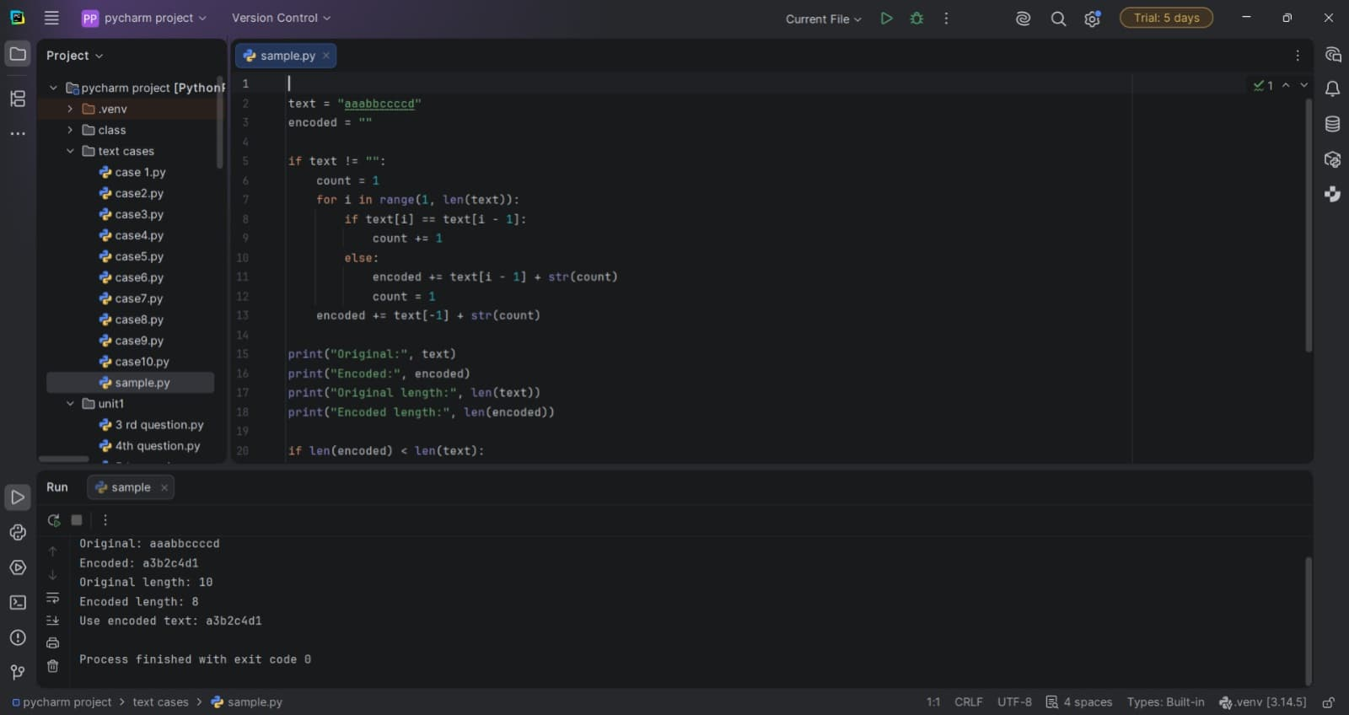

10. Conclusion
The program can identify accidental overlapping assignments for an employee. This is useful when preparing staff rosters and checking availability.

Case Study 55: Bank Transaction Validation

1. Problem Statement
The program validates a small set of transaction records. It reports non-positive amounts, repeated transaction IDs in a specific duplicate condition, and withdrawals above a threshold.

2. Objectives
- Store transaction ID, amount, and transaction type.
- Detect amounts that are zero or negative.
- Count repeated transaction IDs and report a duplicate under the program's implemented condition.
- Flag withdrawals greater than Rs. 5,000.

3. Assumptions
- Amounts are numeric and measured in rupees.
- A valid amount must be greater than zero.
- The threshold for a large withdrawal is Rs. 5,000 and the comparison is strictly greater than.
- The duplicate message is implemented only when the current tuple equals the first transaction tuple; it is not a general duplicate-ID detector.

4. Algorithm
- Store transaction records and set the threshold to 5,000.
- For each record, unpack ID, amount, and type.
- Print an invalid-amount warning if the amount is less than or equal to zero.
- Count all records with the same transaction ID.
- If the count is greater than one and the current record equals the first record, print a duplicate-ID warning.
- If the type is Withdrawal and the amount exceeds the threshold, print a suspicious-withdrawal warning.

5. Flowchart
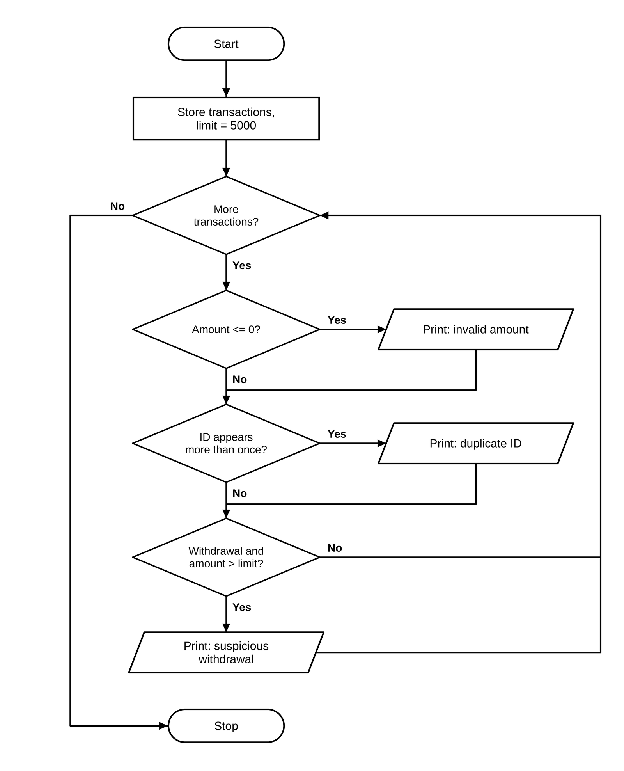

6. Pseudocode
BEGIN
transactions ← list of (ID, amount, type)
threshold ← 5000
FOR each transaction
IF amount ≤ 0, PRINT invalid amount
count records with the same ID
IF count > 1 AND transaction = first transaction, PRINT duplicate ID
IF type = Withdrawal AND amount > threshold, PRINT suspicious withdrawal
END

7. Python Source Code
transactions = [
("A01", 1000, "Deposit"),
("A02", 6500, "Withdrawal"),
("A03", -200, "Deposit"),
("A01", 1000, "Deposit")
]
threshold = 5000
for transaction in transactions:
tid, amount, kind = transaction
if amount <= 0:
print(tid, ": invalid amount")
count = 0
for item in transactions:
if item[0] == tid:
count += 1
if count > 1 and transaction == transactions[0]:
print(tid, ": duplicate transaction ID")
if kind == "Withdrawal" and amount > threshold:
print(tid, ": suspicious large withdrawal")

8. Test Cases
Test Case 1
Input: Given transactions
Expected result: A01 : duplicate transaction ID; A02 : suspicious large withdrawal; A03 : invalid amount; A01 : duplicate transaction ID

Test Case 2
Input: (“B1”, 0, “Deposit”)
Expected result: B1 : invalid amount

Test Case 3
Input: (“C1”, 5000, “Withdrawal”)
Expected result: No output (5000 is not above the threshold)

9. Output Screenshot
The following screenshot-style terminal capture shows the output produced by the supplied script.
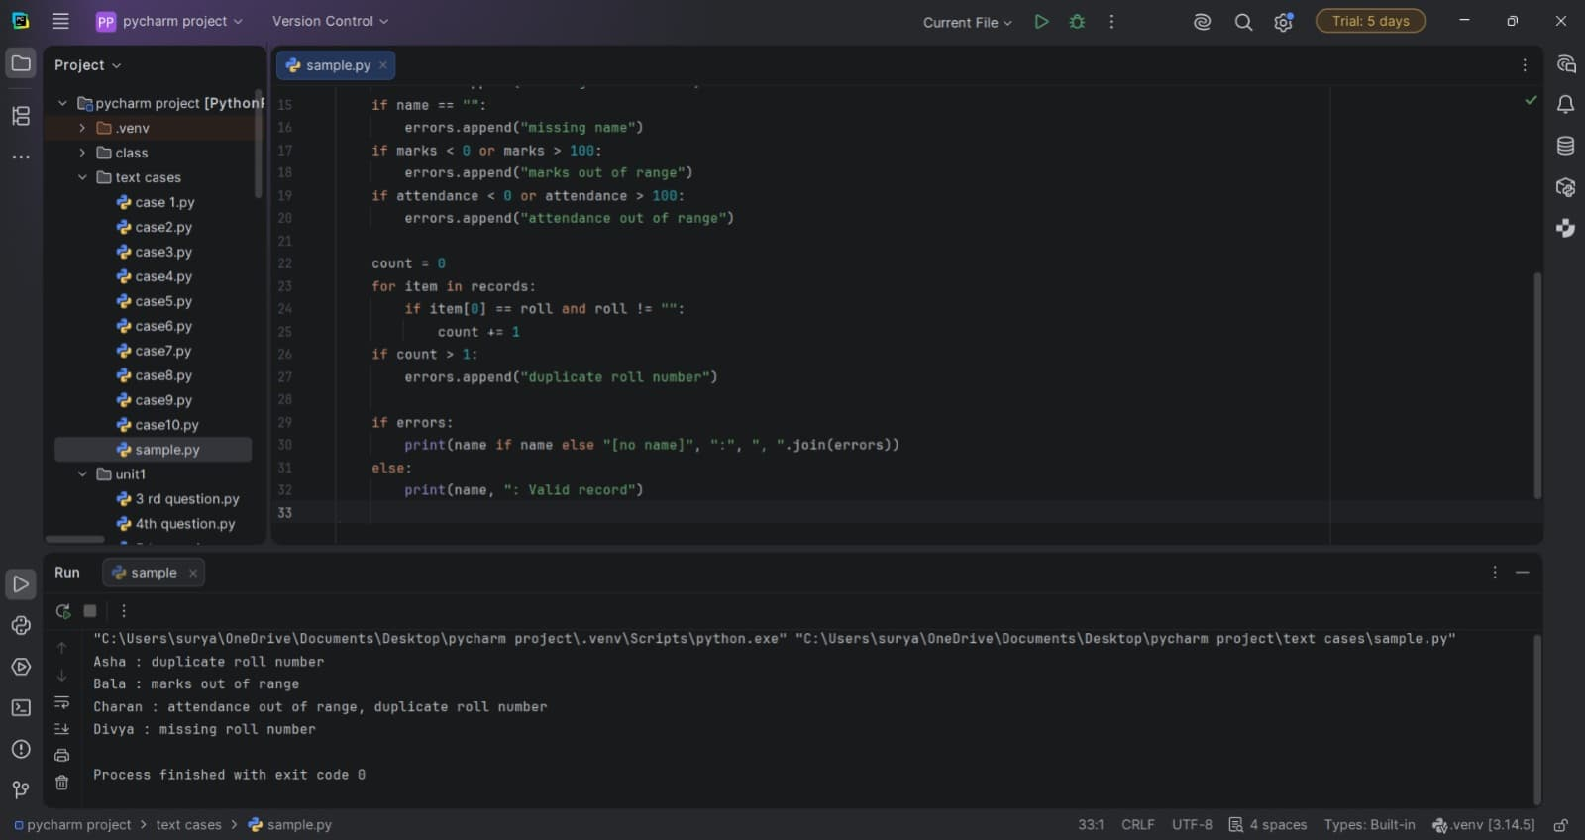

10. Conclusion
The program demonstrates simple transaction validation and alert rules. The duplicate-ID logic is narrower than a general duplicate check and should be revised if every repeated ID must be reported.

Case Study 61: Seating Arrangement Validation

1. Problem Statement
A seating grid contains roll numbers, a reserved-seat marker, and hyphens for empty seats. The program checks whether a designated seat is reserved correctly, finds duplicate roll numbers, and counts empty seats.

2. Objectives
- Represent seating as a two-dimensional list.
- Check a particular row and column for the reserved marker.
- Collect roll numbers and detect duplicates.
- Count empty seats represented by a hyphen.

3. Assumptions
- The seating layout is a rectangular nested list.
- The marker R means reserved and '-' means empty.
- The designated reserved seat is row index 0, column index 2 using zero-based indexing.
- Other seat values are treated as roll numbers.

4. Algorithm
- Create the seat grid and designate the reserved row and column.
- Traverse each seat, count hyphens, and collect values other than R and hyphen as roll numbers.
- Find roll numbers that occur more than once without repeating them in the duplicate list.
- Check the designated seat for the reserved marker.
- Print the reserved-seat result, duplicates, and empty-seat count.

5. Flowchart
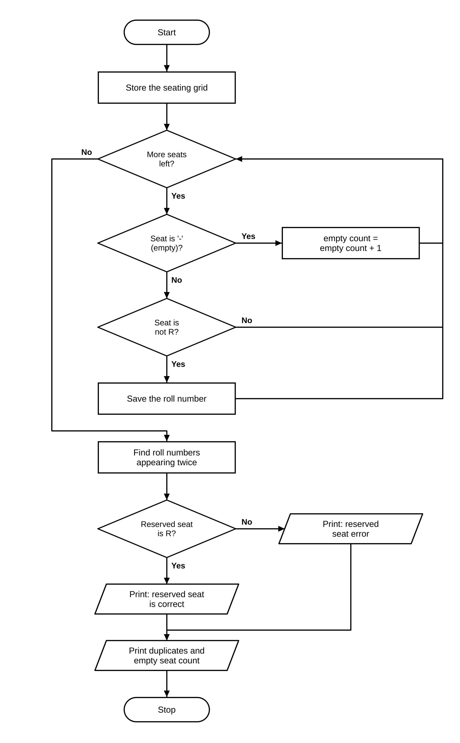

6. Pseudocode
BEGIN
seats ← seating grid; reserved_row ← 0; reserved_col ← 2
rolls ← empty list; empty_count ← 0
FOR each seat
IF seat = '-', empty_count ← empty_count + 1
ELSE IF seat ≠ 'R', append seat to rolls
duplicates ← unique roll values occurring more than once
IF seats[reserved_row][reserved_col] = 'R', PRINT reserved seat correct
ELSE PRINT reserved seat error
PRINT duplicates or no duplicates
PRINT empty_count
END

7. Python Source Code
seats = [
["101", "102", "R"],
["103", "101", "-"],
["104", "-", "105"]
]
reserved_row = 0
reserved_col = 2
rolls = []
empty_count = 0
for row in seats:
for seat in row:
if seat == "-":
empty_count += 1
elif seat != "R":
rolls.append(seat)
duplicates = []
for roll in rolls:
if rolls.count(roll) > 1 and roll not in duplicates:
duplicates.append(roll)
if seats[reserved_row][reserved_col] == "R":
print("Reserved seat is correct.")
else:
print("Reserved seat error.")
if duplicates:
print("Duplicate roll numbers:", duplicates)
else:
print("No duplicate roll numbers.")
print("Empty seats:", empty_count)

8. Test Cases
Test Case 1
Input: Given grid
Expected result: Reserved seat is correct; Duplicate roll numbers: ['101']; Empty seats: 2

Test Case 2
Input: [1, 2, R], [3, 4, 5]
Expected result: Reserved seat is correct; No duplicate roll numbers; Empty seats: 0

Test Case 3
Input: [1, 2, 3], [4, -, R]
Expected result: Reserved seat error; No duplicate roll numbers; Empty seats: 1

9. Output Screenshot
The following screenshot-style terminal capture shows the output produced by the supplied script.
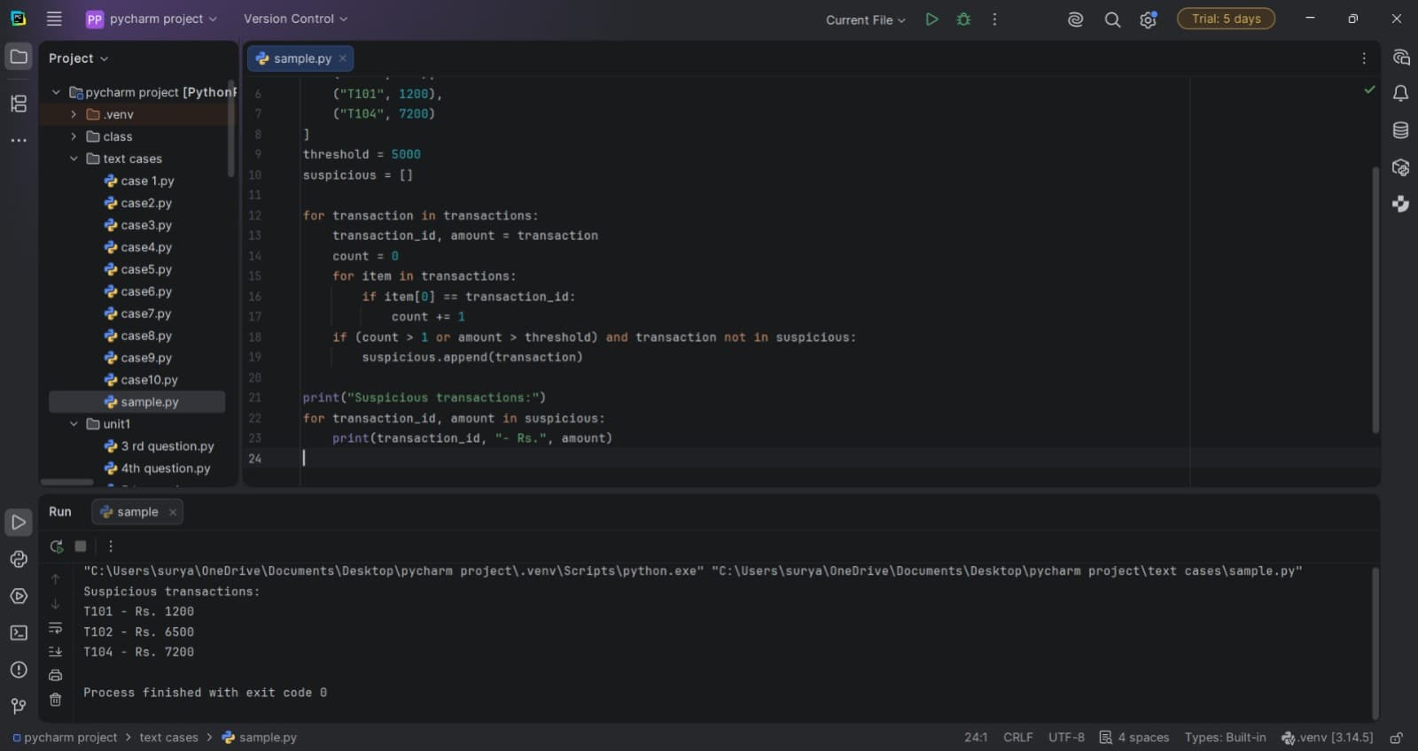

10. Conclusion
The program performs basic consistency checks on a seating plan. It helps locate repeated roll numbers, empty seats, and an incorrectly marked reserved seat.

Case Study 66: Student Academic Risk Classification

1. Problem Statement
For each student, the program calculates the average of subject marks and checks average marks, attendance, and lab score against thresholds. It classifies students as High, Medium, or Low Risk according to the number of warning conditions.

2. Objectives
- Calculate each student's average marks.
- Check for low marks, low attendance, and low lab score.
- Classify risk based on how many conditions are met.
- Display the category, average, and reasons for risk.

3. Assumptions
- Each student has marks, attendance, and lab score values.
- Low average means below 50; low attendance means below 75; low lab score means below 50.
- Two or more risk conditions indicate High Risk, one indicates Medium Risk, and none indicates Low Risk.
- Threshold comparisons are strict less-than comparisons.

4. Algorithm
- Store student names, marks, attendance, and lab scores.
- For each student, calculate the average marks.
- Build a list of risk reasons for each threshold that is not met.
- Assign High Risk for at least two reasons, Medium Risk for one, otherwise Low Risk.
- Print the student, risk category, average, and any reasons.

5. Flowchart
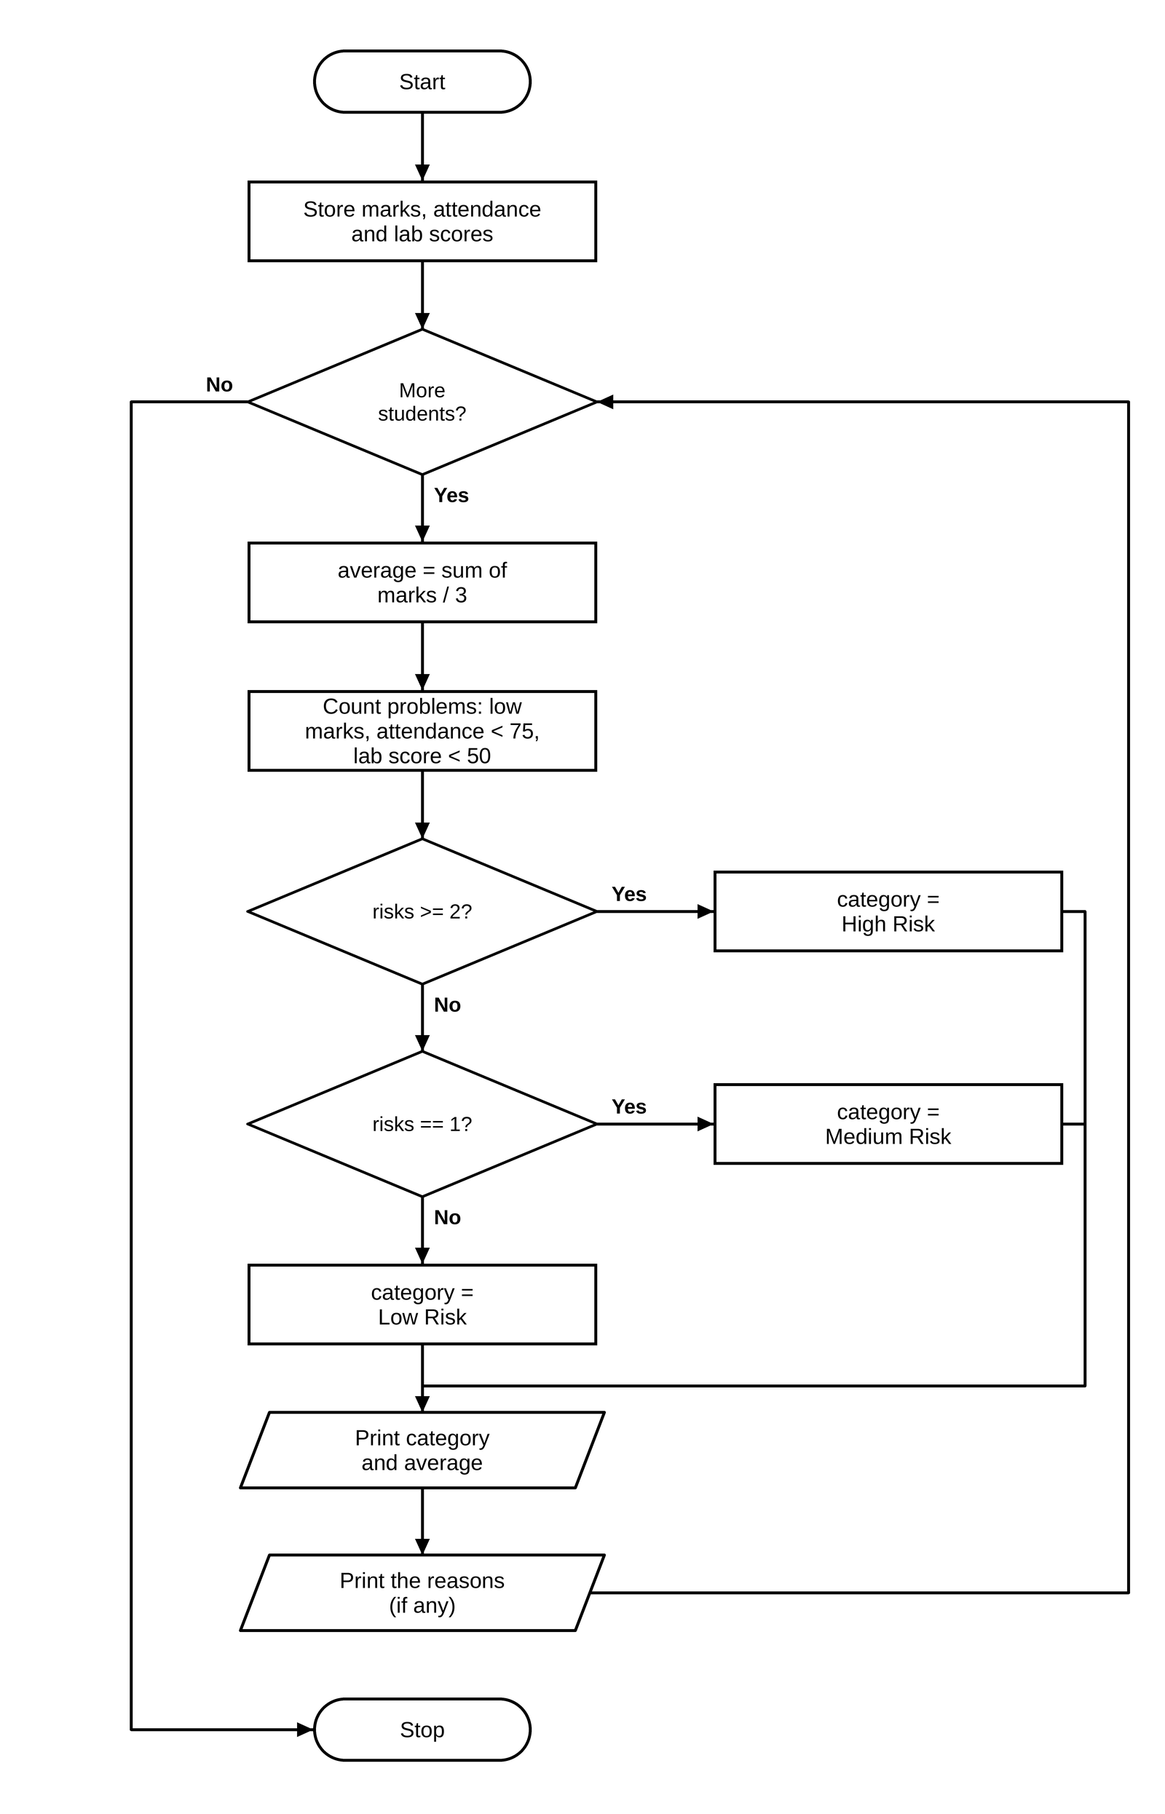

6. Pseudocode
BEGIN
FOR each student i
average ← sum(marks[i]) / number of subjects
risks ← empty list
IF average < 50, add 'low marks'
IF attendance[i] < 75, add 'low attendance'
IF lab_score[i] < 50, add 'low lab score'
IF number of risks ≥ 2, category ← High Risk
ELSE IF number of risks = 1, category ← Medium Risk
ELSE category ← Low Risk
PRINT student, category, average, and reasons
END

7. Python Source Code
names = ["Anu", "Bharat", "Chandu"]
marks = [[70, 65, 72], [45, 48, 42], [80, 75, 78]]
attendance = [88, 68, 82]
lab_scores = [76, 42, 65]
for i in range(len(names)):
average = sum(marks[i]) / len(marks[i])
risks = []
if average < 50:
risks.append("low marks")
if attendance[i] < 75:
risks.append("low attendance")
if lab_scores[i] < 50:
risks.append("low lab score")
if len(risks) >= 2:
category = "High Risk"
elif len(risks) == 1:
category = "Medium Risk"
else:
category = "Low Risk"
print(names[i], "-", category, "|", "Average:", round(average, 1))
if risks:
print("Reasons:", ", ".join(risks))

8. Test Cases
Test Case 1
Input: Given students (Anu, Bharat, Chandu)
Expected result: Anu - Low Risk, Average 69.0; Bharat - High Risk, Average 45.0; Reasons: low marks, low attendance, low lab score; Chandu - Low Risk, Average 77.7

Test Case 2
Input: Marks [70, 70, 70], attendance 70, lab 80
Expected result: Medium Risk; Reasons: low attendance

Test Case 3
Input: Marks [80, 80, 80], attendance 90, lab 75
Expected result: Low Risk

9. Output Screenshot
The following screenshot-style terminal capture shows the output produced by the supplied script.
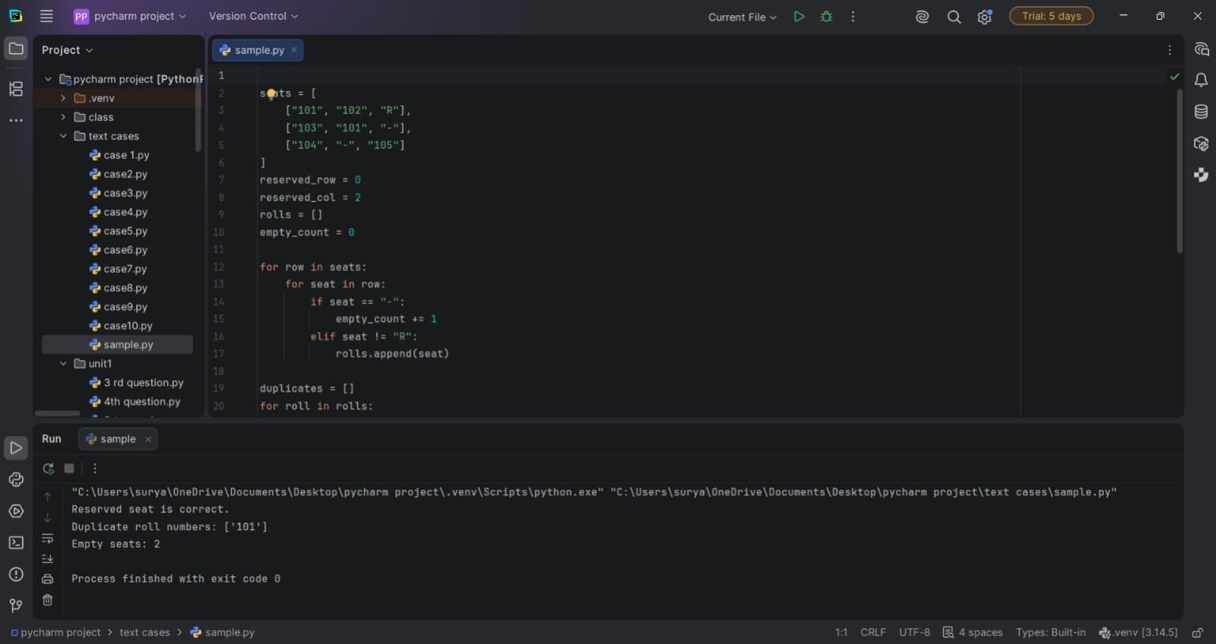

10. Conclusion
The program provides a simple early-warning classification based on three measurable indicators. It can support follow-up, but the categories are only as reliable as the selected thresholds and input data.

Case Study 75: Student Record Validation

1. Problem Statement
A set of student records is checked for missing roll numbers or names, marks and attendance outside the 0–100 range, and duplicate non-empty roll numbers.

2. Objectives
- Validate required identity fields.
- Check marks and attendance ranges.
- Detect repeated roll numbers while ignoring blank roll numbers for duplicate counting.
- Print the errors for each record or mark it valid.

3. Assumptions
- A valid roll number and name are non-empty strings.
- Marks and attendance must be between 0 and 100 inclusive.
- Duplicate roll numbers are checked only when the roll value is non-empty.
- Each record contains fields in the expected order.

4. Algorithm
- Store student records as tuples.
- For each record, initialize an empty error list.
- Add errors for missing roll number or name.
- Add errors if marks or attendance are outside the inclusive 0–100 range.
- Count records with the same non-empty roll number and flag duplicates.
- Print the student's name and all errors, or print that the record is valid.

5. Flowchart
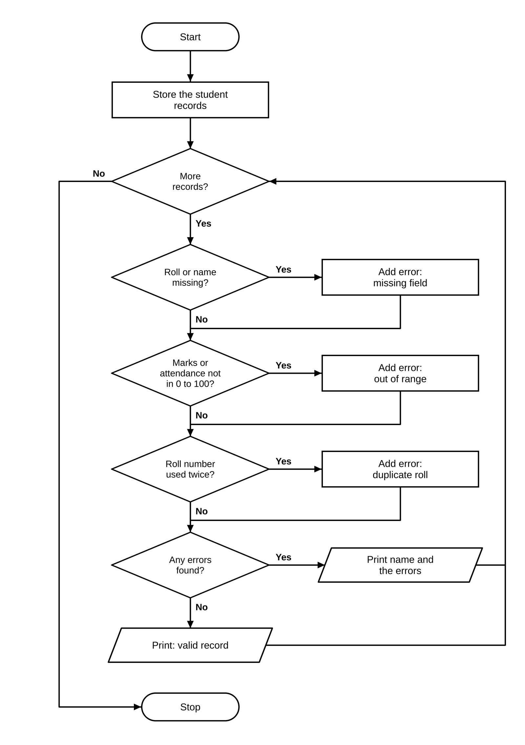

6. Pseudocode
BEGIN
records ← list of student records
FOR each record
errors ← empty list
IF roll is empty, add missing roll number
IF name is empty, add missing name
IF marks < 0 OR marks > 100, add marks out of range
IF attendance < 0 OR attendance > 100, add attendance out of range
count records with same roll where roll is not empty
IF count > 1, add duplicate roll number
IF errors not empty, PRINT name and errors
ELSE PRINT valid record
END

7. Python Source Code
records = [
("101", "Asha", 86, 92, "Python"),
("102", "Bala", 105, 78, "Maths"),
("101", "Charan", 65, 110, "Python"),
("", "Divya", 74, 80, "Physics")
]
for record in records:
roll, name, marks, attendance, course = record
errors = []
if roll == "":
errors.append("missing roll number")
if name == "":
errors.append("missing name")
if marks < 0 or marks > 100:
errors.append("marks out of range")
if attendance < 0 or attendance > 100:
errors.append("attendance out of range")
count = 0
for item in records:
if item[0] == roll and roll != "":
count += 1
if count > 1:
errors.append("duplicate roll number")
if errors:
print(name if name else "[no name]", ":", ", ".join(errors))
else:
print(name, ": Valid record")

8. Test Cases
Test Case 1
Input: Given records
Expected result: Asha : duplicate roll number; Bala : marks out of range; Charan : attendance out of range, duplicate roll number; Divya : missing roll number

Test Case 2
Input: (“1”, “A”, 0, 100, “Python”)
Expected result: A : Valid record

Test Case 3
Input: (“”, “”, 50, 50, “Python”)
Expected result: [no name] : missing roll number, missing name

9. Output Screenshot
The following screenshot-style terminal capture shows the output produced by the supplied script.
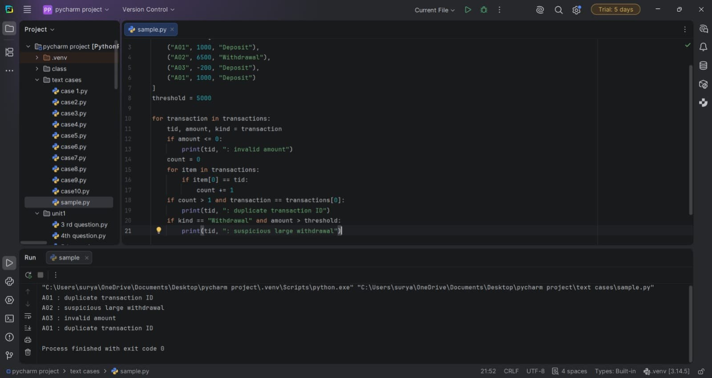

10. Conclusion
The program checks important data-quality rules before student records are used elsewhere. Clear validation messages make records easier to correct.

Case Study 87: Multiple-Choice Question Difficulty Analysis

1. Problem Statement
The program compares student answer strings against an answer key. For each question, it counts correct responses, calculates the success percentage, labels the question Difficult when fewer than 50% answer correctly, and reports the most frequently missed question.

2. Objectives
- Compare each student's answer with the answer key by question position.
- Count correct responses per question.
- Calculate the percentage of students answering each question correctly.
- Classify each question using a 50% success threshold.
- Identify the question with the fewest correct answers.

3. Assumptions
- The answer key contains one character per question.
- Student answers are position-aligned with the answer key.
- Answers are compared case-insensitively after converting the student's character to uppercase.
- Missing answer positions do not count as correct.
- The student count is the total number of answer strings supplied.

4. Algorithm
- Set the answer key and student answer strings.
- For each question position, count answers that contain the position and match the key.
- Calculate correct percentage using the total number of students.
- Label the question Difficult if percentage is below 50%, otherwise Acceptable.
- After all questions, find the smallest correct count and print that question number.

5. Flowchart
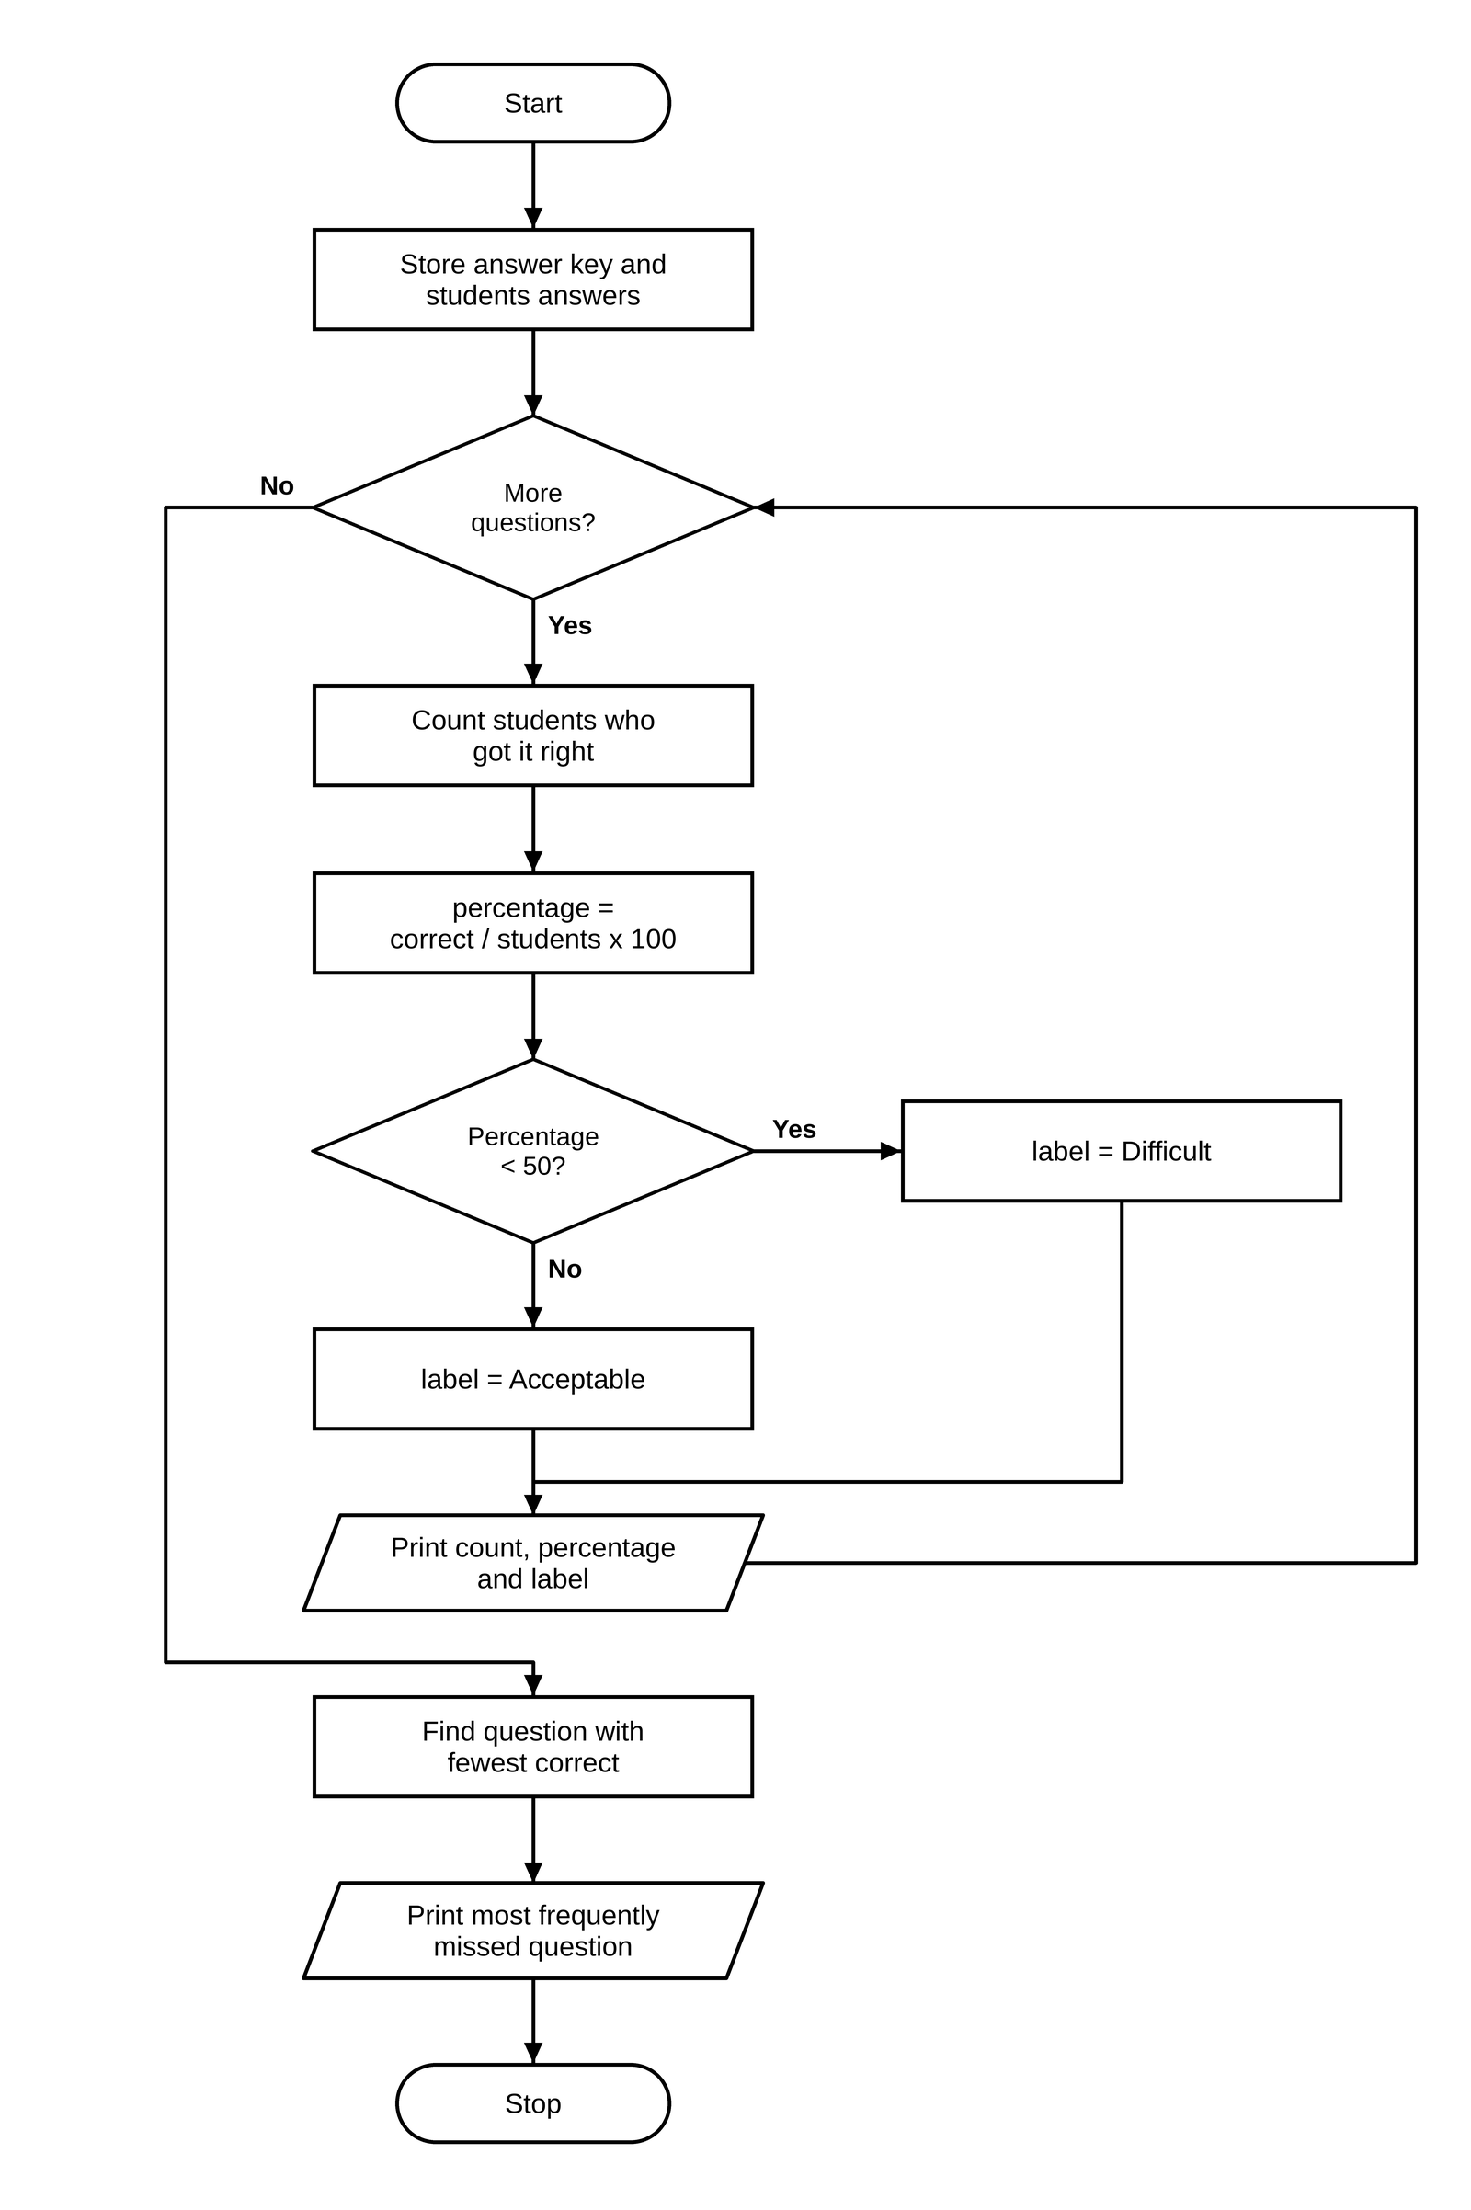

6. Pseudocode
BEGIN
answer_key ← correct answers; answers ← student responses
student_count ← number of answers
correct_counts ← empty list
FOR each question position q
correct ← count answers with a character at q matching answer_key[q]
append correct to correct_counts
percentage ← correct / student_count × 100
IF percentage < 50, difficulty ← Difficult
ELSE difficulty ← Acceptable
PRINT question number, correct count, percentage, difficulty
hardest_index ← index of minimum correct_counts
PRINT hardest_index + 1 as most frequently missed question
END

7. Python Source Code
answer_key = "ABCA"
answers = ["ABCA", "ABBA", "CBCA", "A-CA"]
student_count = len(answers)
correct_counts = []
for q in range(len(answer_key)):
correct = 0
for answer in answers:
if q < len(answer) and answer[q].upper() == answer_key[q]:
correct += 1
correct_counts.append(correct)
percentage = correct / student_count * 100
difficulty = "Difficult" if percentage < 50 else "Acceptable"
print("Question", q + 1, "- correct:", correct,
"success:", round(percentage, 1), "% -", difficulty)
hardest_index = correct_counts.index(min(correct_counts))
print("Most frequently missed question:", hardest_index + 1)

8. Test Cases
Test Case 1
Input: Key ABCA, answers ABCA, ABBA, CBCA, A-CA
Expected result: Question 1 - correct: 3 success: 75.0 % - Acceptable; Question 2 - correct: 3 success: 75.0 % - Acceptable; Question 3 - correct: 3 success: 75.0 % - Acceptable; Question 4 - correct: 4 success: 100.0 % - Acceptable; Most frequently missed question: 1

Test Case 2
Input: Key AB, answers AB, AB
Expected result: Both questions: correct 2, success 100.0 % - Acceptable; Most frequently missed question: 1

Test Case 3
Input: Key AB, answers BA, CC, DD
Expected result: Both questions: correct 0, success 0.0 % - Difficult; Most frequently missed question: 1

9. Output Screenshot
The following screenshot-style terminal capture shows the output produced by the supplied script.
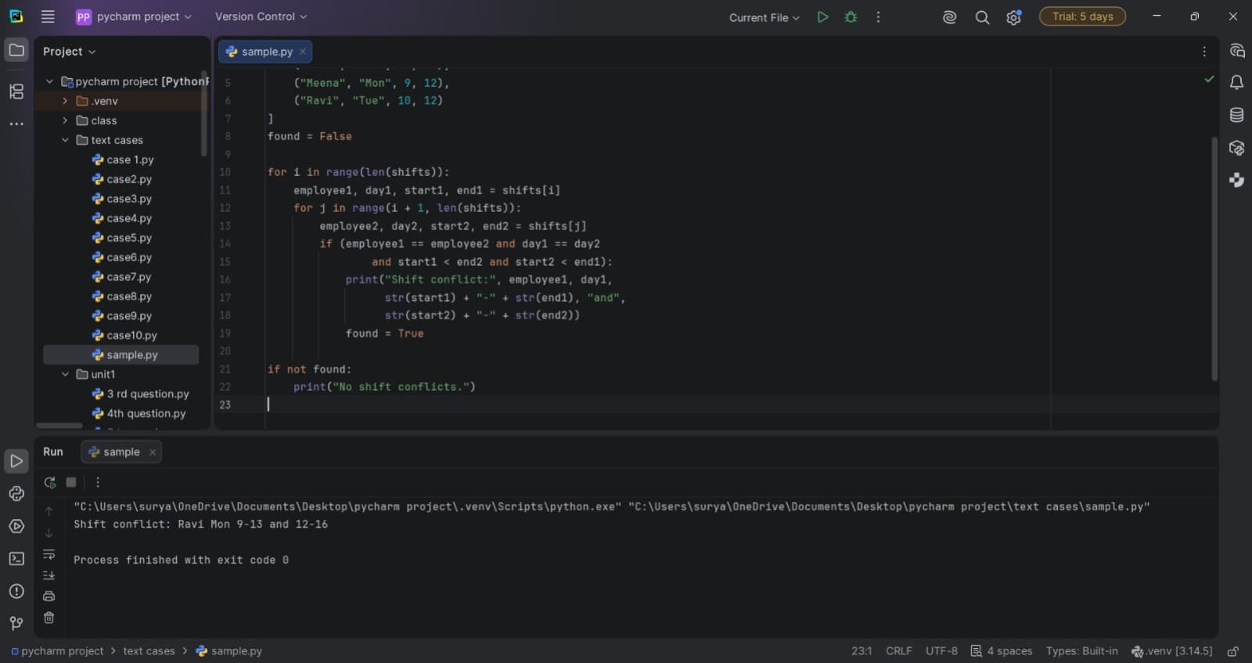

10. Conclusion
The program gives a basic item-analysis report that can help identify questions students found difficult. It uses answer frequency and a simple threshold to support review of assessment questions.

