**HourlyData**

HourlyData is a MVC Project written in dot net core.

Tools Used

1. Dot Net core ( VS2019 )
2. EntityFramework Core.
3. SQL Server Express 2017.
4. JQuery Datatable.
5. StyleCop

The application generates and displays Hourly Interval Data, by converting Half Hourly to Hourly, the Jquery Data Table allows user to view and download the excel report.

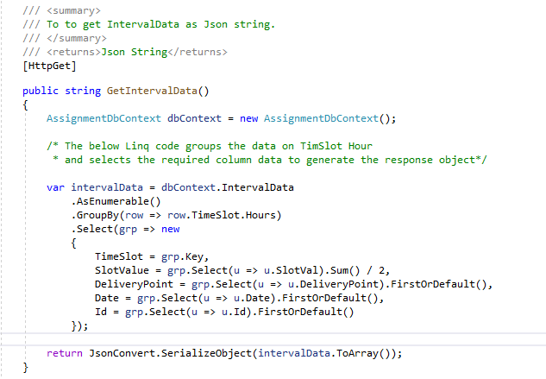

The above action method returns the Json string data, the Json string is generated out of Linq code which returns the calculated Interval Data.

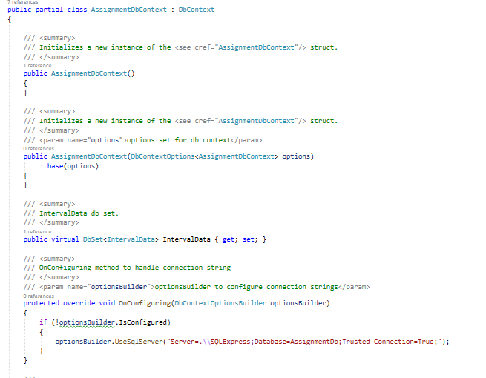

AssignmentDBContext class OnConfigureMethod configures the connection string (This can to be moved to AppSettings.Json ).