**REST API Test cases:**

**Positive Tests:**

1. Query for " DUCK "

REST URL : http://localhost:8091/animal/DUCK

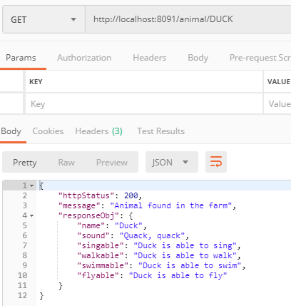

2. Query for " CHICKEN "

REST URL : http://localhost:8091/animal/DUCK

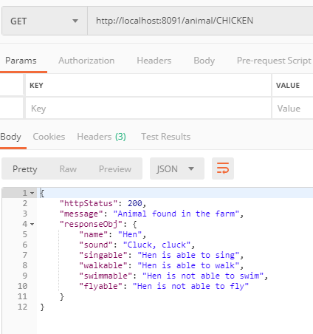

3. Query for " ROOSTER "

REST URL : <http://localhost:8091/animal/ROOSTER>

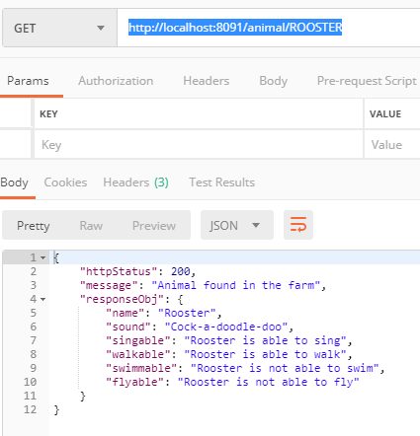

4. Query for " PARROT "

REST URL : <http://localhost:8091/animal/PARROT>

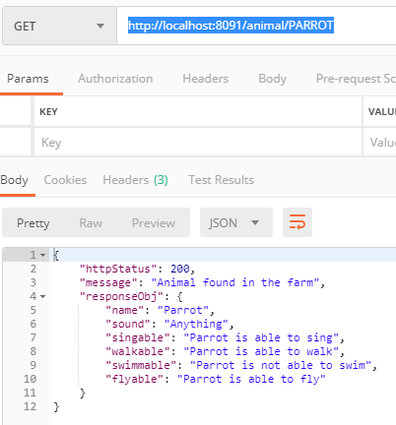

5. Query for " SHARK "

REST URL : <http://localhost:8091/animal/SHARK>

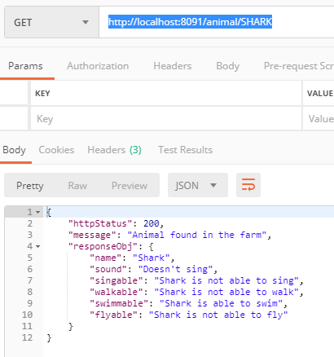

5. Query for " DOLPHIN "

REST URL : <http://localhost:8091/animal/DOLPHIN>

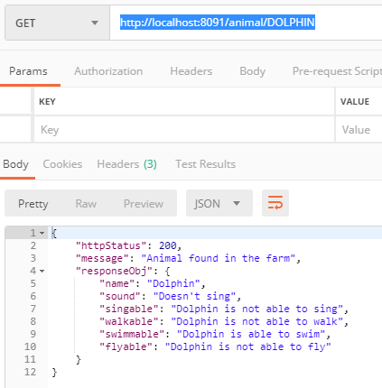

6. Query for " CATERPILLAR "

REST URL : http://localhost:8091/animal/CATERPILLAR

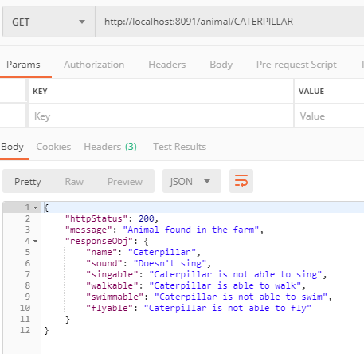

7. Query for " STATISTICS"

REST URL : <http://localhost:8091/animal/statistics>

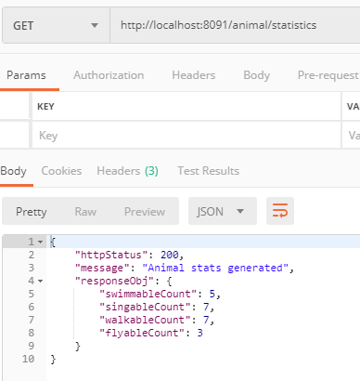

**Negative Tests:**

1. When query for animal which is not in the farm

REST URL : <http://localhost:8091/animal/xxx>

