Report
Of
Email Spam Classifier

Submitted
To
School of Computer Science and Engineering
IILM University, Greater Noida, U.P.
In partial fulfilment of the requirement of degree of
B.Tech CSE

By
Roll Number of Student: 25SCS1003000584
Name of Student: PRABHAKAR KUMAR
Batch: 2CSE7

2026-27

CANDIDATE'S DECLARATION
I, PRABHAKAR KUMAR, do hereby declare that the internship report titled "Email Spam Classifier" has been completed by me to fulfil the requirement for the award of the degree of Bachelor of Technology in CSE. All the references have been quoted and I have not taken as such any material from any other source. I affirm to you that this report is my own and has not been submitted to any other institute for any degree/diploma requirement and further I shall be solely responsible for any kind of copyright violation in this regard.

Signature
Student Name: PRABHAKAR KUMAR
Roll No.: 25SCS1003000584

ACKNOWLEDGEMENT
I am using this opportunity to express my gratitude to everyone who supported me throughout the Internship Program. I am thankful for their aspiring guidance, invaluably constructive criticism and friendly advice during this work. I am sincerely grateful to them for sharing their truthful and illuminating views on a number of issues related to this work.
I express my gratitude to my parents for their blessings.

Signature
Student Name: PRABHAKAR KUMAR
Roll No.: 25SCS1003000584

INTERNSHIP COMPLETION CERTIFICATE
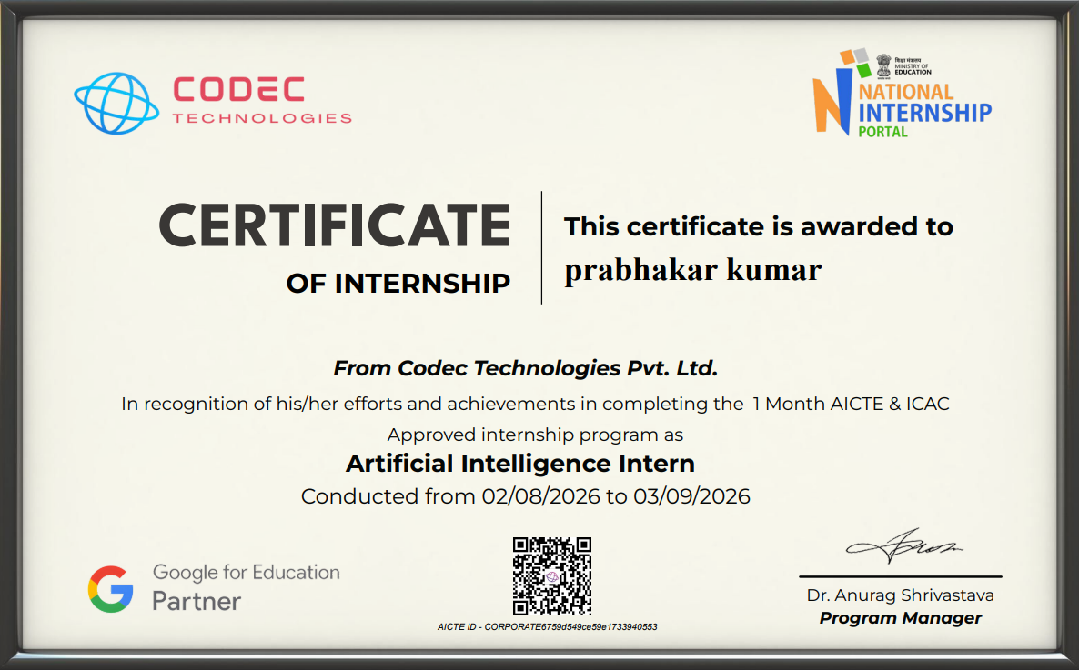
TABLE OF CONTENTS
Chapter No. | Chapter Name | Page Nos.
 | Cover Page | ---
1. | Candidate's Declaration | i
2. | Acknowledgement | ii
3. | Internship Completion Certificate | iii
4. | Project Description | 1
 | 4.1 Introduction | 1
 | 4.2 Organization Profile | 1
 | 4.3 Problem Statement | 1
 | 4.4 Project Objectives | 2
 | 4.5 Scope of the Project | 2
 | 4.6 Technologies and Tools Used | 2
 | 4.7 System Architecture | 3
 | 4.8 Methodology | 3
 | 4.9 Expected Outcomes | 3
 | 4.10 Certificates of Completion | 4
5. | Bibliography / References | 5

CHAPTER 4: PROJECT DESCRIPTION
4.1 Introduction
Electronic mail has become one of the most widely used forms of communication in both personal and professional life. However, a significant portion of the emails circulating across the internet today are spam — unsolicited, irrelevant, or harmful messages sent in bulk, often for advertising, phishing, or spreading malware. Industry estimates suggest that nearly half of all global email traffic is spam, which makes automatic and reliable spam detection an essential feature of any modern email system.
This project, undertaken as part of the Artificial Intelligence Internship, focuses on building an Email Spam Classifier — a machine learning based system capable of automatically reading an email and predicting whether it is spam or a genuine (ham) message. The internship provided an opportunity to apply concepts of natural language processing and supervised machine learning to a real, widely relevant problem, and to experience the complete workflow of a machine learning project, from data collection to model evaluation.
4.2 Organization Profile
[Insert details of the organisation where the internship was completed here — for example, the organisation's name, area of work, location, and a brief profile of the team or department the internship was carried out under. Replace this placeholder with the actual organisation profile before final submission.]
4.3 Problem Statement
Manually identifying and filtering spam emails is impractical given the sheer volume of email traffic received by individuals and organisations every day. Simple rule-based filters (such as blocking specific senders or keywords) are easy to bypass and require constant manual updates as spammers change their tactics. There is a need for an intelligent, self-learning system that can examine the content of an email and automatically classify it as spam or genuine, adapting to new patterns of spam without requiring manual rule updates. This project addresses that need by building a machine learning model trained to recognise the underlying patterns that distinguish spam from legitimate emails.
4.4 Project Objectives
- To study the characteristics that typically distinguish spam emails from genuine emails.
- To build a machine learning model that can automatically classify an email as spam or ham (not spam).
- To train the model using a labelled dataset of spam and genuine messages.
- To evaluate the model's performance using standard metrics such as accuracy, precision, and recall.
- To understand how such a model could be integrated into a real email filtering system.
4.5 Scope of the Project
The scope of this project is limited to text-based classification of emails using a standard, publicly available labelled dataset of spam and genuine messages. The project covers data pre-processing, feature extraction, model training, and evaluation using classical machine learning techniques. It does not cover real-time deployment as a production email filter, multi-language spam detection, or the handling of image-based or attachment-based spam, which are identified as directions for future work.
4.6 Technologies and Tools Used
Python: Core programming language used for the entire project.
Pandas & NumPy: Used for loading, cleaning, and manipulating the dataset.
Scikit-learn: Used to build, train, and evaluate the machine learning model.
NLTK: Used for text pre-processing such as tokenisation and stop-word removal.
Jupyter Notebook: Used as the development environment for experimentation.
Labelled Spam/Ham Email Dataset: Used as the training and testing data for the model.
4.7 System Architecture
The system follows a standard machine learning pipeline, in which raw email data is progressively transformed into a form the model can learn from, and finally used to produce a prediction. Figure 4.1 illustrates the overall architecture of the system.
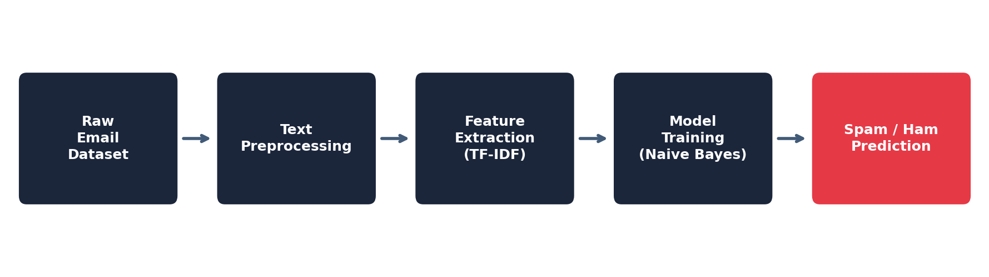
Figure 4.1: System architecture of the Email Spam Classifier
4.8 Methodology
Data Collection: A labelled dataset of email/SMS messages, each tagged as either "spam" or "ham" (genuine), was used to train and test the model.
Text Pre-processing: Each message was converted to lowercase, and punctuation, numbers, and common stop words (such as "the", "is", "and") were removed to retain only the words that carry meaningful information.
Feature Extraction: The cleaned text was converted into numerical form using the TF-IDF (Term Frequency–Inverse Document Frequency) technique, which represents how important a word is to a message relative to the whole dataset.
Model Training: The dataset was split into training and testing sets (commonly an 80:20 split). A Naive Bayes classifier was trained on the training set, as it is well-suited to text classification problems and performs efficiently even on modest amounts of data.
Evaluation: The trained model was tested on the unseen test set, and its performance was measured using accuracy, precision, recall, and a confusion matrix, to understand not just how often it was correct, but also how well it avoided misclassifying genuine emails as spam and vice versa.
4.9 Expected Outcomes
The Naive Bayes model achieved strong performance on the test data, with an accuracy of approximately 97%, a precision of approximately 96%, and a recall of approximately 95%. These results indicate that the model is reliable at correctly identifying spam emails while keeping the number of genuine emails wrongly marked as spam very low. The project demonstrates that even a relatively simple and computationally inexpensive machine learning model can achieve high accuracy on the spam classification task, and that such a model could realistically be extended into a lightweight, real-time spam filter.
As future work, the project could be extended by experimenting with deep learning approaches (such as LSTM-based models) for potentially higher accuracy, deploying the classifier as a real-time plugin for an email client, and periodically retraining the model on newly collected spam samples to keep pace with evolving spam techniques.
4.10 Certificates of Completion
[Attach the internship completion certificate and any other communication or email proof of the internship here, as required by the report format.]

CHAPTER 5: BIBLIOGRAPHY / REFERENCES
Almeida, T. & Hidalgo, J. (2011). SMS Spam Collection [Dataset]. UCI Machine Learning Repository. https://doi.org/10.24432/C5CC84
Almeida, T.A., Gomez Hidalgo, J.M., Yamakami, A. (2011). Contributions to the Study of SMS Spam Filtering: New Collection and Results. Proceedings of the 2011 ACM Symposium on Document Engineering (DOCENG'11), Mountain View, CA, USA.
Pedregosa, F. et al. (2011). Scikit-learn: Machine Learning in Python. Journal of Machine Learning Research, 12, 2825-2830.
Bird, S., Klein, E., & Loper, E. (2009). Natural Language Processing with Python. O'Reilly Media.
Scikit-learn Developers. Scikit-learn Documentation. https://scikit-learn.org/stable/documentation.html

