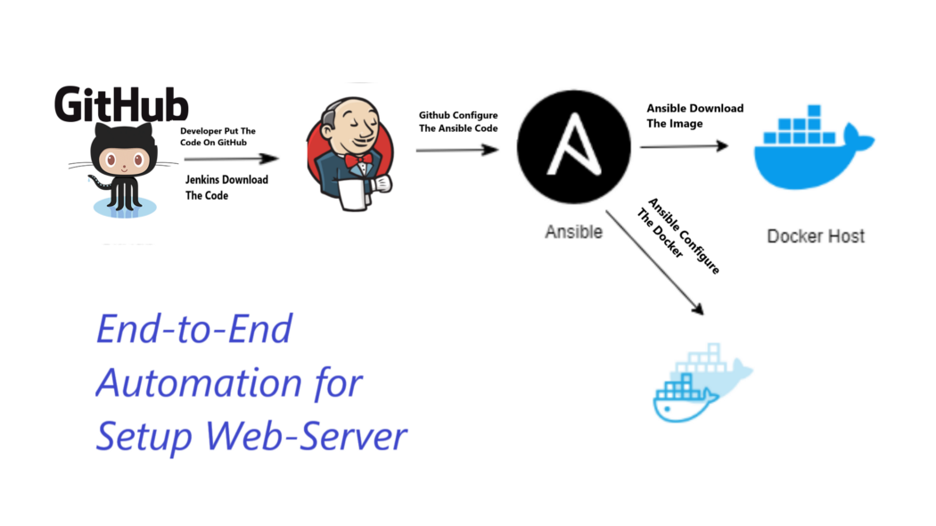

1. Write the code on local and push it to git.

Git and maven installed

Create a maven web project: mvn archetype:generate -DgroupId=com.sample.webproject -DartifactId=SampleWebApp -DarchetypeArtifactId=maven-archetype-webapp -DinteractiveMode=false

SampleWebApp/

├── pom.xml

└── src

└── main

├── resources

└── webapp

├── index.jsp

└── WEB-INF

└── web.xml

git init

git add .

git commit -m "first commit"

git branch -M main

git remote add origin <https://github.com/vikas99341/jenkins-ansible-> integration.git

git push -u origin main

Integrate git and Jenkins

systemctl enable Jenkins

service Jenkins status

write the code and run it

1. Install Ansible on the Jenkins server

Install ansible plugin

Change global tool configuration details

1. Run the job

https://github.com/vikas99341/jenkins-ansible-integration