Report: Optimising NYC Taxi Operations
Include your visualisations, analysis, results, insights, and outcomes. Explain your methodology and approach to the tasks. Add your conclusions to the sections.
1. Data Preparation
  - Loading the dataset
    - Sample the data and combine the files
Methodology: The NYC Taxi 2023 monthly trip files were sampled at 5% within each pickup-date and pickup-hour group using a fixed random seed, then the sampled monthly files were combined. The combined sampled dataset contained 1,896,400 records. To meet the assignment guideline of approximately 250,000–300,000 records, a reproducible random sample of 300,000 records was retained before further cleaning.
- Data Cleaning

Fixing Columns
    - Fix the index
The dataframe index was reset after combining and sampling so that it is a unique sequential index. No business meaning is assigned to the index.
    - Combine the two airport_fee columns
The airport fee fields were consolidated into one airport_fee column. The final dataset uses a single airport_fee field for subsequent analysis.

Handling Missing Values
    - Find the proportion of missing values in each column
Missing-value proportions were calculated as: missing count divided by total records multiplied by 100. This identifies columns requiring treatment without assuming that every missing value represents an error.

    - Handling missing values in passenger_count
Passenger_count was checked for missing values and zero values. Missing values and invalid zero passenger counts were treated using the passenger-count median, because passenger count is numeric and the median is less sensitive to extreme observations.

    - Handle missing values in RatecodeID
RatecodeID was treated as a categorical/code variable. Missing RatecodeID values were imputed using the mode. The supplied data dictionary defines valid RatecodeID values as 1=Standard rate, 2=JFK, 3=Newark, 4=Nassau or Westchester, 5=Negotiated fare, and 6=Group ride; therefore values outside this set should be reviewed rather than automatically relabelled.
    - Impute NaN in congestion_surcharge
NaN values in congestion_surcharge were imputed with 0 because the absence of a congestion surcharge is represented by a zero charge. The result was verified by rechecking the missing-value counts.

Handling Outliers and Standardising Values
    - Check outliers in payment type, trip distance and tip amount columns
Outlier analysis covered payment_type, trip_distance and tip_amount, together with the assignment-specific data-quality checks. Invalid payment types were identified from the data dictionary. Very large trip distances were reviewed, including the instruction to remove trips above 250 miles. Tip values were checked for implausibly large observations rather than treating every high tip as an error.

Exploratory Data Analysis

General EDA: Finding Patterns and Trends
    - Classify variables into categorical and numerical
Categorical/code variables include VendorID, RatecodeID, store_and_fwd_flag, PULocationID, DOLocationID and payment_type. Numerical variables include passenger_count, trip_distance, fare_amount, extra, mta_tax, tip_amount, tolls_amount, improvement_surcharge, total_amount, congestion_surcharge and airport_fee. Pickup and dropoff timestamps are datetime variables.
    - Analyse the distribution of taxi pickups by hours, days of the week, and months
Pickup demand was analysed by pickup hour, day of week and month. The purpose is to identify recurring demand peaks and differences between weekdays, weekends and months. The actual busiest hour/day/month should be taken directly from the generated frequency tables and charts rather than being assumed.
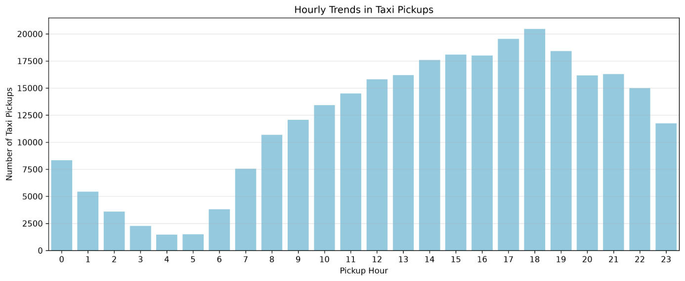
Figure: Hourly Trends in Taxi Pickups
The hourly distribution rises strongly from the morning into the afternoon and evening, with the highest observed pickup volume around 18:00 and the lowest volume around 04:00–05:00.
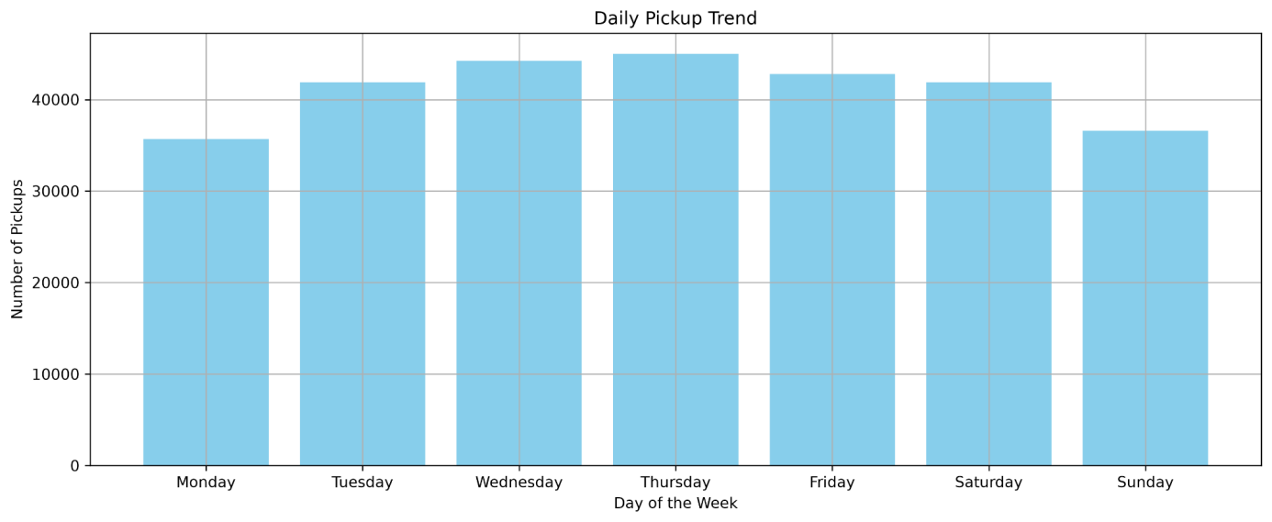
Figure: Daily Trends in Taxi Pickups
The daily chart shows the highest observed pickup volume on Thursday and the lowest on Monday, with the remaining days relatively close to one another.
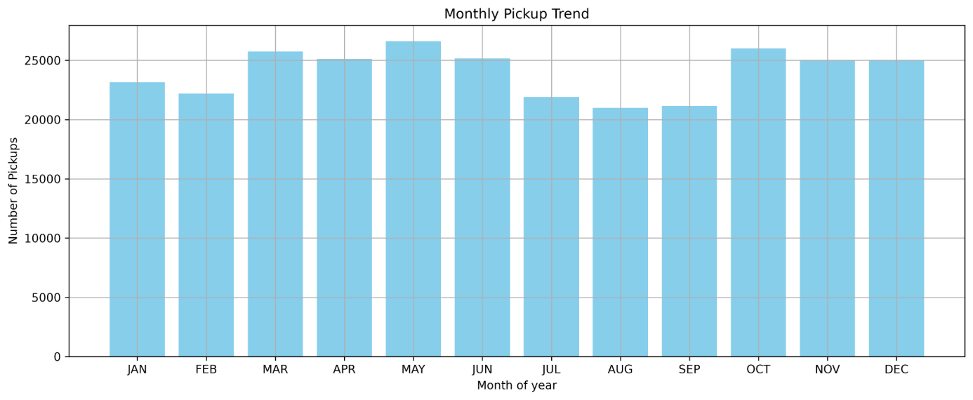
Figure: Monthly Trends in Taxi Pickups
The monthly chart shows the highest observed pickup volume in May and relatively lower volumes during August and September. October also shows a strong pickup level.
    - Filter out the zero/negative values in fares, distance and tips
Negative monetary observations were removed from the monetary columns. Sixteen records were identified with at least one negative monetary value in the cleaning step. Zero values were not automatically treated as errors because zero fare, zero tip or zero distance can represent legitimate business cases. For analyses where a positive distance is required, a derived dataset with trip_distance > 0 was used.
    - Analyse the monthly revenue trends
Monthly revenue was calculated as the sum of total_amount grouped by pickup month. The resulting trend shows how total observed revenue varies across the twelve months. Because the working dataset is a sample, the values represent the sampled dataset unless explicitly scaled.
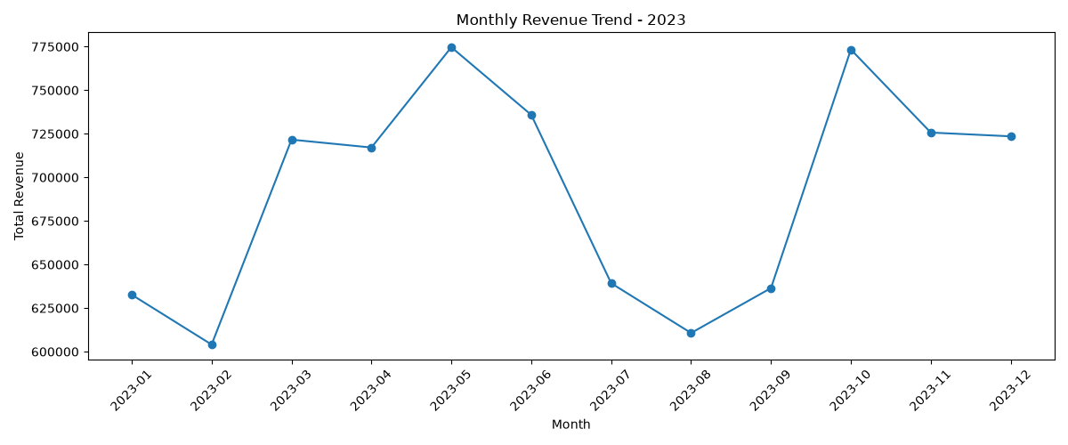
Figure: Monthly Revenue Trend – 2023
Observed sampled revenue is highest around May and October and lower around February and August. These values are totals for the working sample and should not be interpreted as full-population revenue without scaling.
    - Find the proportion of each quarter’s revenue in the yearly revenue
Quarterly revenue was calculated from total_amount and each quarter was expressed as a percentage of annual observed revenue. The four percentages sum to approximately 100%, subject to rounding
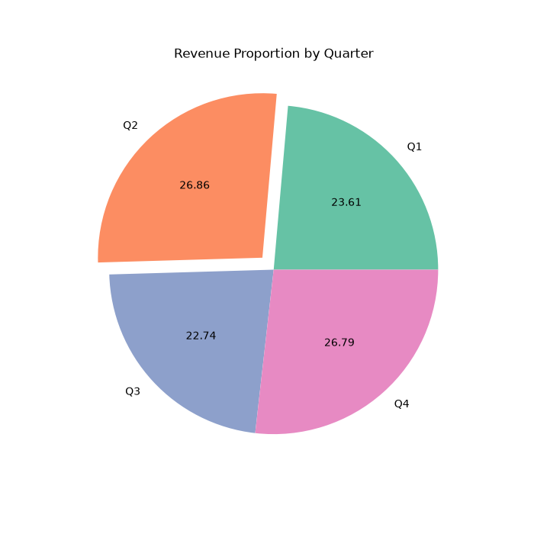.
    - Analyse and visualise the relationship between distance and fare amount
The relationship between trip_distance and fare_amount was analysed using a scatter plot and Pearson correlation on records with positive trip distance. The analysis is intended to show whether longer trips generally correspond to higher fares while also revealing unusual observations.
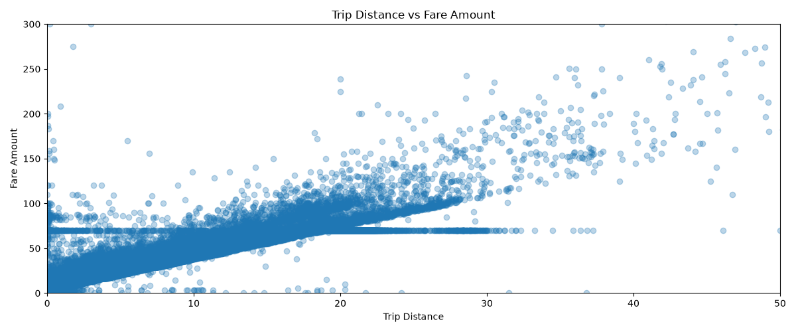

    - Analyse the relationship between fare/tips and trips/passengers
Fare, tip and passenger relationships were examined using correlations and grouped summaries. Trip duration was also derived from pickup and dropoff timestamps to assess the relationship between fare and journey duration. Zero-tip trips were retained because a zero tip is a legitimate payment outcome.
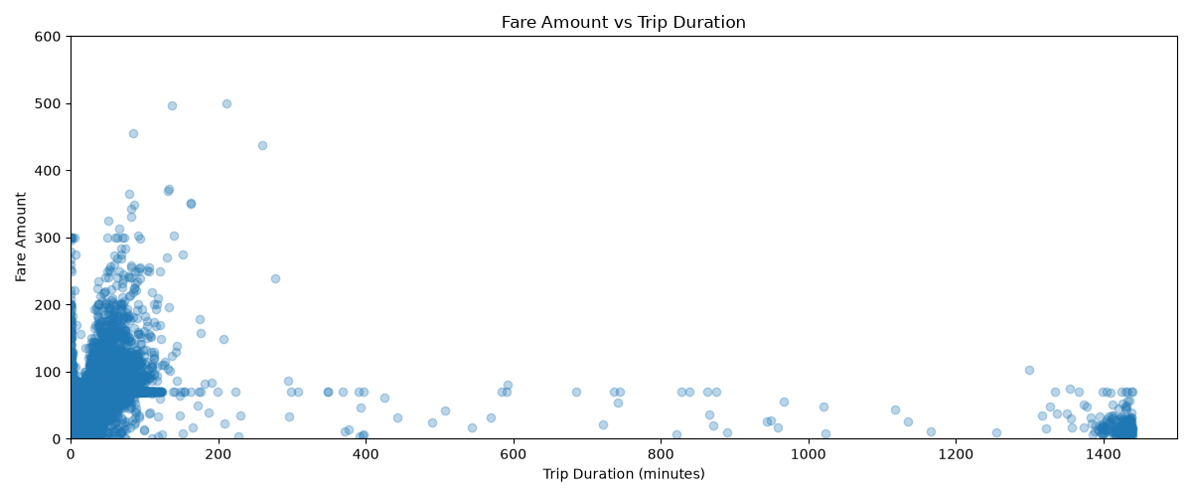
Figure: Fare Amount vs Trip Duration
The scatter plot shows a dense concentration of trips at shorter durations and several extreme-duration observations extending to roughly 1,400 minutes. These extreme durations should be treated as data-quality outliers when interpreting the fare-duration relationship.

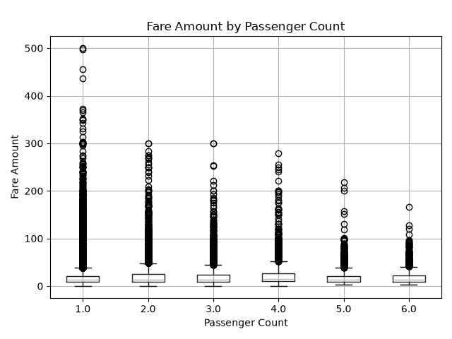
Figure: Fare Amount by Passenger Count
The boxplot shows that fare amounts vary within every passenger-count group and contain high-value observations. The central distributions are broadly similar, while one- and two-passenger trips show more high-fare observations in this sample.

    - Analyse the distribution of different payment types
Payment types were analysed using the supplied mapping: 1=Credit card, 2=Cash, 3=No charge, 4=Dispute, 5=Unknown and 6=Voided trip. Counts and percentages were calculated for each category, and any value outside 1–6 was treated as invalid and reviewed.
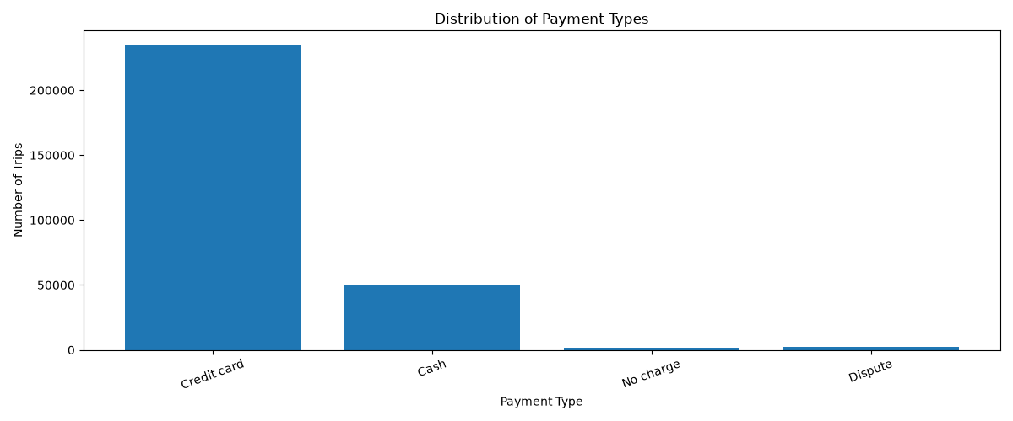
Figure: Distribution of Payment Types
Credit-card payments form the largest category, followed by cash. No-charge and dispute trips are much smaller categories in the sampled data.
    - Load the taxi zones shapefile and display it
The taxi_zones.shp file was loaded with GeoPandas. The zone dataset provides LocationID, zone, borough and geometry, which were used for geographic analysis and mapping.
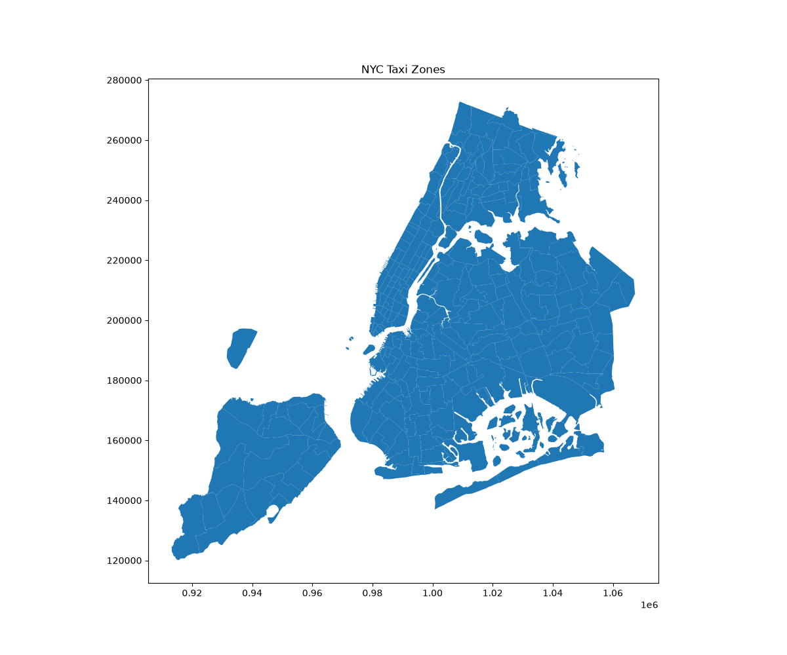
Figure: NYC Taxi Zones
The taxi-zone shapefile was visualised to verify the geographic coverage and zone boundaries used in the subsequent spatial analysis.
    - Merge the zone data with trips data
Trip records were merged with taxi-zone information using PULocationID = LocationID. A left join was used so that all trip records remain available while zone and borough attributes are attached where a matching LocationID exists.
    - Find the number of trips for each zone/location ID
The number of trips per pickup LocationID was calculated using a group-by count on PULocationID and sorted in descending order to identify the locations generating the highest observed pickup demand.
    - Add the number of trips for each zone to the zones dataframe
The trip-count table was merged into the taxi-zones dataframe using LocationID. Zones with no observed trips in the sampled dataset were assigned a trip count of zero for mapping.
    - Plot a map of the zones showing number of trips
A choropleth map was prepared using the trip count as the geographic variable. Darker/higher-value areas in the generated map represent zones with greater observed pickup demand in the sampled data.
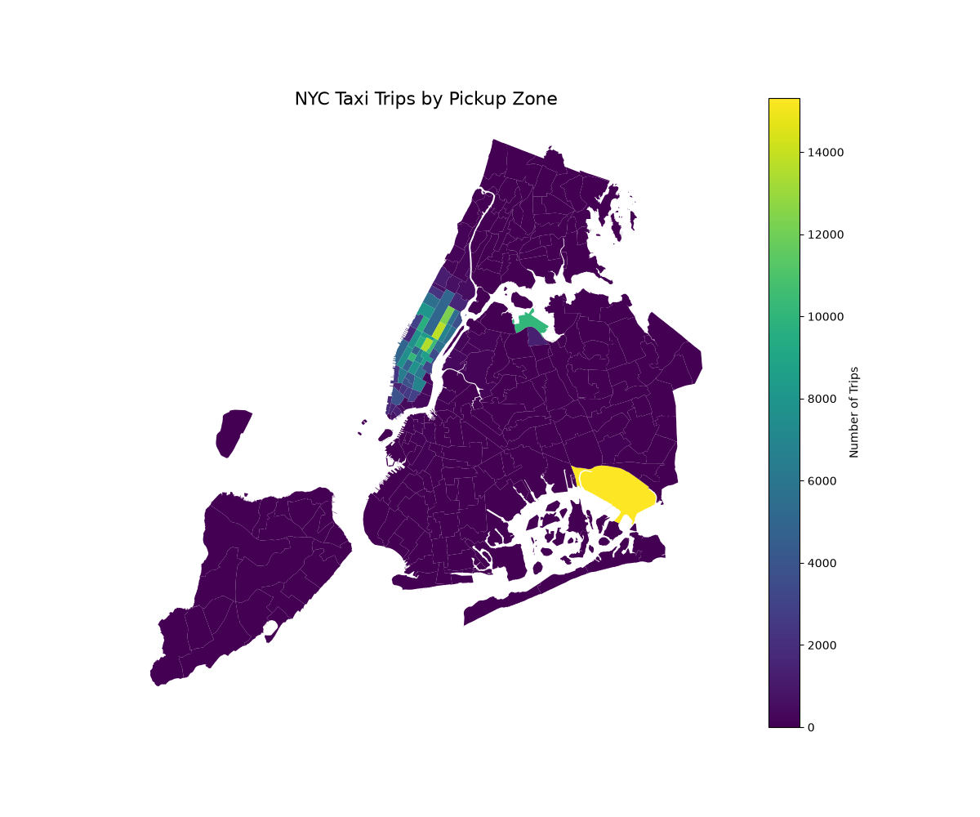
Figure: NYC Taxi Trips by Pickup Zone
Pickup demand is geographically concentrated in a subset of zones, with substantially higher trip counts in the brightest areas of the map. The map supports zone-level demand and dispatch analysis.
    - Conclude with results
The geographic analysis identifies where pickup demand is concentrated and provides the basis for zone-level dispatching and cab-positioning decisions. Final zone names and counts should be taken from the generated busiest-zones table and map, not inferred without running the analysis.

Detailed EDA: Insights and Strategies
    - Identify slow routes by comparing average speeds on different routes
Slow routes were identified by calculating average speed as average trip distance divided by average trip duration for pickup/dropoff route pairs and pickup hour. Routes with sufficient trip volume were retained to avoid conclusions from very small samples. Low-speed routes indicate potential congestion or operational inefficiency and can support dispatch and routing decisions.
    - Calculate the hourly number of trips and identify the busy hours
Hourly trip counts were calculated from the pickup timestamp. The hour with the maximum count is the busiest observed pickup hour in the sample. The exact hour and count should be taken from the generated hourly frequency table.
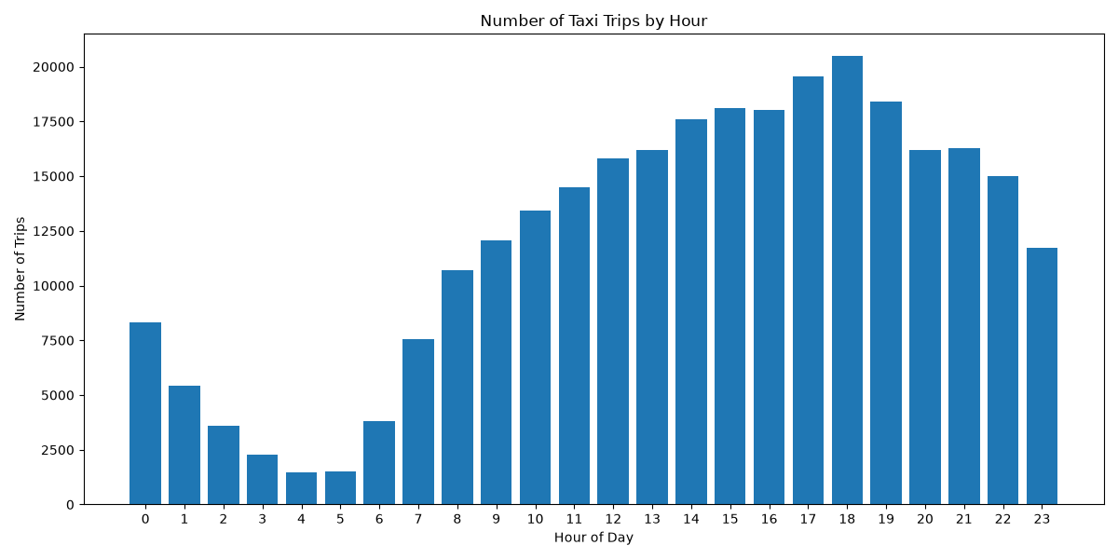
Figure: Number of Taxi Trips by Hour
The hourly count confirms that 18:00 has the highest observed pickup volume, while 04:00–05:00 have the lowest. Demand increases substantially from about 07:00 onward and remains high through the evening.
    - Scale up the number of trips from above to find the actual number of trips
Because the initial sampling fraction was 5%, an approximate actual trip count can be estimated by dividing the sampled hourly count by 0.05. This is an estimate, not an exact population count, especially after the additional reduction to approximately 300,000 records.
    - Compare hourly traffic on weekdays and weekends
Hourly weekday and weekend demand were compared using pickup hour. Weekday patterns can be used to identify commuting-related peaks, while weekend patterns can reveal different demand windows. The two curves should be used to plan different dispatch schedules.
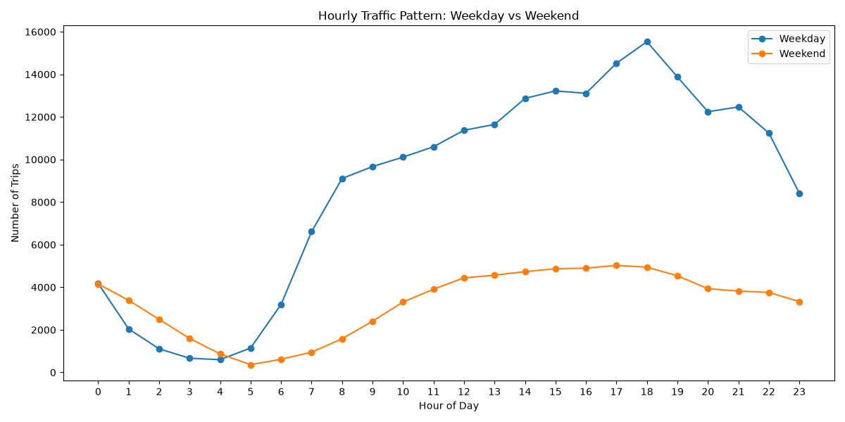
Figure: Hourly Traffic Pattern – Weekday vs Weekend
Weekday demand is substantially higher than weekend demand during most daytime and evening hours. Weekend demand is relatively stronger during the early-morning hours, while weekday demand rises sharply from about 07:00 and peaks around 18:00.
    - Identify the top 10 zones with high hourly pickups and drops
The top 10 pickup and dropoff LocationIDs were identified using value_counts. These rankings identify high-demand origins and destinations. The exact zone names should be read from the merged taxi-zone table.
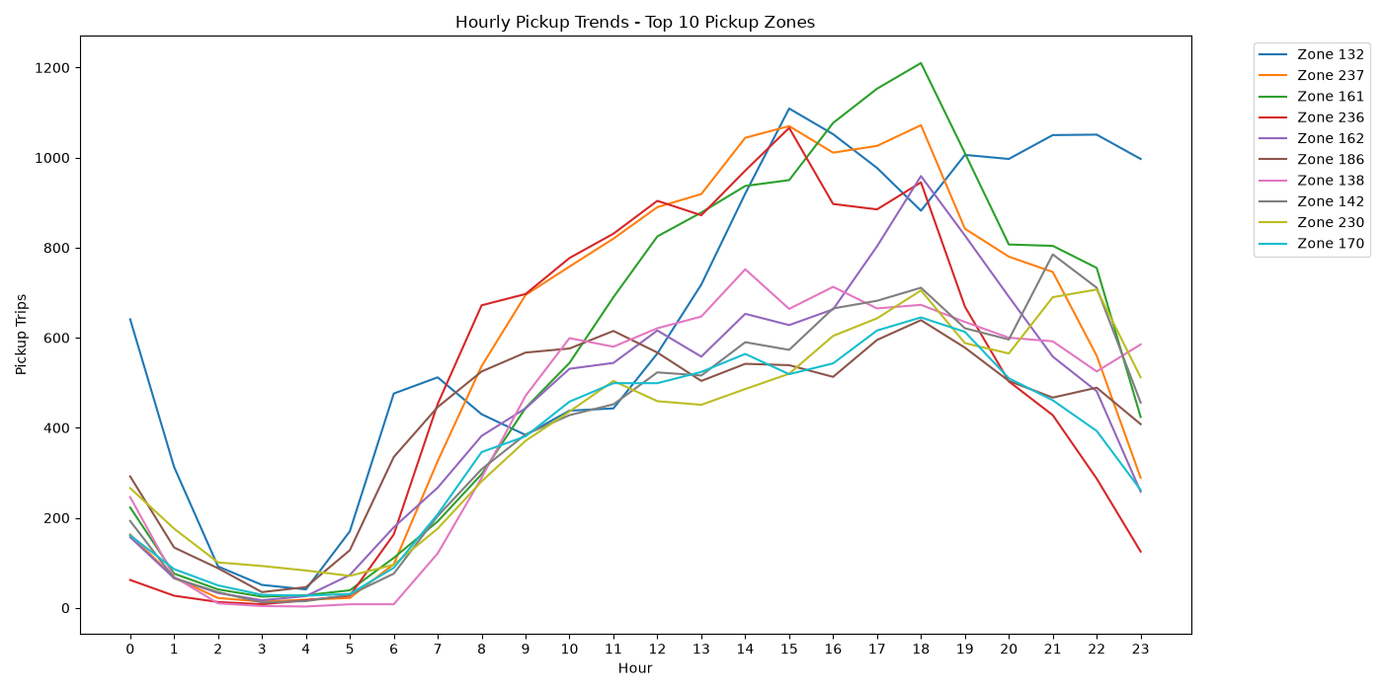
Figure: Hourly Pickup Trends – Top 10 Pickup Zones
The top pickup zones show similar low demand during the early-morning hours followed by strong growth during the day. Several zones peak during the late afternoon or evening, although the exact peak hour differs by zone.

    - Find the ratio of pickups and dropoffs in each zone
Pickup/dropoff ratio was calculated for each LocationID as pickup_count divided by dropoff_count. A high ratio indicates relatively stronger pickup demand, while a low ratio indicates relatively stronger dropoff demand. Zones with zero dropoffs were excluded from ratio ranking to avoid division by zero.
    - Identify the top zones with high traffic during night hours
Night demand was defined as pickups from 23:00 through 04:59. Separate pickup and dropoff rankings were calculated for these hours so that late-night cab positioning is based on night-specific demand rather than overall demand.
    - Find the revenue share for nighttime and daytime hours
Nighttime revenue was calculated for 23:00–04:59 and compared with daytime revenue. The two percentages were calculated as each period's total_amount divided by the combined revenue. The exact percentage should be taken from the generated output.
    - For the different passenger counts, find the average fare per mile per passenger
Fare per mile per passenger was calculated as fare_amount / trip_distance / passenger_count for records with positive trip distance and passenger count. The mean was then calculated for each passenger-count group to compare effective fare intensity across different occupancy levels.
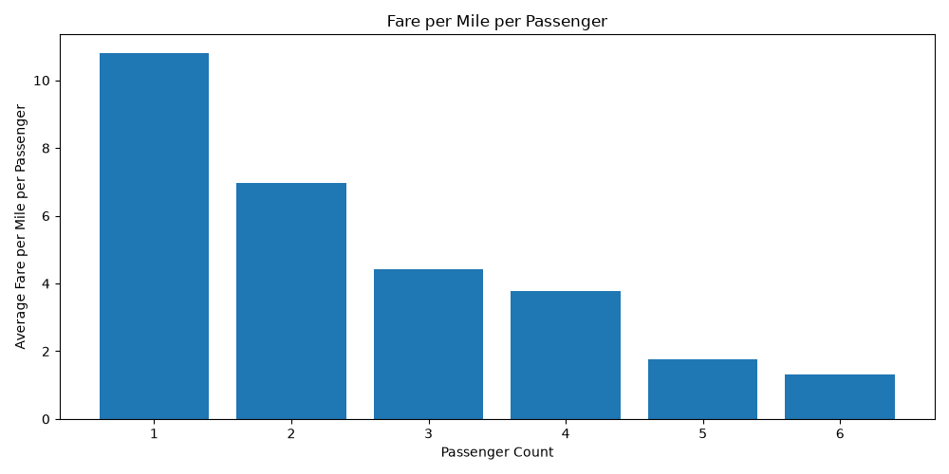
Figure: Fare per Mile per Passenger
Average fare per mile per passenger decreases as passenger count increases in the sampled data, from roughly 10.8 for one passenger to roughly 1.3 for six passengers. This should be interpreted as a per-passenger allocation metric rather than a change in the underlying taxi fare tariff.
    - Find the average fare per mile by hours of the day and by days of the week
Average fare per mile was calculated by pickup hour and by day of week using records with positive trip distance. This highlights periods when observed fare per mile is relatively higher or lower and can be considered alongside demand and trip duration.
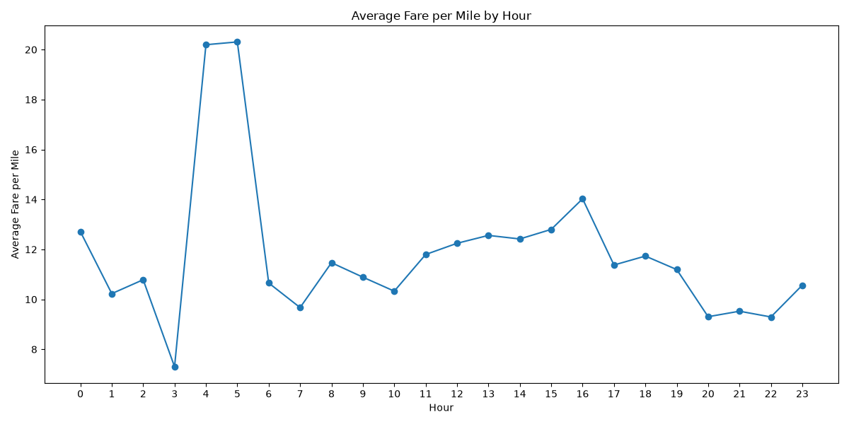
Figure: Average Fare per Mile by Hour
Average fare per mile varies substantially by pickup hour. The chart shows unusually high values around 04:00–05:00 and a local high around 16:00, while the lowest observed value occurs around 03:00. Low trip volume in some hours can make these averages sensitive to individual trips.
    - Analyse the average fare per mile for the different vendors
The dataset contains two vendor IDs used in this analysis: Vendor 1 (VendorID=1) and Vendor 2 (VendorID=2). Average fare per mile was calculated separately for each vendor. The analysis compares the observed values without assigning an overall winner; the actual values should be taken from the generated vendor summary.
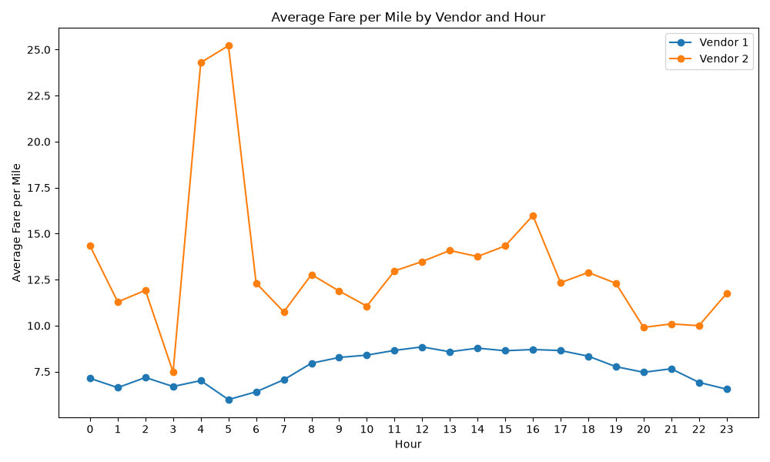
Figure: Average Fare per Mile by Vendor and Hour
Vendor 2 has a higher observed average fare per mile than Vendor 1 across the displayed hours. The difference is particularly large around 04:00–05:00 and remains visible across most other hours. This is a descriptive comparison of the sample, not an overall vendor ranking.
    - Compare the fare rates of different vendors in a distance-tiered fashion
Vendor 1 (VendorID=1) and Vendor 2 (VendorID=2) were compared across three distance tiers: Up to 2 miles, 2 to 5 miles, and More than 5 miles. Fare per mile was calculated within each tier to avoid comparing short and long trips as though their pricing behaviour were identical.
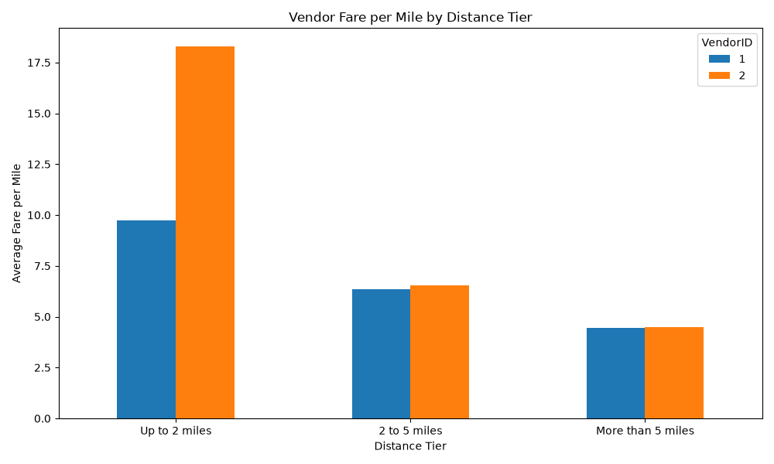
    - Analyse the tip percentages
Tip percentage was calculated as tip_amount / fare_amount × 100 for trips with positive fare and positive distance. The analysis was further grouped by distance category, passenger count and pickup hour. Zero-tip trips were retained because they are legitimate observations.

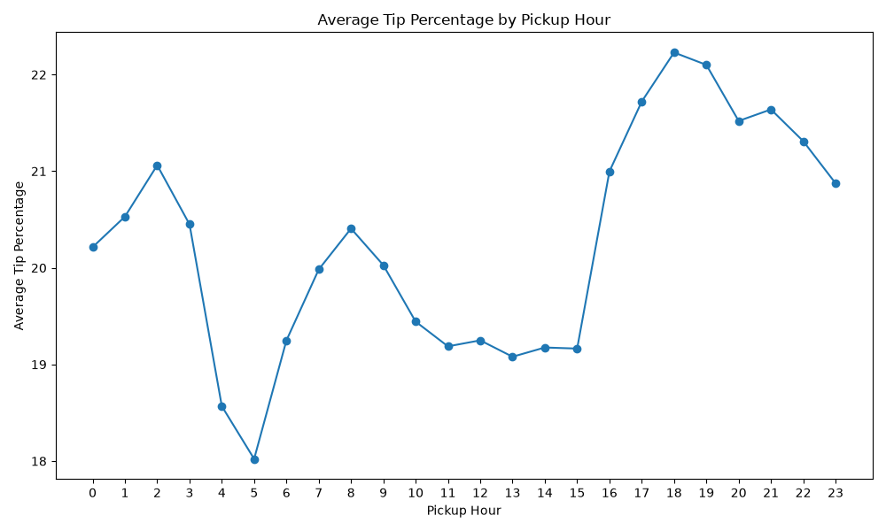
Figure: Average Tip Percentage by Pickup Hour
Average tip percentage is lowest around 05:00 and increases later in the day, reaching its highest observed level around 18:00–19:00 before declining gradually toward 23:00.
    - Analyse the trends in passenger count
Passenger-count trends were analysed by pickup hour and day of week using the mean passenger count. This helps identify periods with relatively higher or lower occupancy and can support vehicle-capacity planning.
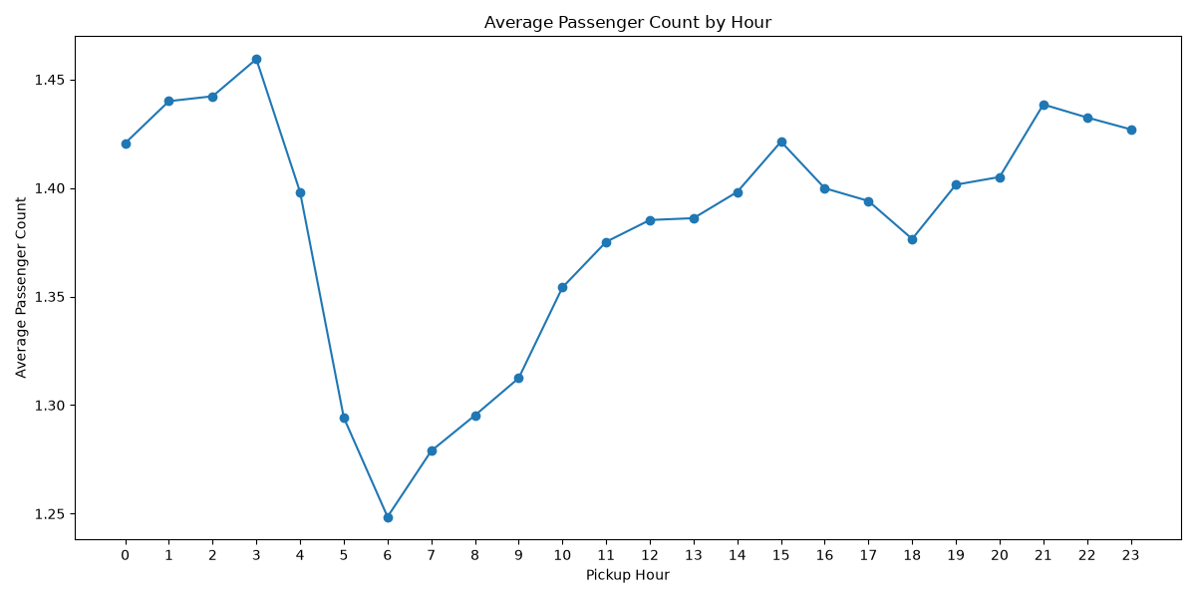
Figure: Average Passenger Count by Hour
Average passenger count is highest around 03:00 and lowest around 06:00. It rises again through the daytime and shows another relatively high level during the late evening.
    - Analyse the variation of passenger counts across zones
Average passenger count was calculated for each pickup zone and combined with trip volume. The zone map can then show where higher average occupancy occurs, while trip count prevents low-volume zones from being interpreted without context.
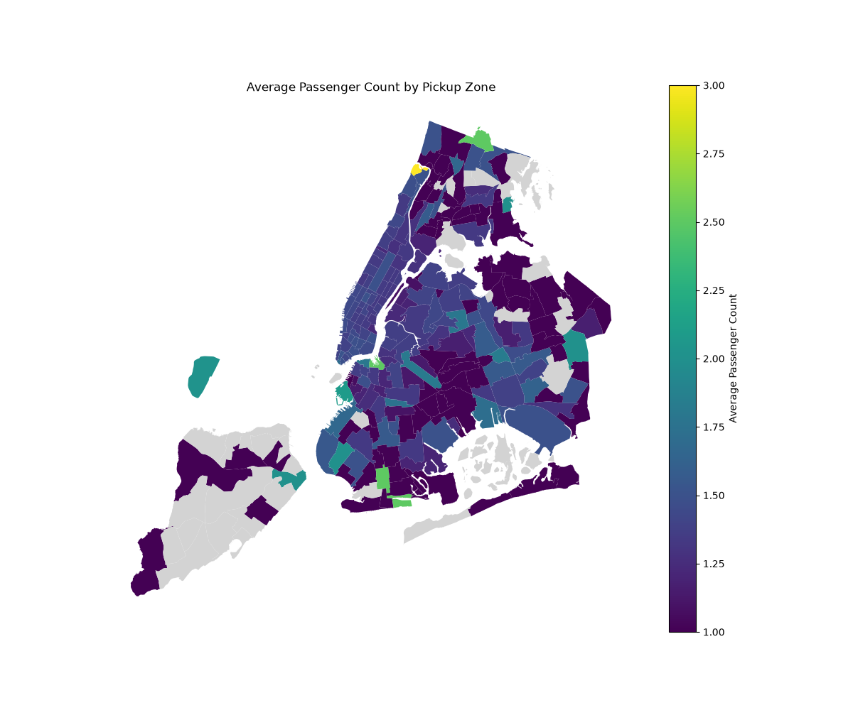
Figure: Average Passenger Count by Pickup Zone
The geographic distribution shows that average passenger counts vary by pickup zone, with most zones clustered around lower values and a small number of zones showing higher average occupancy. These higher values should be considered together with trip volume.
    - Analyse the pickup/dropoff zones or times when extra charges are applied more frequently.
Extra-charge prevalence was calculated for extra, mta_tax, tolls_amount, improvement_surcharge, congestion_surcharge and airport_fee by counting trips where each charge was greater than zero. Additional grouping by pickup hour and zone can identify when and where particular charges occur more frequently.
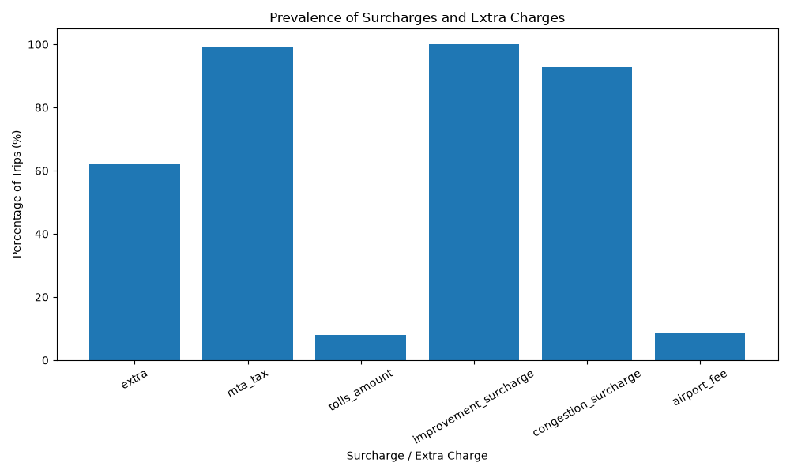
Figure: Prevalence of Surcharges and Extra Charges
Improvement surcharge and MTA tax are applied on nearly all observed trips, while congestion surcharge is also very common. Extra charges occur on a substantial share of trips, whereas tolls and airport fees occur on a much smaller share.

Conclusions

Final Insights and Recommendations
    - Recommendations to optimize routing and dispatching based on demand patterns and operational inefficiencies.
1. Use hourly and zone-level pickup demand to allocate available cabs before peak periods rather than waiting for demand to appear.
2. Use the slow-route analysis to identify recurring low-speed routes and consider alternative routing or dispatch rules during affected hours.
3. Maintain separate weekday and weekend dispatch plans because demand patterns differ by day type.
4. Use pickup/dropoff imbalance ratios to identify zones that may require repositioning of empty vehicles.
5. Use night-specific demand from 23:00–04:59 for late-night positioning rather than relying only on all-day rankings.
6. Monitor trip duration and route speed to reduce idle time and improve vehicle utilisation.

    - Suggestions on strategically positioning cabs across different zones to make best use of insights uncovered by analysing trip trends across time, days and months.
1. Position more available cabs near the highest observed pickup-demand zones during their peak hours.
2. Use hourly zone trends to reposition vehicles shortly before demand peaks.
3. Use pickup/dropoff ratios to identify zones where additional vehicles are likely to be needed after dropoffs.
4. Apply different positioning rules for weekdays, weekends and nighttime hours.
5. Reassess zone demand monthly so that seasonal changes are reflected in the positioning plan.
6. Use the taxi-zone map together with trip counts, rather than relying on zone names alone, to make operational decisions.

    - Propose data-driven adjustments to the pricing strategy to maximize revenue while maintaining competitive rates with other vendors.
1. Use observed fare-per-mile by distance tier as a pricing benchmark: up to 2 miles, 2–5 miles and more than 5 miles.
2. Review fare-per-mile differences by hour and day of week before making time-based pricing adjustments.
3. Compare Vendor 1 (VendorID=1) and Vendor 2 (VendorID=2) within the same distance tier so that pricing comparisons are like-for-like.
4. Consider demand, trip duration and congestion when evaluating time-based pricing rather than using fare per mile alone.
5. Preserve transparent pricing and monitor customer-facing effects of any adjustment.
6. Validate proposed pricing changes against observed revenue, trip volume and customer tipping behaviour before implementing them broadly.

END

