University of Kalyani

*Department of Controller of Examinations*

**Programme for M.A 3rd Semester in English Examination, 2021**

**(Regular+Supple)**

**Time: 12.00 noon to 4.00 pm**

|  |  |  |  |
| --- | --- | --- | --- |
| **Date** | **Day** | **Paper** | **Paper Name** |
| 18-03-2021 | Thursday | CC301 | 20th Century: Poetry and Drama (1901 to the present) |
| 20-03-2021 | Saturday | CC302/X | Literary Criticism up to the end of the 19th Century |
| 22-03-2021 | Monday | OC501 | European Literature in Translation |
| OC502 | Literature of the USA/American Drama and Poetry |
| 24-03-2021 | Wednesday | OC505 | Indian Literature in English |
| 26-03-2021 | Friday | OC508 | Post-Colonial Writing: Literature |
| 31-03-2021 | Wednesday | OC511 | New Gender Studies |

Date – 02-03-2021

Sd/-

**Controller of Examinations**

**Copy to :**

1. The Hon’ble Vice-Chancellor, K.U.
2. The Hon’ble Pro-Vice-Chancellor, K.U.
3. The Head, Department of English, K.U.
4. The Head, Department of English, Berhampore Girls’ College.
5. The Head, Department of English, Haringhata College.
6. The Registrar, K.U.
7. The Finance Officer, K.U.
8. The Cash Section, K.U.
9. The University Engineer, K.U.
10. In-charge, Result Publication Section, Dept. of Controller of Examinations, E-Technology Bhawan, K.U.
11. The System-in-Charge, K.U.: With a request to upload the schedule in the University Website.

This notification may kindly be removed from University Website on and from 01-04-2021.

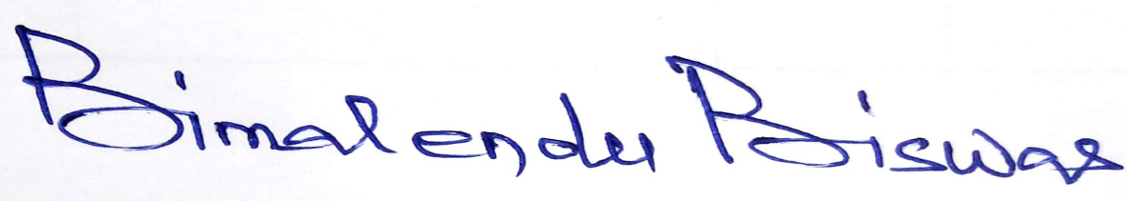

**Controller of Examinations**