SmartSpend

SmartSpend is a household cash management app designed for Indian families who want full control over their finances. Unlike existing expense trackers that rely on auto-debits or passive logging, SmartSpend empowers users to schedule payments with approval, integrate UPI seamlessly, and generate insightful reports—all while supporting shared family access and privacy-first design
Our edge lies in controlled automation: users stay in charge, not just informed.

📊 Feature Comparison Matrix (SmartSpend vs. Competitors)

Feature | SmartSpend ✅ | Money View | Monefy | Wallet | Spendee | Axio | Expensewise
Manual Expense Entry | ✅ | ✅ | ✅ | ✅ | ✅ | ✅ | ✅
UPI Integration | ✅ Real-time | SMS-based | ❌ | Bank sync | ❌ | SMS-based | ✅ Real-time
Scheduled Payments | ✅ With Approval | ❌ | ❌ | ❌ | ❌ | ❌ | ✅ (Business only)
Approval Prompt Before Payment | ✅ | ❌ | ❌ | ❌ | ❌ | ❌ | ✅
Family Mode (Role-Based Access) | ✅ | ❌ | ❌ | ✅ | ✅ | ❌ | ❌
Budget Alerts & Nudges | ✅ | ✅ | ❌ | ✅ | ✅ | ✅ | ❌
Offline Entry & Sync | ✅ | ❌ | ✅ | ❌ | ❌ | ❌ | ❌
Exportable Reports (PDF/Excel) | ✅ | ❌ | ✅ | ✅ | ✅ | ✅ | ✅
Target Audience | Households | Individuals | Individuals | Individuals | Couples | Individuals | Corporates

💡 Core Features to Include
🧾 Expense Tracking
- Categorized entries (groceries, utilities, education, etc.)
- Smart tagging using merchant names or UPI handles
- OCR-based bill scanning for auto-entry
🔁 Scheduled Payments with Approval
- Customizable frequency: daily, weekly, monthly, etc.
- Approval prompt: push notification or in-app alert on due date
- Grace period: allow postponement or partial payment
- Audit trail: log of approvals, declines, and modifications
📊 Reporting & Insights
- Period-based reports: weekly, monthly, custom range
- Visual dashboards: pie charts, bar graphs, trend lines
- Export options: PDF or Excel for offline use
- Budget vs. actual comparisons
💸 UPI Integration
- UPI Autopay with user-triggered approval: aligns with NPCI’s guidelines
- Multi-bank support: allow linking multiple UPI handles
- Mandate management: view/edit/delete recurring mandates

🛡️ Differentiators to Stand Out
- Privacy-first design: no auto-debit without user consent
- Family mode: shared dashboard with role-based access (e.g., spouse, kids)
- Offline fallback: allow manual entry and sync later
- Smart nudges: alert if spending exceeds budget or if a payment is missed

🔧 Tech Stack Suggestions
Layer | Recommendation
Frontend | Flutter (cross-platform) or React Native
Backend | Node.js with MongoDB or Firebase
UPI Integration | NPCI-approved gateway like Cashfree
Notifications | Firebase Cloud Messaging or OneSignal
Reporting Engine | Python (Pandas + Matplotlib) or Chart.js

🚀 Monetization Ideas
- Freemium model: basic features free, premium for advanced reports and family mode
- Affiliate tie-ins: link to budgeting tools, investment platforms
- White-labelling: offer to NBFCs or fintechs for customer engagement

🗺️ Product Roadmap (6-Month Sprint Plan)
Phase 1: Discovery & Validation (Weeks 1–4)
- Conduct user interviews (target: 25 households across income brackets)
- Define MVP scope: expense tracking, UPI integration, scheduled approvals
- Competitive analysis: Walnut, Money View, ET Money, etc.
- Finalize tech stack and compliance requirements (NPCI, data privacy)
Phase 2: MVP Development (Weeks 5–12)
- Build core modules:
  - Expense entry (manual + OCR)
  - UPI-linked payment scheduling with approval prompts
  - Basic dashboard with monthly summary
- Integrate push notifications and SMS alerts
- Internal alpha testing with 10–15 users
Phase 3: Beta Launch & Feedback (Weeks 13–18)
- Launch closed beta via TestFlight/Play Store beta
- Collect feedback on UI/UX, approval flow, and reporting
- Add exportable reports (PDF/Excel)
- Begin work on family mode and budget alerts
Phase 4: Public Launch & Growth (Weeks 19–24)
- Launch on Play Store and App Store
- Run digital campaigns targeting salaried professionals and homemakers
- Add premium features: multi-user access, smart nudges, offline sync
- Begin partnerships with fintechs or NBFCs for white-labeling

🎯 Pitch Deck Outline (10 Slides)
Slide | Title | Key Points
1 | Title Slide | App name, tagline, your name and role
2 | Problem Statement | Lack of control in household expense management, auto-debits without consent
3 | Solution | Controlled scheduling, UPI integration, smart reporting
4 | Market Opportunity | 300M+ UPI users, rising demand for personal finance tools
5 | Product Demo | Screenshots or mockups of key flows
6 | Unique Value Proposition | Approval-first payments, family mode, privacy-first design
7 | Business Model | Freemium, premium features, affiliate tie-ins
8 | Go-to-Market Strategy | Beta launch, influencer tie-ins, app store optimization
9 | Team & Tech Stack | Your background + dev partners, stack overview
10 | Ask | Funding, partnerships, pilot users, feedback loop

🖼️ Mock UI Flow (User Journey Overview)
Here’s a suggested screen-by-screen flow for the MVP:
1. Home Dashboard
- Monthly expense summary
- Upcoming scheduled payments
- Budget vs. actual tracker
2. Add Expense
- Manual entry or scan bill
- Category selection (food, utilities, etc.)
- UPI handle or merchant auto-fill
- Optional notes
3. Schedule Payment
- Select payee and amount
- Set frequency (monthly, weekly, custom)
- Choose approval method (push, SMS, in-app)
- Preview next due date
4. Approval Prompt (Notification)
- “Approve ₹X to Y for electricity bill?”
- Options: ✅ Approve | ❌ Decline | ⏳ Snooze
- Link to payment screen via UPI
5. Reports
- Select date range
- View by category, merchant, or payment method
- Export as PDF or Excel
- Visual charts (pie, bar, trend)
6. Settings
- Link UPI accounts
- Set monthly budget
- Manage family access
- Notification preferences

🗣️ Pitch Deck Content (Slide-by-Slide)

Slide 1: Title
“SmartSpend: Household Cash Management with Control”

Slide 2: Problem
Most household finance apps either auto-debit or lack control.
Families need a tool that tracks expenses, schedules payments, and asks for approval—without surprises.

Slide 3: Solution
SmartSpend offers:
- Controlled scheduling with user approval
- UPI integration for seamless payments
- Visual reports and budget tracking
- Family-friendly access and privacy-first design

Slide 4: Market Opportunity
- 300M+ UPI users in India
- ₹1,000 Cr+ monthly household spending
- Rising demand for personal finance tools post-COVID
- Untapped segment: middle-income families and homemakers

Slide 5: Product Demo
[Insert mock screens: Dashboard, Add Expense, Approval Prompt, Report View]

Slide 6: Unique Value Proposition
- No auto-debit: user always approves
- Family mode with role-based access
- Offline sync and exportable reports
- Smart nudges for budget control

Slide 7: Business Model
- Freemium app
- Premium features: multi-user, advanced reports
- Affiliate tie-ins with investment platforms
- White-labeling for NBFCs and banks

Slide 8: Go-to-Market Strategy
- Beta launch via Play Store
- Influencer tie-ins (finance YouTubers)
- App store optimization
- Targeted ads for salaried professionals and homemakers

Slide 9: Team & Tech Stack
- Founder:
- Dev team: Flutter, Node.js, Firebase
- UPI integration via Cashfree or Razorpay
- Reporting engine: Python + Chart.js

Slide 10: Ask
- ₹25L seed funding for MVP and launch
- Strategic partnerships with fintechs
- Pilot users for feedback
- Mentorship in product scaling

Home dashboard:
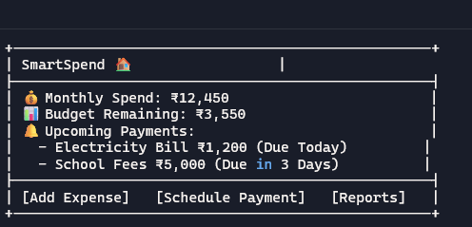

Add expense:
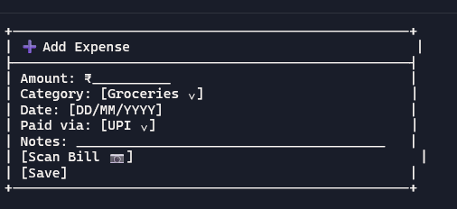

Schedule payment:
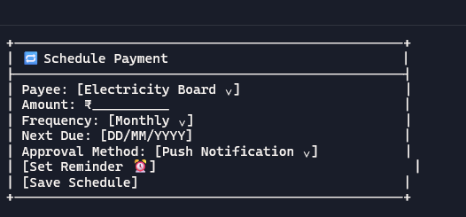

Approval Prompt:
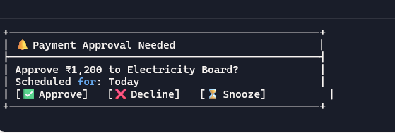
Reports:
