{_id: ObjectId('615589d480cdf8b12c8530b9')}

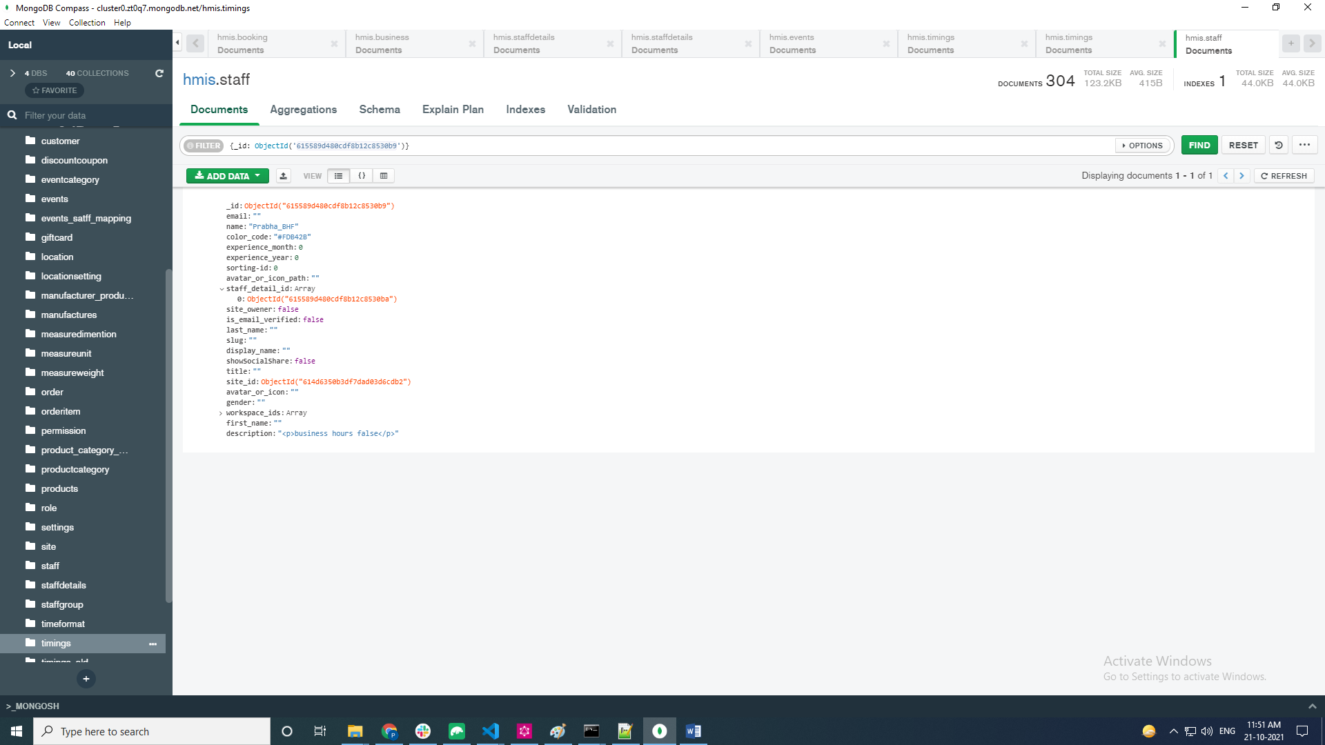

**Business Hours : False**

|  |  |  |  |  |  |
| --- | --- | --- | --- | --- | --- |
|  | Staff_id | Name | Staff Details id | Workspace_id | Site_id |
|  | 615589d480cdf8b12c8530b9 | Prabha_BHF | 615589d480cdf8b12c8530ba | 614d63c649a63250a673d1a3 | 614d6350b3df7dad03d6cdb2 |

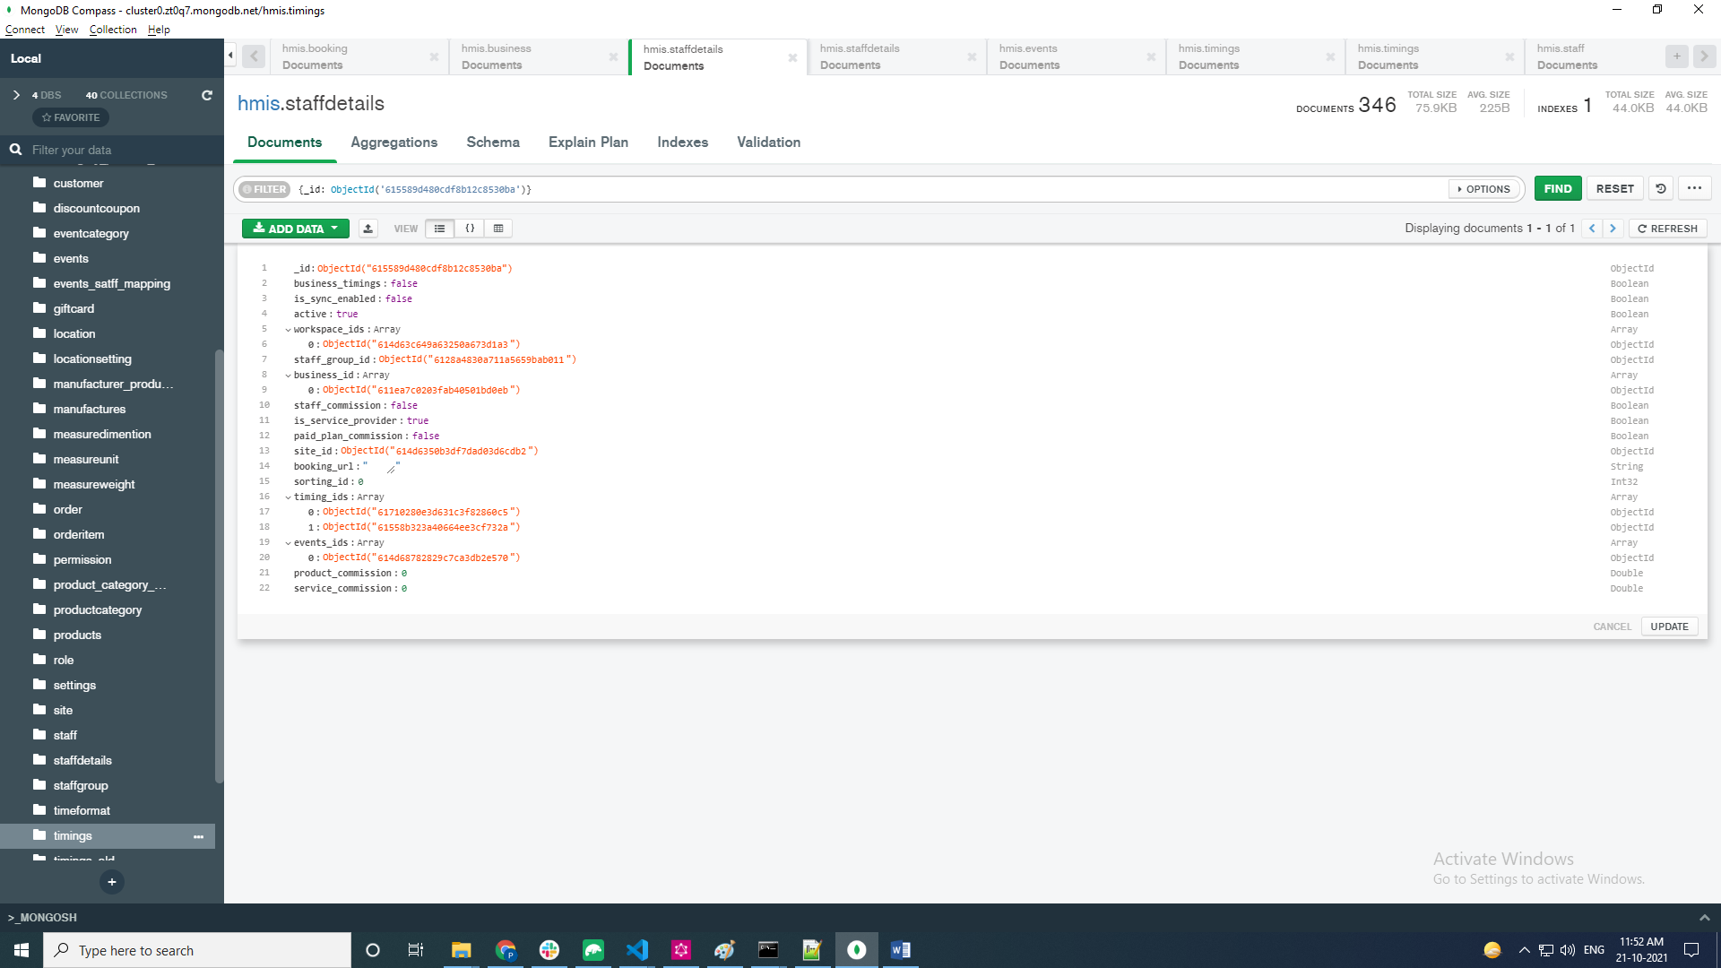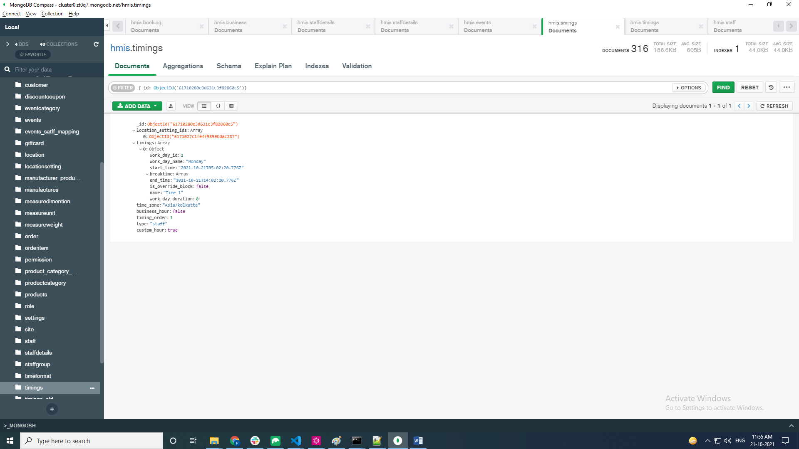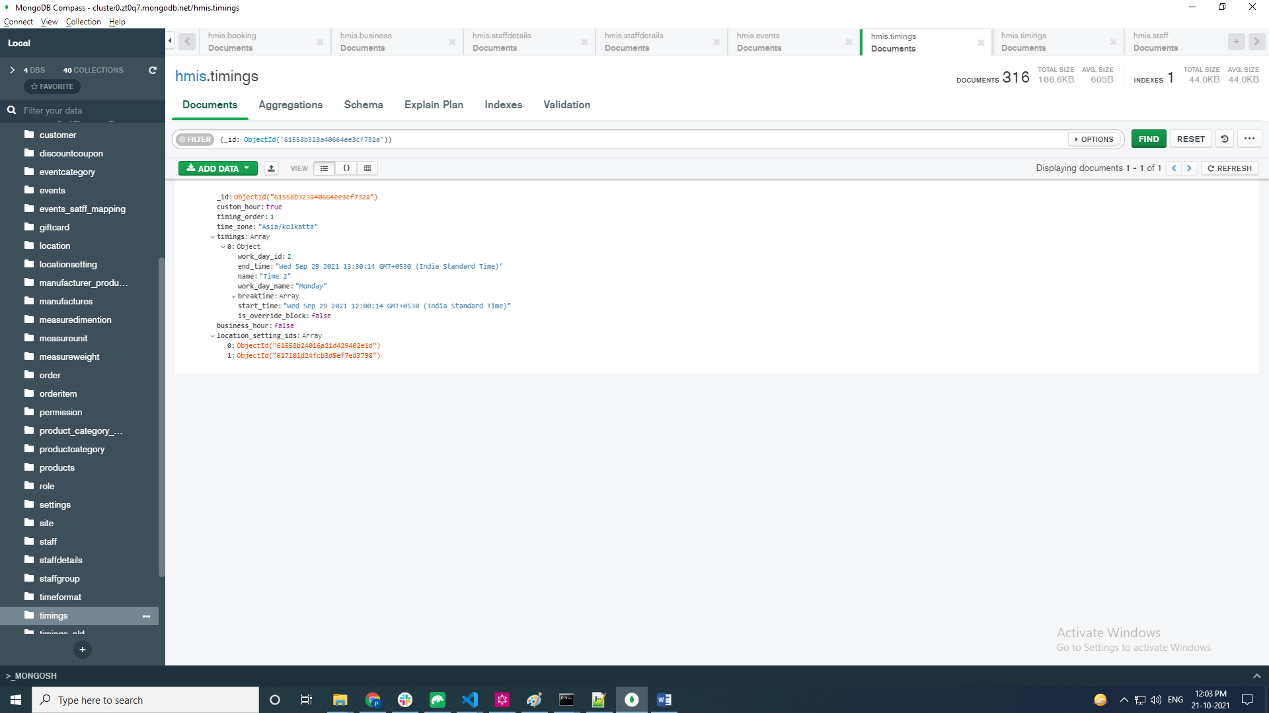

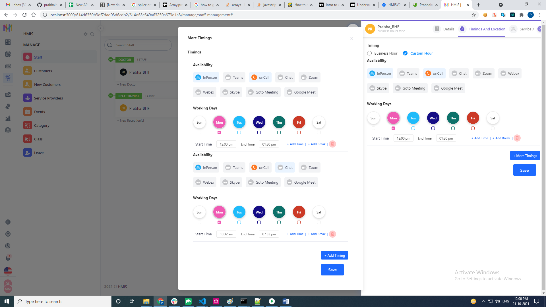

**Business Hours : True**

|  |  |  |  |  |  |
| --- | --- | --- | --- | --- | --- |
|  | Staff_id | Name | Staff Details id | Workspace_id | Site_id |
|  | 614d6350b3df7dad03d6cdb1 | Prabha_BHT | 614d65a5b3df7dad03d75ea6 | 614d63c649a63250a673d1a3 | 614d6350b3df7dad03d6cdb2 |

