**Human Computer Interaction.**

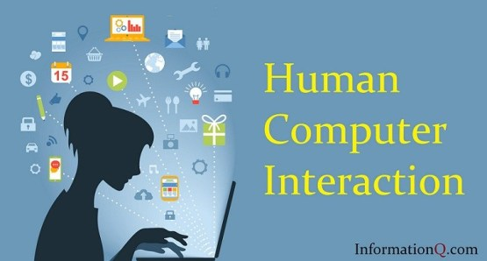

**Class activity.**

Identify the interface designs which are using “attention” theory to grab the user attention. Briefly explain 3 scenarios using examples.

* Command Line. (CLI)
* Graphical User interface. (GUI)
* Natural Language. (NLI)

----------------------------------------------------------------------------------------------------------------------------------

* Command Line. (CLI)

Command Line Interface (CLI) converts command line lines in to a computer program. The program that manipulates the interface is called a command line converter or command line processor. Enables a command line interface in an operating system shell for interactive access to operating system activities or services. Such terminals have been primarily provided to users by computer terminals since the mid – 1960s and continued to be used on personal computer systems including VAX/VMS, Unix systems and DOS, CP/M and Apple DOS throughout the 1970s and 1980s.

Many users today rely on graphical user interfaces and menu-based interactions. However, some programs and maintenance tasks may not have a graphical user interface and still use a command line. Alternatives to the command line interface are text-based user interface menus (for example:- IBM AIX SMIT), keyboard shortcuts, and various desktop images centred on the index (usually mouse-controlled). Examples include Microsoft Windows, DOS Shell, and Mouse Systems Power panel. Command line interfaces also often run on terminal devices and are available for screen-oriented text-based user interfaces.

Programs with command line interfaces are usually easier to automate via scripting. Enables command line interfaces for most software system controls and operations. This includes programming environments and utility programs.

Examples:- Microsoft Windows, DOS Shell and Mouse Systems Power Panel. Command line interfaces also often run on terminal devices and are available for screen-oriented text-based user interfaces.

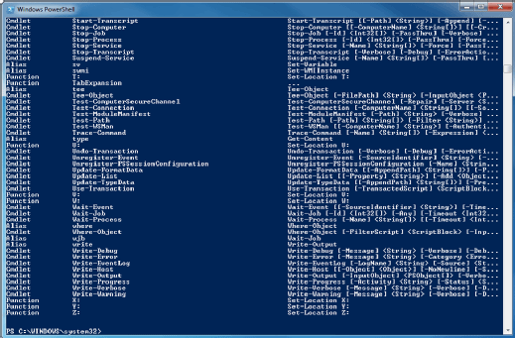

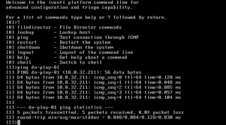

* Graphical User Interface. (GUI)

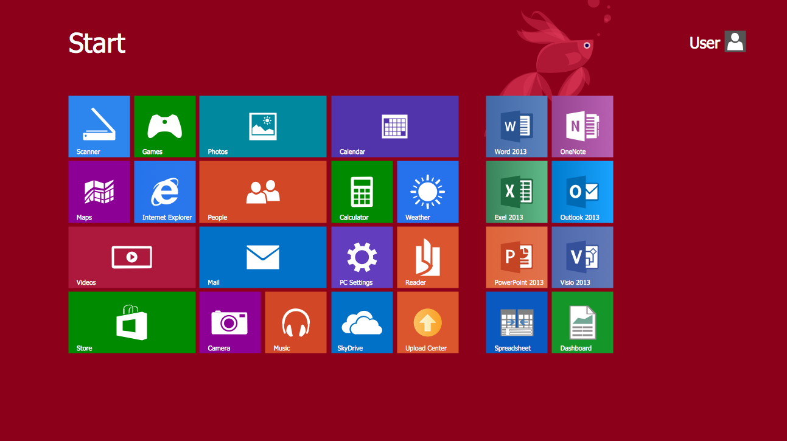

The Graphical User Interface was planned as a reaction to the matter of wasteful convenience in right on time, text-based order line interfaces for the regular client. Graphical User interface turns into the norm of the client-focused plan in programming application programming, giving clients the inclination to instinctively work PCs and other electronic gadgets through the immediate control of graphical symbols like catches, scroll bars, windows, tabs, menus, cursors, thus the mouse pointing gadget. Numerous advanced graphical user interface highlight touchscreen and voice –order association abilities.

Examples:- Desktop environments include Microsoft Windows, MacOS, Ubuntu Unity and Gnome Shell and Android, Apple iOS, BlackBerry OS, Windows 10 Mobile, Palm OS-WebOS and Firefox OS for Smartphones.

* Natural Language. (NLI)

The Natural language User interface (LUI or NLUI) is a computer human interface that processes linguistic phenomena such as words, phrases and phrases as UI controllers to create, select and modify data in computer applications. When designing interfaces, natural language interfaces are also sought for their speed and ease of use, but many face the challenge of understanding the various obscure inputs. [1] natural language interfaces are a field of active study of natural language processing and computer linguistics. A typical natural language interface is one of the functional goals of the definition web.

Text interfaces are also “natural” to varying degrees. Many formal (non-natural) programming languages include idiots of natural human language. Similarly, a traditional keyword search engine can be described as a “Shallow” natural language user interface.

Example:- Siri, Alexa, Google Assistant or Cortana are natural language interfaces that allow you to use your own spoken language and interact with your device’s operating system.

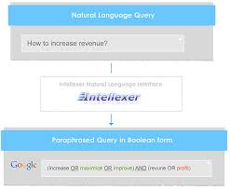

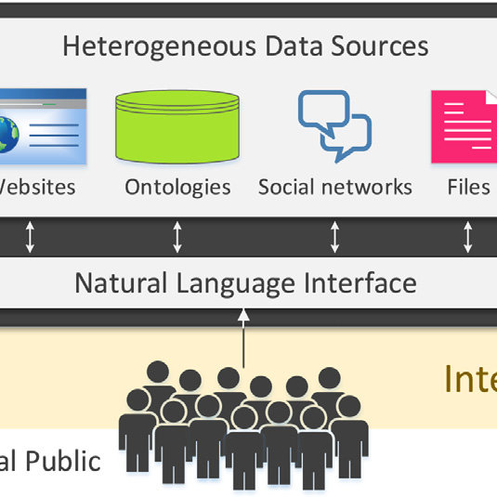

*Group Members.*

Plymouth ID Plymouth Name

10707375 Balage Silva.

10707362 Saunda Sanjula.

10707193 Ruhunu Fernando.

10707202 Sasindu Gamage.

10707428 Ran Yasiru.

10707297 Godalla Pathirana.

***Thank You!***