**HUMAN COMPUTER INTERACTION.**



**PRABHANI**

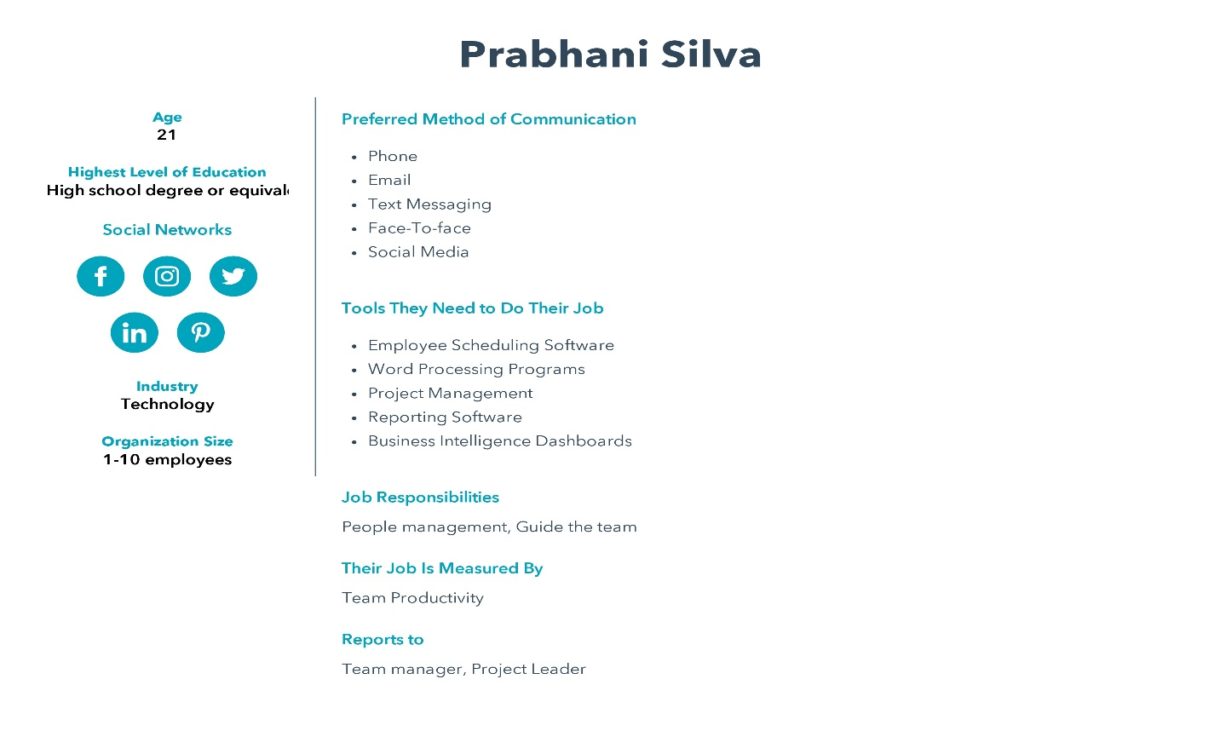

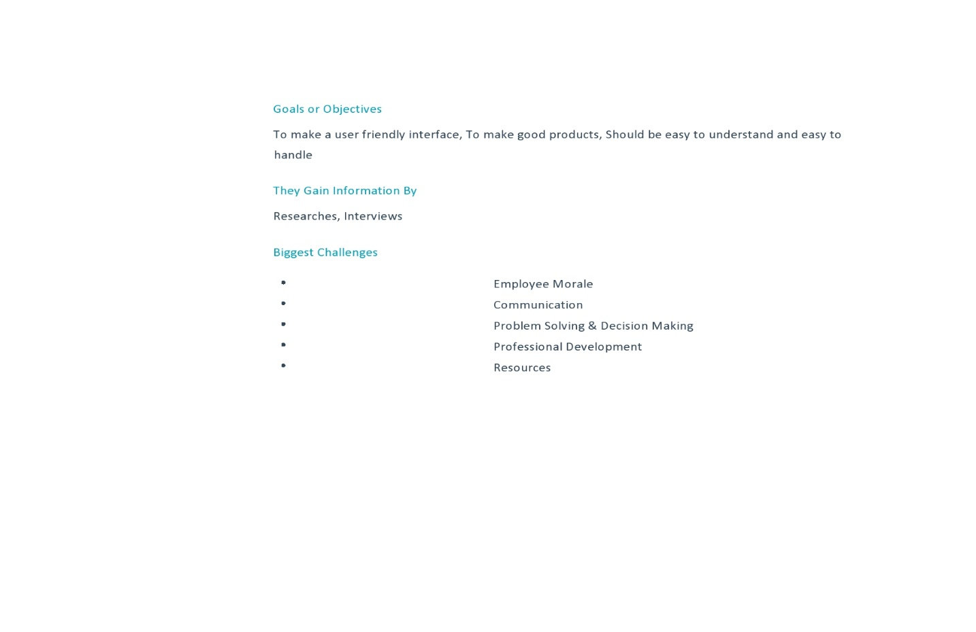

**NISAL**

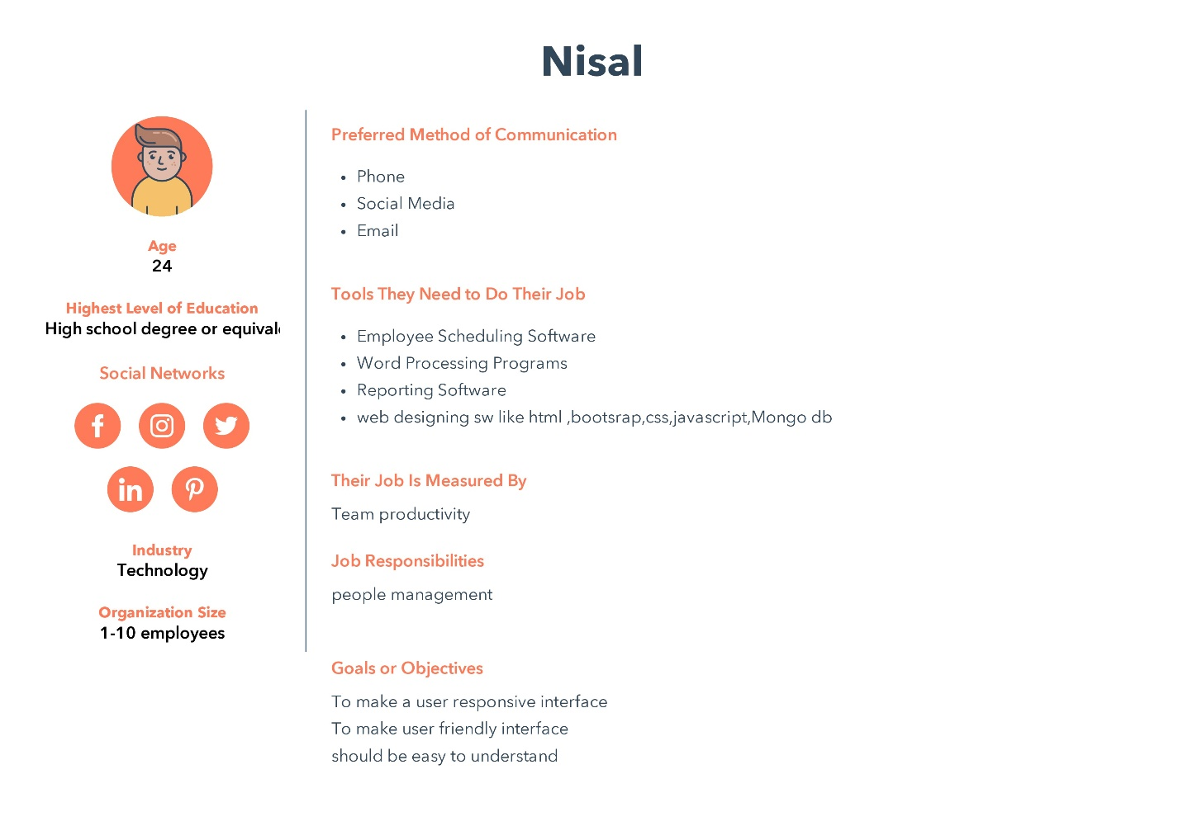

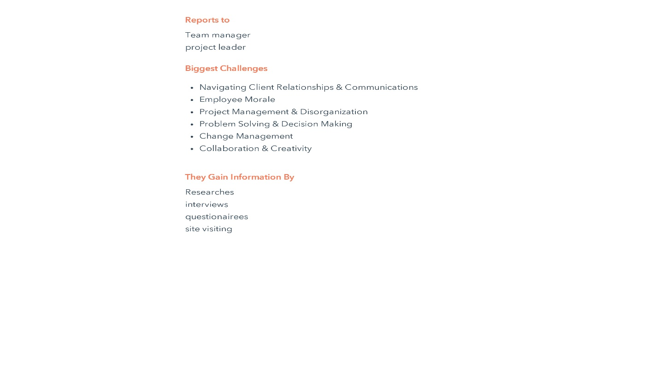

**JINUKA**

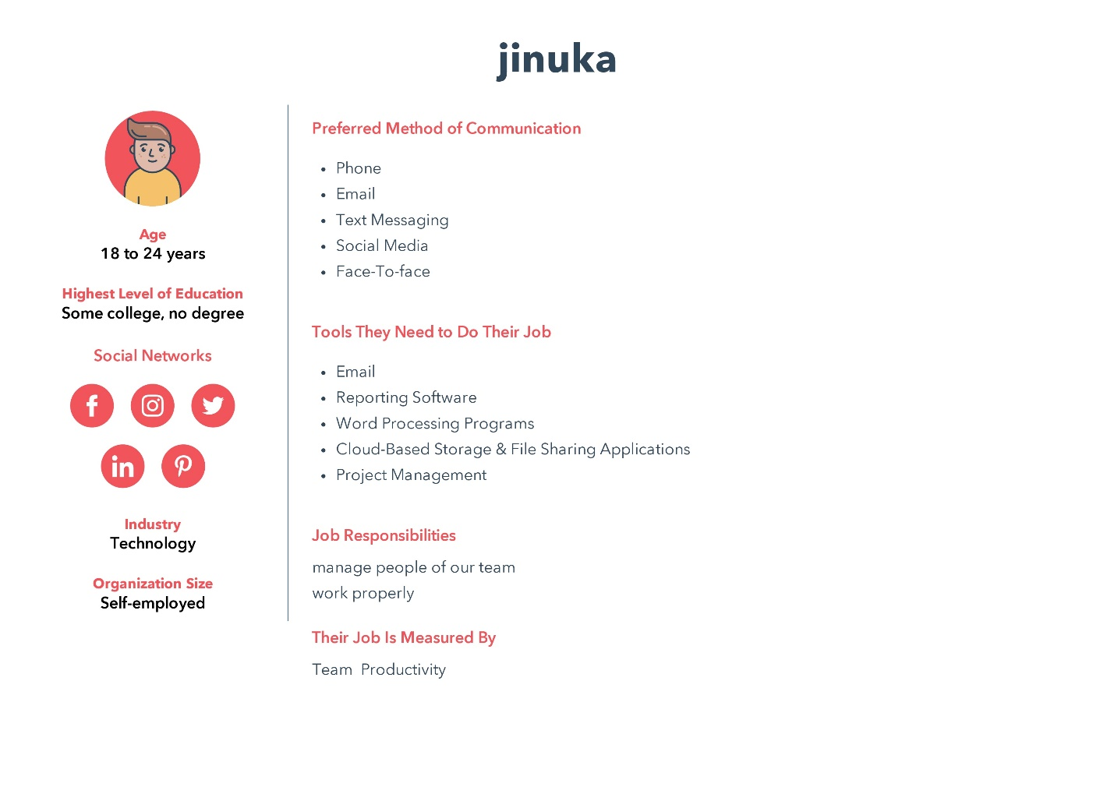

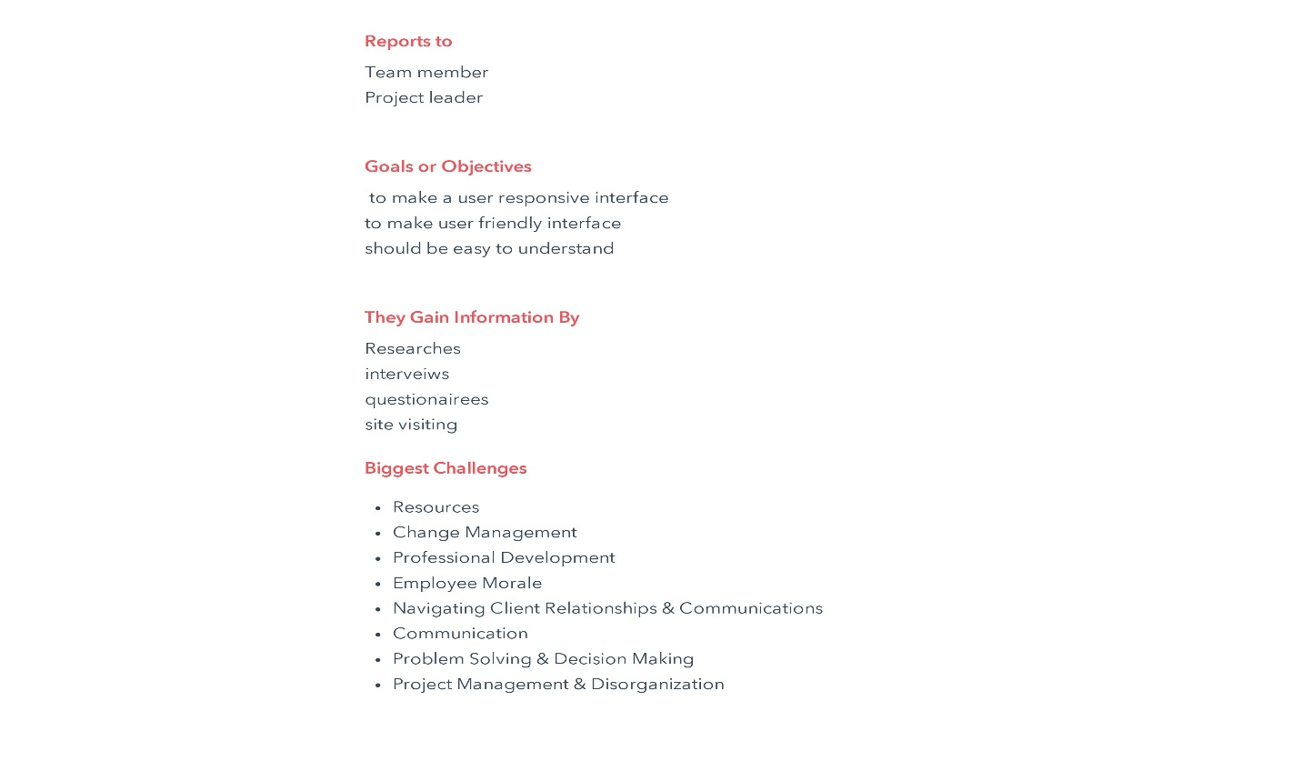

**SASINDU**

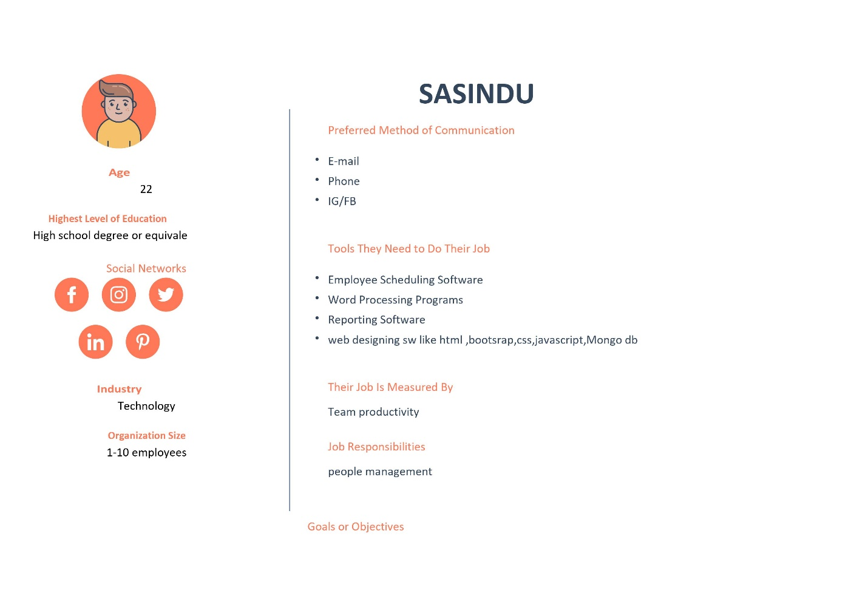

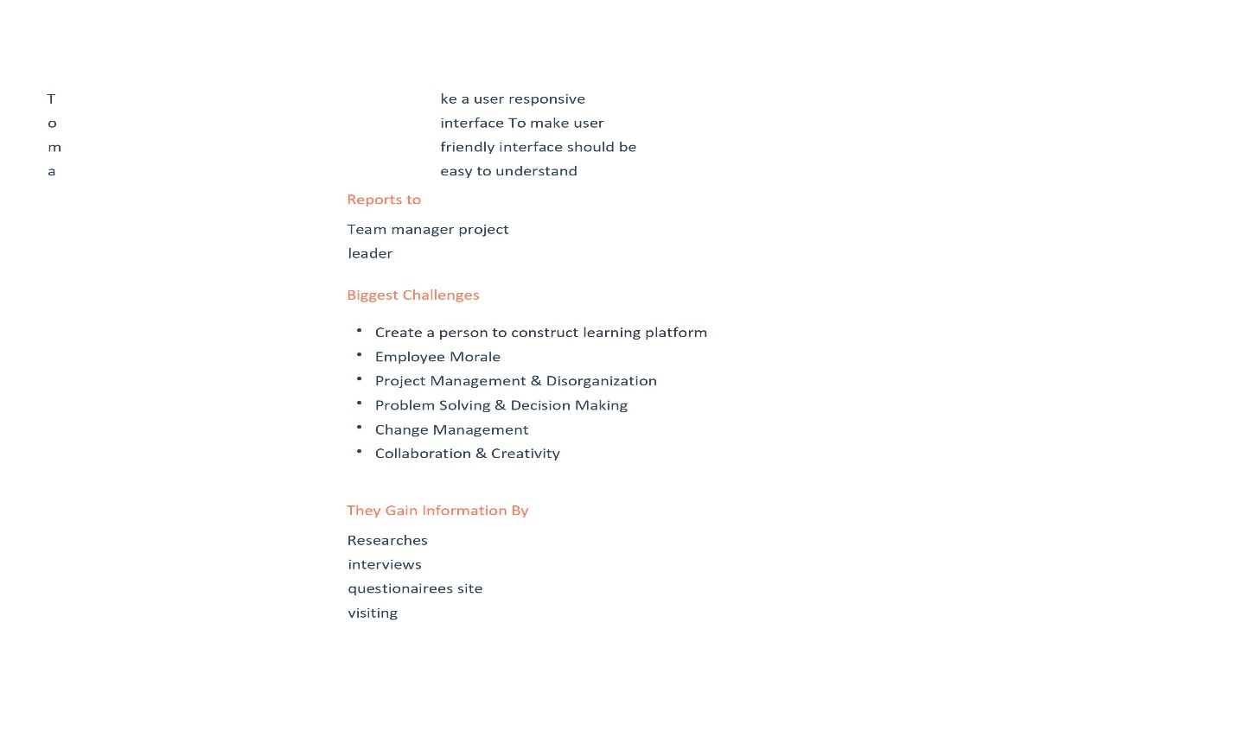

**YASIRU**

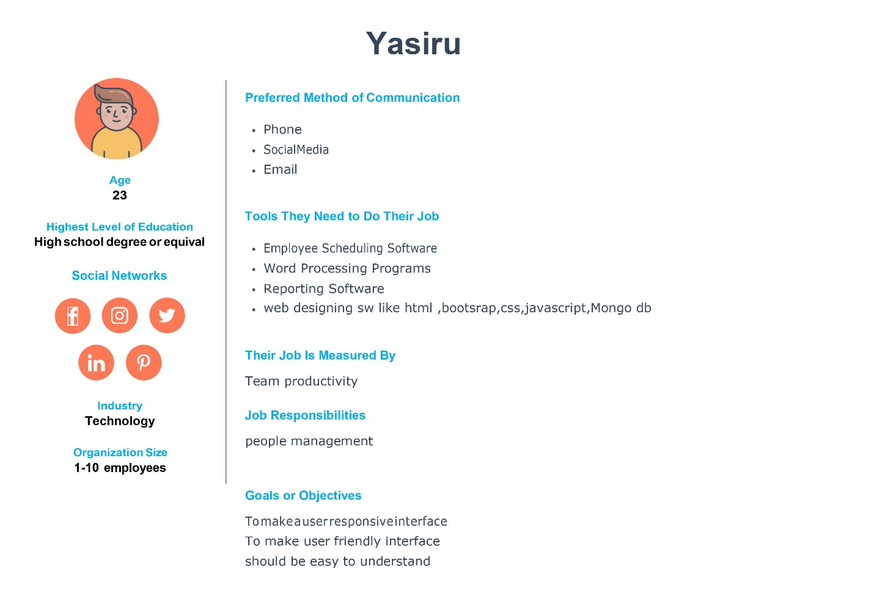

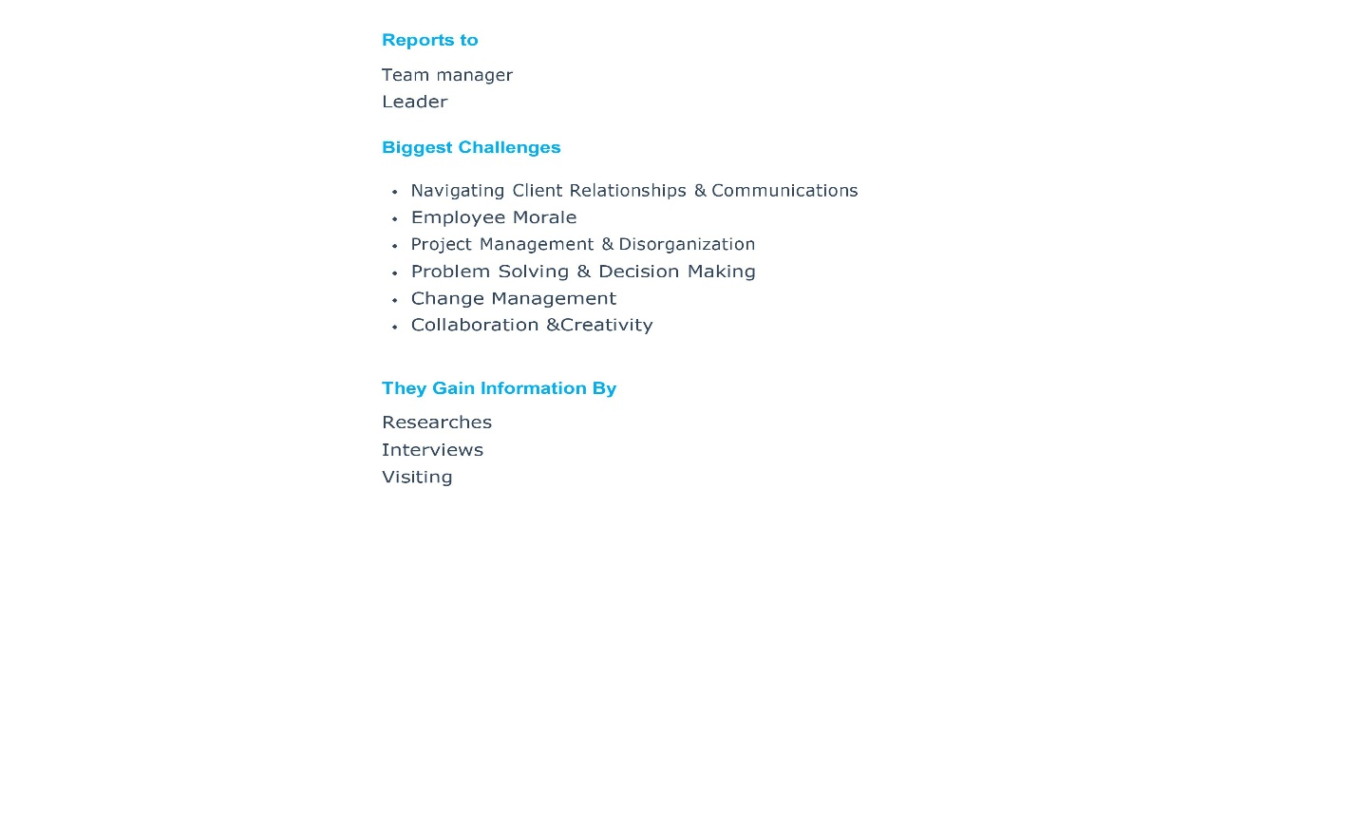

**SUBHASH**

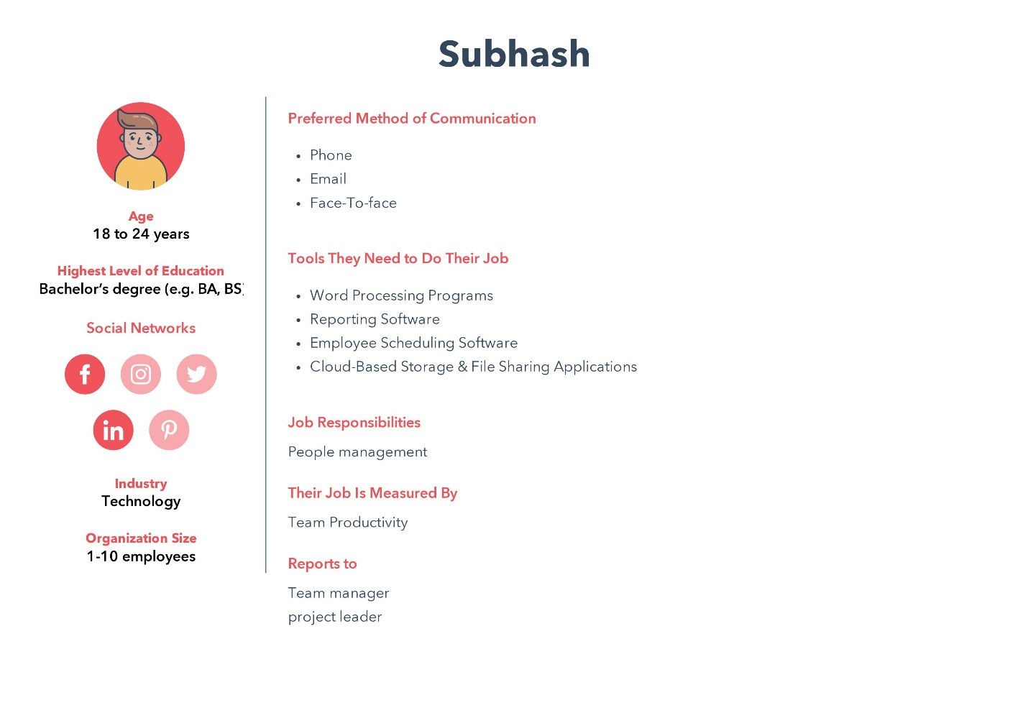

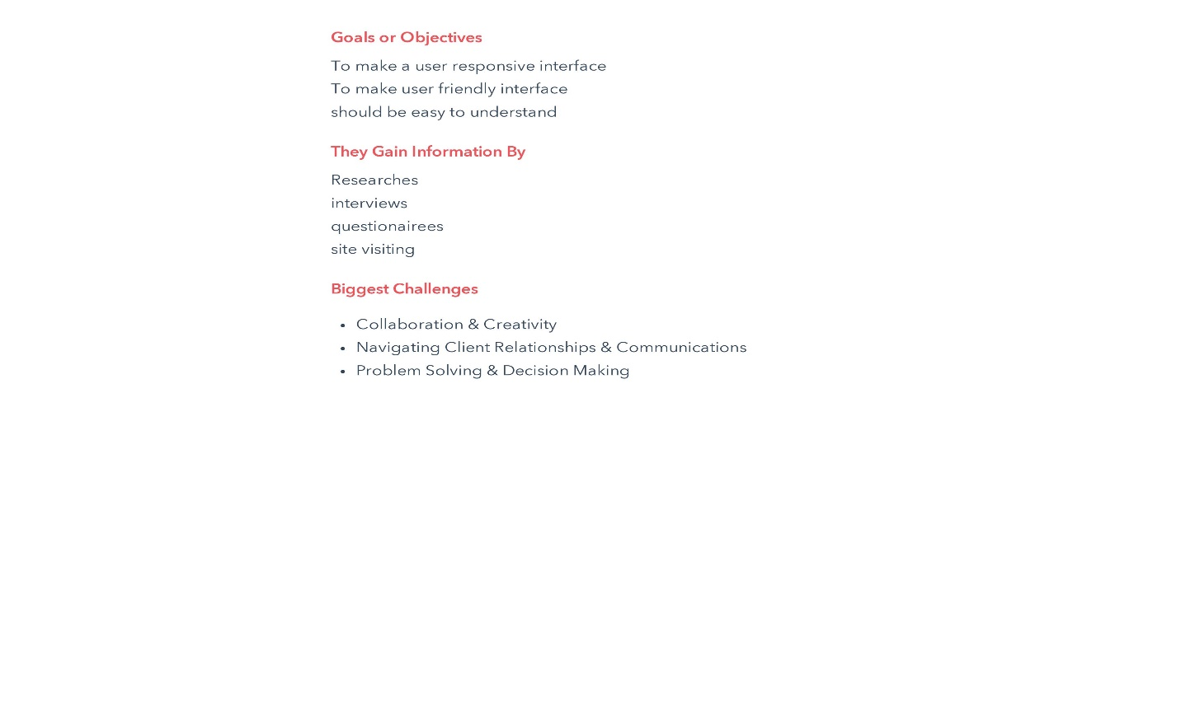

*GROUP MEMBERS.*

Plymouth ID Plymouth Name

**10707375 Balage Silva.**

**10707362 Saunda Sanjula.**

**10707193 Ruhunu Fernando.**

**10707202 Sasindu Gamage.**

**10707428 Ran Yasiru.**

**10707297 Godalla Pathirana.**

