# 

# Introduction

Along with the Keels, the Department of Agriculture (DoA) of Sri Lanka aims to launch a website to establish a market for farmers where farmers can feed their harvests and employees of Keels can purchase them.By this web site farmers can enter their harvest type which is the type of vegetables or fruits,also they can add their harvested crop photos to the system and by looking the quality of the harvested vegetables and fruits keeels staff can purchase the farmers harvest and sell that to their customers. In this system farmers can signup to the system and add their locations harvest type to the website.also keels can generate a report of the farmer harvest.

# Scenario of the system

* Using national ID numbers and crop-related information, any farmer can register with the system.
* A farmer will submit the information via the website when the crop is chosen, with some supporting images of the harvest.
* They may also analyze the facts and accept the reports of farmers and submit requests to the areas reported seen on a map
* Through sending direct messages to farmers and buying goods from farmers, Keels employees may connect..
* The DoA can see the results as various graphs, such as percentages of good purchases and wasted harvests of fruits, vegetables, etc.

# Functional requirements

* A "Web Master" should be able to build accounts for the employees of Keels and DoA.
* Farmers may register for free. Authorized farmers can input, delete and edit their own reports with data (including images).
* Keels workers will either purchase or reject the goods and set a flag for awful products depending on the nature of the product, such as red flag
* The general users could see the accounts of farmers on a map, but without the farmers' information. The public is also responsible for graph viewing.
* The graphs can be used by DoA employees; study of crop forms, where most farmers live, efficient sales, and waste goods.

# Challenges Faced

## Not sharing information

Information isn't power – except if it's shared. Task colleagues all bring a one of a kind arrangement of abilities, information, experience and insight to the table. Viable task groups boldly share consistently and liberally to support everybody and to help the undertaking's prosperity. This causes the capacity of the entire group to develop and gives the group more force.

# **Not going in the same way**

To stroll a similar way, a group has to know where it is going or what it is adding to (vision) and why (reason). Invest energy on this with your group. This clearness gives a structure and 'motivation to be' that can revitalize any given task group to cooperate. Remember that dreams should be convincing and purposes important. Individuals react to the significance of both.

In the event that you need to make an incredible task group, give specific consideration to practices. How we carry on affects others and influences how they act. It's the point at which we change our practices that we can accomplish groundbreaking change.

# Functioning in silos

For several project teams, operating at Silo is a reality. Members of the team may sit side by side, but they may not necessarily function together. Like the three musketeers, a strong project team should be one for one and one for one. So, if you're in a band, you could really be in it as well. Working in earnest together is about getting the best of the reality that you are a team. Honour your time and energy by seeing yourself, as just an individual contributor, but a full-time member of the team. Imagine how amazing it would feel to be part of a team where someone cares about the team and not just themselves, by working together to make the project a success. (Flint, 2016)

# Screenshots of the System

Farmer map locations

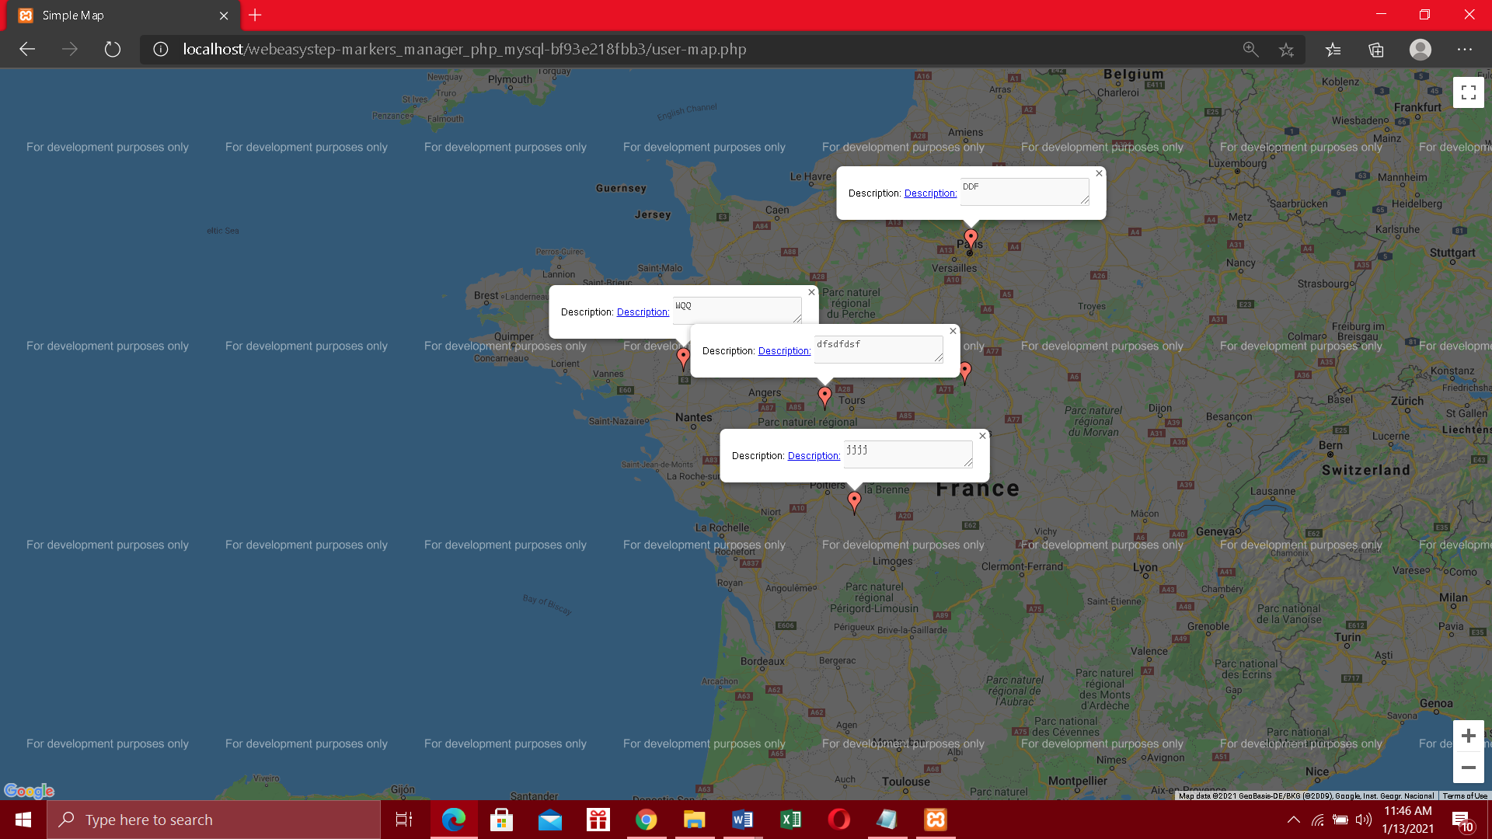

Admin confirmaion map

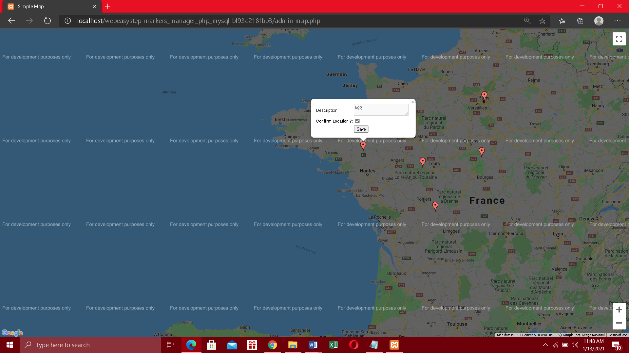

Chat System

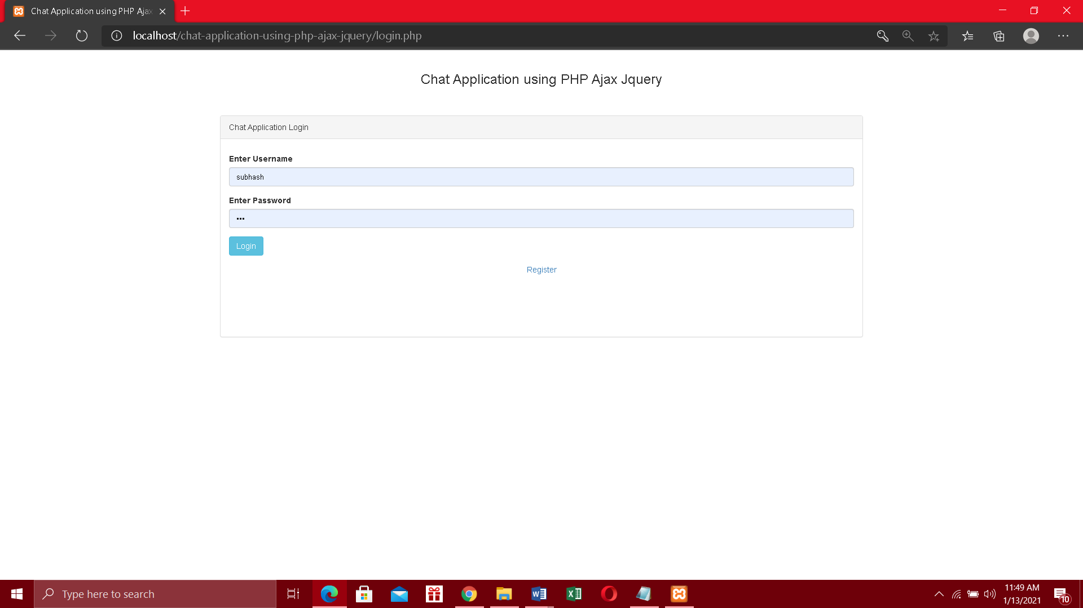

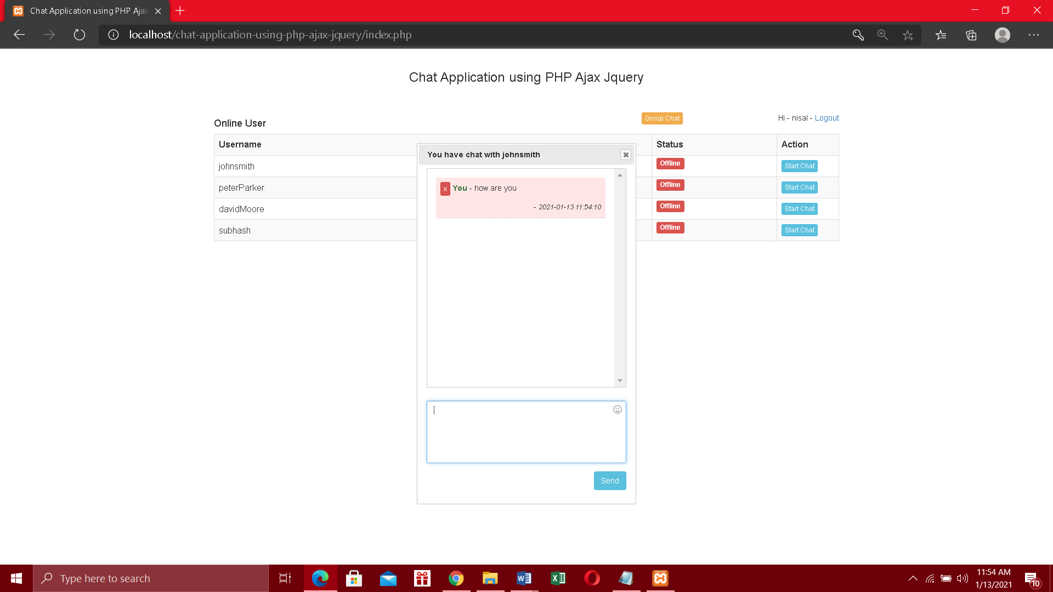

Workload

S.H.N.Sanjula ………. Google map user locations

R.J.D.Fernando………. Google map admin confirmation

R.P.Yasiru…………….. chat system signup

S.A.W.Gamage……… farmer login ,signup

B.P.P.Silva…………. chat system register

G.S.M.Pathirana……. Webmaster

# Bibliography

Flint, M., 2016. *apm.org.* [Online]   
Available at: https://www.apm.org.uk/blog/10-common-problems-project-teams-face/  
[Accessed 13 1 2021].