**cpmFS – A Simple File System**

Venkatesh Prabhanjan

Contents

1. Overview 3

2. Design Document 3

3. Sample Inputs and Outputs 4

4. Lessons Learned 5

# Overview

The designed system is a simple file system called *cpmFS.* The file system allows users to list directory entries, rename files, copy files, delete files, as well as code to the following functions read/write/open/close files. This is the same version of the CP/M file system used on 5.25” and 8” floppy disks in the 1970’s. The file system is built in C Language and this is a standalone program.

# Design Document

The following are the functions implemented as a part of construction of cpm file system:

* mkDirStruct
  + A function used to copy data from the disk to directory Structure
* writeDirStruct
  + A Function used to copy data from directory structure to Memory
* makeFreeList
  + Update all the unused blocks to free blocks
* printFreeList
  + Function used to print all the free blocks
* checkLegalName
  + Function used to check the legal names of the files (usually called when name is changed)
* findExtentWithName
  + function that looks to match a given filename with the names in block
* cpmDir
  + Lists all the files in a block
* cpmDelete
  + Function to delete a file
* cpmRename
  + Function to rename a file

# Sample Inputs and Outputs

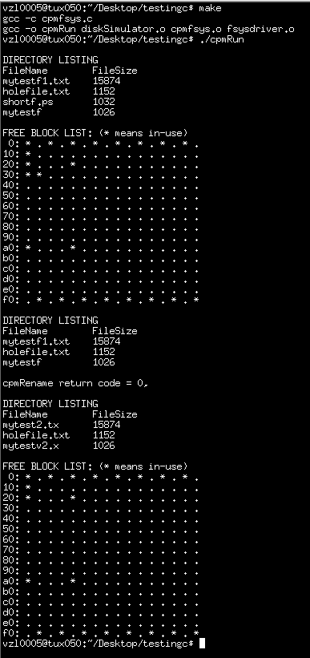

# Lessons Learned

The following are the lessons learnt:

* Functions of a Filesystem and internal operations of each of them
* Memory Allocation and file organization on a filesystem
* Directory Structure and generic attributes of its contents
* Memory Management and Segmentation issues
* Pointers, Arrays, Functions, Regular Expressions, Memory Access