SCHOOL OF COMPUTERSCIENCEANDARTIFICIAL INTELLIGENCE |  |  |  |  | DEPARTMENTOFCOMPUTERSCIENCE ENGINEERING
Prabhas G  2403A53033  24BTCACIYB02  LAB:4.3 |  |  |  | AssignmentType:Lab |  |  | AcademicYear:2025-2026
CourseCoordinatorName |  |  |  | VenkataramanaVeeramsetty
Instructor(s)Name |  |  |  | Dr.V.Venkataramana(Co-ordinator)
 |  |  |  | Dr.T.SampathKumar
 |  |  |  | Dr.PramodaPatro
 |  |  |  | Dr.BrijKishorTiwari
 |  |  |  | Dr.J.Ravichander
 |  |  |  | Dr.MohammandAliShaik
 |  |  |  | Dr.AnirodhKumar
 |  |  |  | Mr.S.NareshKumar
 |  |  |  | Dr.RAJESHVELPULA
 |  |  |  | Mr.KundhanKumar
 |  |  |  | Ms.Ch.Rajitha
 |  |  |  | Mr.M Prakash
 |  |  |  | Mr.B.Raju
 |  |  |  | Intern1(Dharmateja)
 |  |  |  | Intern2(SaiPrasad)
 |  |  |  | Intern3(Sowmya)
 |  |  |  | NS_2(Mounika)
CourseCode |  |  | 24CS002PC215 | CourseTitle |  | AIAssistedCoding
Year/Sem |  |  | II/I | Regulation |  | R24
Date and Day ofAssignment |  |  | Week2 - Wednesday | Time(s)
Duration |  |  | 2Hours | Applicableto Batches
AssignmentNumber:2.3(Presentassignmentnumber)/24(Totalnumberofassignments)
 | Q.No. | Question |  |  |  |  |  |  | ExpectedTime  to  complete
 | 1 | Lab4:Advanced PromptEngineering– Zero-shot,One-shot,andFew-shotTechniques  Lab Objectives:  - ToexploreandapplydifferentlevelsofpromptexamplesinAI-assistedcode generation. |  |  |  |  |  |  | Week2 - Wednesday

- Tounderstandhowzero-shot,one-shot,andfew-shotpromptingaffectAIoutput quality.
- Toevaluatetheimpact ofcontext richnessandexamplequantityonAI performance.
- Tobuildawarenessofpromptstrategyeffectivenessfordifferentproblemtypes.

LabOutcomes (LOs):
Aftercompletingthislab, studentswill beableto:

- Usezero-shotpromptingtoinstructAI withminimalcontext.
- Useone-shotpromptingwithasingleexampletoguideAIcode generation.
- Applyfew-shotpromptingusingmultipleexamplestoimproveAIresponses.
- CompareAIoutputsacrossthethreeprompting strategies.

Prompt:writeafunctionthatchecks whetheragivenyearisaleapyear.
TaskDescription#1
  - Zero-shot:PromptAI towriteafunctionthatcheckswhetheragivenyearisaleap year.
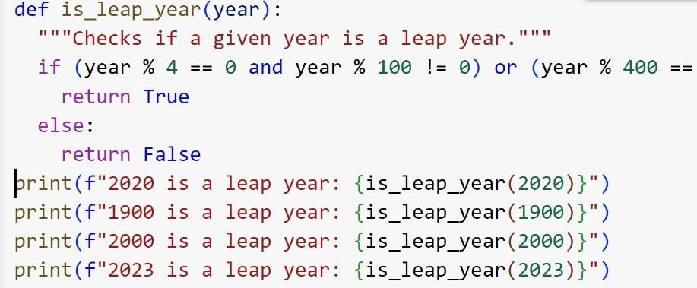

Explaination:ThecodeIprovideddefinesafunctioncalledis_leap_yearthattakesayear as input and returns True if it's a leap year and False otherwise.
Here'showit works:
- Ayearisaleap yearifit isdivisibleby4.
- However,iftheyearisalsodivisibleby100,itisnot aleap year, unless...
- .theyearisalsodivisibleby400.Inthat case, it isaleapyear.
Thecodeimplementstheserulesusingconditionalstatements(if,else,and,or)andthemodulo operator (%) to check for divisibility.
Theoutputoftheexecutionshowsthat:
2020isaleapyear(divisibleby4,not by100)
- 1900isnot aleap year(divisibleby100,but not by400)
- 2000isaleap year(divisibleby400)
- 2023isnotaleap year(notdivisibleby4)
Conclusion:

The function correctly identifies leap years based on the standard rules. Prompt:Giveoneinput-outputexampletoguideAI inwritingafunctionthatconverts centimeters to inches.
ExpectedOutput#1
  - AI-generatedfunctionwithnoexamples provided

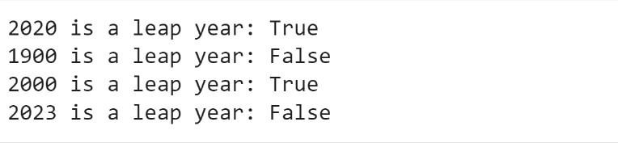
Prompt :writeafunctionthatconvertscentimeterstoinches.

TaskDescription#2
- One-shot:Giveoneinput-outputexampletoguideAIinwritingafunctionthat converts centimeters to
inches.
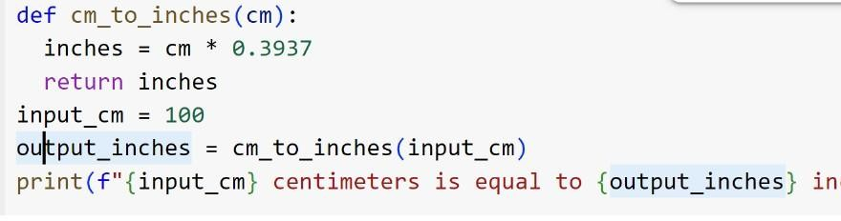
Explanation:
- Keyaspectsofthecode
- Theconversionfactor
- Potentialapplicationsofthe conversion

Conclusion:
- Asummaryofthe keyfeaturesofthe conversionfunction
- Importantconsiderationswhenperformingunitconversions
- Specificdetailsabouttheconversionfactororformula
ExpectedOutput#2
  - Functionwithcorrectconversion logic
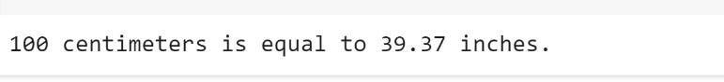
Prompt:ToGenerate afunctionthatformatsfullnamesas“Last,First”.

TaskDescription#3
  - Few-shot:Provide2–3examplestogenerateafunctionthatformatsfullnamesas “Last,
First”.

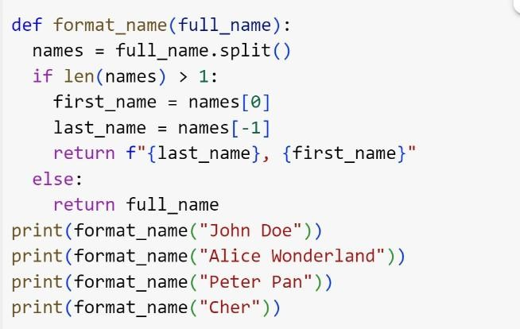

Explaination:

- Thefunctionsplitstheinputfull nameintoseparatepartsbased onspaces.
- Itidentifiesthefirstnameasthefirst partandthelast name asthelastpart ofthesplit.
- Itformatsandreturnsthename as"Last,First"usingtheidentified
- Iftheinputdoesn'tcontainat least twoparts, itreturnstheoriginameunchanged.
Conclusion:
- Thefunctionreliablyreformatsnamesfrom “FirstLast”to“Last, First.”
- Itusessimplestringsplittingandindexingtoextract name parts.
- Ithandlesedgecasesbyreturningtheoriginalinputifformattingisn’t possible.
- Thisapproachensuresconsistentandclearname presentationin applications.
ExpectedOutput#3
  - Well-structuredfunctionrespectingthe examples
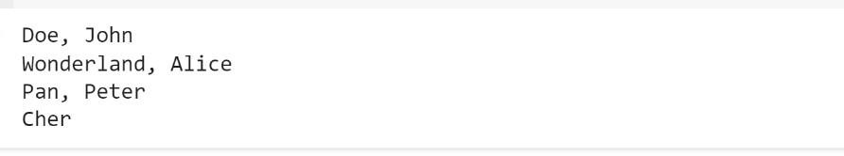

Prompt :Writeafunctionthatcountsthenumberofvowelsina string.

TaskDescription#4
  - Comparezero-shotandfew-shotpromptsforwritingafunctionthatcountsthenumber of vowels in a
string.

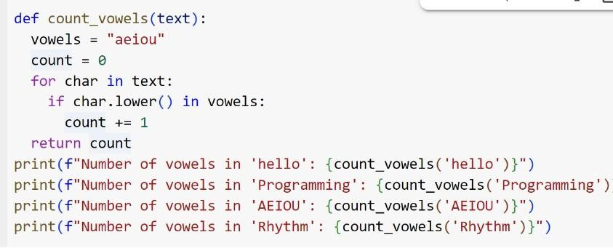

Explanation:
- Howthecodehandlescase sensitivity
- Theuseofthe forloop
- The in operator
- Thevariableinitialization

Conclusion:

- Addingsubheadingstothecurrent notebook
- OrganizingtheexplanationsI'veprovidedwith subheadings
- Something else entirely

ExpectedOutput#4
  - Functionaloutputandcomparative reflection

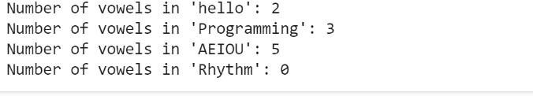

Prompt:Togenerateafunctionthatreadsa.txtfileandreturnsthenumberoflines.

TaskDescription#5
  - Usefew-shotpromptingtogenerate afunctionthatreadsa.txtfile andreturnsthe number of
lines.
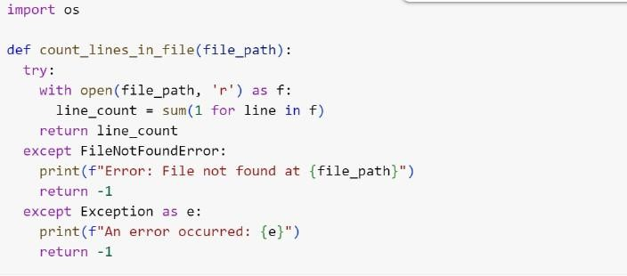

Explanation:

- Breakingdownthepreviouspointsintomoredetailedsub-points
- Creatingahierarchicalstructurefortheinformation
- Somethingelserelatedtoorganizinginformationorplanningataskwithsub-steps

Conclusion:

- Wecreatedafunctiontocheckif ayearisaleapyear,considering thespecialrulesforyearsdivisible by 100 and 400.
- Wedevelopedafunctiontoconvertmeasurementsfromcentimeterstoinchesusingtheconversion factor 0.3937.
- Webuilta functiontoreformatfullnamesintoa"Last,First"format,handlingnameswithmultiple parts and single names.
- Weimplementedafunctiontocountthenumberoflinesina textfile,includingerrorhandling for missing files.

ExpectedOutput#5
  - Workingfile-processingfunctionwithAI-guided logic

Note:Reportshouldbesubmittedaworddocumentforalltasks inasingledocumentwith prompts, comments & code explanation, and output and if required, screenshots

EvaluationCriteria:
 | Criteria | MaxMarks
 | ZeroShot(Task #1) | 0.5
 | OneShot(Task#2) | 0.5
 | FewShot (Task#3&Task #5) | 1.0
 | Comparison(Task#4) | 0.5
 | Total | 2.5Marks

