Lumina Competitive Evaluation Report
Generated: 2026-04-19 12:41:19

Executive Summary
Best overall variant: Lumina + PeCAR (overall=0.837, pedagogical=0.769, pass_rate=100.00%).
Benchmark compares three application patterns: Existing Generic Tutor baseline, Existing Structured RAG baseline, and Lumina with PeCAR reasoning.

Benchmark Setup
- Same underlying model family across all variants to isolate orchestration effects.
- Same benchmark scenarios and source context for each compared variant.
- Evaluation uses the same semantic, pedagogical, and structural rubric.
- Constraint checks include quality thresholds and latency threshold.

Aggregate Comparison
Variant | N | Semantic | Pedagogical | Structural | Overall | Pass Rate | Latency(s)
Lumina + PeCAR | 2 | 0.866 | 0.769 | 0.913 | 0.837 | 100.0% | 65.37
Existing Structured RAG | 2 | 0.769 | 0.643 | 0.846 | 0.734 | 0.0% | 38.61
Existing Generic Tutor | 2 | 0.797 | 0.407 | 0.787 | 0.639 | 0.0% | 3.88

Detailed Results
Scenario | Variant | Semantic | Pedagogical | Structural | Overall | Latency(s)
Photosynthesis Foundations | Existing Generic Tutor | 0.820 | 0.432 | 0.750 | 0.651 | 3.06
Photosynthesis Foundations | Existing Structured RAG | 0.730 | 0.604 | 0.758 | 0.685 | 57.05
Photosynthesis Foundations | Lumina + PeCAR | 0.847 | 0.809 | 0.892 | 0.841 | 65.21
Recursion Versus Iteration | Existing Generic Tutor | 0.773 | 0.381 | 0.825 | 0.627 | 4.70
Recursion Versus Iteration | Existing Structured RAG | 0.808 | 0.681 | 0.933 | 0.782 | 20.17
Recursion Versus Iteration | Lumina + PeCAR | 0.886 | 0.728 | 0.933 | 0.832 | 65.54

Visual Comparison
Educational quality metric profile
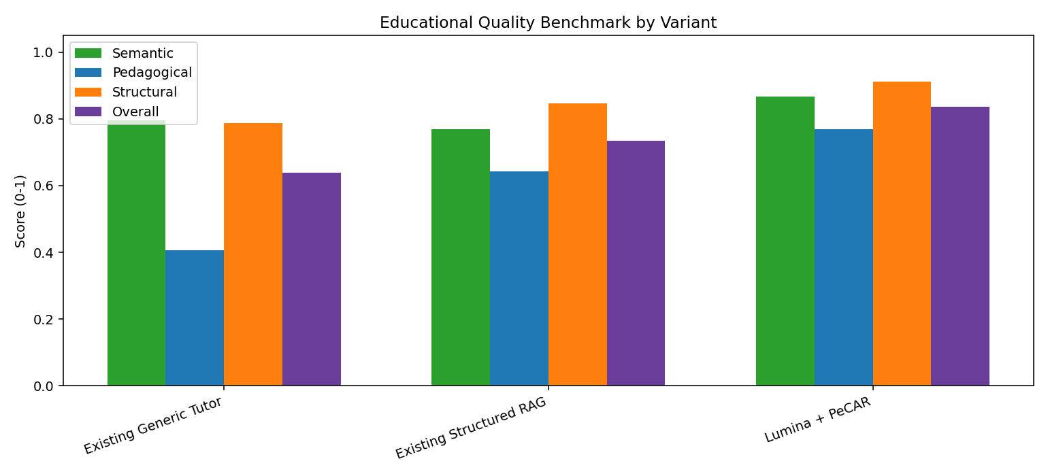
Quality-latency frontier
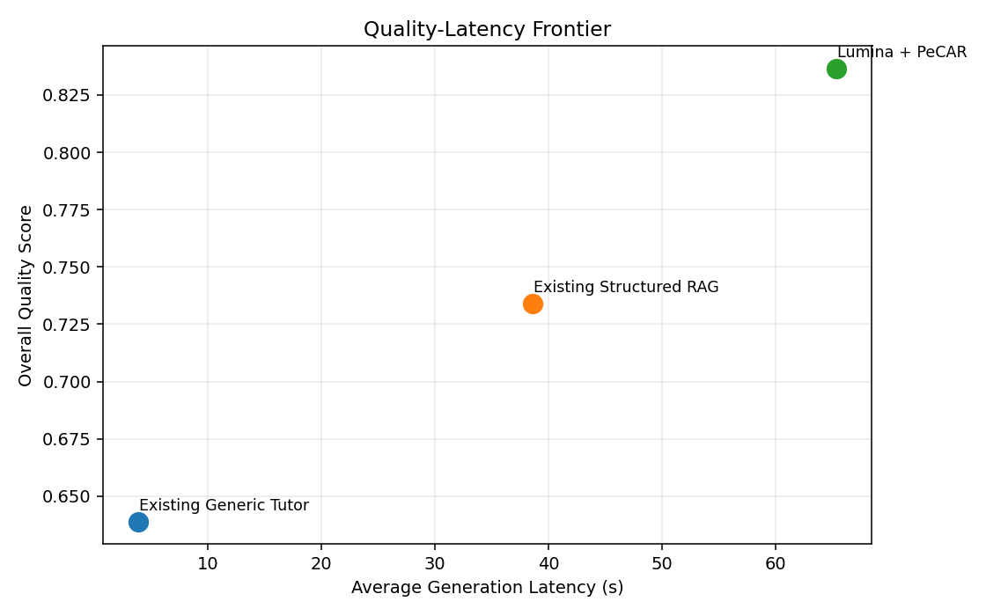
Constraint compliance
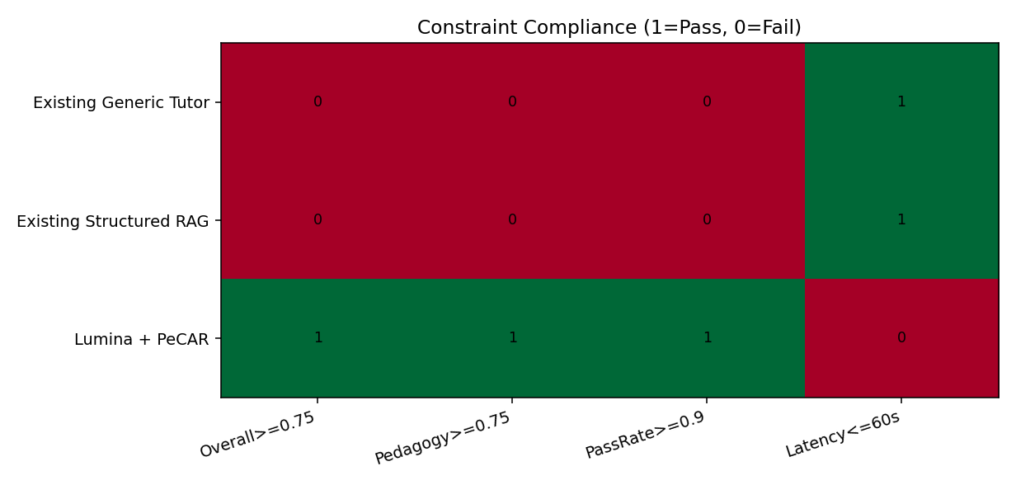

Interpretation
This report demonstrates quality gains from PeCAR-enabled generation under the same evaluation rubric. Because all variants use the same underlying model family, the quality lift is attributable to orchestration, reasoning strategy, and pedagogical assembly rather than model replacement.

