Lumina Backend Evaluation Report
Generated: 2026-04-19 12:37:30

Executive Summary
This document consolidates the latest comprehensive, mocked integration, and targeted live evaluator test evidence. It includes pass/fail outcomes, runtime characteristics, warning profile, and compliance against operational constraints.
Comprehensive: passed=0, failed=0, skipped=0, pass_rate=N/A.
Mocked integration: passed=1, failed=0, warnings=5, duration=2.02s.
Live targeted evaluators: passed=16, failed=0, warnings=36, duration=217.56s.

Data Sources
Comprehensive source: comprehensive_latest.log
Mocked integration source: mocked_integration_latest.log
Targeted live evaluator source: targeted_live_eval_latest.log
Partial comprehensive runs:
- comprehensive_latest.log: incomplete, observed span ~501.8s
- comprehensive_latest2.log: incomplete, observed span ~286.1s

Core Metrics
Suite | Passed | Failed | Skipped | Warnings | Duration (s) | Pass Rate
Comprehensive | 0 | 0 | 0 | N/A | 501.80 | N/A
Mocked Integration | 1 | 0 | 0 | 5 | 2.02 | 100.00%
Live Targeted | 16 | 0 | 0 | 36 | 217.56 | 100.00%

Constraint Compliance Matrix
Suite | <=10s | <=180s | Pass>=95% | Warn/test<=5 | Completed
Comprehensive | 0 | 0 | 0 | 0 | 0
Mocked Integration | 1 | 1 | 1 | 1 | 1
Live Targeted | 0 | 0 | 1 | 1 | 1

Warnings and Quality Signal
- Other warning: 64
- LLM parse warning: 10
Observed quality score points: 13 | mean=0.923, min=0.800, max=1.000.

Visual Evidence
Comprehensive outcome distribution

Module status breakdown
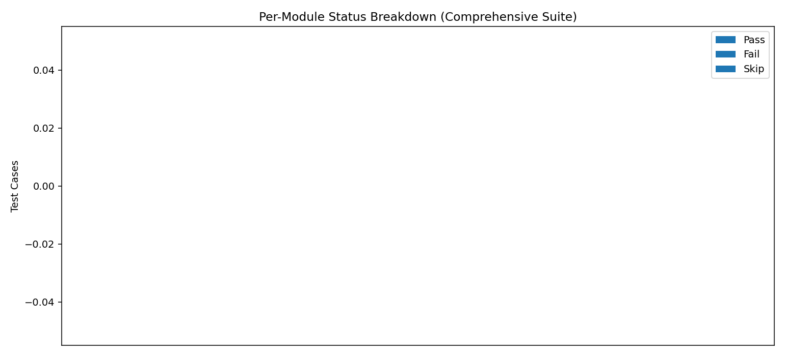
Execution time comparison
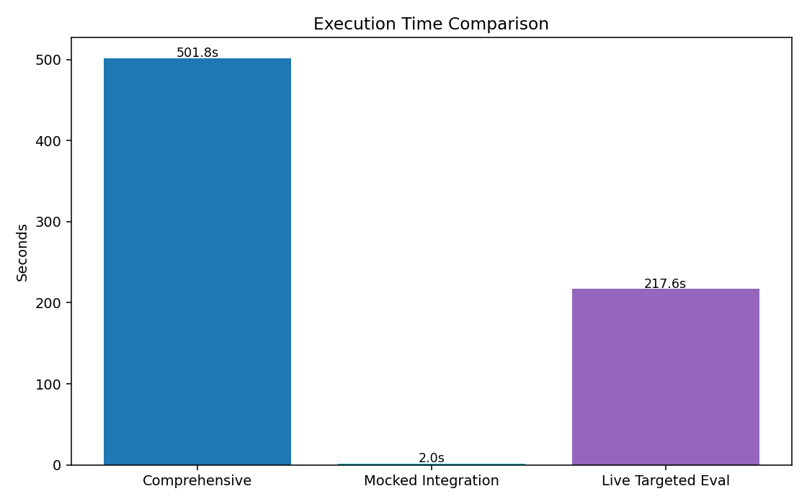
Warning type frequency
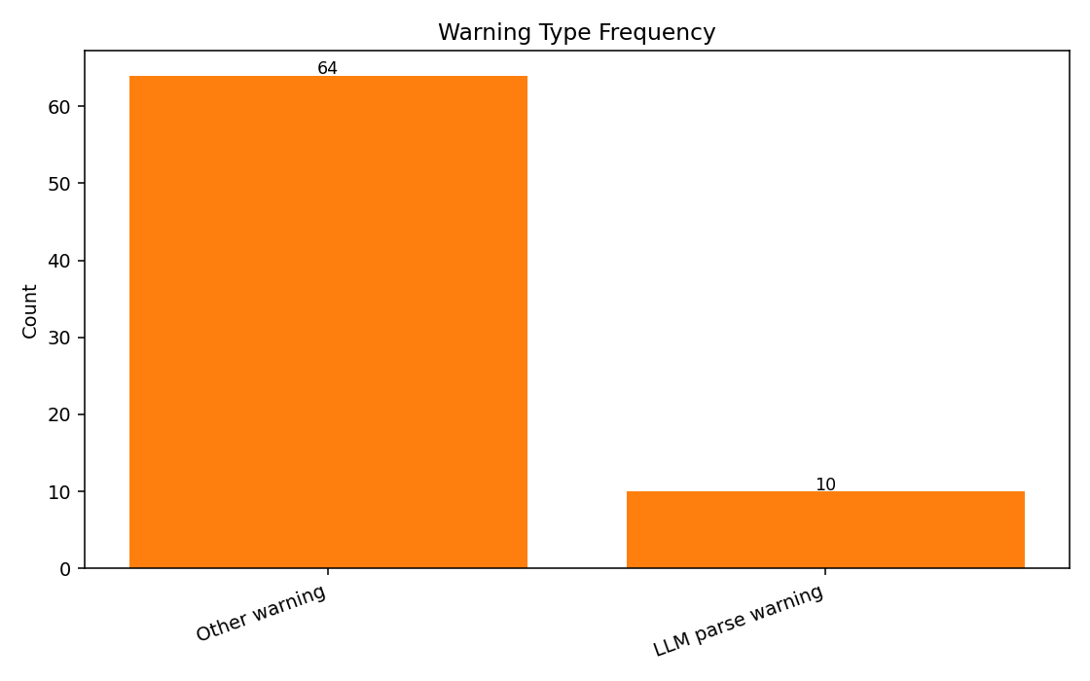
Quality score trend
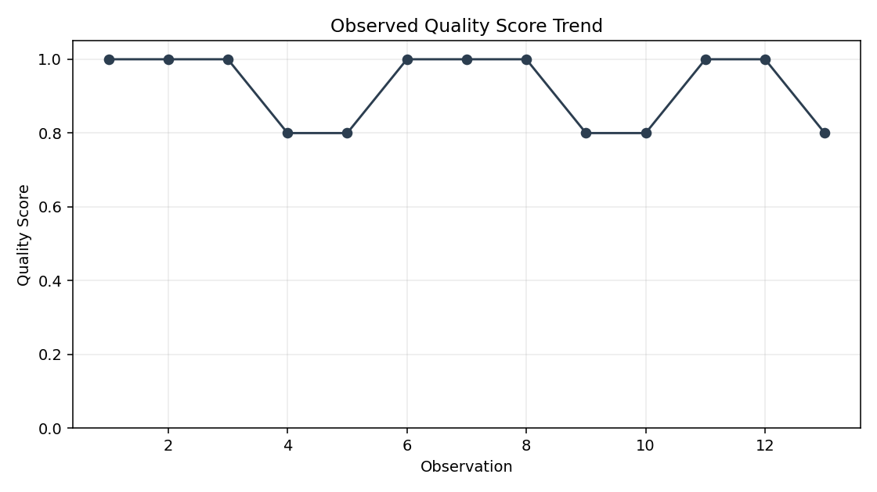
Constraint compliance heatmap
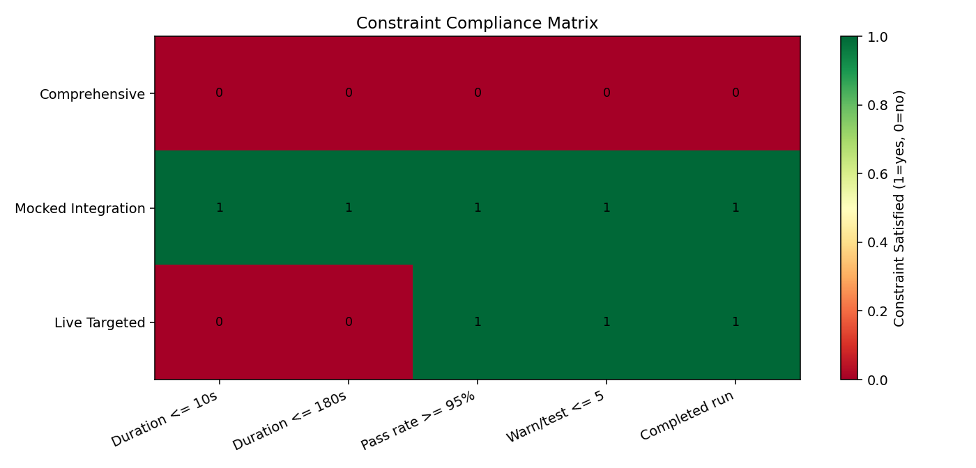
Scenario-based suite ranking
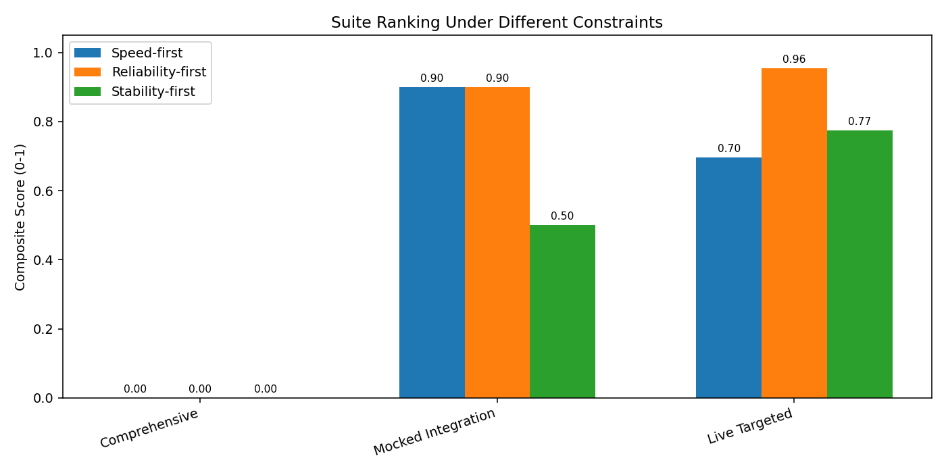

Interpretation and Recommendations
1. Keep mocked integration checks as fast CI gates and run live evaluator checks in scheduled or pre-release pipelines.
2. Preserve machine-readable test summary output in all long-running suites to avoid visibility loss on interrupted runs.
3. Track warning-rate KPI over time (especially parse and timeout categories) alongside pass/fail outcomes.
4. Maintain regular quality-score trend sampling to detect silent regressions in response quality.

