**DOLL-UP YOUR LITTLE DIVA THIS ASHTAMI**

The festive season has announced its arrival with the onset of Navratri. The last two days of Navratri, known as Ashtami and Navami, are marked by a ritual known as Kanya Puja also known as Kanjak, where young girls are worshipped as a form of Goddess Durga.

It’s an exciting time for the kids as they doll-up for the puja and receive special gifts from everyone. Now who doesn’t love some pampering especially if you add to it a chance to dress up…something every girl loves! Playing dress-up with their mom’s clothes and make-up is almost like a ritual in every girl’s life. So, when it comes to dressing up your little one for the special puja, why not let her own her style just like her mom would? Or even better, add a fun element to your day by twinning with your girl (check out BIBA’s festive collection). It also seems like a great way to bond with your child and an interesting way to dress up. Here are some gorgeous options from the house of BIBA for your girl’s special day.

**Twinning in suits!**

Simplicity is the key when dressing-up for a puja. Suits have never been so versatile. You can play around with the style of bottoms, the shape of the kurtas, depending on your young fashionista’s choice! A cotton anarkali suit in a soft shade and minimal embroidery/print works like magic on girls. Or pair a plain kurta and churidar in a bright shade with a jacket for a different yet pretty look!

**Cheery yellows**

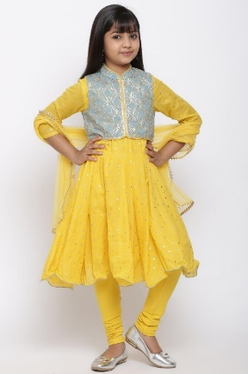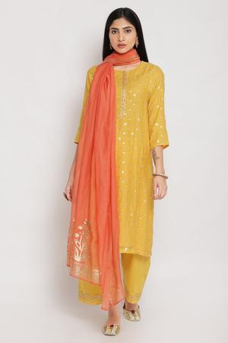

### Girls yellow Anarkali - KW3786AW20YTBLU

The set includes an anarkali kurta, matching churidar, embroidered jacket and dupatta. Crafted in finest cotton, it is a perfect set for your little girl’s delicate skin.

**Women Yellow Suit Set**

A festive worth suit set in a gorgeous combination of yellow and orange colour. The set comprises a straight fit kurta, straight fit palazzo and dupatta. Kurta features sitara work all over the front, slit on either side and highlighted placket. Dupatta features metallic print and bottom comes with highlighted edges.

**Shades of Sea**

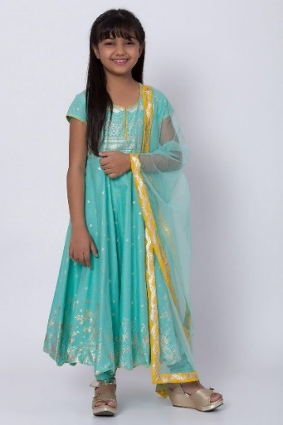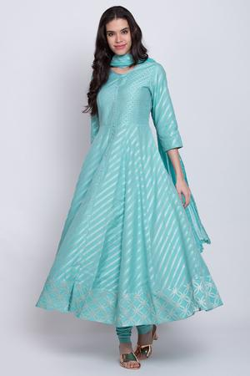

### Girls Anarkali in Turquoise Blue - KW3728SS20TURQ

The set includes a metallic print Anarkali, matching churidar and net dupatta with highlighted borders.

**Matching Turquoise Women Anarkali Suit**

This gorgeous Anarkali suit set is a perfect mix of contemporary style and traditional design. Kurta comes with diagonal stirpes on the ghera, highlighted yoke, long buttoned placket on the front, round neck and three forth sleeves.

**Subtle Tones**

### Girl’s Green Sharara Suit Set - KW3805AW20GPNK

The set comprises an embroidered kurta, sharara pants with lace trim and dupatta with sitara detailing on all sides.

### Women Green Suit Set - SKDRAKHICO6629AW20LGRN

The set included green kurta, contrasting pink palazzo bottom and dupatta matching to the kurta. Kurta comes accentuated with lace trim work, bottom features lace trim too with floral patti on the edges , cotton lining and dupatta comes in crushed bodice.

**Puja Red**

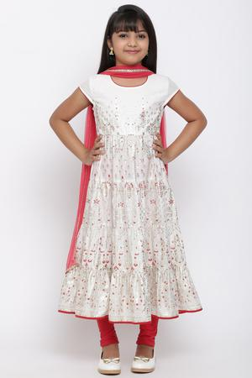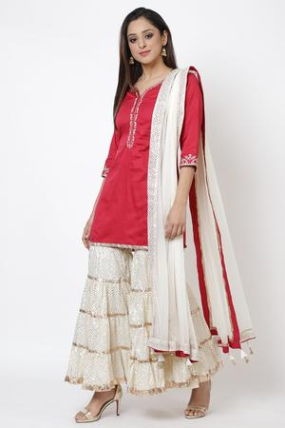

### Women Sharara Red Suit Set - SKD7033AW20CPNKI

The set combines a short kurta, garara bottom and dupatta. Kurta comes accentuated with intricate embroidery on neckline, placket and sleeves. Garara comes with metallic embedded detailing and dupatta comes in net fabric with matching metallic detailing.

### Girl’s Tiered Suit Set - KW3844AW20OWHT

### The set includes a tiered metallic print kurta, knitted churidar and net dupatta. It is a cotton made set.

### Festive White

### https://storage.sg.content-cdn.io/cdn-cgi/image/width=300,height=450,quality=75,format=auto,fit=cover,g=top/in-resources/6c57599f-2c43-4c82-806a-e07c3410f5d3/Images/ProductImages/Source/skd6515aw20wht-1.jpghttps://storage.sg.content-cdn.io/cdn-cgi/image/width=300,height=450,quality=75,format=auto,fit=cover,g=top/in-resources/6c57599f-2c43-4c82-806a-e07c3410f5d3/Images/ProductImages/Source/kw3375aw19ivr-1.jpg

### Women White Suit Set

### An Anarkali suit set combining long white Anarkali kurta matching churidar and leheriya print dupatta.

### Girl’s Double Layered White Suit Set

### This set comprises a white flared inner, matching straight fit kurta, knitted leggings and dupatta.

### Apart from these options you can pick black suit for girls with festive twining.

### Links -

|  |  |
| --- | --- |
| <https://www.biba.in/suit-sets> | suits |
| <https://www.biba.in/suit-sets/black-suit-sets-collection> | black suit for girls |
| https://www.biba.in/suit-sets/green-suit-sets-collection | green suit |
| <https://www.biba.in/suit-sets/pink-suit-sets-collection> | pink suit |
| https://www.biba.in/suit-sets/red-suit-sets-collection | red suit |
| https://www.biba.in/suit-sets/white-suit-sets-collection | white suit |
| https://www.biba.in/suit-sets/yellow-suit-sets-collection | yellow suit |