**5 Festive Suit-Sets That Need Your Instant Attention**

No festive wardrobe is perfect without festive suit sets in it. There are too many options available with different color combination, detailing and of course price tag. Finding the best is kind of task already. You can get a straight suit set with embroidery, kalidar suit with festive perfect print, Anarkalis with intricate detailing, flared suit set with metallic print, double layered styles and so on.

With so many options available its really tough to pick the one that can make offer you a stealer look. You need to think about the occasion, theme and climate in particular, while deciding the perfect outfit for the festivities.

**Red Lehariya Print Kalidar Suit Set**

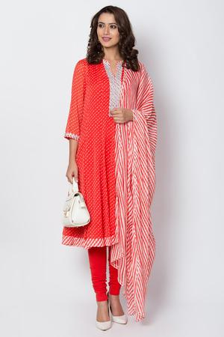

What can be more enticing than an all red **Kalidar** Suit? This one has our special recommendation. If you want to look outstanding this festive season, do invest in it. It comes with gorgeous lehariya print all over the kurta and dupatta, plus highlighted placket, hemline and cuffs.

[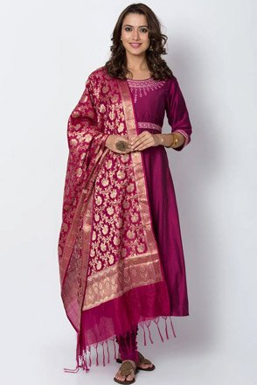](https://www.biba.in/wine-poly-viscose-anarkali-suit-set/p/14775833)

**Anarkali With Banarasi Style Dupatta**

If graceful is what you have thinking to go with this festive season, then this wine colored Anarkali with fine detailing, will get our vote. It comes with a gorgeous Banarasi style dupatta which has increased its charm two times. The color of this set is also very pretty, which guarantee an adorable look effortlessly.

[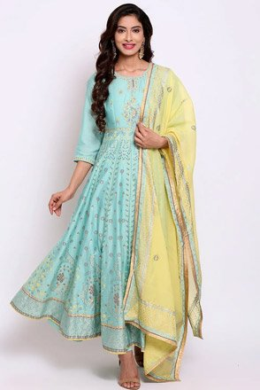](https://www.biba.in/sky-blue-cotton-silk-anarkali-suit-set/p/15334931/11830261)

**Long Pastel Green Anarkali**

If going cotemporary is what you have been planning for the festive day, then you must pick this new Anarkali Suit Set from Biba’s latest festive range. It comes with a mix of embroidery, print and sitaras with a contrasting yellow dupatta.

[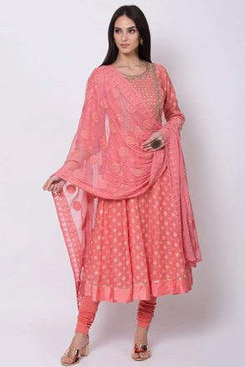](https://www.biba.in/coral-cotton-silk-anarkali-suit-set/p/15335007/11830681)

**A Chic Anarkali In Pink**

This style is no less than any designer piece. It comes in gorgeous pink color with exquisite detailing. Style with and embroidered dupatta and matching churidar, it possess feminine appeal. The charm of this style in unbeatable, the color of this set is very pleasing.

[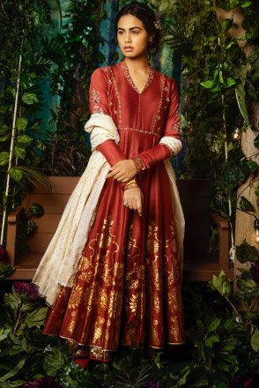](https://www.biba.in/maroon-silk-chanderi-anarkali-set-by-anju-modi/p/14775875/11070965)

**A Designer Anarkali**

Last but not the least – A Designer Anarkali! If you can get your hands over a designer Anarkali in affordable price, than there is no better deal than that. This style is designed by Designer Anju Modi. It comes with very elegant metallic print pattern on it with a mix of embroidery and sitara work. Styled with a contrasting cream dupatta, this set is perfect to offer you chic traditional look.

Apart from these festive suit sets for women you can also shop girl frock suit online to plan a twinning with your little Miss Fashionista.

|  |  |  |
| --- | --- | --- |
| https://www.biba.in/new-arrivals/suit-sets/kalidar | kalidar | done |
| https://www.biba.in/all-suit-sets-kalidar-suit-set | kalidar suit | done |
| https://www.biba.in/ethnic-wear/anarkali-suit-sets | anarkali | done |
| https://www.biba.in/new-arrivals/suit-sets/anarkali | new anarkali | done |
| https://www.biba.in/girls/suit-sets/anarkali | girls frock suit | done |