**Where to shop Affordable Festive Wear online?**

Festive season is already here. Though we are hit by a pandemic, but there is nothing that can stop us from celebration and festivities. We live in a country where we have dedicated a season to festivities and this the peak time which will end grand Diwali celebration.

**What is Diwali?**

Diwali is a Hindu festival of light which is mainly celebrated in India by the followers of Hindu religion. The history behind Diwali is – The main day of Diwali is considered to be the day of return of Lord Rama to Ayodhya from his exile with his wife Devi Seeta and brother Lakshman in Tretayug. The general public celebrated the day of their king’s return by litting up diyas as the night happened to be new moon night. Countless centuries have gone but people celebrate this fest with same joy.

Though the essence of celebration is same but time has changed a lot of things about Diwali. Now diyas has been replaced by candles and crackers and people use to play cards for fun and dress up their best for the fest. Here comes the need of smart shopping. Where you can shop more in you budget.

**What Will Look Best For Diwali?**

For ladies they can wear lehengas or sarees to look their best but if you are looking something more comfortable than these outfits you can go fort festive kurtas or suit sets. There are many suit designs available in online which you can buy and flaunt of the fest. The best thing is, during Diwali online brands offer huge discount and amazing deals for its customers which makes this time the best time for shopping online, below are some style suggestions for Diwali look.

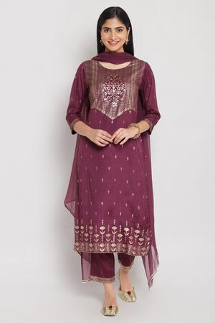

### Code - SKDSHIMMER7029AW20WNE Price – Rs. 3299 Only

**Metallic Print Straight Suit Sets**

A straight suit set in metallic print would be the most comfortable option to pick for Diwali. It is perfect to give your look festive touch plus less flare and dealing makes it a fuss free deal.

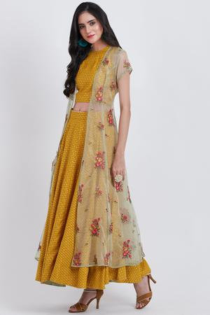

### Code - PRETCOL1010AW19YEL Price – INR 15995 now – INR 7997

**A Three Piece Fusion Wear Set**

Fusion wear are in trend and they are the next top choice of ladies when it comes to comfortable festive look. Just like this three piece set. It comes in festive perfect color combination with a set of cropped top, lehenga bottom and net shrug.

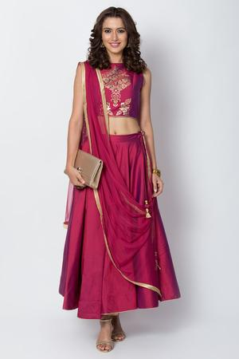

### Code - SKD5700AW19WNE Price – 3,999 Now - 2,399

**Wine Metallic Print Lehenga Set**

This one of the lightest and yet adorable lehenga set we have ever seen. It comes with nominal detailing, which makes it easy for you to flaunt it at small function and Diwali puja at home. Wine color is perfect to offer you an elegant look while metallic print is there to add that much needed festive touch to your look.

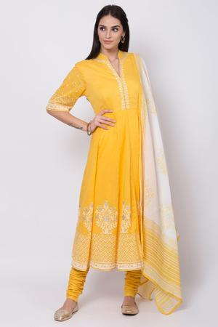

### Code - SKDSKD5919SS20YEL PrICE – ~~R 4,~~500 Now – Rs.3,150

### A Cotton Suit Set

If fancy dressing is not your thing and you just love to keep thing simple, then nothing can win your heart but this Anarkali suit set in yellow. It is from Biba’s festive wear collection and now available at discount. It is a cotton suit set which combines an Anarkali kurta, churidar and dupatta.

|  |  |  |
| --- | --- | --- |
| https://www.biba.in/new-arrivals/suit-sets | suit design | done |
| https://www.biba.in/new-arrivals/suit-sets/straight | straight suit | done |
| https://www.biba.in/suit-set/fusion-wear | fusion wear | done |
| https://www.biba.in/suit-sets/lehenga-set | lehenga set | done |
| https://www.biba.in/cotton-suit-sets-collection | cotton suit sets | done |