**TAKE A CUE FROM CELEB-LOOKS TO STYLE YOUR BOTTOM WEAR**

Festive period has announced its arrival which means it’s time to give your wardrobe an upgrade. Today’s fashion trends allow you to wear your **bottom Wears** in indo-western styles and create stunning looks! From comfy **leggings** to flared skirts, you can a contemporary spin to your outfits by sporting trendy tops and shirts with multiple bottoms. All you have to do is curate it according to your personal taste. So put your shopping shoes on ladies…we bring you the season’s top bottom wear styles to style your fusion festive looks!

**Twirl in Skirts**

Flared skirts take your look up by a notch especially when paired with a shirt. We have seen B-town divas embracing the shirt-skirt combo to make quite a fashion statement. Pick up a plain shirt (white works wonders of course) to wear with a printed or brocade skirt and get ready to swirl! Seal the look with a chunky silver neckpiece to further elevate your look. It’s the easiest way to look gorgeous in that flared attire.

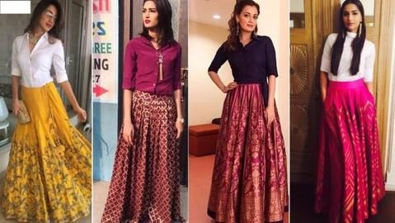

For a quirky look, team up your **long skirt with top**. Throw in a statement neck piece and get ready to be a stunner!

**Cool Culottes**

Culottes have become a staple in our wardrobe and they are here to stay. And why not, they are comfy, stylish, functional, flatter all figures and ideal for every occasion. For a festive look, with pair it a crop top with interesting sleeves or a button down blouse. By pairing culottes with a crop top, you break the look in a way it adds height to your frame. Complete your look with statement neckpieces and earrings!

**Trendy Palazzo Pants**

Women of all ages are fan of palazzo pants. This style has become everyone’s favourite because of its versatility and comfort. You can pair it with your favourite kurta for a semi-formal look or team it up with an off-shoulder top for a cool casual look.

S**tyling Tips For Women Pants**

Cigarette pants accentuate your figure, make you look taller and of course look absolutely gorgeous with a crop top or a shirt. Your favourite celebs have been turning heads in pretty brocade pants teamed with shirts and tops, it’s time for you to embrace the trend too! Pair a bright plain shirt or crop top with brocade pants and you are ready-to-slay!

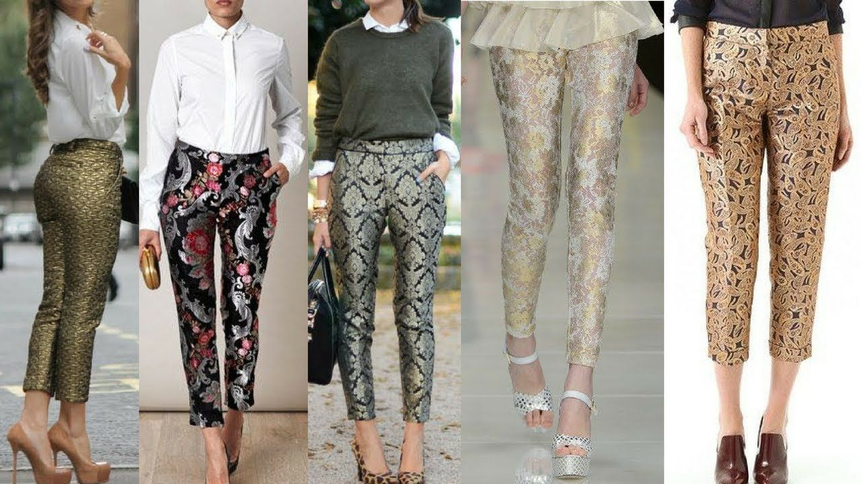

|  |  |
| --- | --- |
| https://www.biba.in/mix-and-match/bottom | bottom wear |
| https://www.biba.in/mix-and-match/bottom/knitted-churidar | ladies churidar |
| https://www.biba.in/mix-and-match/bottom/leggings | leggings |
| https://www.biba.in/mix-and-match/bottom/palazzos | palazzo |
| https://www.biba.in/mix-and-match/bottom/pants | pants for women |
| https://www.biba.in/mix-and-match/bottom/skirts | long skirt with top |