**Girls Ethnic Wear – A Growing Fashion Trend**

At very first fashion used to be associated with the stylish women or celebrity. Then it became about young stylish women. With the passage of time it grown into teenage girls and now you can see the trend evolving amogst your littles ones. Kids fashion is a serious thing now. Big brands are keen to cover the segment and has already offered a lot to please your kid.

**Ethnic Fashion – Girls Segment**

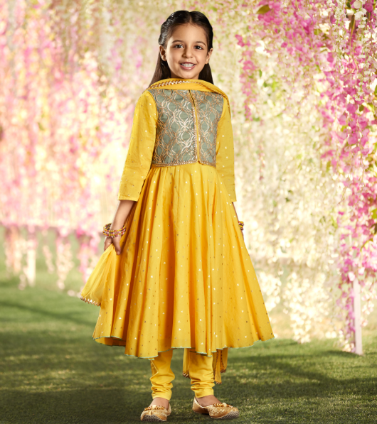

Women of every age love fashion and now that includes you 5 years old daughter too. In India ethnic wear has a prominent space. When it comes to festivities nothing beats ethnic styles. Believe us you little girl has her own taste in here too. She also know where can she find the best looking kurtis for girls.

There are many brands and market places which are offering new dresses for girls every alternate week as we know fashion has the fastest speed. As the segment is new but has a lot of potential, they just don’t want to loose it plus to give it a pace a continuous change in offering is must.

**Most Attractive Silhouettes In Girls Ethnic Fashion**

The first in our list is Anarkali or in child’s language you can call it girls frock suit. Anarkali belong to Mughal era. Can you believe how long it has been here and still nothing beats the charm of an Anarkali kurta, even the younger ones can’t deny it. The beautiful ghera of Anarkali makes them equally happy.

The second in our list is Lehenga for girls. Who doesn’t want to doll up in a pretty lehenga? Every girl! Current fashion trend has evolved the designing quite fashionably. The inclusion of pastels, floral prints and metallic touch made it’s possible for everyone to pick a lehenga as an out of the day, even if it’s not their own wedding day or it’s not at all a wedding. Similarly, how can your little girl remain untouched from this trend. Little girl they just love flaunting lehengas and printed lehengas has made your job a lot easier.

**Brand To Go For**

Speaking of Ethnic wear brands especially for girls, there are very few reliable ones. Biba Girls is one of them. The Brand latest suit designs for girls under is vast collection of girls ethnic wear. You can shop and explore its kids range online anytime. Or you can visit the nearest store to get touch and feel of fabric before shopping.

|  |  |
| --- | --- |
| https://www.biba.in/girls | kurti for girls |
| https://www.biba.in/new-arrivals/girls/set/dresses | new dress for girls |
| https://www.biba.in/girls/suit-sets/anarkali | girls frock suit |
| https://www.biba.in/girls/suit-sets/lehenga-set | lehenga for girls |
| https://www.biba.in/girls/girls-suit-sets | suit design for girls |