Git Mastery Challenge

**Name: Bandaru Prabha Supriya**

**Branch: AI & ML**

**Year: B.Tech 3rd Year**

**Date: 27-10-2025**

**Objective**

The objective of this challenge is to demonstrate understanding of Git branching, merging, resolving conflicts, and version control workflows by performing multiple merges between main, dev, and conflict-simulator branches, and documenting the process.

**Step 1: Repository Setup**

Commands used:

git clone https://github.com/PartnrNetwork/git-mastery-challenge-template.git

git branch

*Created branches: main, dev, conflict-simulator.*

**Step 2: Development Work**

Added and modified files such as README.md, docs/architecture.md, and configuration scripts (deploy.sh, monitor.js). Created multiple commits with progress logs.

Commands:

echo "Day 1 - Practiced merging branches" > progress/log-1.txt

git add progress/log-1.txt

git commit -m "Add learning log 1"

*Repeated for 15 commits total.*

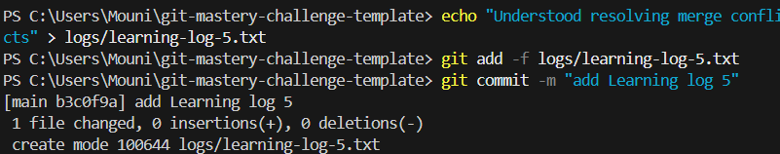

**Step 3: Merging dev into main**

Commands:

git checkout main

git merge dev

Outcome:

Successfully merged with conflict resolution (README.md, architecture.md, and config files).

**Step 4: Merging main into conflict-simulator**

Commands:

git checkout conflict-simulator

git merge main

Outcome of git checkout main , git merge conflict-simulator

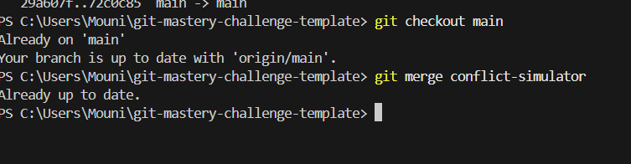

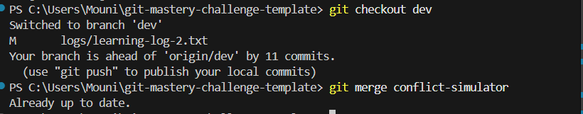

Merged successfully with out conflict between dev and conflict-simulator

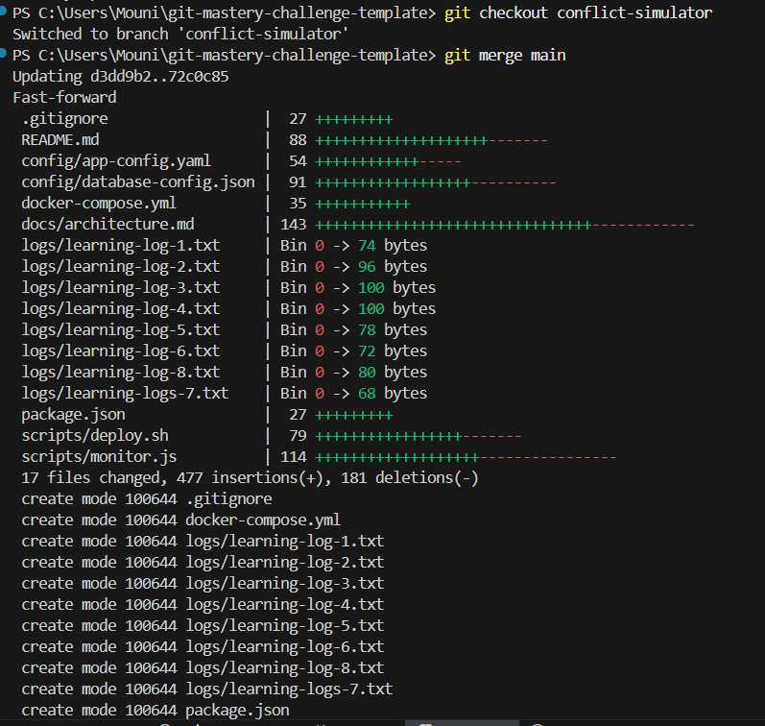

Fast-forward merge completed. All branches are now up to date.

**Step 5: Verifying Commits and Branches**

Commands:

git branch

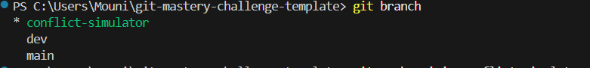

(git log –oneline| Measure-Object -Line).Lines

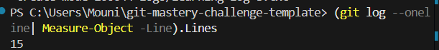

✅ *Confirmed total 15 commits and clean working directory.*

Git log –oneline –graph --all

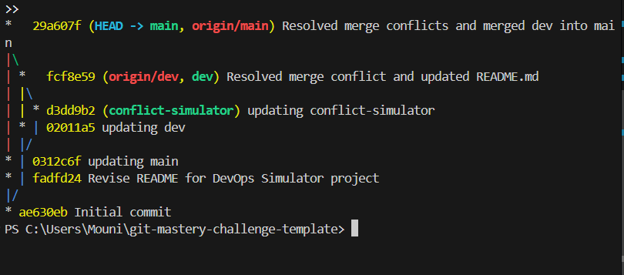

**Checkpoint1.png**

git log –oneline –graph --all

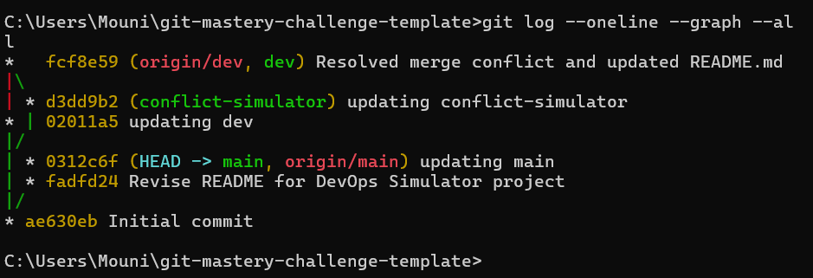

Checkpoint2.png

**Conclusion**

Through this challenge, I learned how to manage multiple branches, perform merges with and without conflicts, resolve merge issues, and maintain a clean commit history. This exercise improved my confidence in using Git effectively for version control and team collaboration.

**GitHub Repository Link**

https://github.com/prabhasupriya/git-solved-STU23A91A6106/