**Web3 and Blockchain Basics: Setup Wallet and Explore DApps**

**Student:** Bandaru Prabha Supriya  
**Task:** Setup Wallet and Explore DApps (MetaMask + Sepolia + OpenSea)  
**Date:** 27/10/2025

**1. Documentation**

**1.1 Screenshots**

(Insert the following screenshots in this order)

1. **MetaMask installation** screen

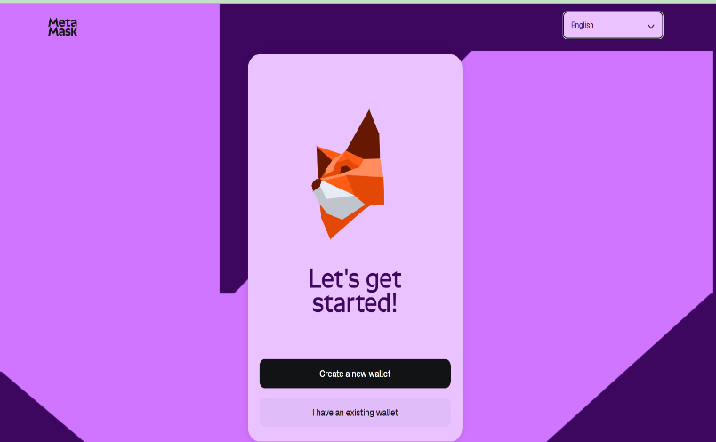

1. **Network configuration** showing Sepolia test network

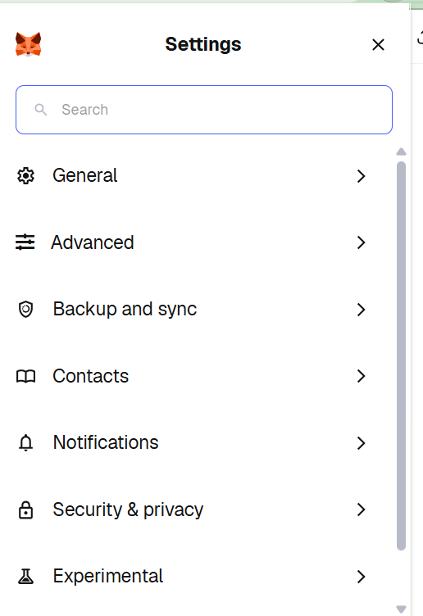 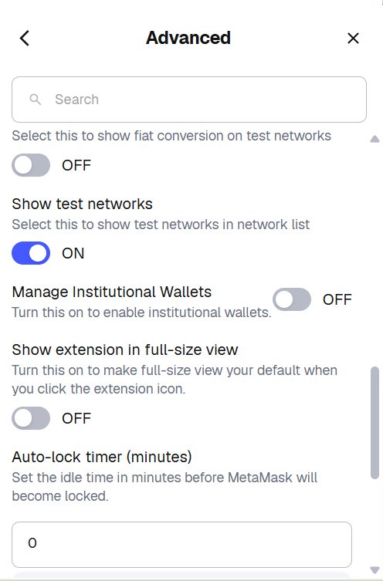

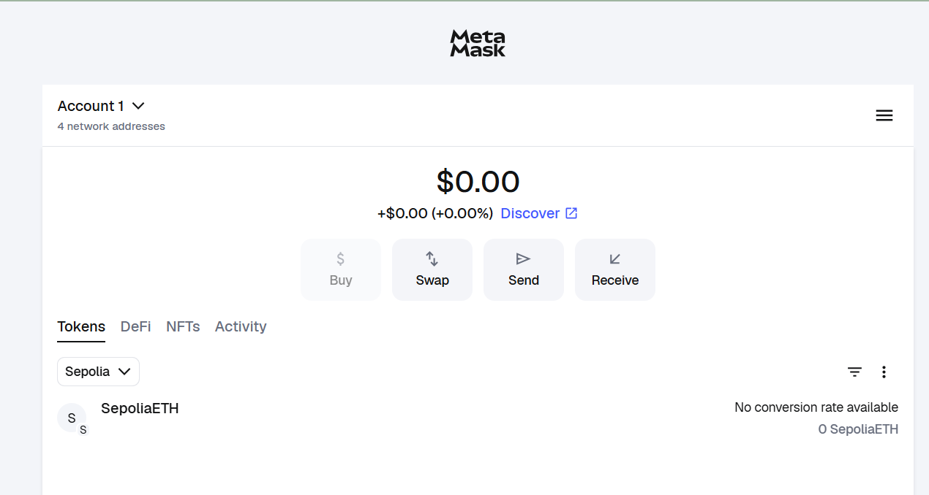

1. **Testnet balance** showing Sepolia ETH

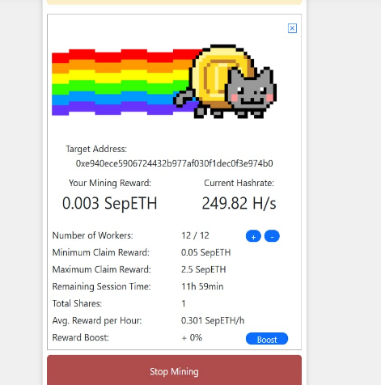

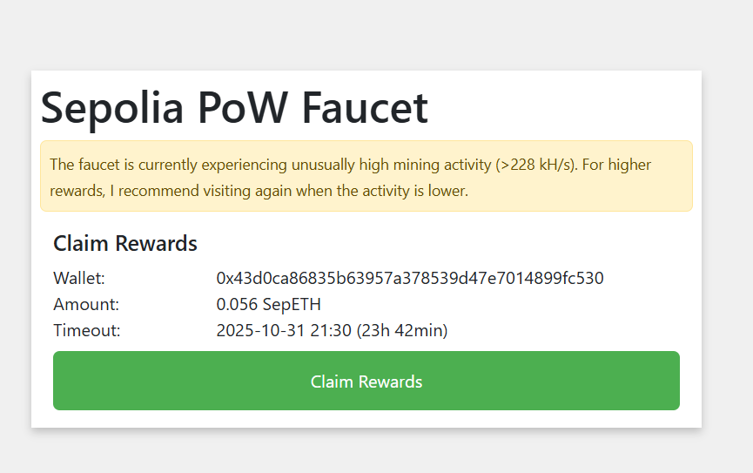

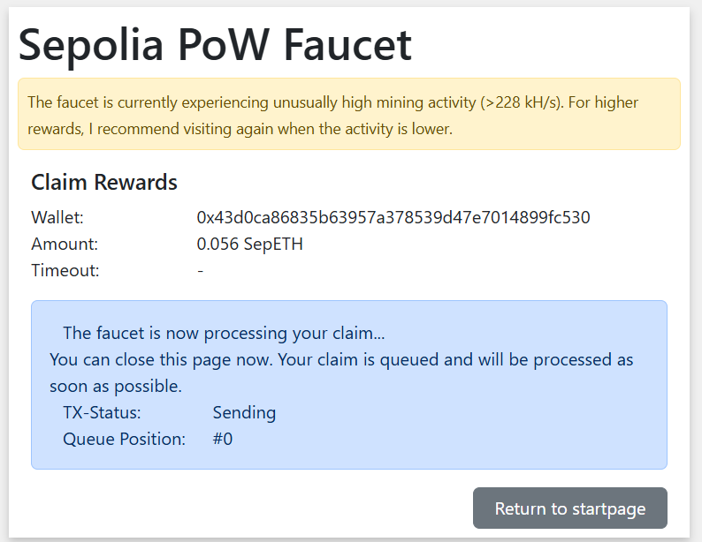

1. **DApp (OpenSea)** connection window

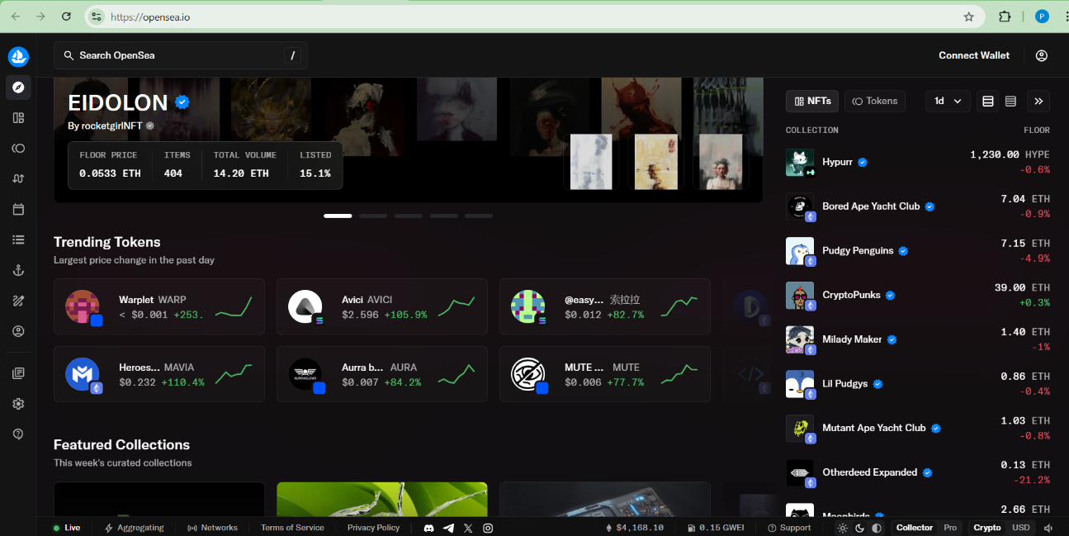

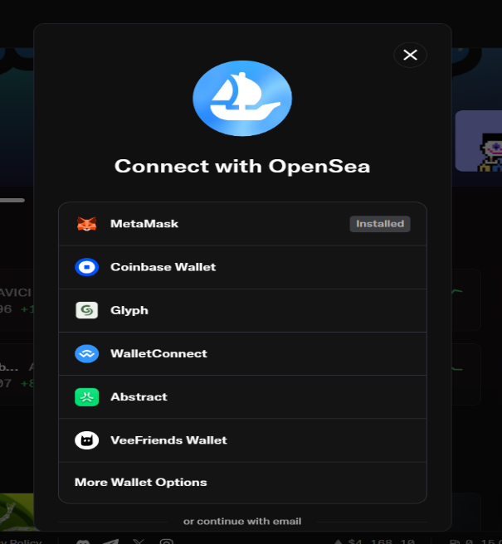

1. **Completed transaction** confirmation from MetaMask

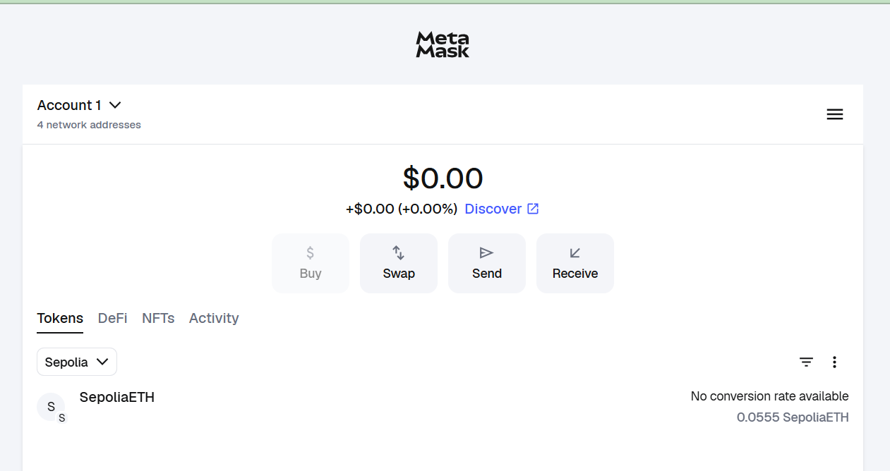

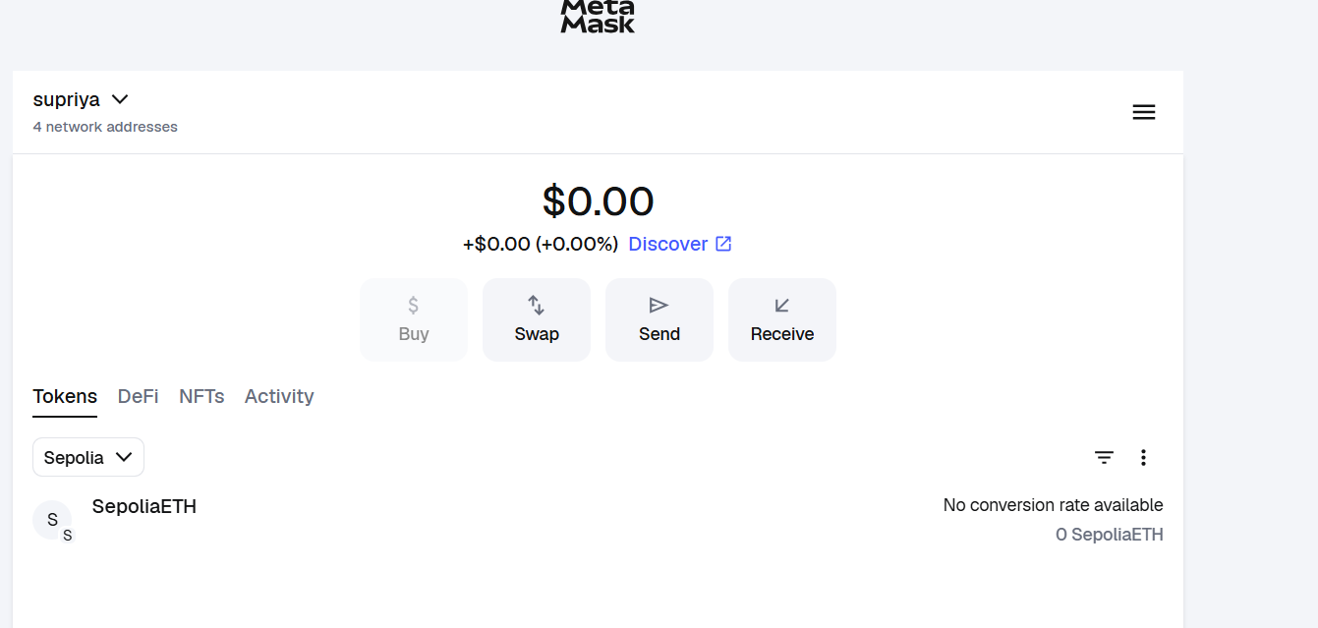

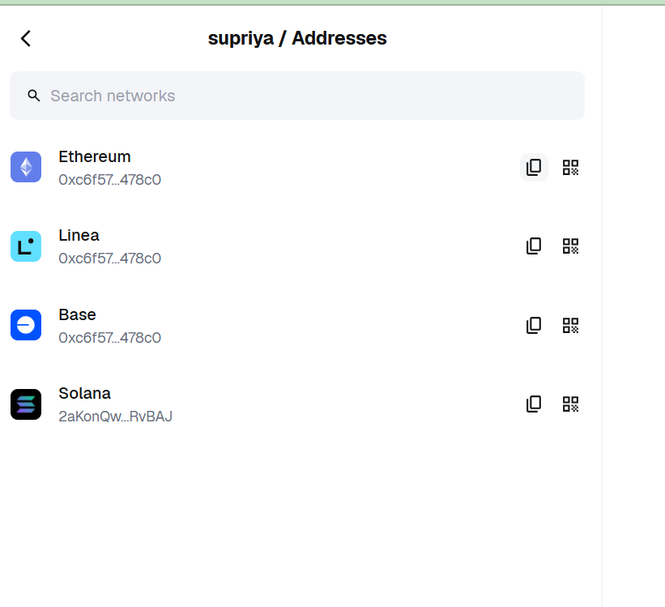

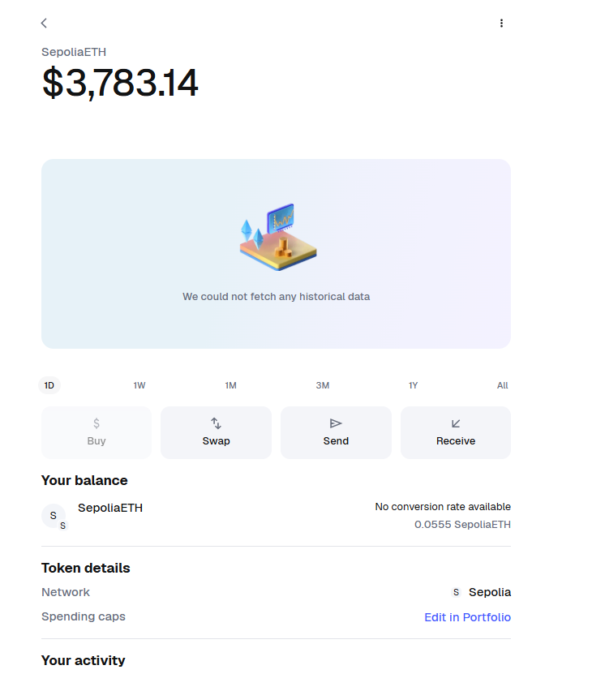

1. **Etherscan** page showing the transaction details

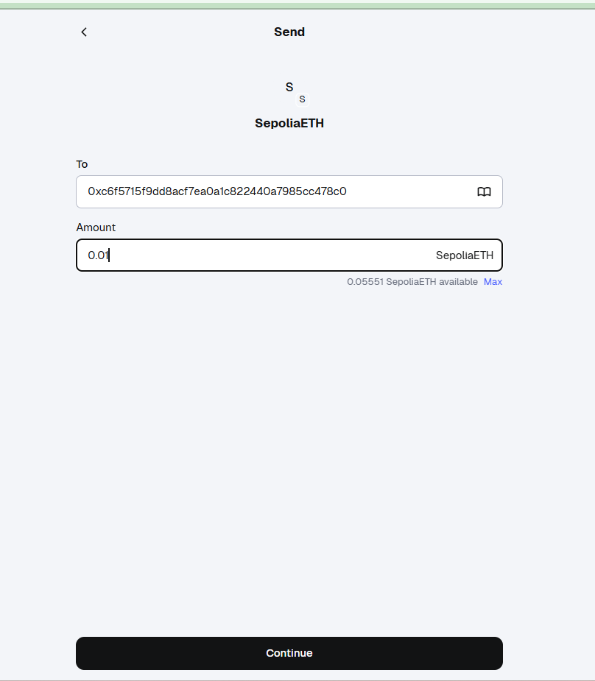

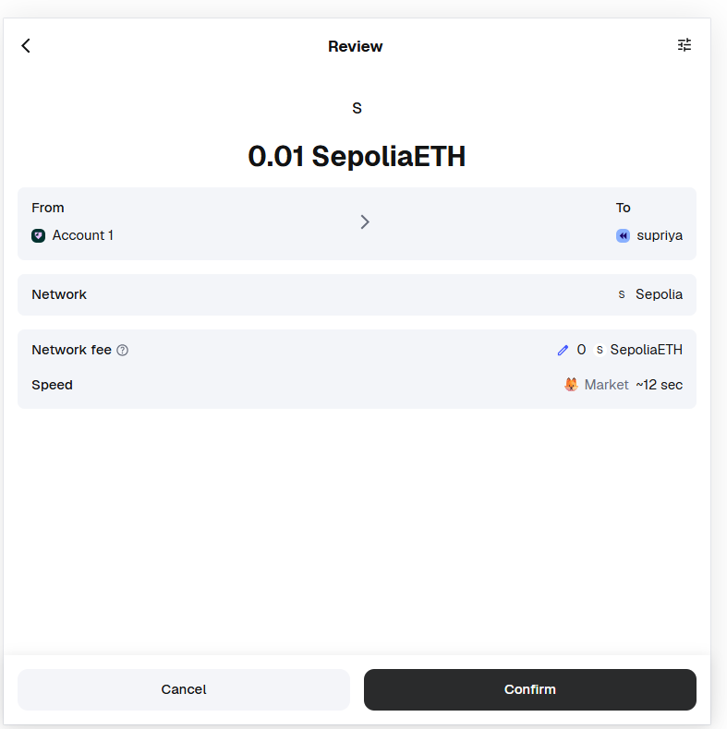

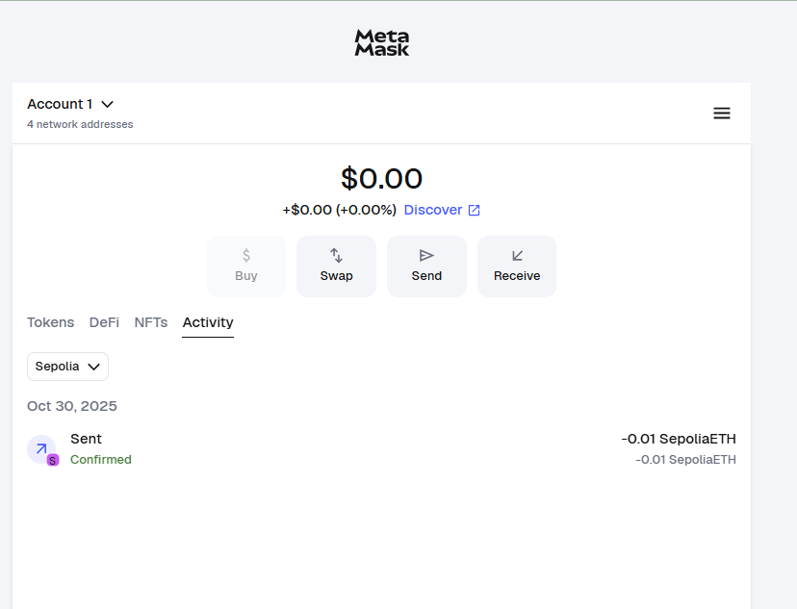

**6]Etherscan / Block Explorer page**

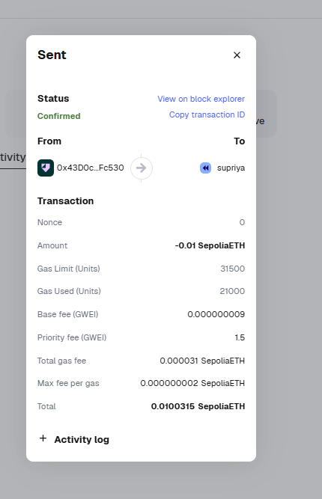

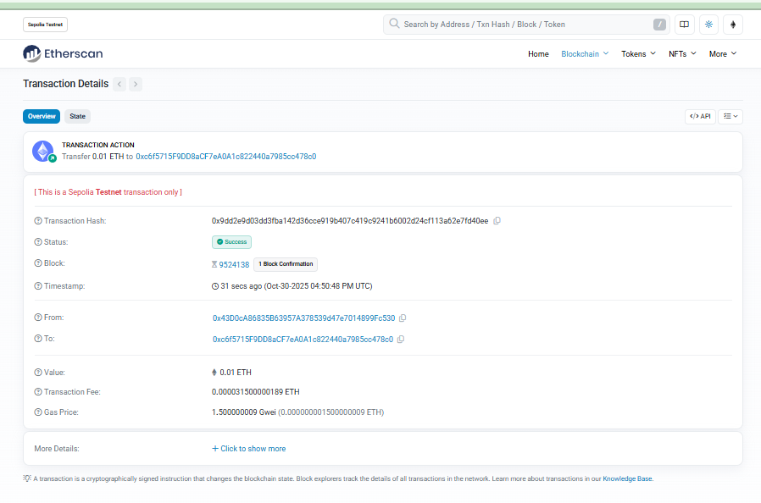

**1.2 Wallet Address**

My public wallet address (Sepolia):  
0x43d0ca86835b63957a378539d47e7014899fc530

**1.3 Transaction Hash :** **0x9dd2e9d03dd3fba142d36cce919b407c419c9241b6002d24cf113a62e7fd40ee**

The **Transaction Hash** (also known as **Transaction ID**) is a unique identifier automatically generated whenever a transaction is executed on the blockchain. It acts like a digital receipt that records and verifies your transaction details permanently on the blockchain ledger.

To find the Transaction Hash in MetaMask:

1. Open **MetaMask** and make sure you are connected to the **Sepolia Test Network**.
2. Click on the **“Activity”** tab — it shows a list of your recent transactions.
3. Select the latest transaction (for example, the one where you received test ETH or interacted with a DApp).
4. Click **“View on block explorer.”**
5. This will open the transaction details on **Sepolia Etherscan**, where you can see the **Transaction Hash** starting with 0x.

**1.4 Etherscan Link**

**https://sepolia.etherscan.io/tx/0x9dd2e9d03dd3fba142d36cce919b407c419c9241b6002d24cf113a62e7fd40ee**

**Etherscan** is a blockchain explorer that allows you to view and verify transactions, wallet addresses, and smart contract details on the Ethereum network (including testnets like Sepolia).

**Etherscan** is one of the most widely used **blockchain explorers** for the Ethereum network. It acts as a transparent window into the blockchain, allowing users to view and verify all transactions, wallet balances, smart contract code, and token transfers that occur on Ethereum and its test networks such as **Sepolia**.

Every transaction made on the blockchain — whether it’s sending ETH, interacting with a DApp, or deploying a smart contract — is publicly recorded. Etherscan provides an easy-to-use interface to **track, verify, and analyze** these transactions. It ensures **transparency**, since anyone can confirm that a particular transaction actually took place and view all its technical details such as block number, timestamp, gas fees, and sender/receiver addresses.

**Steps to Get Your Etherscan Link (Sepolia Network):**

1. **Open MetaMask** in your browser extension.
2. **Ensure you’re connected to the Sepolia Test Network:**
   * At the top of MetaMask, it should say “Sepolia Test Network.”
   * If it shows “Ethereum Mainnet,” click the dropdown and select **Sepolia**.
3. Go to the **“Activity”** tab inside MetaMask.
   * This tab lists all your recent transactions (like receiving test ETH or interacting with a DApp).
4. Click on the **latest transaction** to view its details.
5. Inside the transaction details, click the option **“View on block explorer.”**
   * This will automatically open **Etherscan** (the official blockchain explorer) in a new browser tab.
6. Once Etherscan opens, you will see a page displaying your transaction details such as:
   * **Transaction Hash (TxID):** A unique identifier starting with 0x.
   * **Block Number:** The block in which your transaction was recorded.
   * **Timestamp:** When the transaction was confirmed.
   * **From / To:** Sender and receiver wallet addresses.
   * **Value:** The amount of ETH or tokens transferred.
   * **Gas Fee:** The cost paid to process your transaction.
7. **Copy the link** from your browser’s address bar — that is your **Etherscan link**.
8. Paste this link in your report under **“Etherscan Link”** so your instructor can verify your blockchain transaction.

**Why Etherscan is Important**

* It **verifies authenticity** of blockchain activities.
* It provides **real-time transaction data** and ensures no central authority can alter records.
* Developers and learners use Etherscan to **analyze gas usage, smart contract interactions, and transaction status**.
* It helps in **troubleshooting** failed or pending transactions.

**2. Written Reflection**

During this exercise, I gained a comprehensive understanding of how **decentralized systems** operate through **blockchain technology** and how **digital wallets** such as **MetaMask** serve as the bridge between users and **decentralized applications (DApps)**. This hands-on activity allowed me to move beyond theoretical knowledge and experience firsthand how transactions occur on a blockchain network, how smart contracts work, and how tools like Etherscan help verify blockchain activities.

The first and most important concept I understood was that **blockchain** functions as a **distributed ledger** system. Unlike traditional databases controlled by a single organization, blockchain distributes copies of the ledger across multiple computers, known as **nodes**. Each transaction is stored in a **block** and linked to the previous one using **cryptographic hashes**, forming a secure and unchangeable chain. This decentralized verification process ensures that data on the blockchain remains **transparent, tamper-proof, and permanent**, since any modification in one copy must be validated and agreed upon by all nodes in the network.

I also learned the crucial difference between **centralized** and **decentralized applications**. Centralized applications — such as social media platforms or online banking systems — are controlled by a central server or authority that manages user data, authentication, and access permissions. This means that the organization running the platform has full control over user information and can modify, restrict, or delete data. In contrast, **decentralized applications (DApps)** operate on blockchain networks where data is stored across nodes and controlled by **smart contracts** rather than a single central entity. This gives users more **ownership, transparency, and control** over their assets and data. For instance, in DApps like **OpenSea**, ownership of digital assets such as NFTs (Non-Fungible Tokens) is recorded directly on the blockchain, ensuring authenticity and preventing duplication or fraud.

Another important learning outcome from this exercise was understanding the concept of **smart contracts**. These are self-executing pieces of code stored on the blockchain that automatically execute predefined actions when specific conditions are met. Smart contracts eliminate the need for intermediaries such as banks, brokers, or administrators, making processes faster, cheaper, and more secure. For example, when connecting MetaMask to OpenSea or when receiving test ETH from a faucet, the interaction is governed by a smart contract that verifies and records the transaction on the blockchain.

Through this activity, I also became more aware of the **security practices** that are essential when handling cryptocurrencies and digital wallets. The **Secret Recovery Phrase** (also known as a seed phrase) is the most critical element of wallet security. It acts as a master key to access the wallet and all its assets. Losing it or sharing it with others could result in losing complete control of the wallet. Therefore, it is best to store the phrase **offline**, in a secure place, and never on cloud storage or shared documents. I also learned to verify the authenticity of websites before connecting my wallet to avoid **phishing attacks** or fake DApps that attempt to steal credentials.

While performing the practical part of this task, I encountered a few challenges. Initially, I could not find the **Sepolia Test Network** in MetaMask, but I resolved this by enabling the “Show test networks” option under **Advanced Settings**. Another difficulty was related to **faucets** — sometimes the faucet website failed to send **test ETH** immediately due to high demand or limited availability. I overcame this by refreshing the page, trying alternate faucet links, and waiting for the test transaction to complete. Once I received test ETH in my wallet, I connected MetaMask to **OpenSea’s test environment** and explored how transactions appear in real time on **Etherscan**, which gave me valuable insights into how blockchain explorers work.

Overall, this activity provided me with a solid, **hands-on understanding** of how **Web3 technologies** function. I learned how to connect a wallet, perform test transactions, and verify them using Etherscan. Beyond technical skills, I also developed awareness of **cybersecurity best practices**, decentralized identity, and blockchain transparency. This practical exposure has helped me bridge the gap between theory and real-world blockchain operations, enhancing my confidence and knowledge in decentralized application development. It was a valuable learning experience that strengthened my foundation in blockchain, smart contracts, and the broader Web3 ecosystem.

**3. Technical Summary**

| **Parameter** | **Details** |
| --- | --- |
| **Testnet Used** | Sepolia Test Network |
| **DApp Used** | OpenSea (connected using MetaMask) |
| **Type**  **of Transactions** | Wallet connection, faucet transaction (test ETH transfer), and viewing transaction on Etherscan |
| **Errors Encountered** | Faucet delay in sending test ETH; initially testnet not visible in MetaMask |
| **Troubleshooting Steps** | Enabled “Show test networks” in MetaMask settings, refreshed faucet multiple times until ETH was received, and verified transaction using Etherscan. |