**Krishi Mandi Bank (KMB): an innovative approach to enhancing the financial shape of farmers**

Prabhat Kumar

Research Scholar

Department of Computer Science, Institute of Science,

Banaras Hindu University, Varanasi – 221 005, India.

Email: [prabhat.kumar13@bhu.ac.in](mailto:prabhat.kumar13@bhu.ac.in)

Our society's backbone is comprised of farmers. They are the ones who feed us. As a result, farmers are the sole source of income for the whole population of the country. It makes no difference whether the country is the smallest or the largest. We are only able to survive on this planet because of them. Aside from that, farmers account for around 17% of the Indian economy. That is the absolute maximum. However, a farmer is still denied all of society's privileges. Farmers in India are in desperate need of help. Every week or month, we receive reports of farmer suicides. Furthermore, farmers have had a hard time in recent years. They are underpaid, which is a concern. A farmer gets nothing in hand since the intermediaries grab the majority of the money.

The Krishi Mandi Bank (KMB) is followed the concept of the non-profit organization and is dedicated to the welfare of farmers at every stage. Here, the word “Bank” is situated to demonstrate the fruitful and needed services for farmers. Even though India is an agricultural country, its agricultural marketing has been dismal. Even after putting in a lot of effort, Indian farmers are unable to obtain appropriate rates for their products and are completely abused by intermediaries. Hence, there is the following list of issues with the existing procedure for trading the farming products.

* The existence of too many intermediaries and their victimization of farmers is the one major flaw in Indian agricultural marketing.
* Because of their simple nature, the majority of Indian farmers are illiterate, making them more easily duped by money lenders, dealers, and intermediaries. Similarly, because Indian farmers are dispersed throughout rural regions, they are exploited due to a lack of solidarity among them.
* Rural communities suffer from a lack of financial resources, which means that even their most basic needs are not met. Farmers sell their crop before it ripens under such circumstances.
* Farmers are harmed by the lack of a well-structured marketing system. The farmer sells their farming products to a variety of intermediaries on an individual basis.
* The routes connecting villages and cities are frequently unpaved and impassable during the rainy season. The farmer is unable to convey their products to the proper market and obtain a reasonable price for their commodity due to a lack of transportation infrastructure.
* The absence of storage facilities is a major shortcoming in Indian agricultural marketing. Due to the lack of this facility, the farmer is unable to properly store their goods until they can be sold for a reasonable price, and they are obliged to sell them at a cheap price. Large amounts of grain are wasted because of inadequate and improper shortage facilities that are provided.

The objectives of KMB are devoted to solving and reducing the issues usually faced by farmers, mentioned as follows:

* Minimize the gap between the selling price of both farmers and intermediaries.
* Advice to make all necessary precautions to protect the farming products before spoiling.

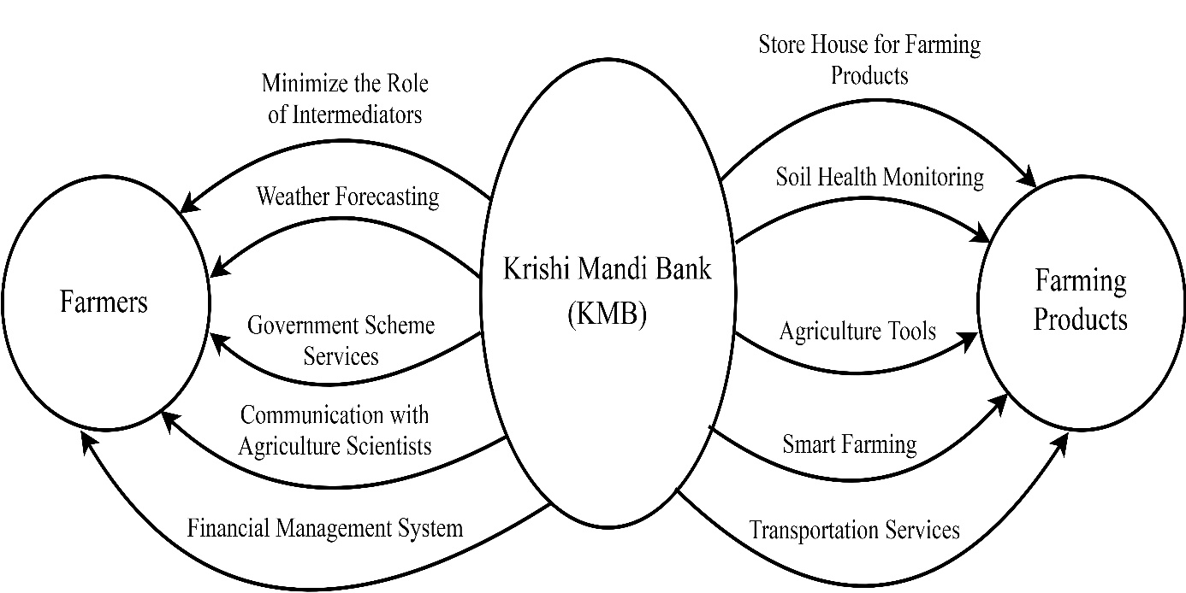

Figure 1. Objectives of Krishi Mandi Bank (KMB) for farmers and farming products.

* Weather forecasting services via social media platforms such as Facebook, Twitter, WhatsApp – group, etc.
* Technical services for sustainable growth in terms of various government schemes such as National Mission For Sustainable Agriculture (NMSA), Pradhan Mantri Krishi Sinchai Yojana (PMKSY), Pradhan Mantri Fasal Bima Yojana (PMFBY), Kisan Credit Card (KCC), Soil Health Card, PM Kisan Samman Nidhi Yojana, etc.
* Easily provide the interaction way to communicate with agriculture scientists using the toll-free number, video conferencing, etc.
* Services of Financial management system for each farmer to evaluate the ratio of investment and income.
* Promote and motivate the farmers to use organic manure instead of chemical fertilizer for maintaining the health of the soil.
* Provides the availability of a wide range of agricultural tools such as hand sickle, pickaxe, hoe, [sprayers](https://www.tractorjunction.com/tools/sprayers/), [brush cutter](https://www.tractorjunction.com/tools/brush-cutter/), [power weeder](https://www.tractorjunction.com/tools/power-weeder/), [power tiller](https://www.tractorjunction.com/tools/power-tiller/), [power reaper](https://www.tractorjunction.com/tools/power-reaper/), etc.
* Smart farming used sensors that help farmers monitor and optimize crops by allowing them to adjust to changes in the environment. Weather stations, drones, and agricultural robots all have these sensors attached.
* Transportation services for farming products.
* Finally, the objectives of the KBM have been graphically summarized and illustrated using figure 1.

Our financial sources will be donation and happy to help facilities to the respective farmers. Aiding these farmers in increasing their crop yields is one strategy to combat hunger, and assisting them in increasing their earnings from the sale of their produce is another.