Inspection Report

**FIRST INSPECTION REPORT**

INSURED/POLICYHOLDER: bhb

ADDRESS: CD- 33 sector- 3 dhurwa ranchi

INSURER: ABCD

CLAIM #: 1234567

ADJUSTER/ CLAIM REP: TOP GUN

DATE OF INSPECTION: 2025-06-11

DATE OF LOSS: 2025-06-18

DATE OF REPORT: 2025-06-10

TYPE OF LOSS: earth

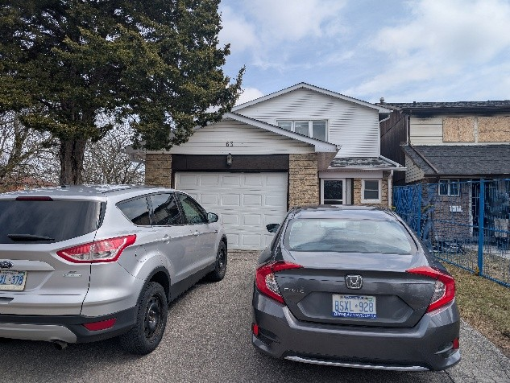

**CAUSE OF LOSS:**

bhbhjv

**SCOPE OF WORK:**

1. Assess, pack and move out all salvageable contents.  
2. Inventory all the affected contents.  
3. Inspect all affected electronics.  
4. Restore salvageable contents.  
5. Dispose of non-salvageable contents.

**RECOMMENDED RESERVES FOR TRINITY’S INVOLVEMENT:**

• Indemnity Work : Should not exceed $9900 plus HST.

• Trinity Listing & Pricing Expense Reserve: Should not exceed $1100 plus HST

**RECOMMENDED RESERVES FOR THE TOTAL CONTENTS LOSS:**

Based on a visual inspection of the extent of non-salvageable items on the main floor, we believe that the total replacement cost for the non-salvageable items should not exceed $2200 plus HST.

**CONCLUSION:**

Once our scope of work is approved, we can attend and begin the pack out process.

Thank You,  
  
Mo Waez  
Trinity Contents Management  
mo@trinitycontents.com  
(647) 613-2246

**KITCHEN & DINING AREA**

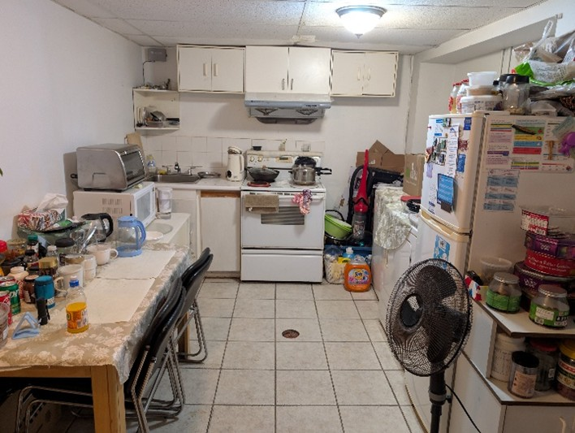

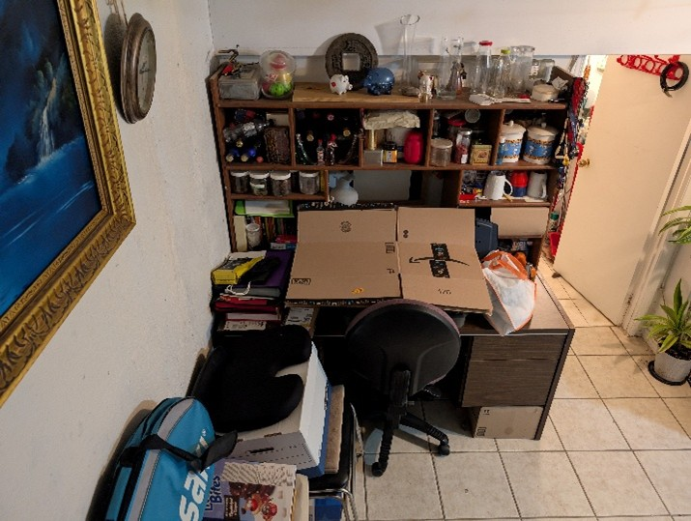

**LIVING ROOM**

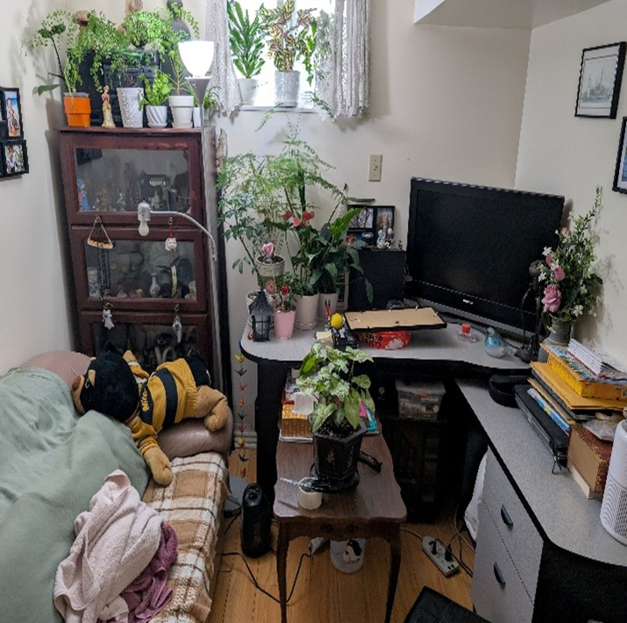

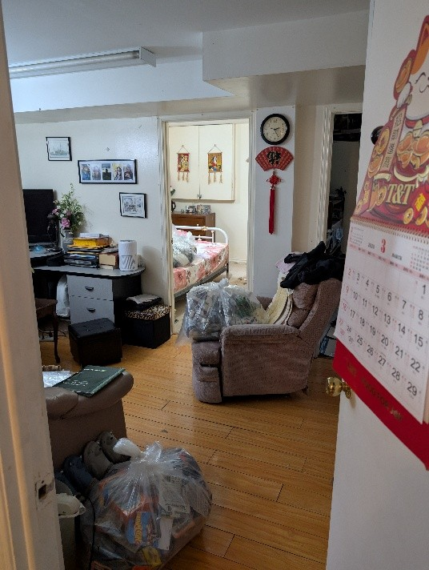

**BEDROOM_A**

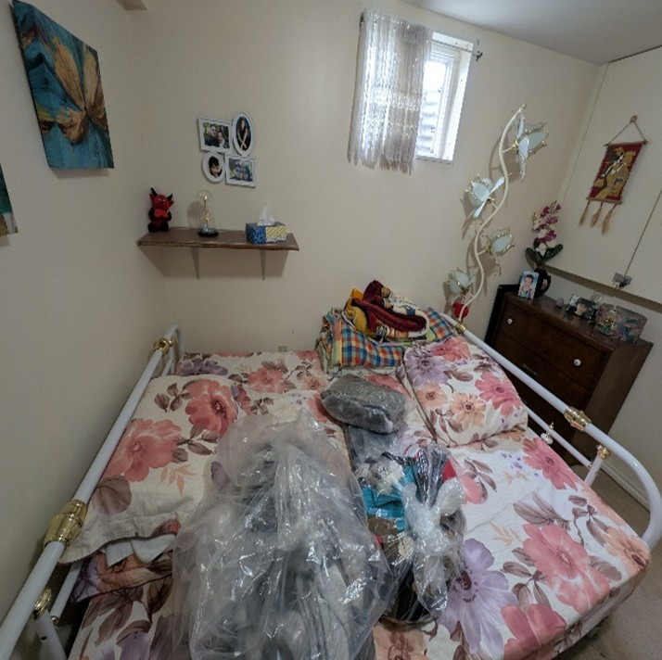

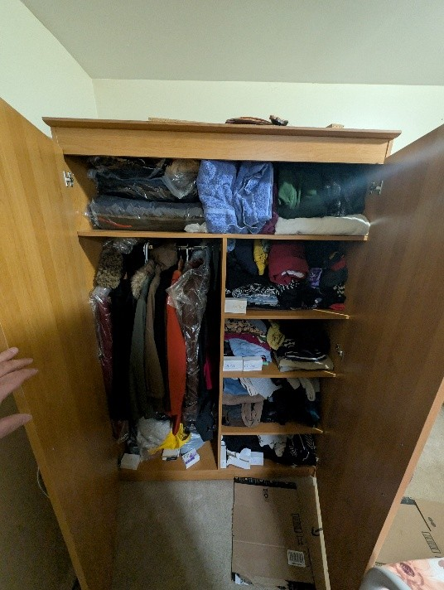

**BEDROOM_B**

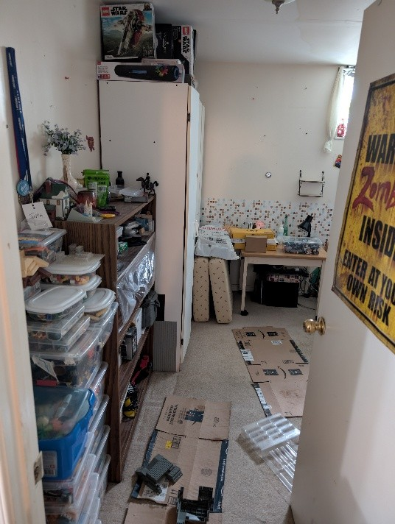

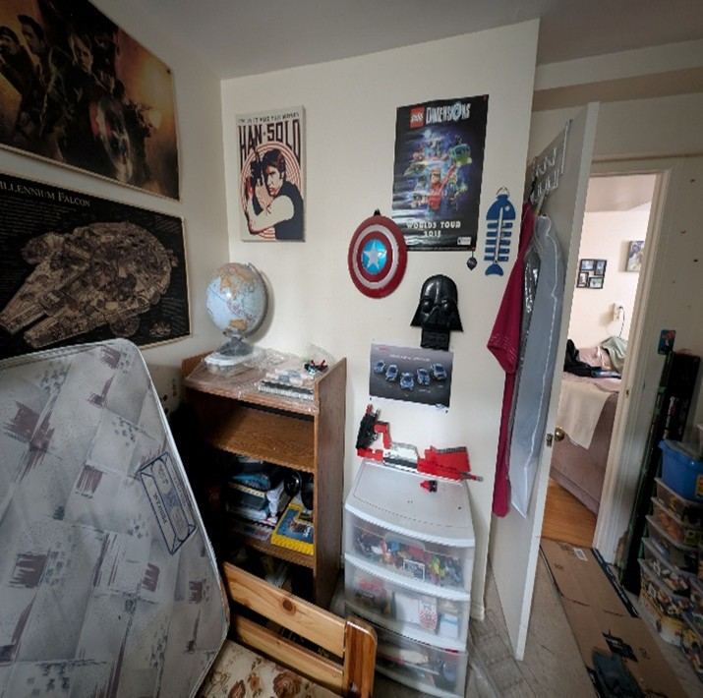

**STORAGE ROOM**

