

Blogging Site

**Team Members:**

|  |  |
| --- | --- |
|  |  |
|  |  |
|  |  |
|  |  |
|  |  |
|  |  |
|  |  |

**Documentation**

**Requirement Analysis :-**

1. Blogger can

1.1 Create new or login to existing

1.2 Update profile details

1.3 Delete his/her profile

1.4 View his/her profile

1.5 Can create post

1.6 Can Comment on post

1.7 Can upvote and downvote any post

1.8 can search for post by name/blogger.

2. Admin

2.1 Login to exisiting.

2.2 Create community

2.3 Manage Community (change name or description)

3. Community

3.1 Any user can be part of one or more community.

3.2 Only admin can delete community

3.3 Only admin can manage community

4. Comments

4.1 Any user can create comment

4.2 Only comment owner can edit comment

4.3 Only comment owner can delete comment

4.4 Moderator can shadow the inappropriate comment

4.5 Anyone can reply the comment

5. Moderator

5.1 Shadow the Post if content is inappropriate.

5.2 Can create post

5.3 Can Comment on post

5.4 Can upvote and downvote any post

5.5 can search for post by name/blogger.

**Use Case Diagram :-**

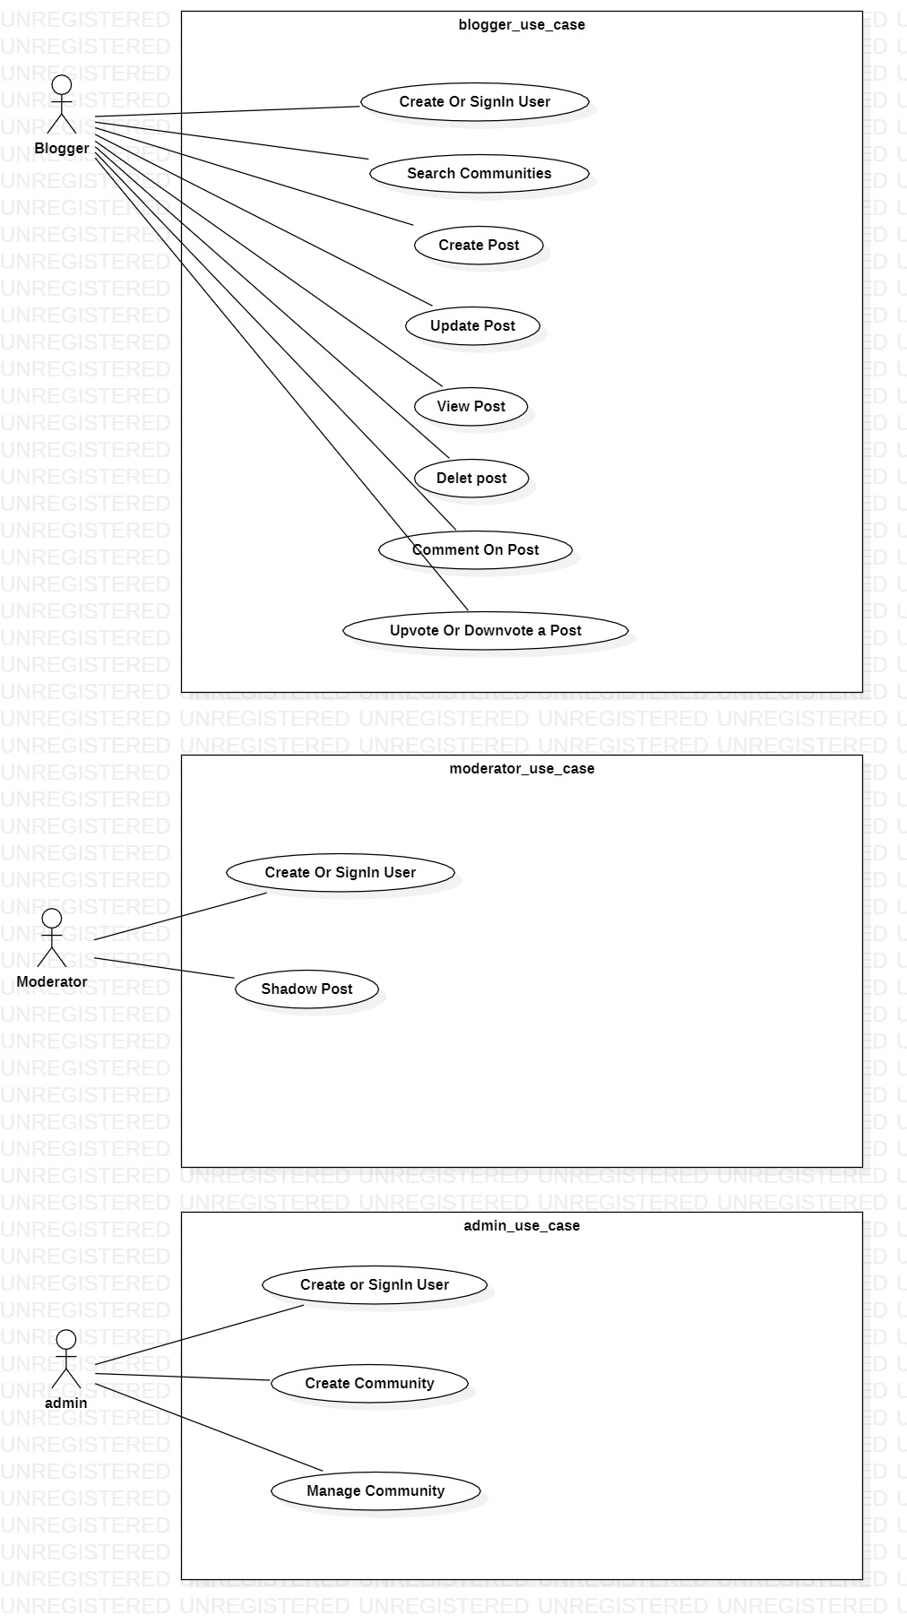

**Flow Diagram:**

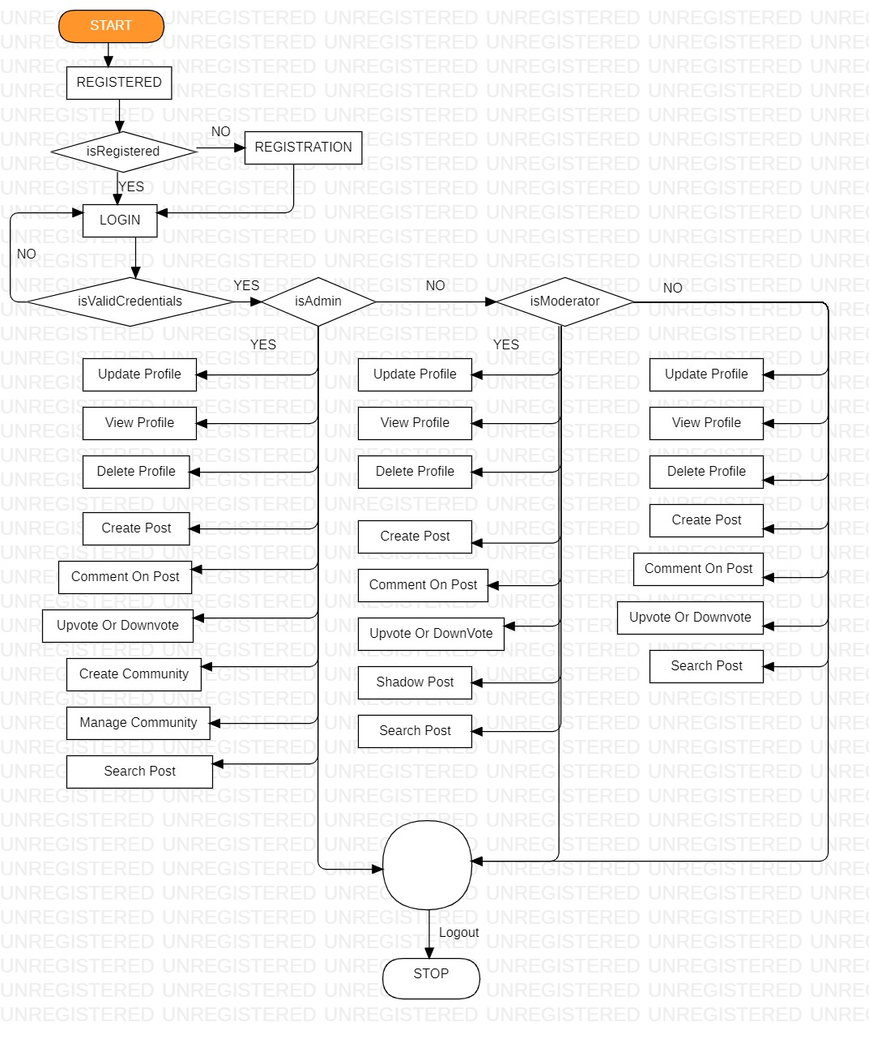

**POJOs :**

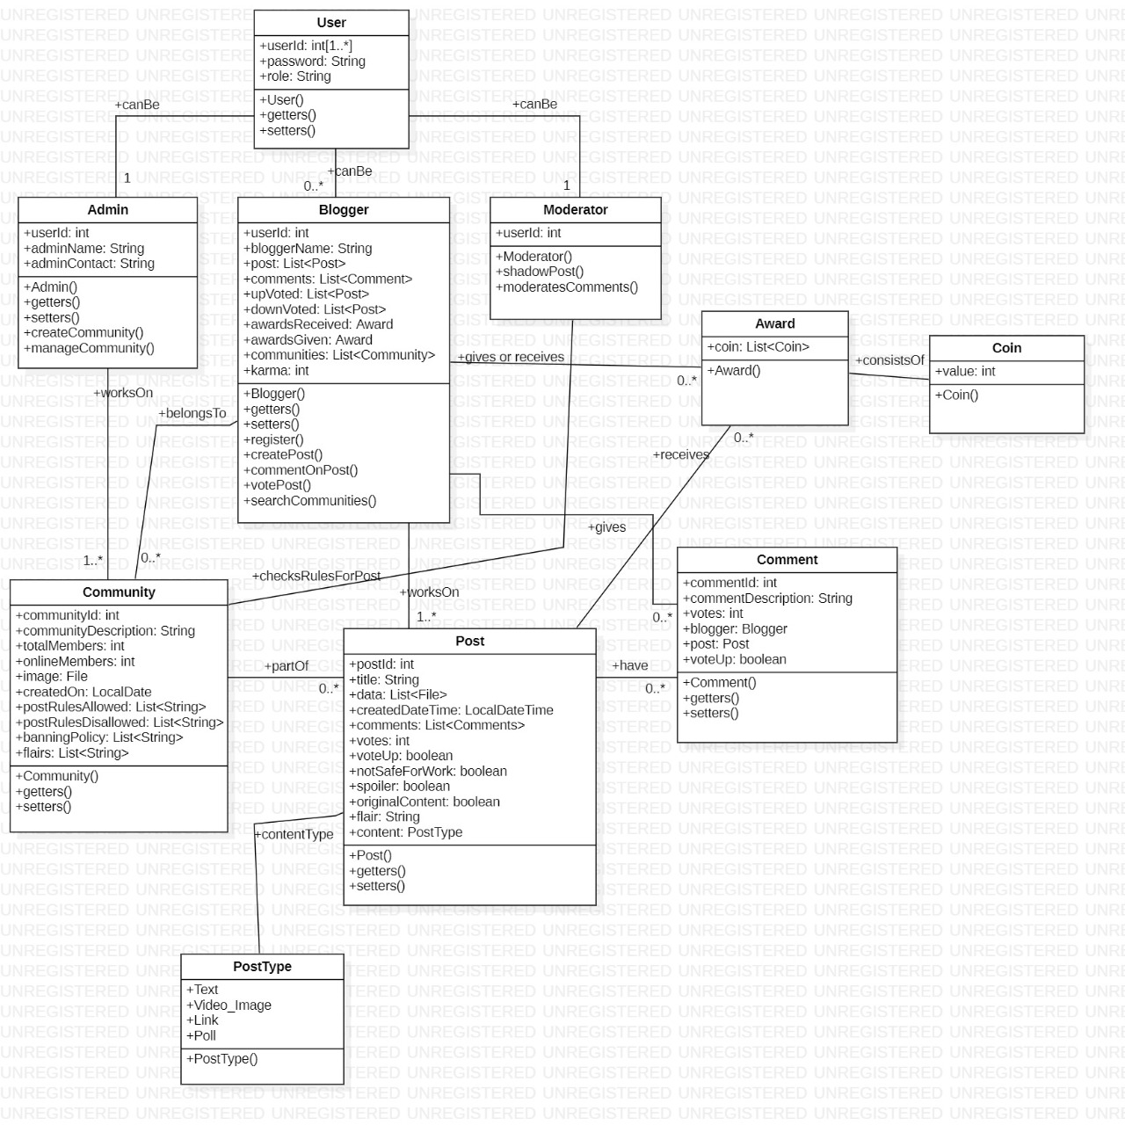

**Blogger Flow Diagram:**

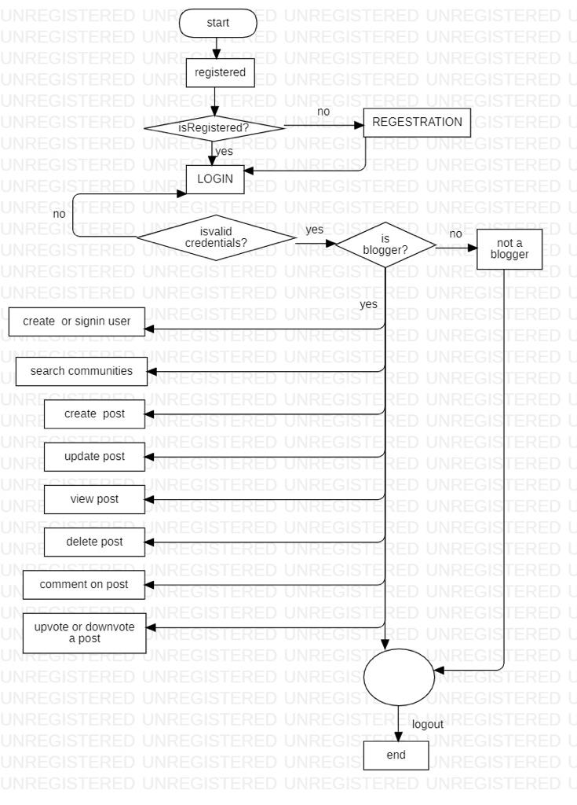

1. **Create/SigIn/SignOut Blogger**

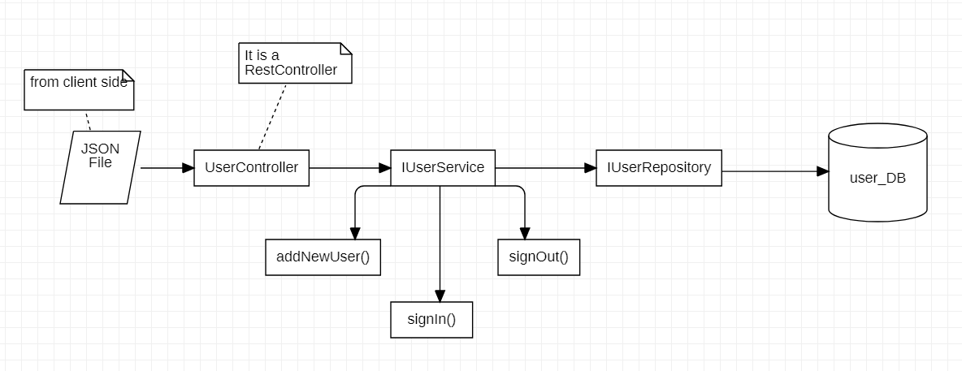

1. **Manage bloggers.**

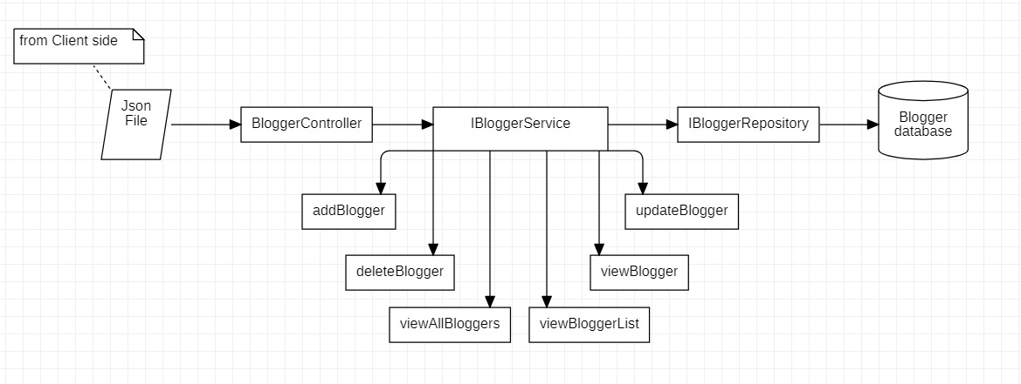

**Admin Flow Diagram:**

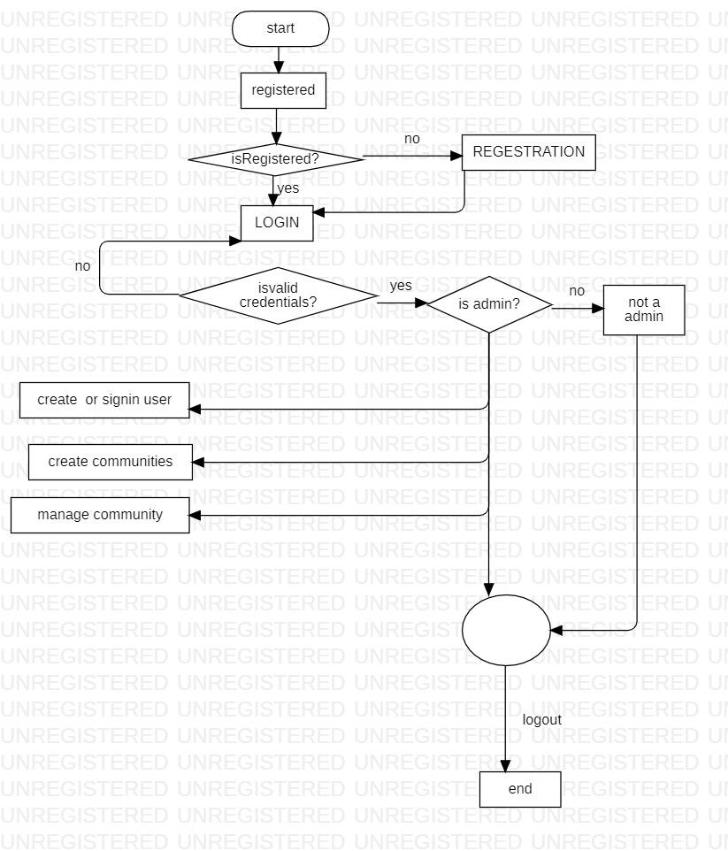

1. **Create/SigIn/SignOut Admin**



1. **Manage community**

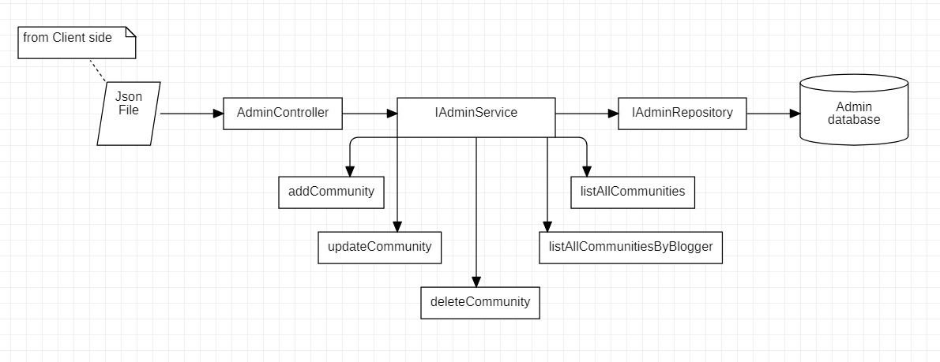

**Moderator:**

**Flow Diagram:-**

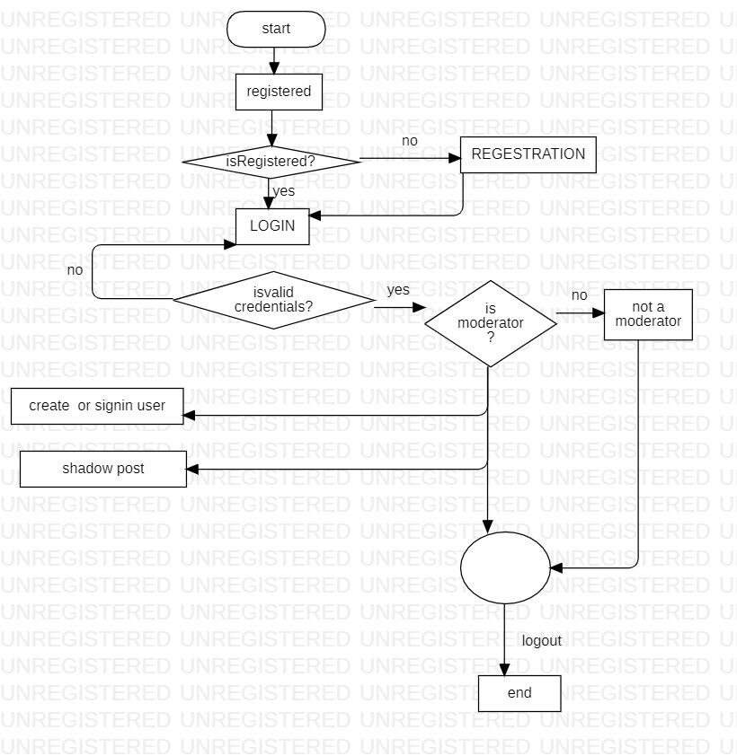

1. **Create/SigIn/SignOut Moderator**



1. **Moderates post or comments**

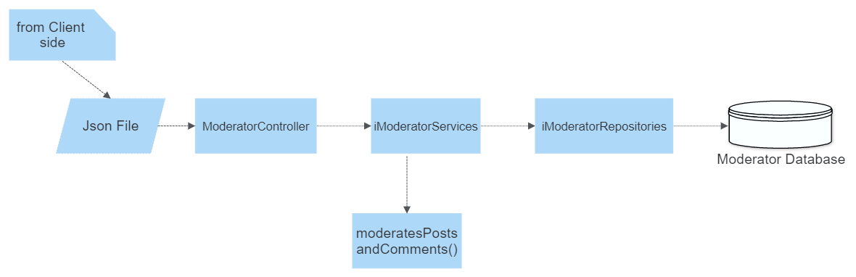

**ER Diagram:-**

