1. **Docker installation in ubuntu(Docker version 20.10.6, build 370c289)**

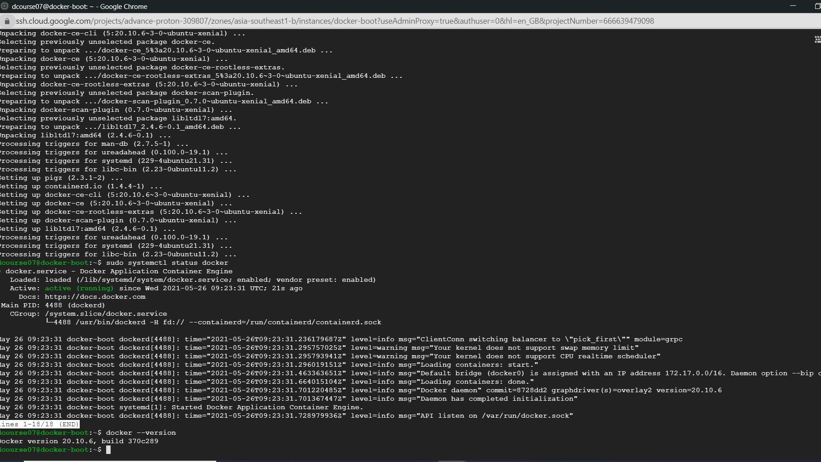

1. **Git clone** [**https://github.com/prabhat2020/bootcamp10**](https://github.com/prabhat2020/bootcamp10)
2. **Update dockerfile to use nginx as base image and run index.html**

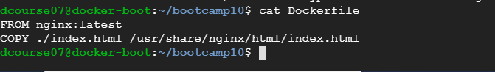

1. **Build the dockerfile**

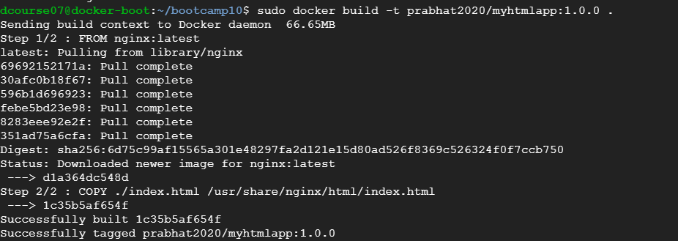

1. **Run the docker image**

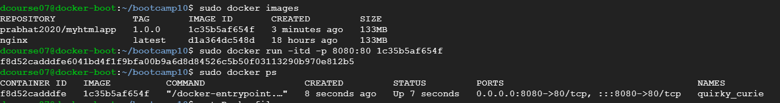

1. **See the html webpage**

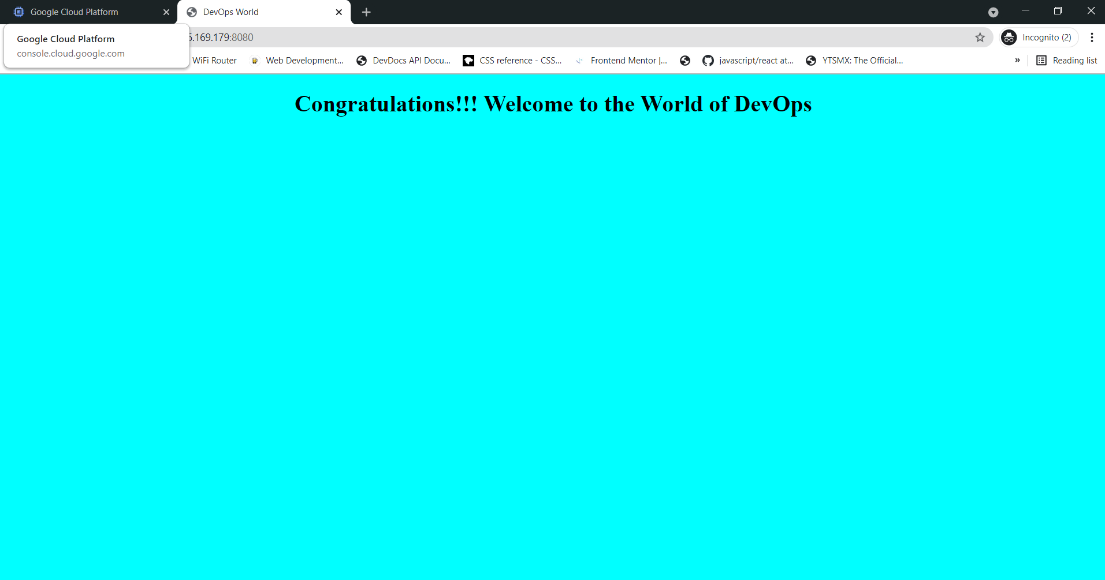

1. **Docker login and push to docker hub**

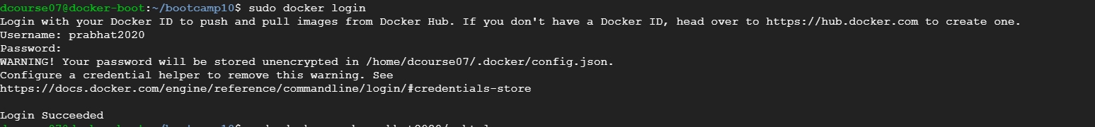

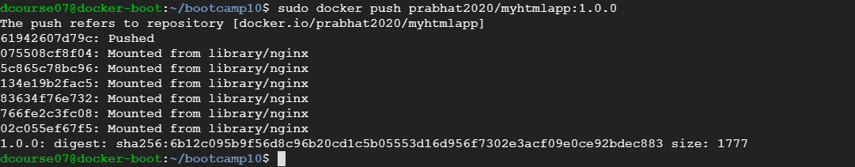

1. **Image present in docker hub**

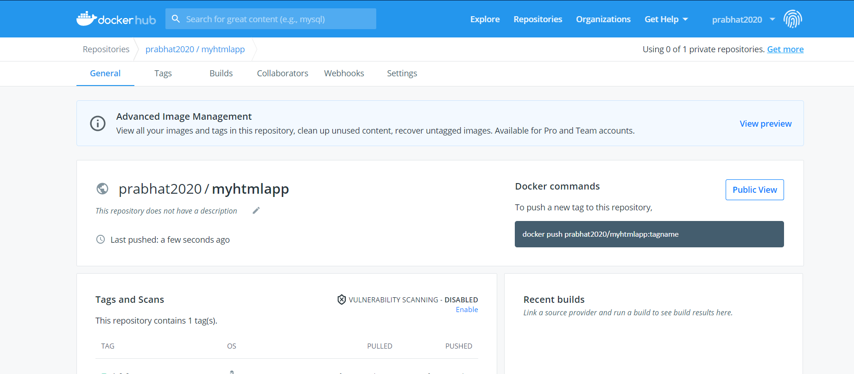

1. **Remove the image from local and do docker pull**

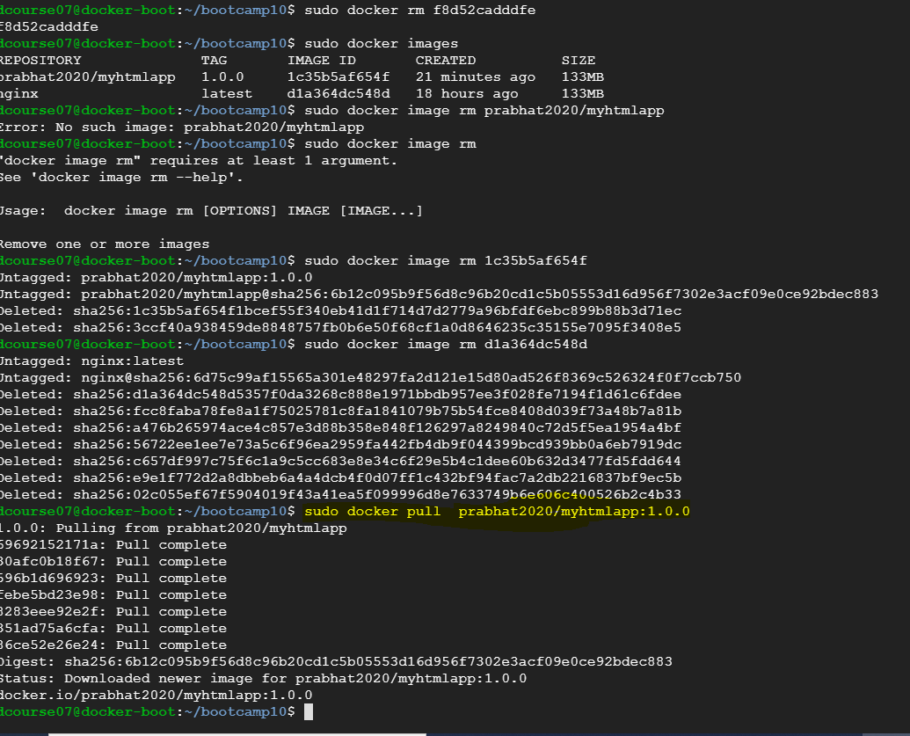

1. **Run the downloaded image on port 8090**



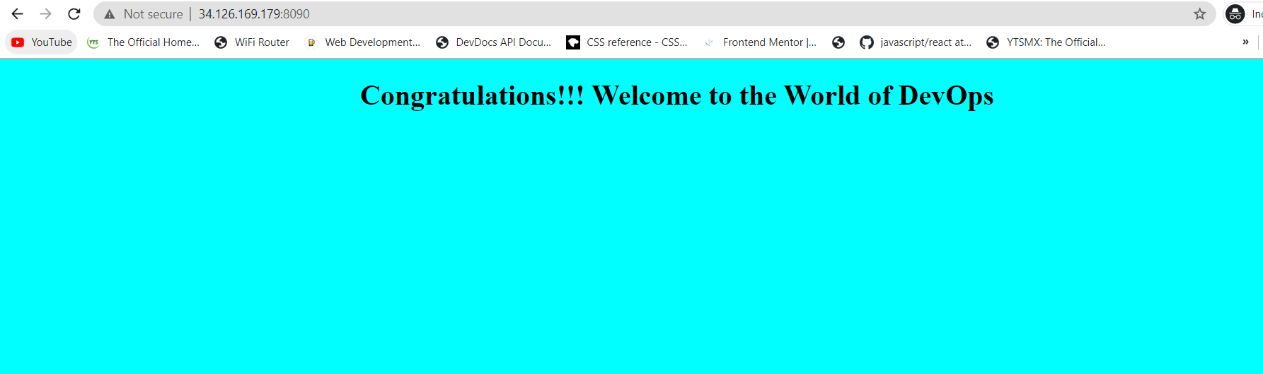

**Part2: Docker Compose**

1. **Install Docker compose**



1. **Write docker compose yaml to run the application that we have created above using its image,with a mysql database container together:**

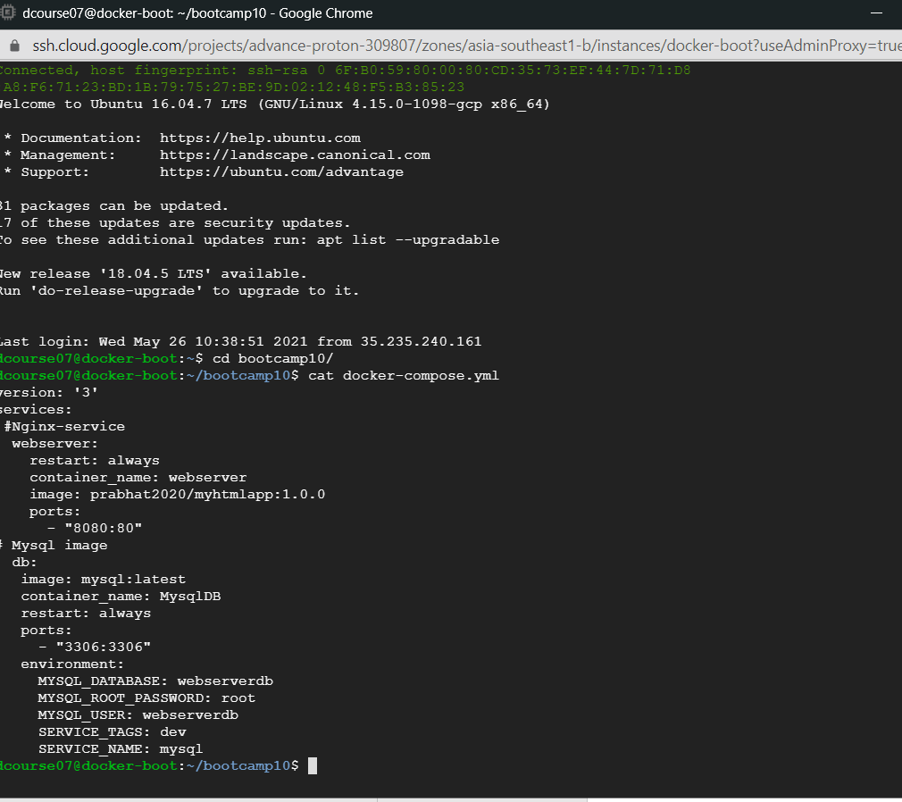

1. **Run the docker compose**

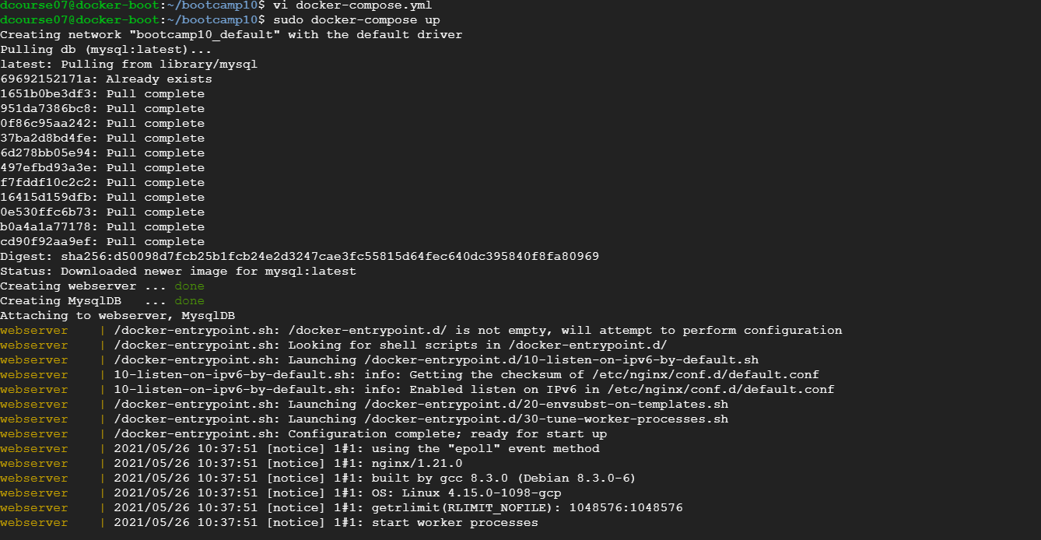

1. **See if the images are running(mywebserver and sql)**

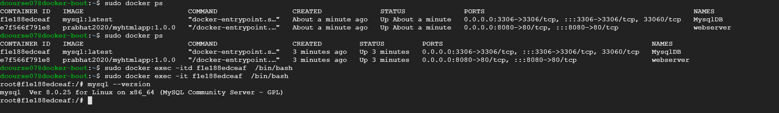

1. **Webserver running in nginx**

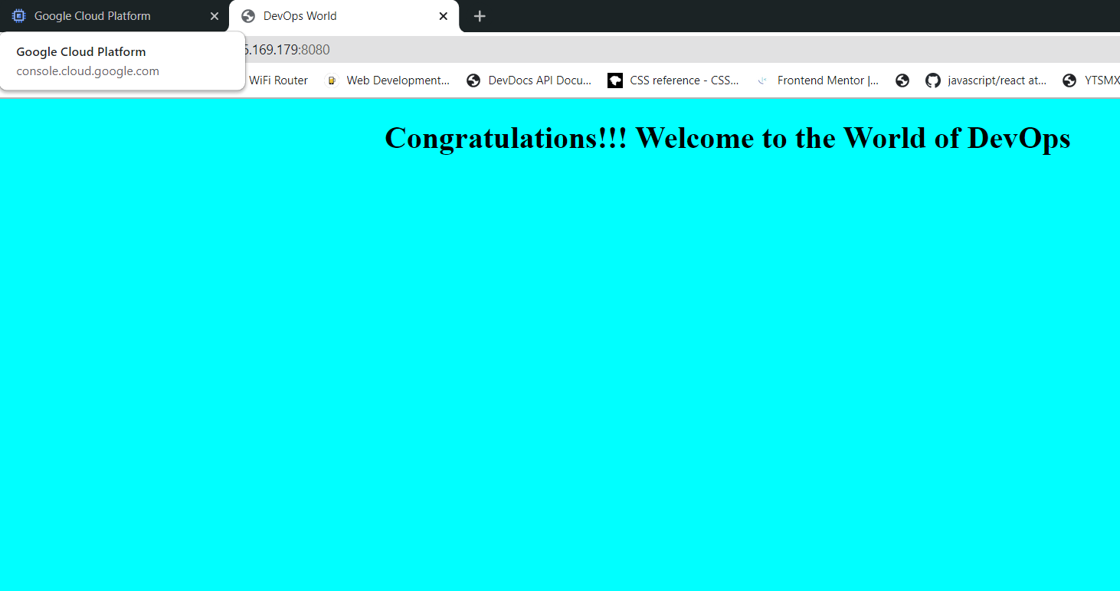

1. **Login to Mysql and see the databases**

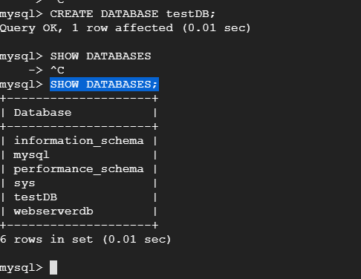

1. **Create a table test having id ,name,and age as attributes**

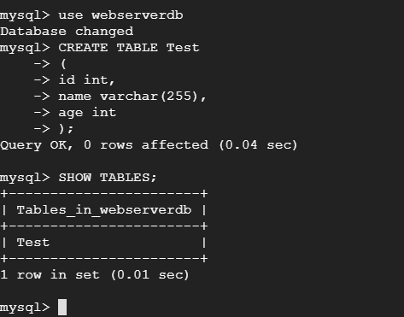

1. **Insert and select in mysql**

