1. Create two nodes,one is the the master and another one is salve

Created two VM instances in GCP

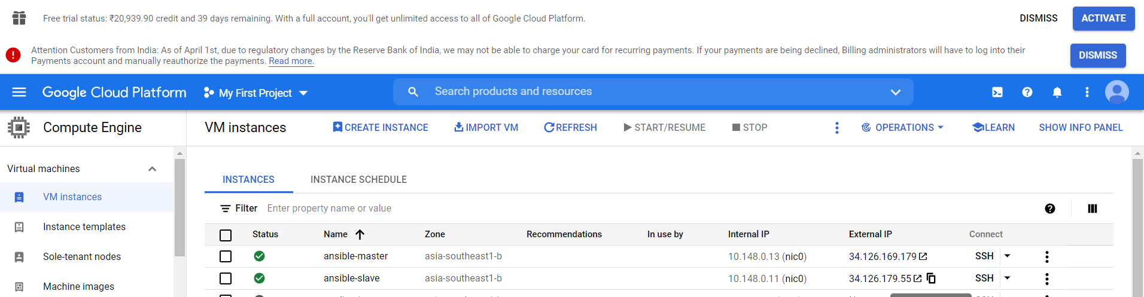

1. Configure the master node to enable password less authentication
2. In slave go to root and update sshd_config

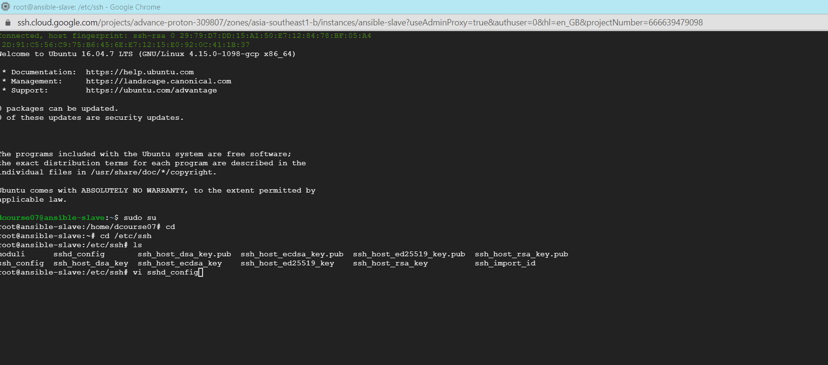

1. Change password authentication ad rootlogin to yes

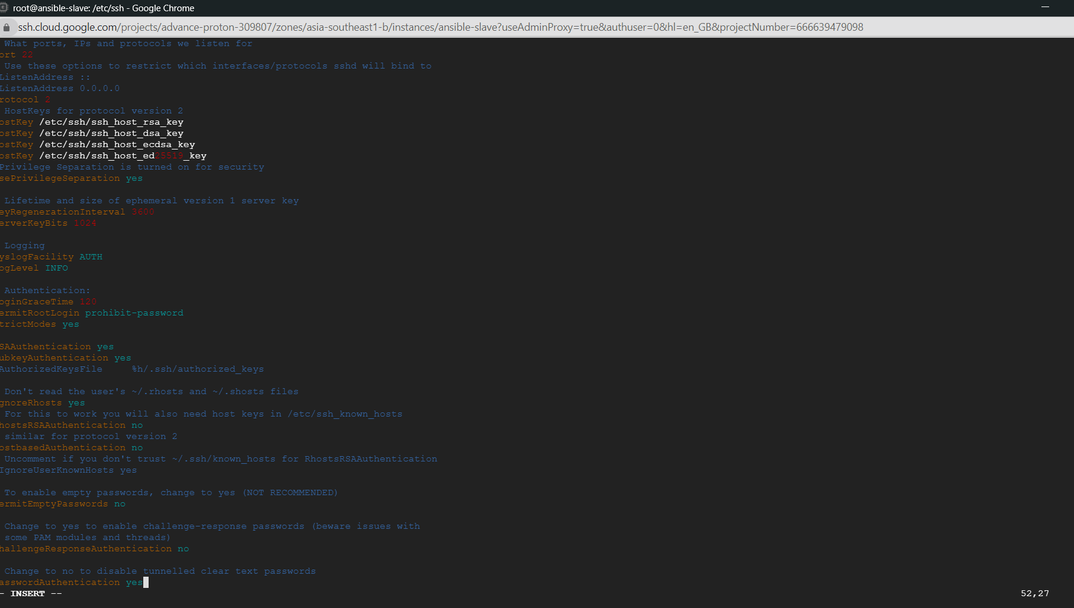

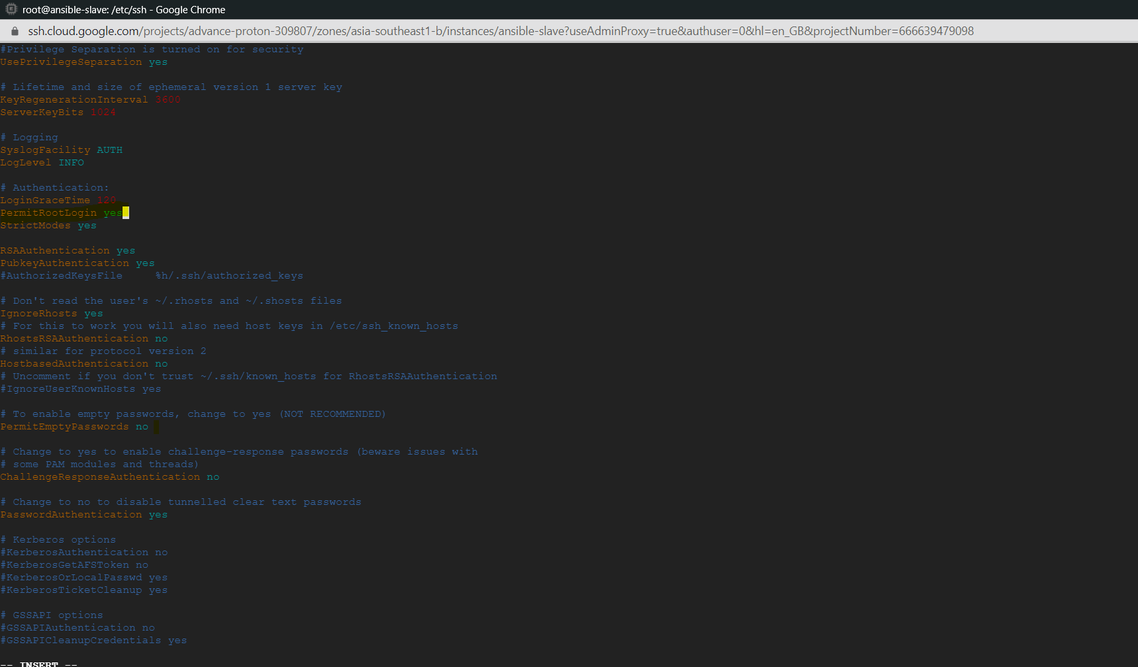

1. Restart sshd and set a password to be used from master to connect to slave

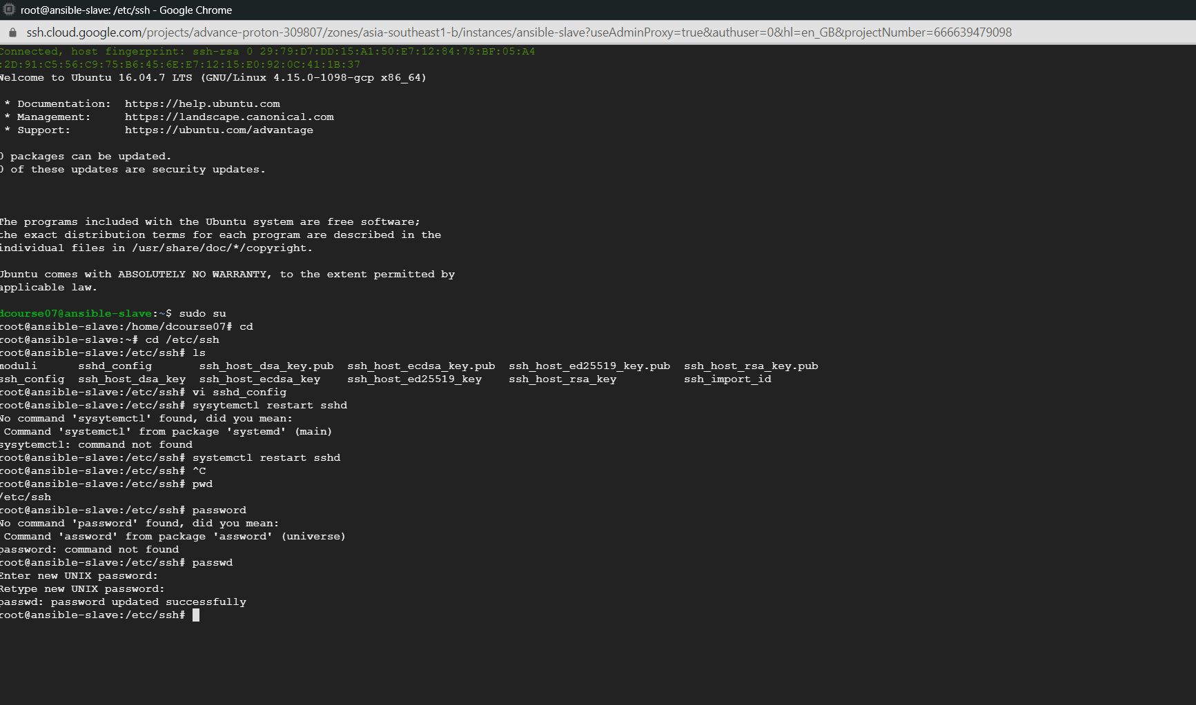

1. In master generate ssh-key and copy the id of slave node

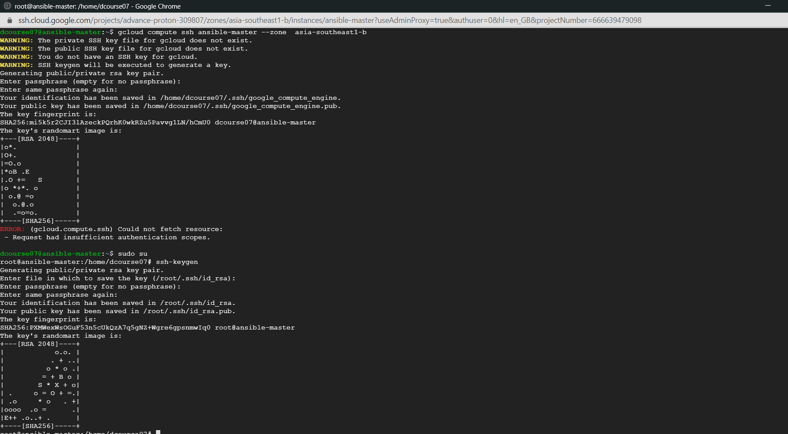

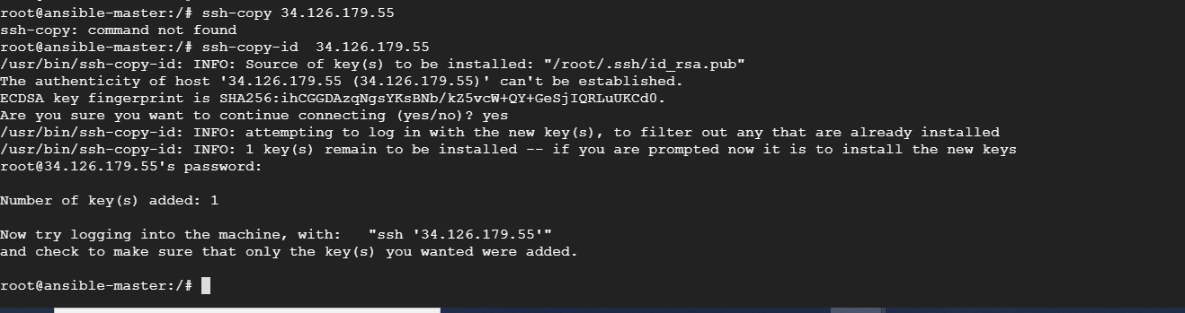

1. Able to login in slave from master with ssh

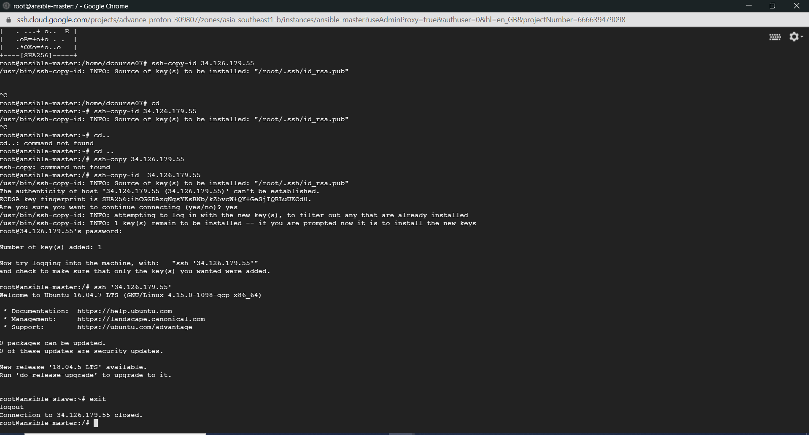

1. Install ansible in master and check ansible version

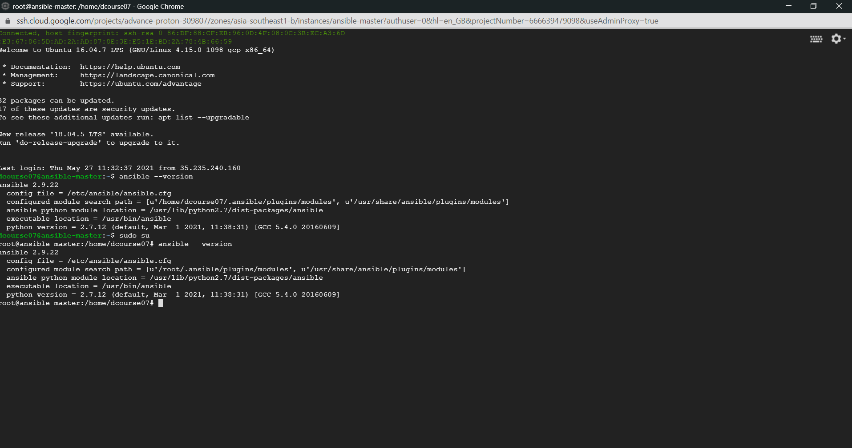

To verify if we can Ping to slave from master and see if ping is successful

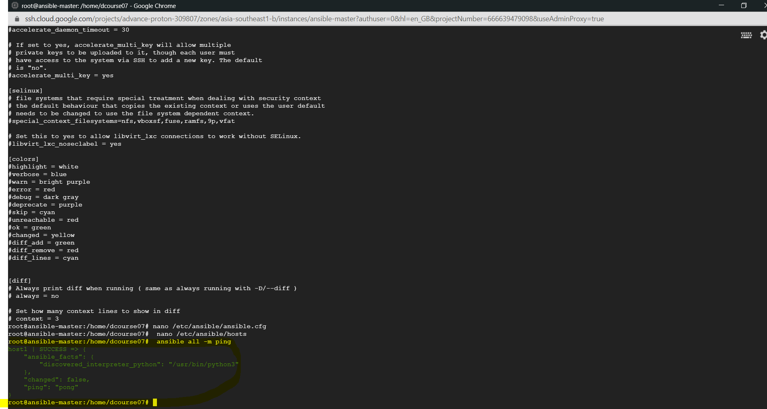

1. Playbook to install java,maven,nginx ,docker and in the slave node

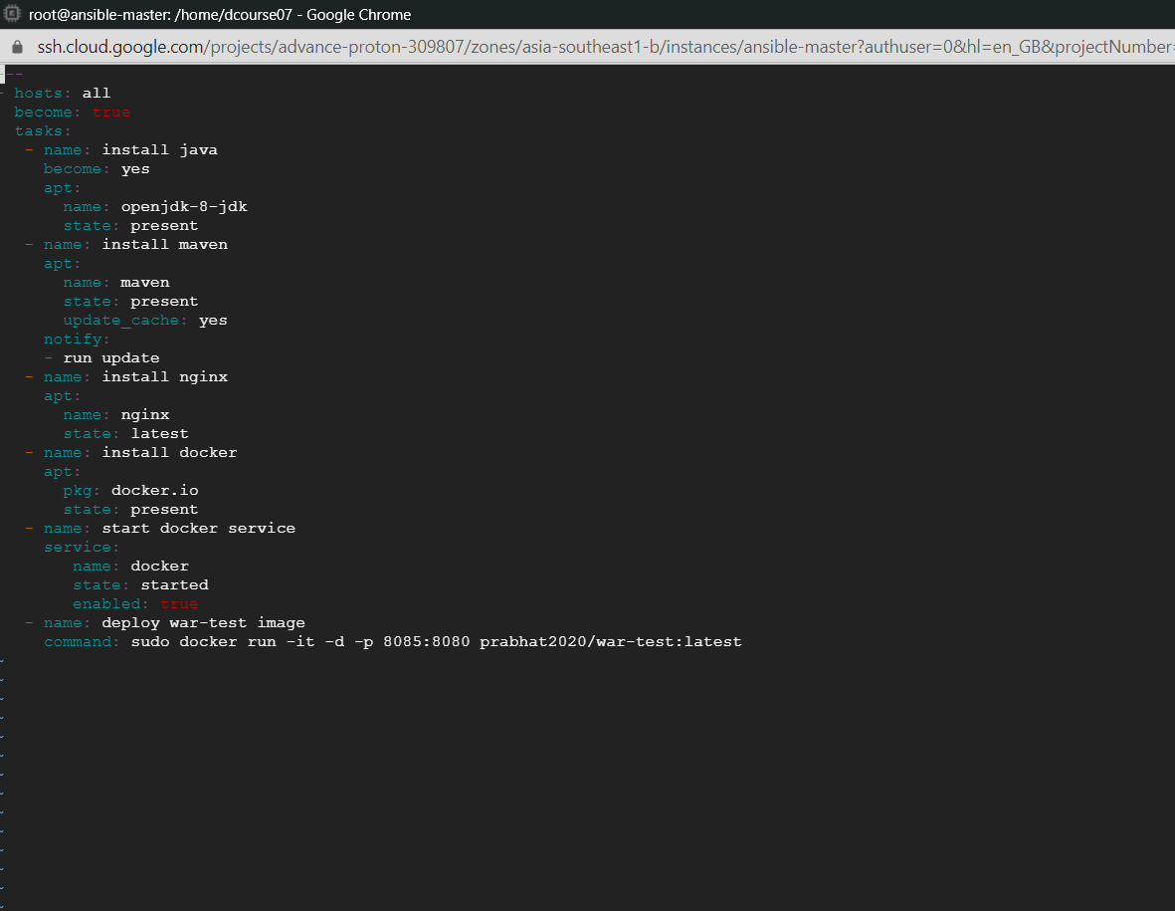

1. Run playbook and see if it is working

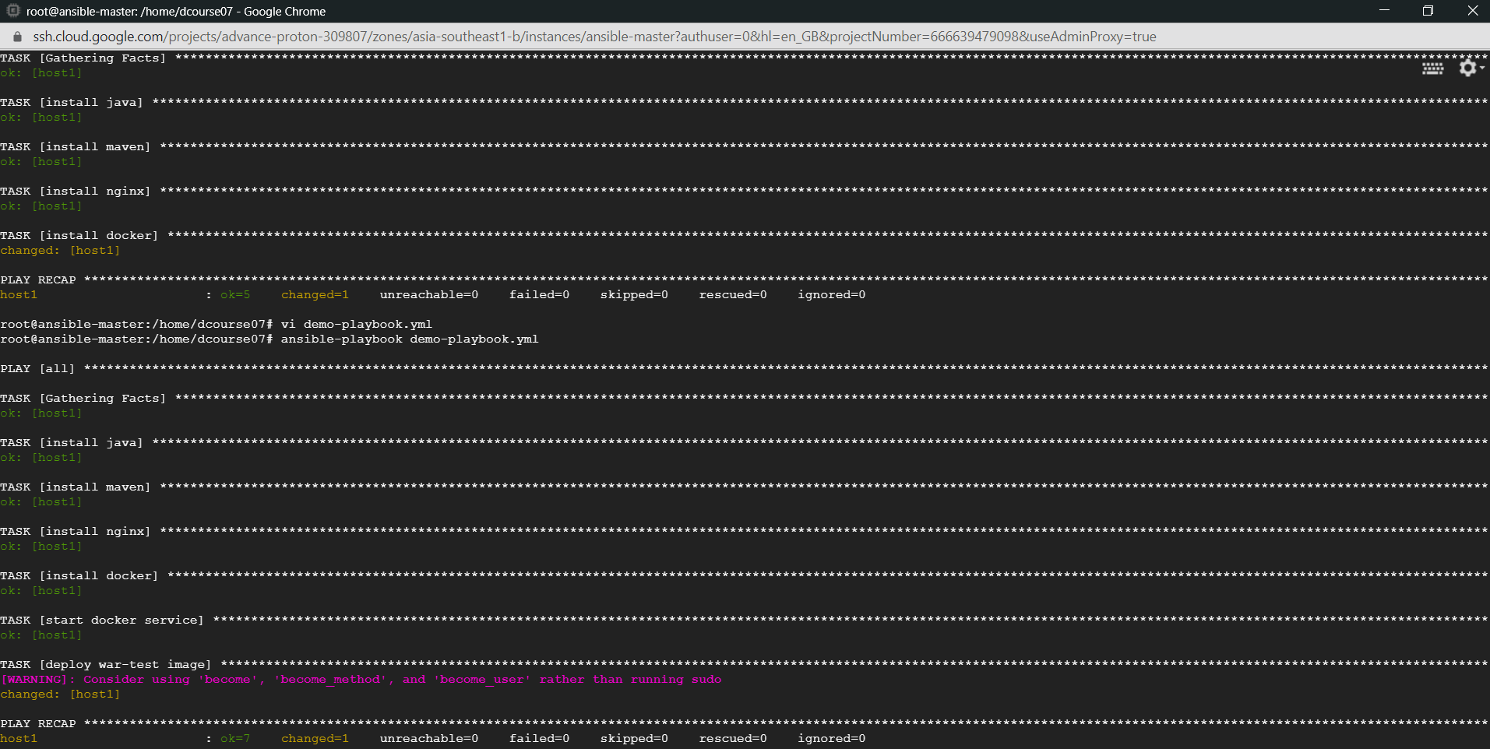

1. Check if everything is running in slave node

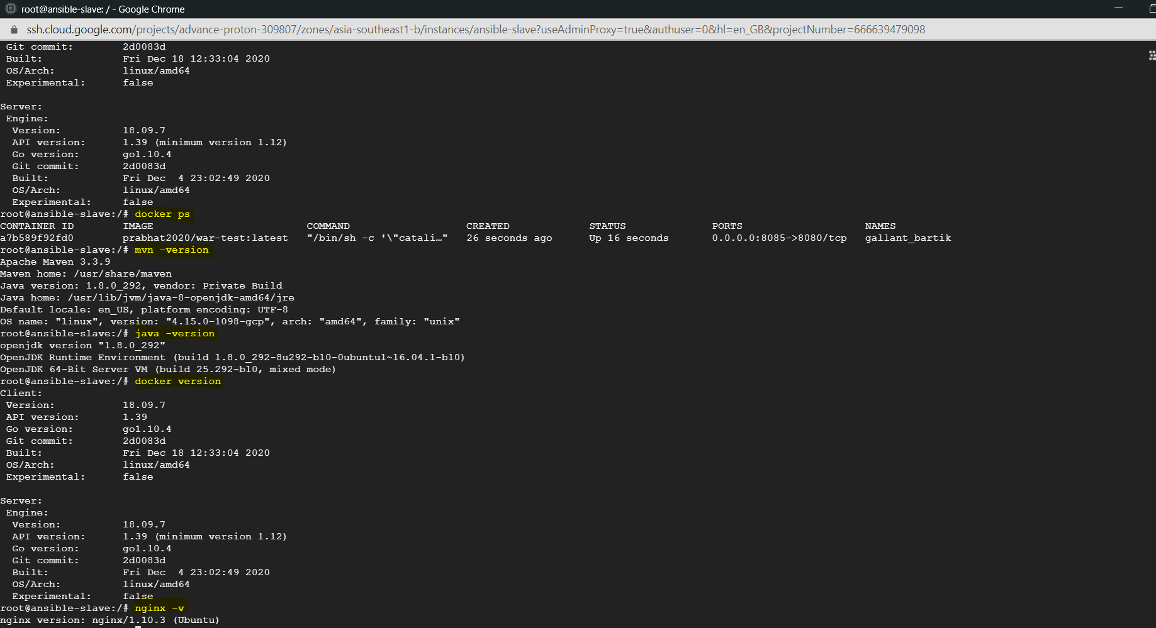

1. Nginx and war-test application running from slave in web

