1. **Create Local repository and add 3 files in it.**
2. **Add them in staging area and commit to local repository**

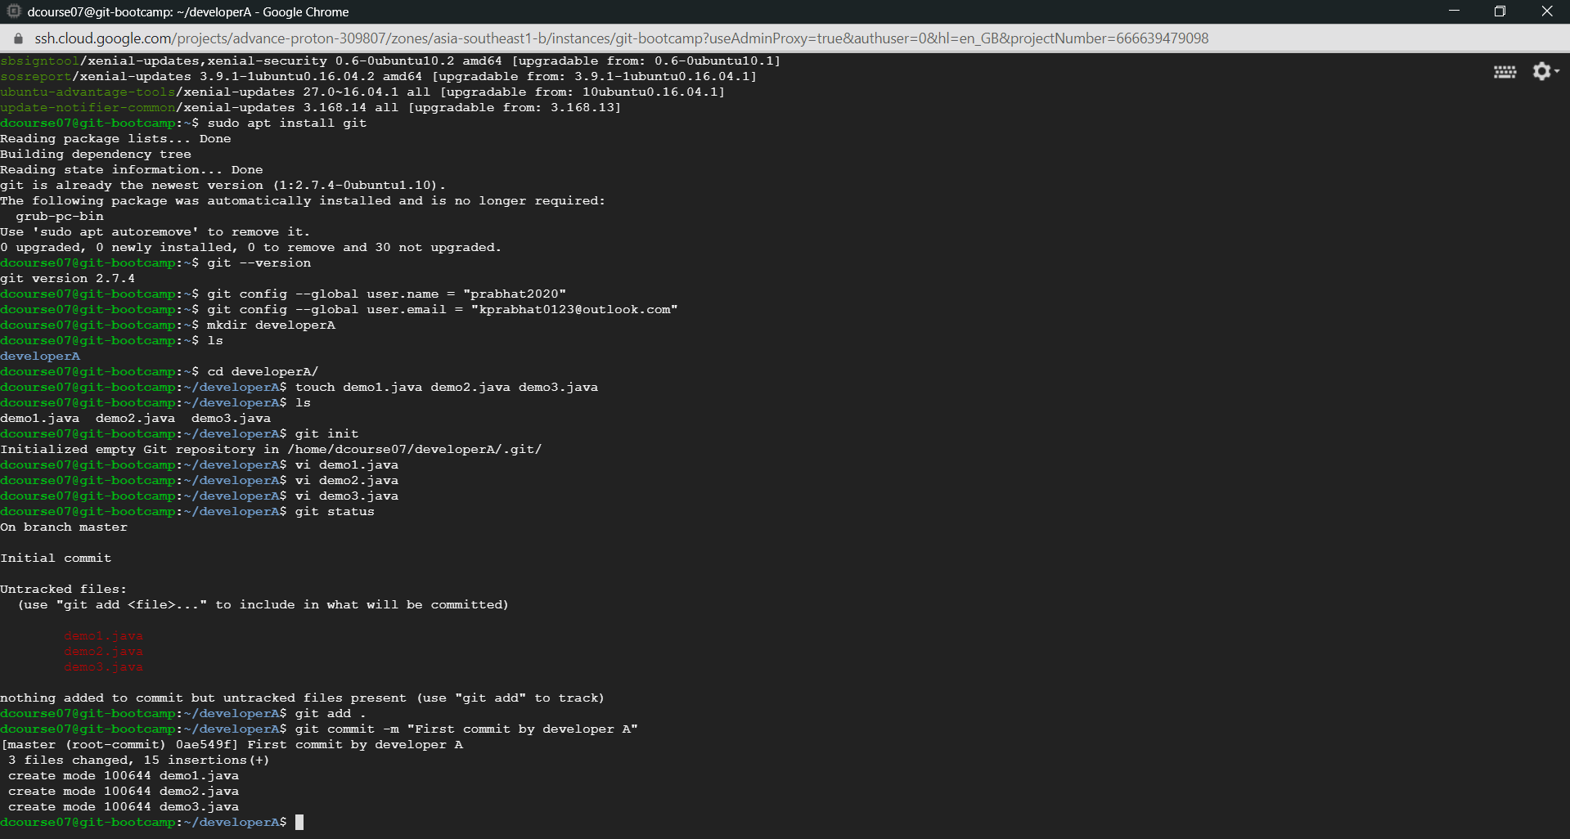

1. **Create a Remote Repository**

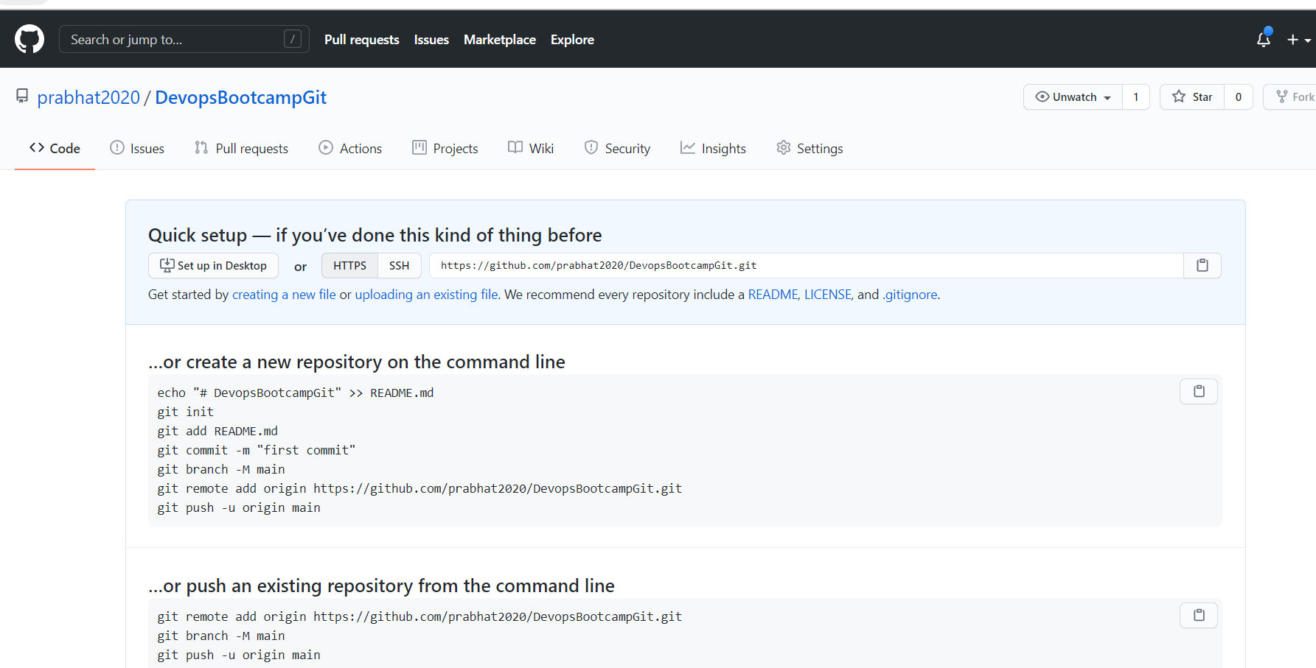

1. **Add the remote repository to the local repository and push the changes from local to remote repository.**

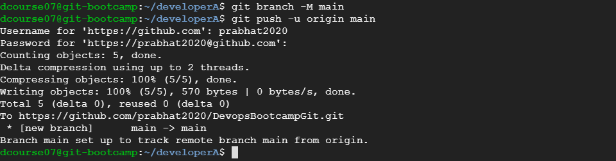

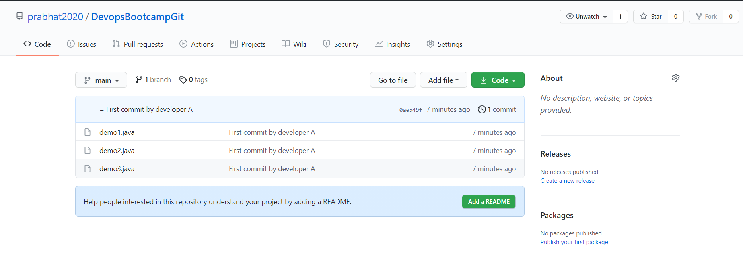

1. **Clone the repository to another folder developer**

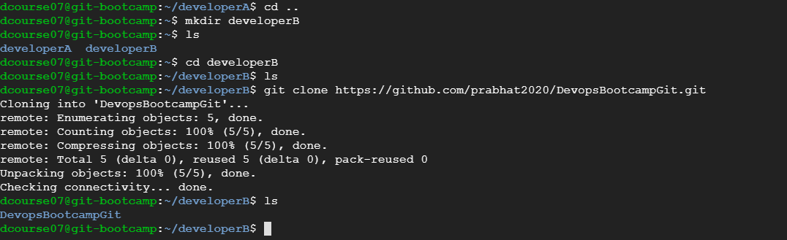

1. **Make and commit changes via developer**

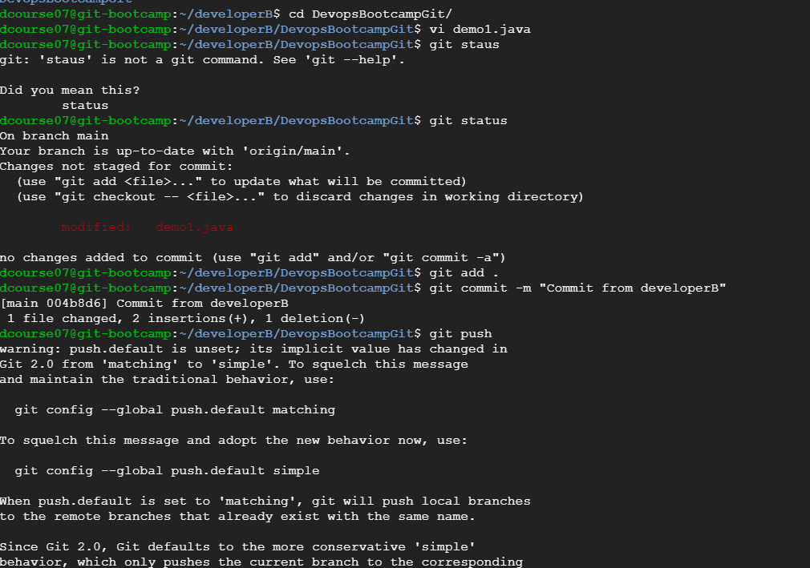

1. **Synchronize the changes in developerA repo**

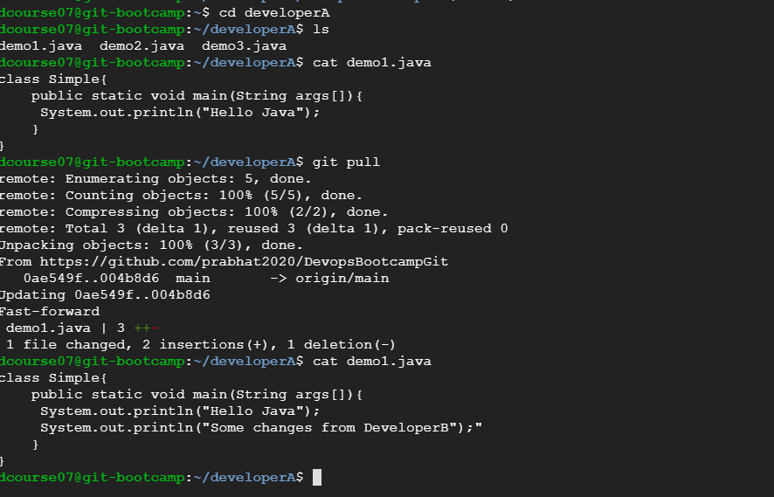

1. **Create a new branch for a new feature and change the files**

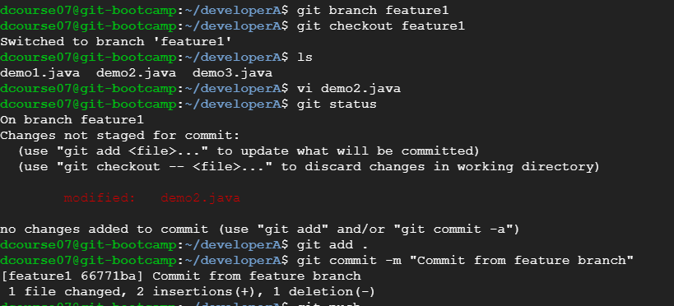

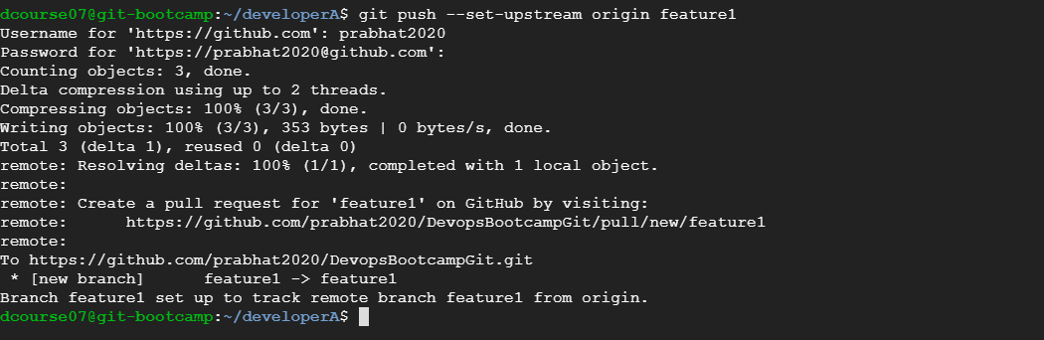

1. **Merge back the created branch with master**

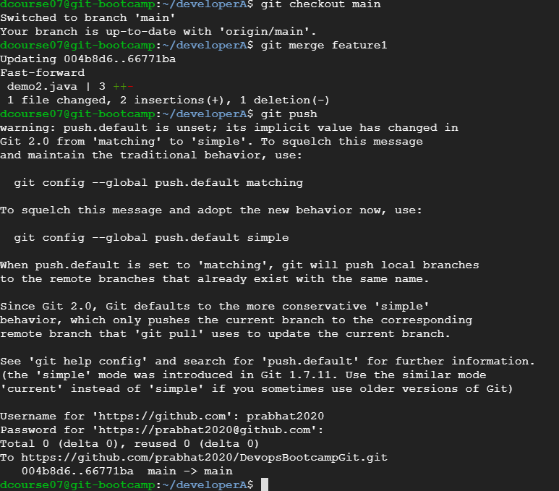

1. **Delete the feature branch after merging**

