**Git :**

1. Create two separate branches from master

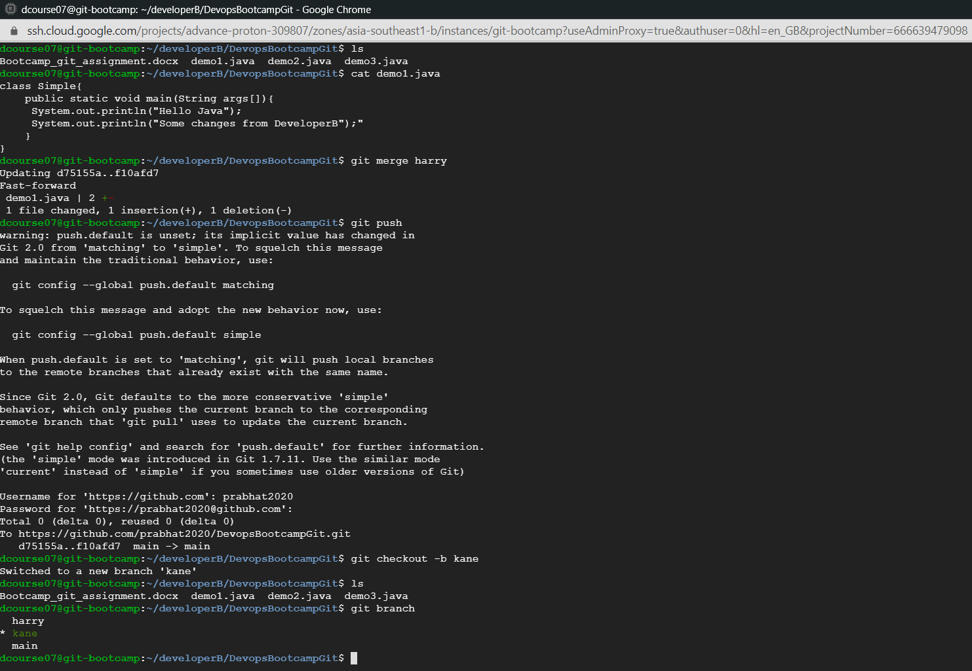

1. Make changes in the same function of the source code in both the branches
2. Changes made from branch harry

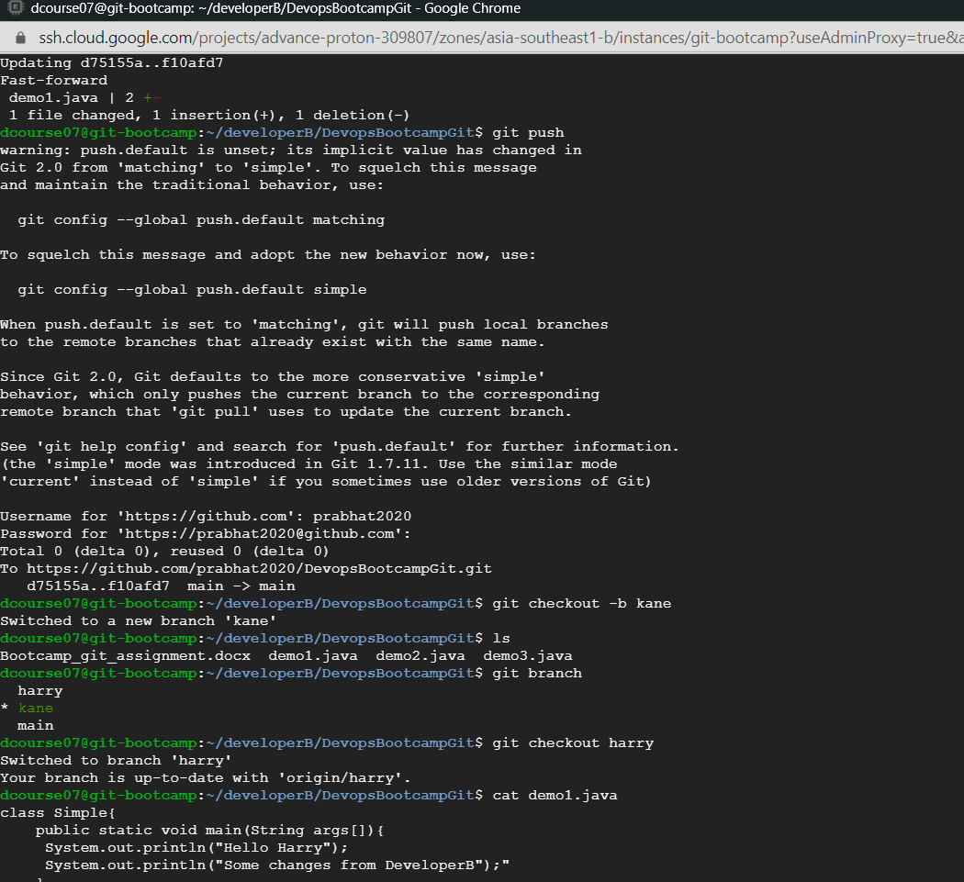

b. Changes made from branch kane

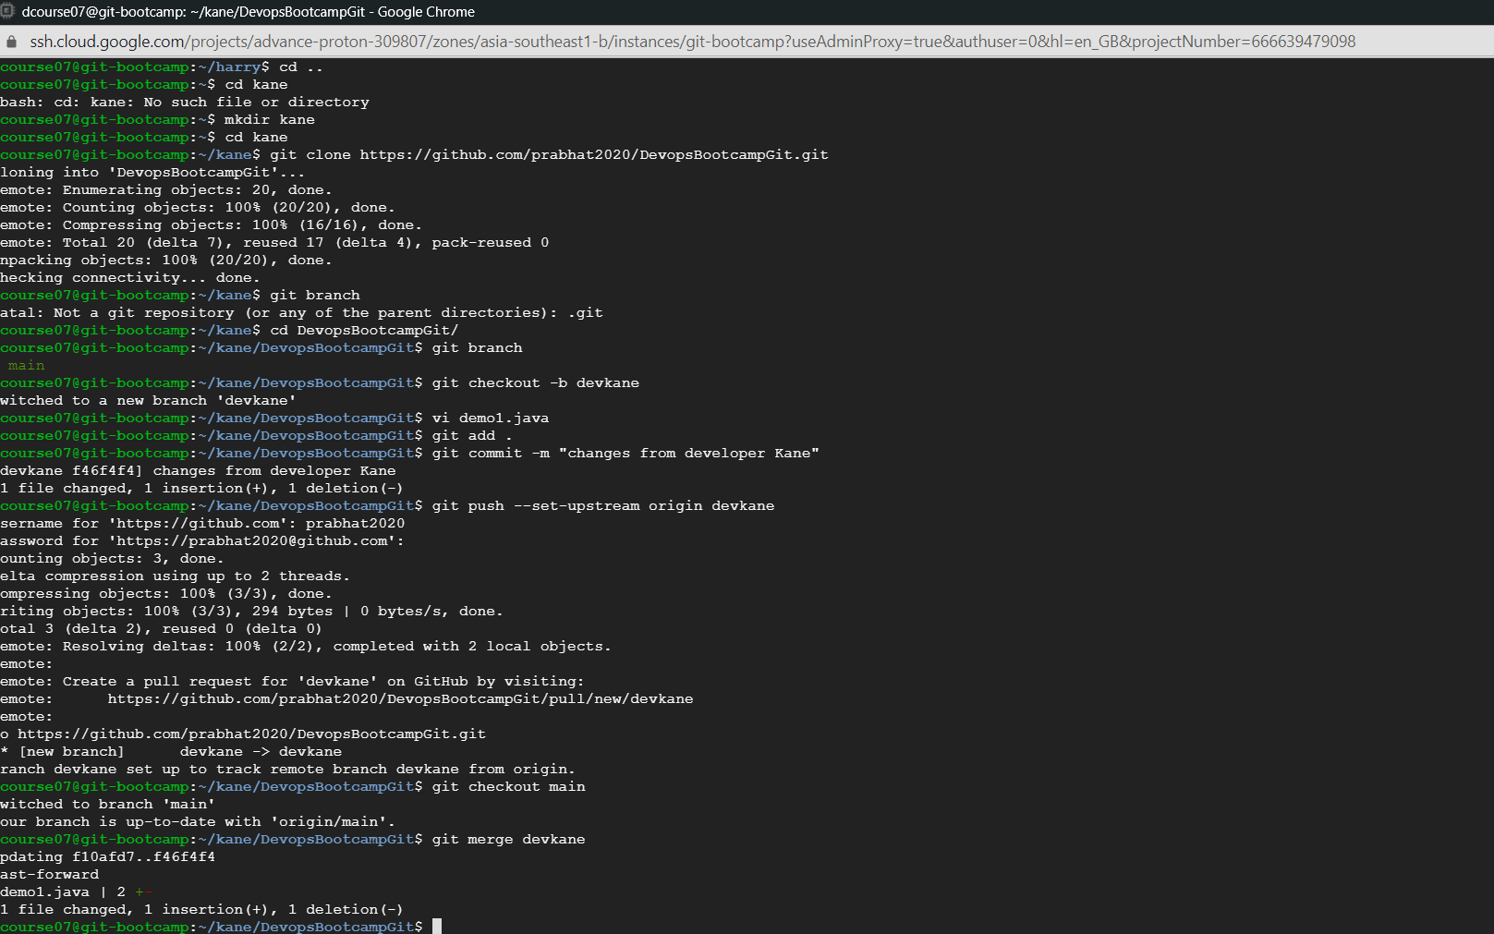

1. **Try and merge that should throw conflict**

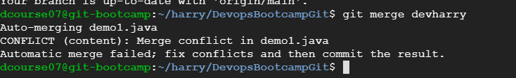

1. **Git merge tool**

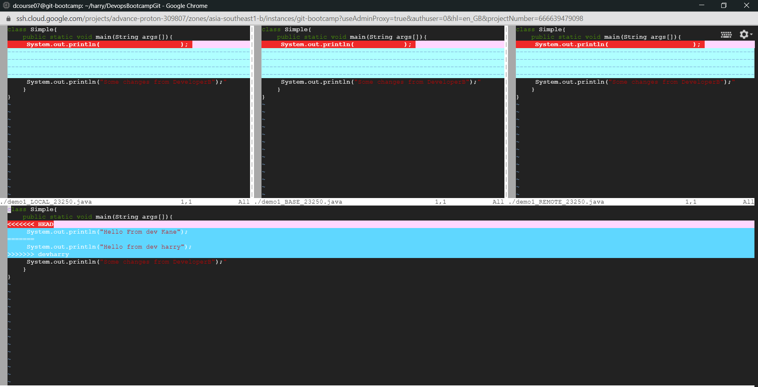

1. **Resolve the commit**

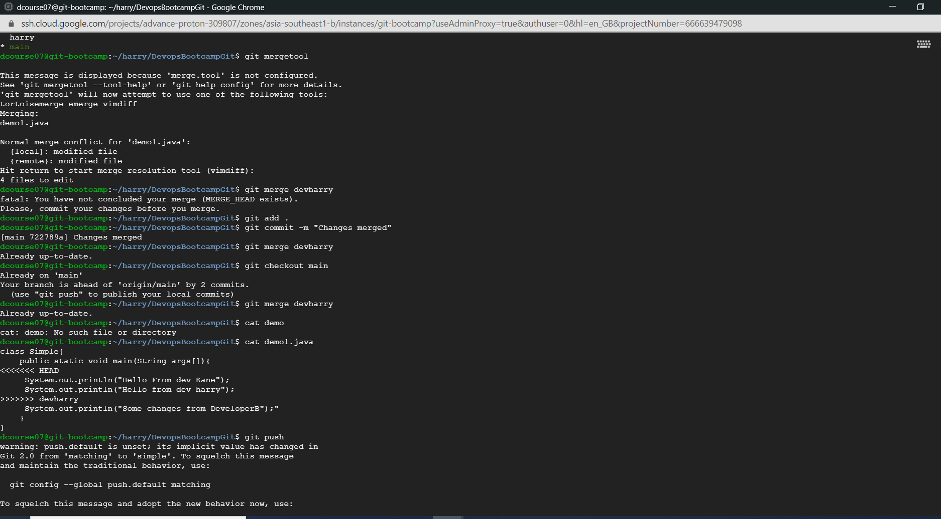

**Jenkins:**

1. Create multiple freestyle project in Jenkins to checkout, build, test, package and deploy the web application in a tomcat9 server
2. Installation of git ,maven,Jenkins,tomcat

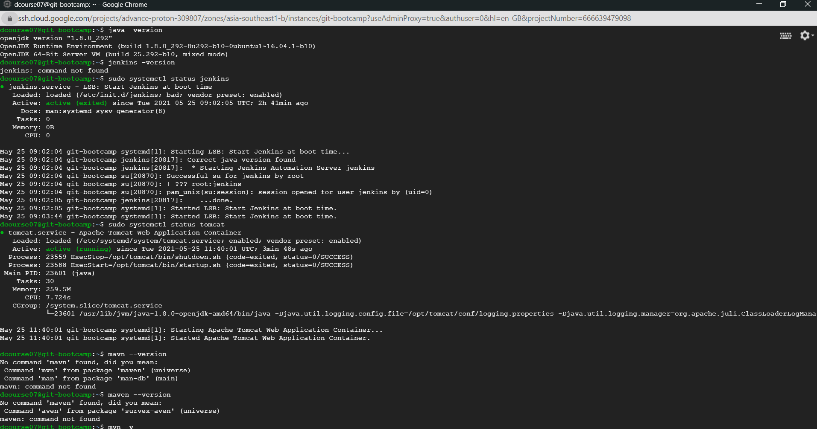

1. Installation of maven in Jenkins tool

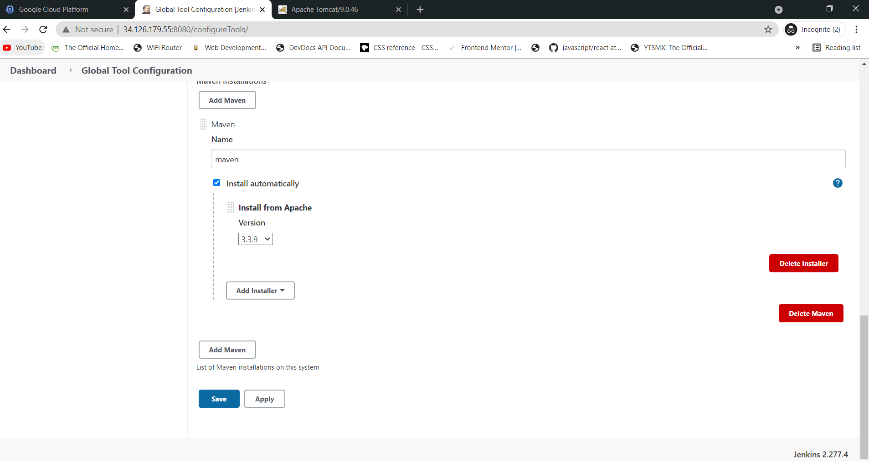

1. Checkout Job in Jenkins with git:

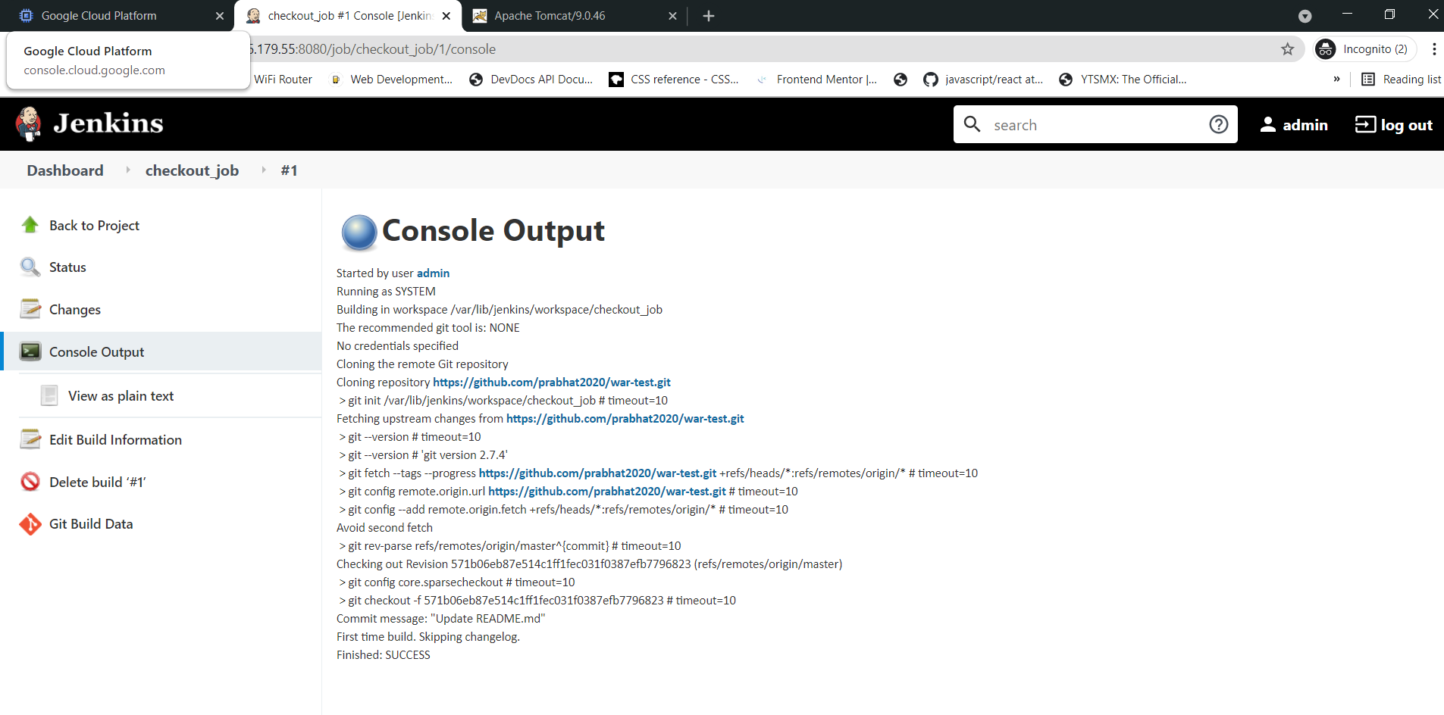

1. Build job – to build and deploy to tomcat

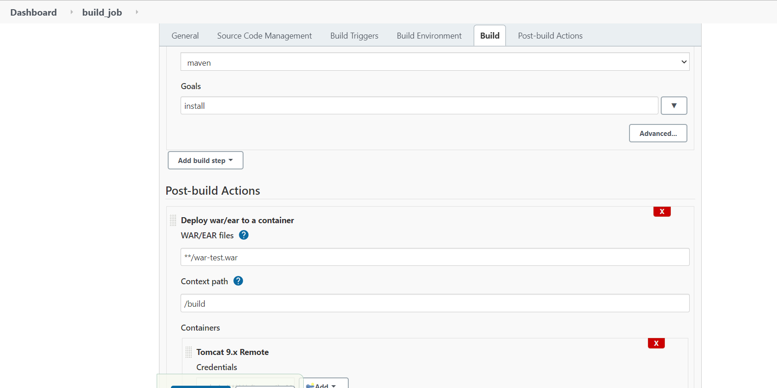

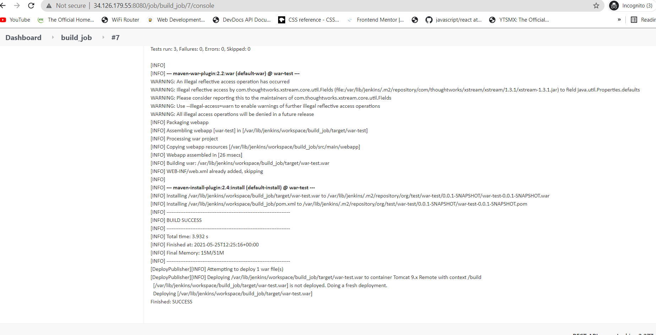

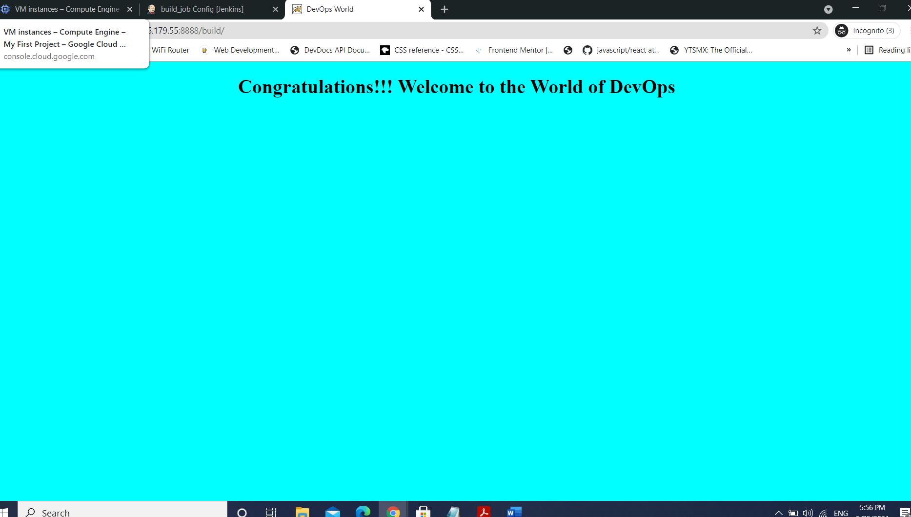

1. Test_job – to test the code

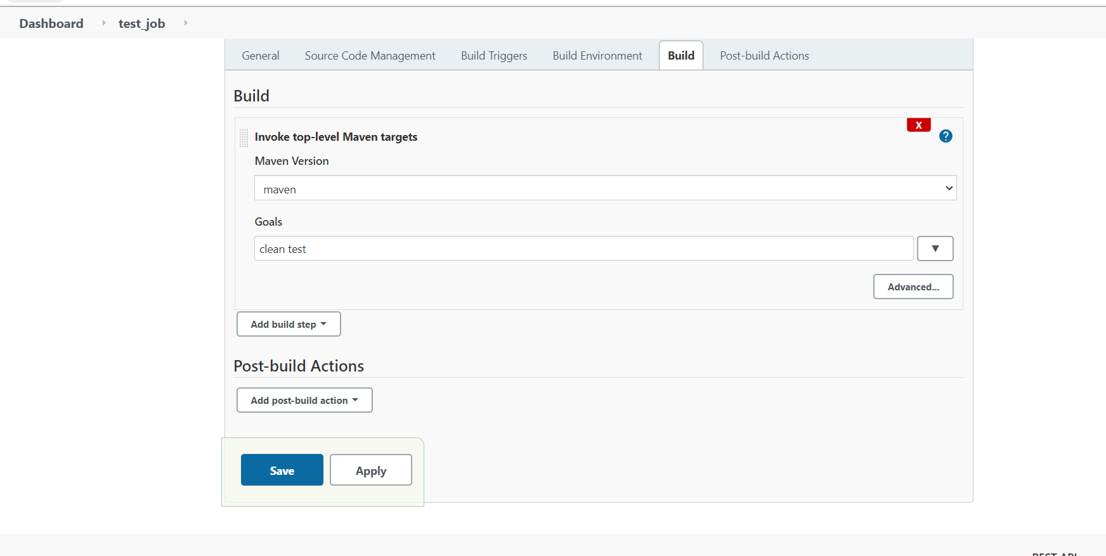

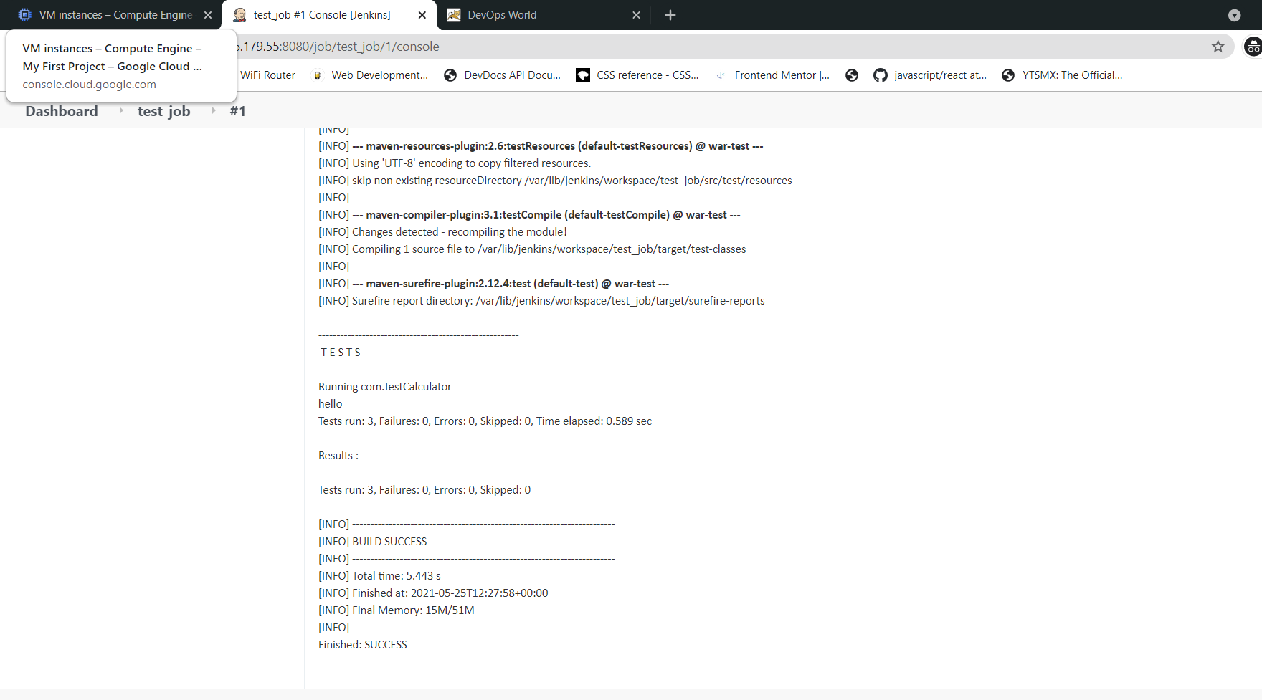

1. Package_job – will do mvn package and deploy to tomcat

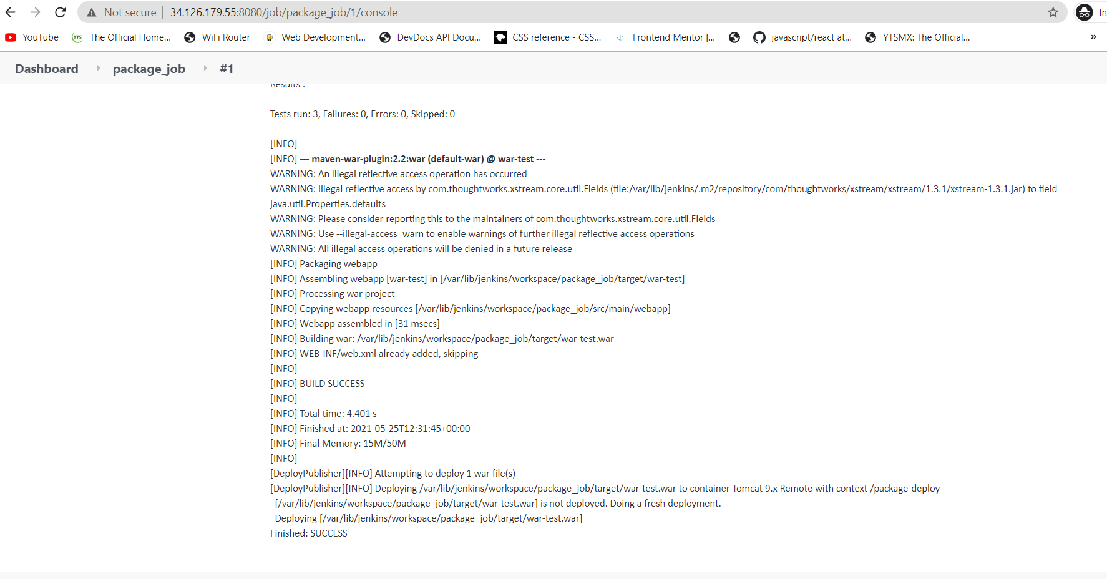

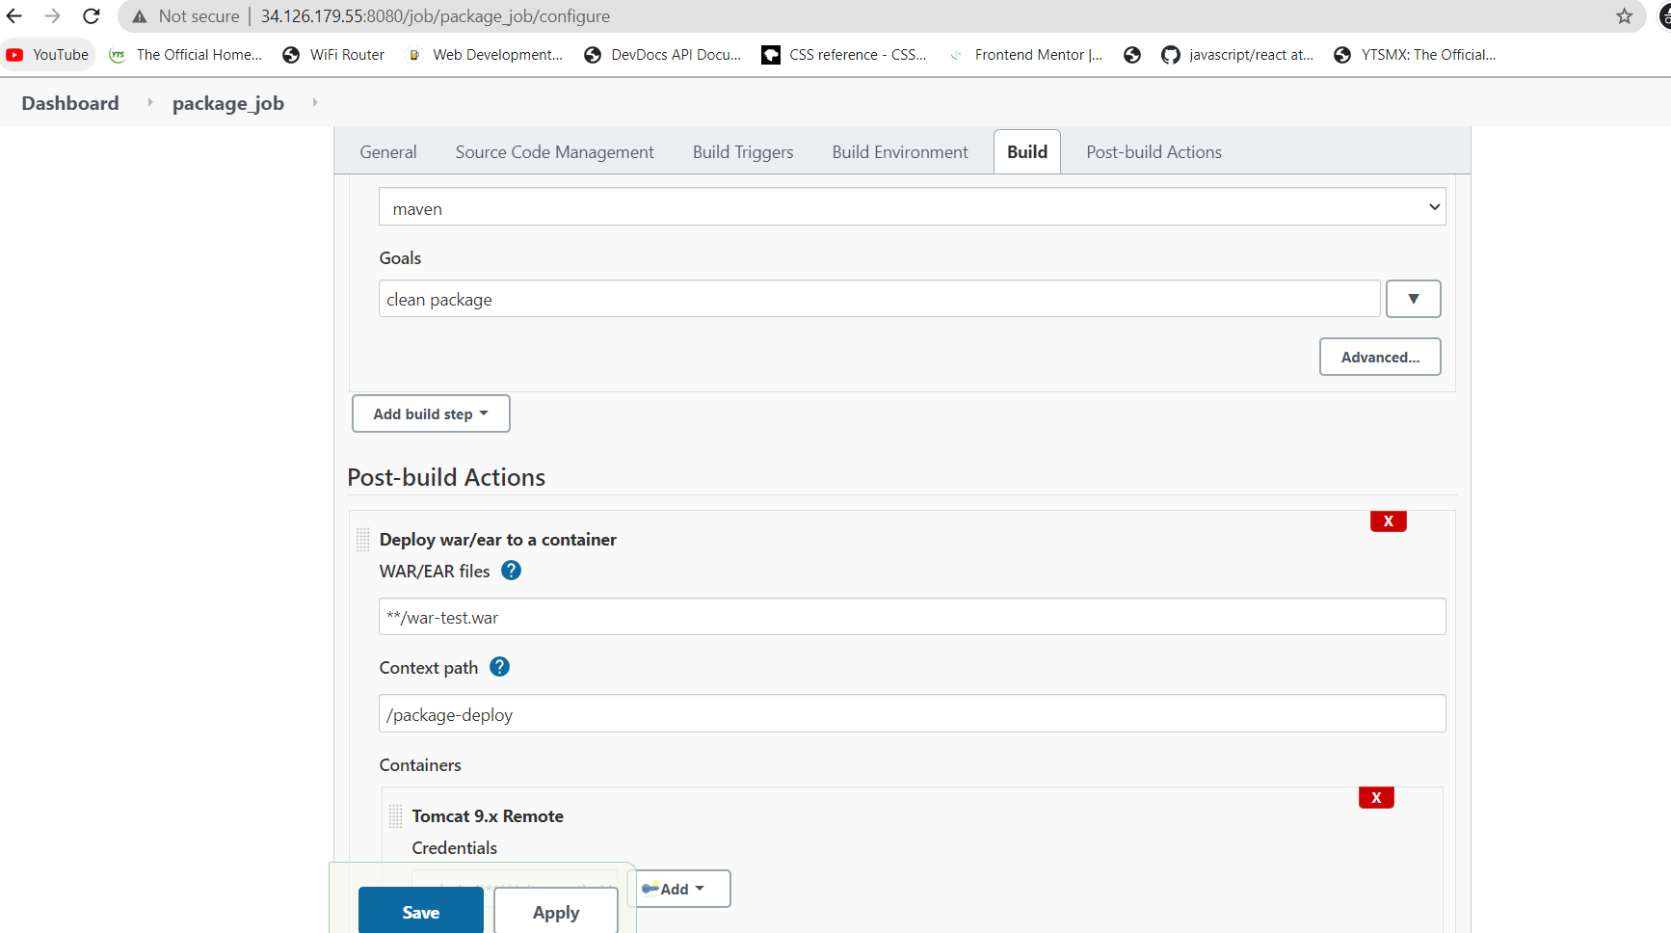

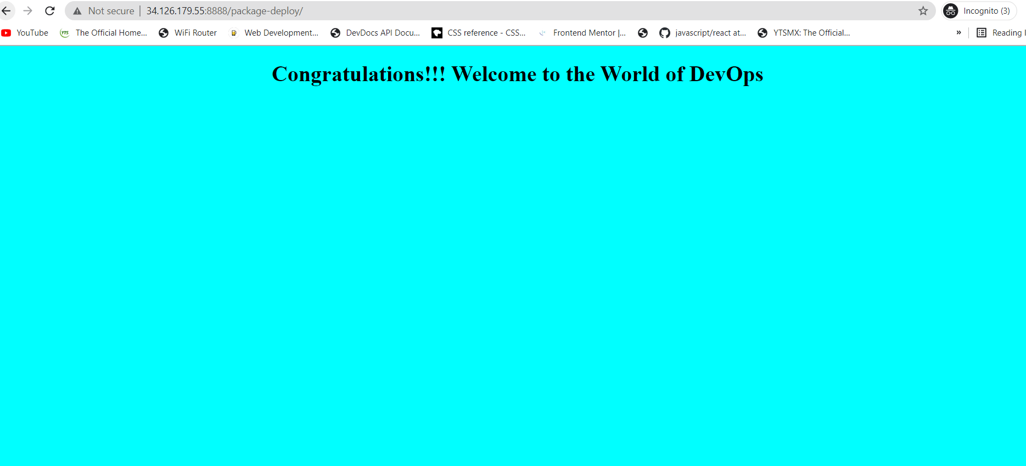

1. Create a pipeline job and write the script to achieve the same tasks. Pipeline must be triggered with a GitHub webhook upon every commit.
2. Add webhook in github

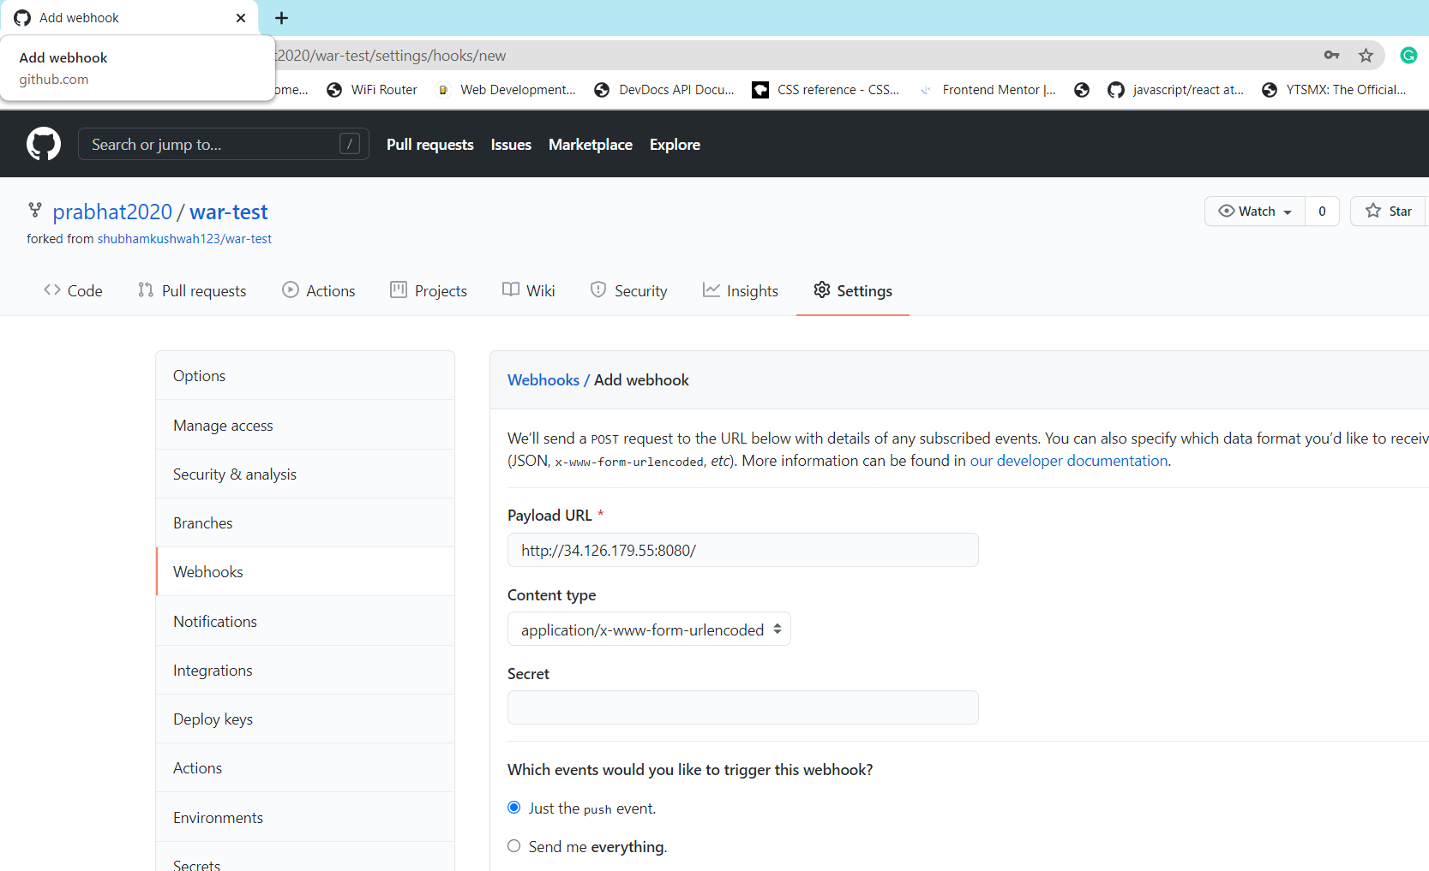

1. Pipeline script

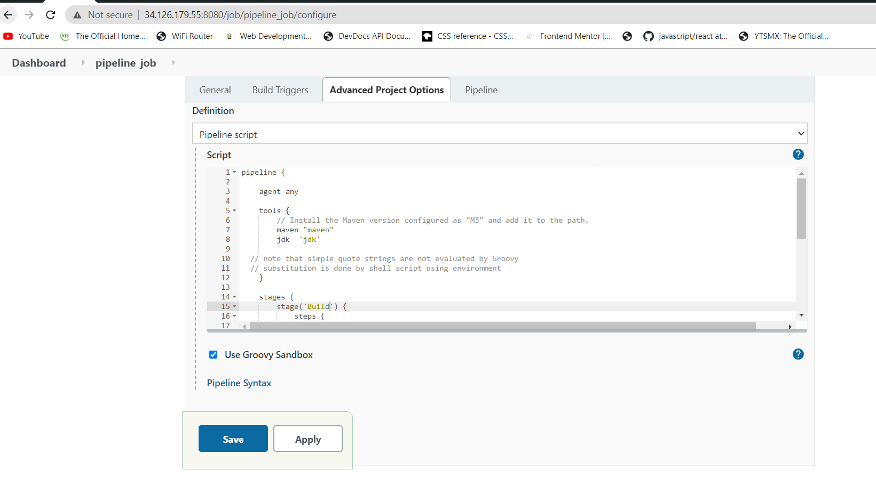

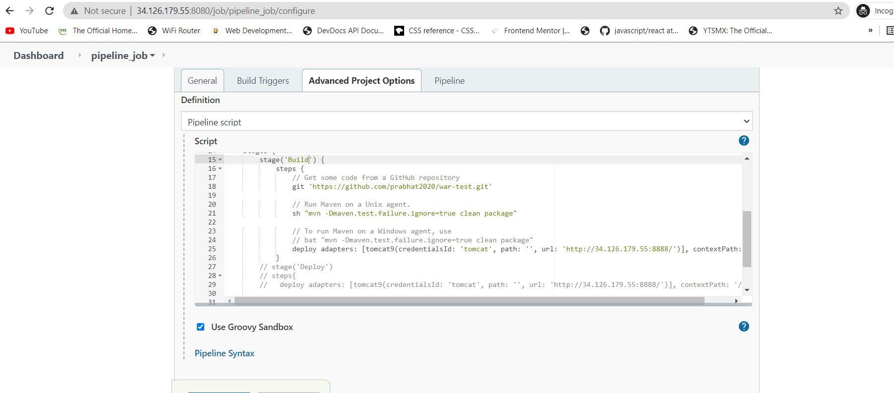

1. Github commit started the job

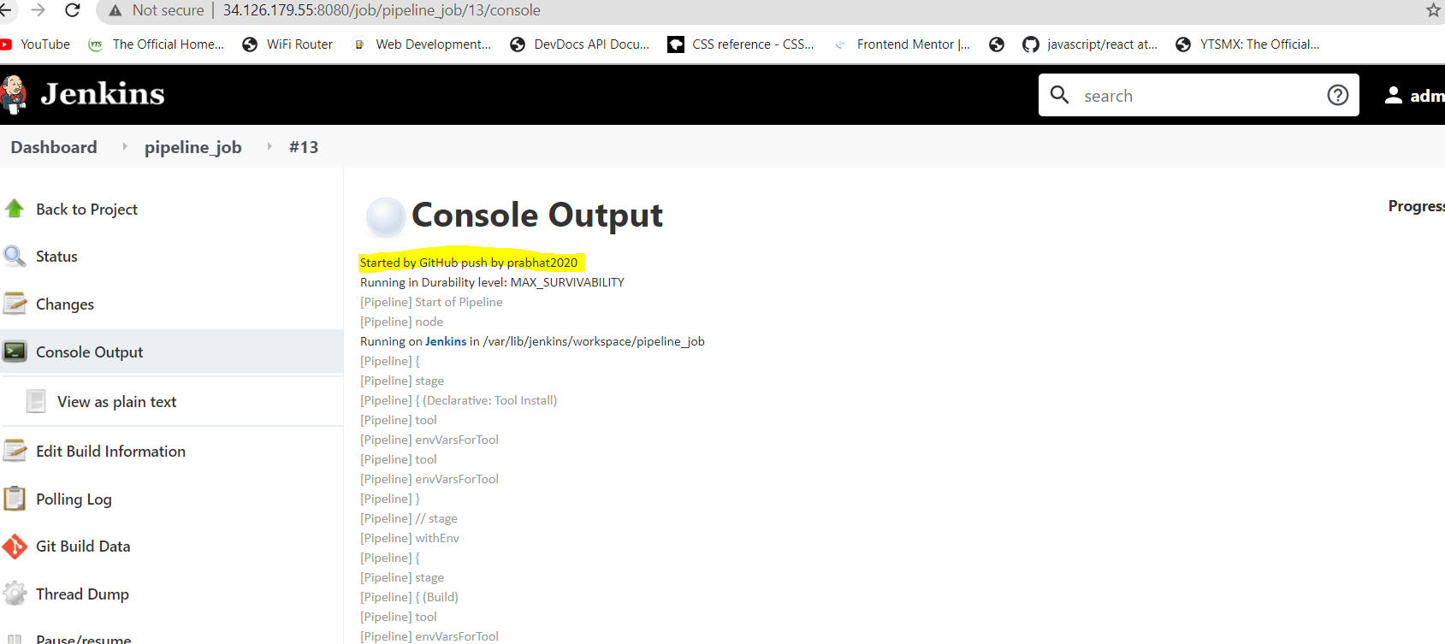

1. Build got success

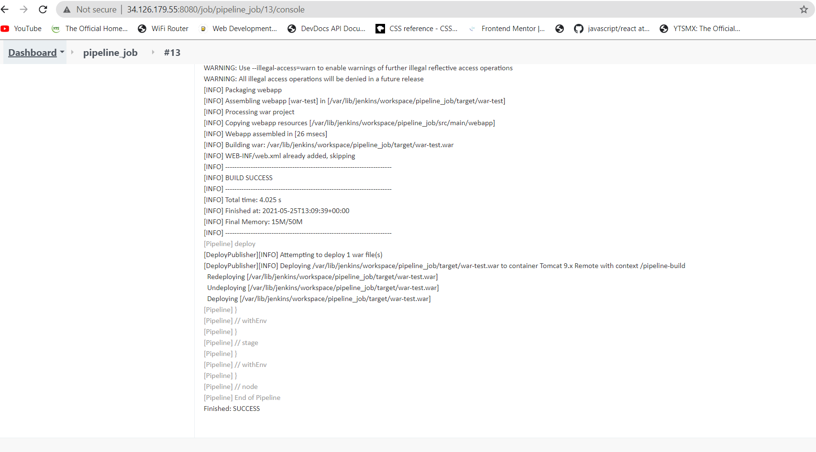

1. Deployed in tomcat

