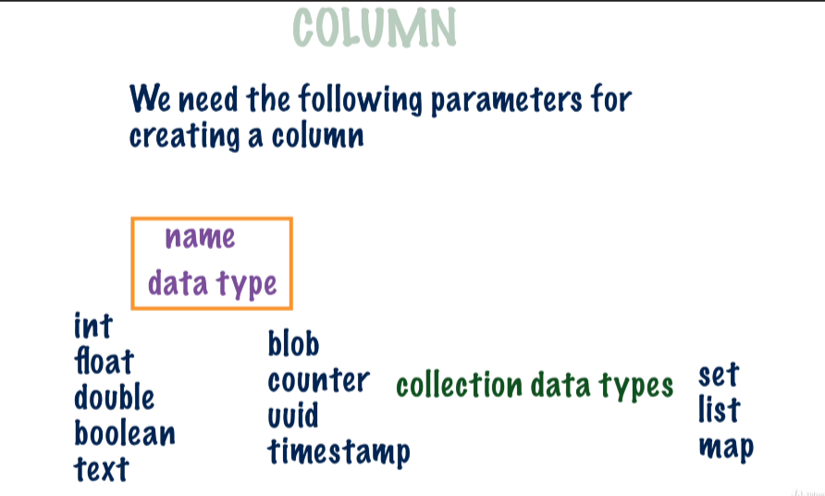

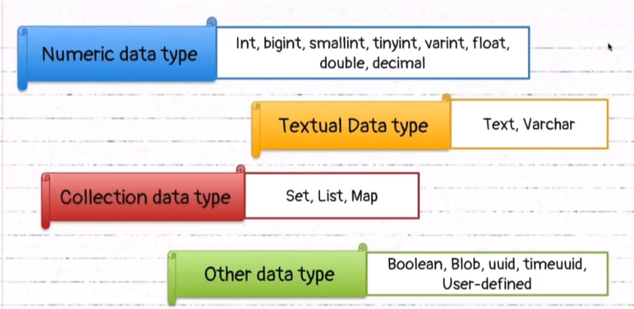

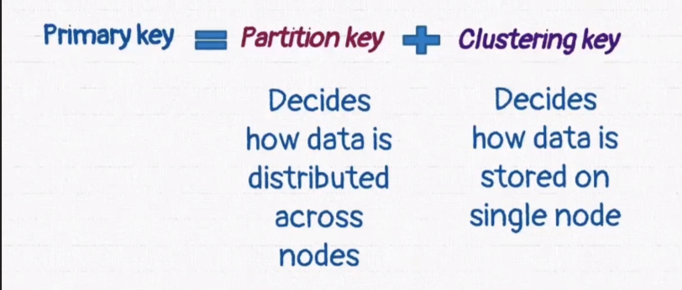



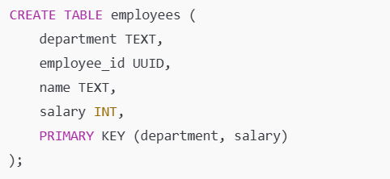

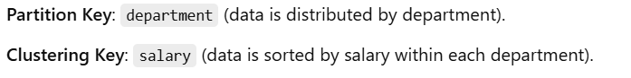



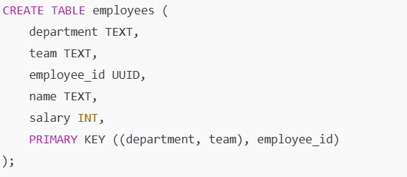



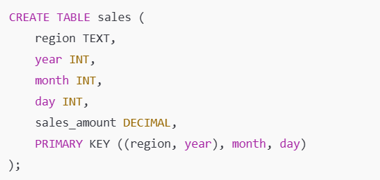

Data is automatically sorted by clustering keys, so additional ORDER BY clauses are not needed unless reversing the order:

SELECT * FROM sales WHERE region = 'North' AND year = 2024 ORDER BY month DESC

**Using TTL:-**

**TTL (Time to Live) in Databases**

TTL (Time to Live) is a feature in databases, especially in NoSQL systems like Cassandra, Redis, and MongoDB, which allows you to set an expiration time for data. Once the TTL expires, the data is automatically deleted from the database.

**INSERT INTO users (id, name, email) VALUES (1, 'John Doe', 'john.doe@example.com') USING TTL 300;**

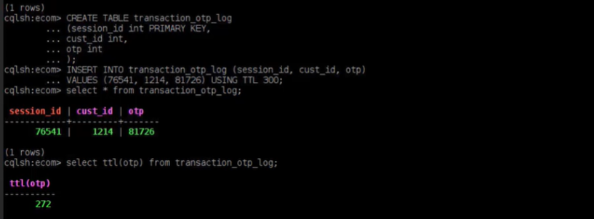

Support for the collection(SET,LIST,MAP)

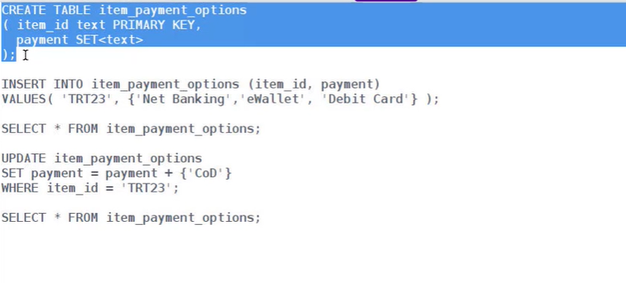

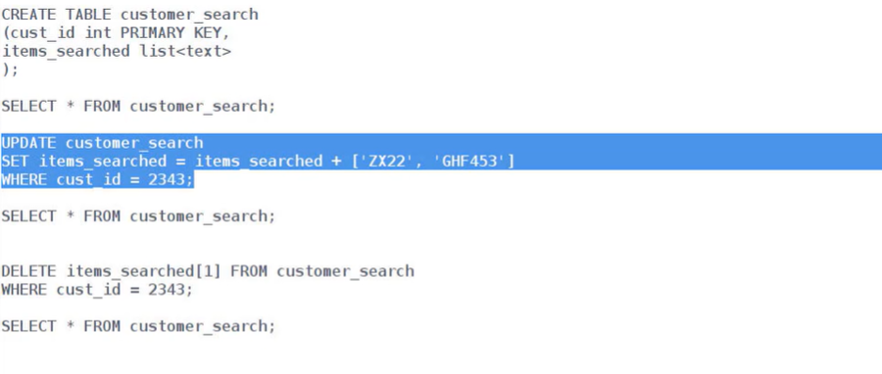

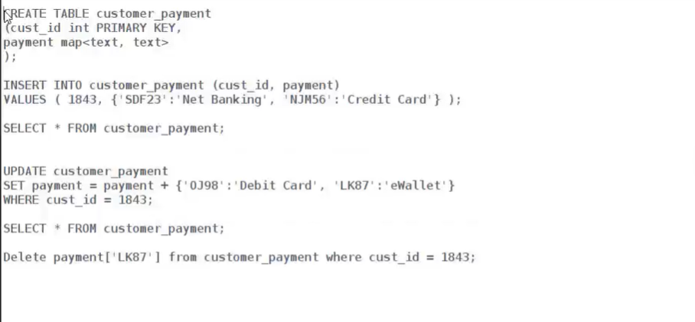

Indexes:-

CREATE TABLE employees ( id INT PRIMARY KEY, name TEXT, department TEXT, salary INT );

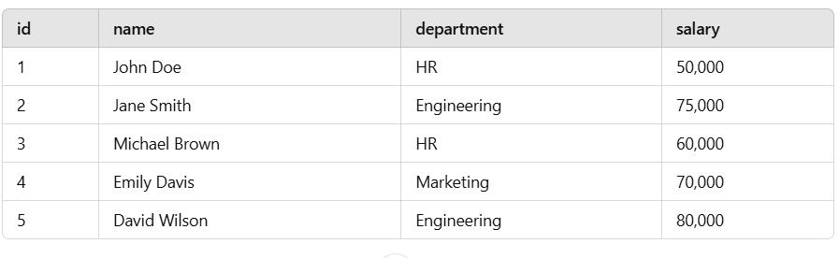

SELECT * FROM employees WHERE department = 'HR'; Error

Cassandra will not execute this query because department is not part of the primary key.

CREATE INDEX idx_department ON employees(department);

A secondary index creates a hidden table that maps column values (department) to the primary keys (id) of rows containing those values.

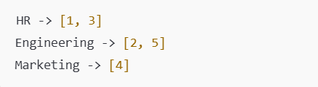

**Note:-when index is applied no need to use allow filtering**

In Cassandra, you cannot create a secondary index on collection columns (e.g., list, set, map)