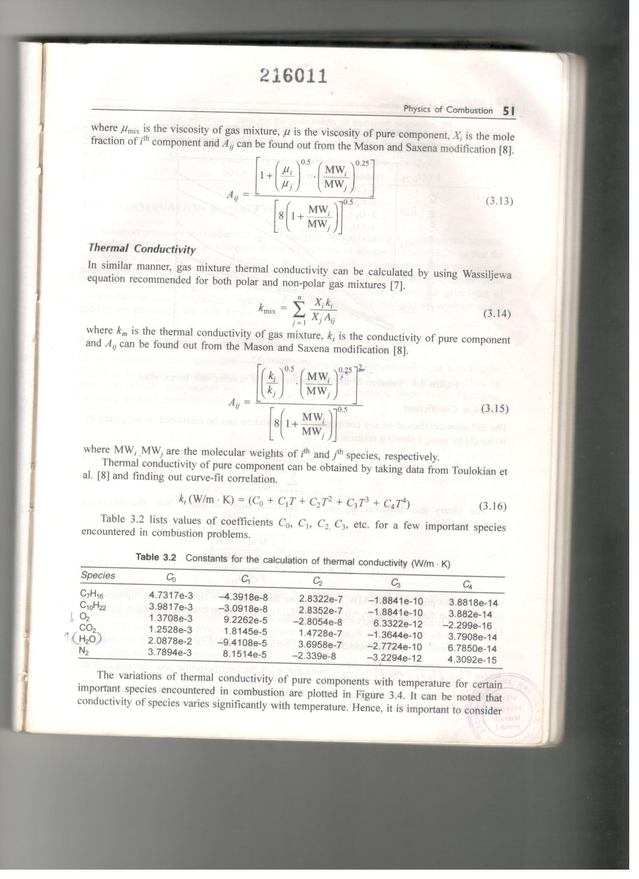

Reference : Fundamentals of Combustion; D. P. Mishra; Prentice-Hall of India Pvt Ltd, 2008



Reference: Mathur, S., and S. C. Saxena. "Viscosity of polar gas mixtures: Wilke's method." *Applied Scientific Research, Section A* 15, no. 1 (1966): 404-410.