Indian Express

[print](javascript:window.print())

**Babes in the Woods: Was Mowgli real? Could The Jungle Book be based on a true story?**

Written by Raza Kazmi | New Delhi | Updated: April 25, 2016 4:20 pm

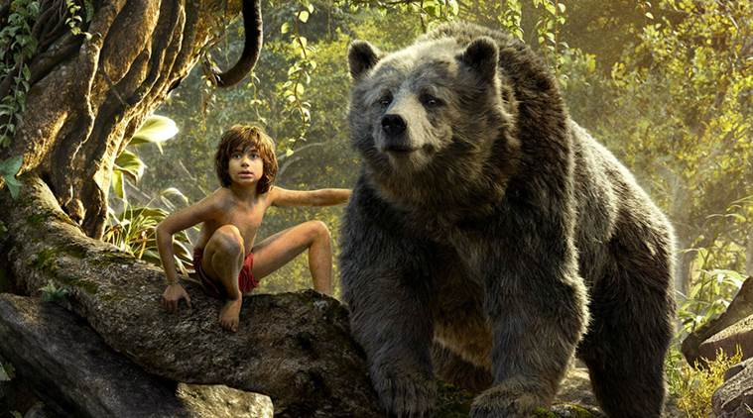Rudyard Kipling, who never visited any central Indian forest that he would go on to immortalise in Jungle Book, wrote the book while living in USA.

Mowgli, the “man-cub” of the Seonee wolf pack in Rudyard Kipling’s fabled works — The Jungle Book (1894) and The Second Jungle Book (1895) — is, perhaps, among the most iconic fictional characters ever created. Mowgli evokes a sense of wonder and curiosity among readers, as well as those who have only known him through the 1967 Disney film or the recent stunning Jon Favreau version, or, closer home, through Doordarshan’s The Jungle Book (the Hindi dubbed version of the internationally acclaimed Japanese anime series). Was he real? Did a boy like him really exist in some remote Indian forest, living with the wolves, gambolling with a bear, watched over by a black panther, frolicking with sundry denizens of the forest and hounded by the king of the jungle, the tiger? Could Kipling’s story have been a fictionalised account of some real-life incident?

Kipling, who never visited Seoni (or Sivni as the locals call it), or any other central Indian forest that he would go on to immortalise, wrote the book while living in USA. He is said to have derived inspiration for the book’s setting and animal characters primarily from the works of Robert Armitage Sterndale, a pioneer naturalist, sportsman, artist, writer and among the earliest editors of the Journal of Bombay Natural History Society (JBNHS), especially from his little-known book, Seonee, or Camp Life on the Satpura Range (1887).

However, where did the inspiration for Mowgli come from? Kipling himself never disclosed if there was a back story, but what if I told you that there exist many little-known, perplexing and completely forgotten real-life accounts of “feral children” written by colonial administrators and sportsmen? A bulk of these accounts, if not all, were written before Kipling took up writing, some even pre-dating his birth by decades. However, as mysterious and baffling these accounts may be, almost all of them are sad stories of suffering — a far-cry from the happy-go-lucky Mowgli story.

**The Mowgli Files**  
The subject of “feral children” gained significant traction throughout the world after Kipling’s book, and while a number of cases were reported from all over the globe, India accounted for the maximum number of cases. Perhaps, the most well-known and widely published case was that of Amala and Kamala, sisters claimed to be have been recovered from a wolf-den in 1920 in undivided Bengal’s Midnapore district, by a local orphanage priest Joseph Amrito Lal Singh. However, soon after the news broke, anthropologists and doctors cast doubts on its veracity. Eventually, a French surgeon proved that it was an elaborate hoax, where the two girls with neuro-developmental disorders had been exploited to raise funds for the orphanage.

But for every Amala-Kamala hoax, there are more than a dozen other unexplained, long-forgotten accounts of “feral children” — from wolf-children of the plains to the “panther-child of Assam” and the “bear-girl” of Bengal — mostly from the mid to late 19th century that remain unexplained and little-known.

The earliest accounts of wolf-children from India comes from a small obscure pamphlet published from Plymouth, England, titled, An Account of Wolves Nurturing Children in Their Dens, by an Indian Official (1851). Its author, legendary British soldier-administrator Sir William Henry Sleeman — the man who is singlehandedly believed to have ended the secret murderous cult of Thuggee, and has a town to his name in Sleemanabad — was, according to his grandson Sir James Sleeman, a well-known sportsman and writer, “quite the last man to be taken in by any cock-and-bull story of wolf-children”. This pamphlet had detailed six cases of wolf-children, excerpts of which were later reproduced in Sleeman’s Journey through the kingdom of Oude in 1848-1850 (1858). All but one of Sleeman’s wolf-children were captured around “Sultanpoor” (present day Sultanpur, Uttar Pradesh), while one was captured in “Bahraetch district” (present day Bahraich, UP).

“Wolves are numerous in the neighbourhood of Sultanpoor, and, indeed, all along the banks of the Goomtree river, among the ravines that intersect them; and a great many children are carried off by them from towns, villages and camps”, wrote Sleeman to give an idea of how numerous wolves were in “Oudh” (Awadh).

So severe were the depredations they carried out that Sleeman narrates how a particular class of nomads used to make a living by selling off the jewels that they found in wolf dens, the only remnants of the canid’s child victims.

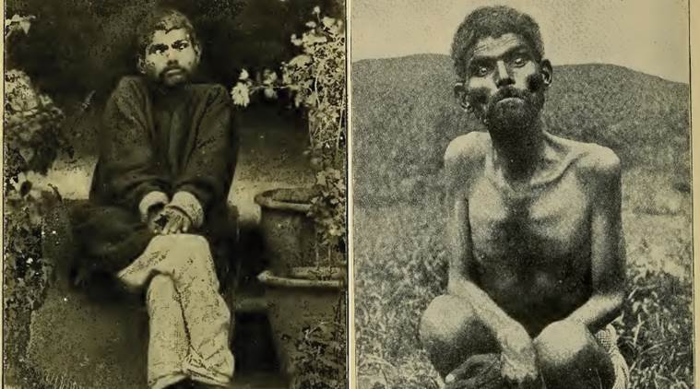Sanichar The Wolf Boy of India.

It was in central Awadh’s “Sultanpoor” province that the first “Mowgli” was caught: “There is now (Feb. 1850) at Sultanpoor, a boy who was found alive in a wolf’s den, near Chandour, 10 miles from Sultanpoor…A trooper… was passing along the bank of the river… when he saw a large female wolf leave her den, followed by three whelps and a little boy. The boy went on all fours, and seemed to be on the best possible terms with the old dam and the three whelps, and the mother seemed to guard all four with equal care: they all went down to the river and drank, without perceiving the trooper…; as soon as they were about to turn back, the trooper pushed on to cut off and secure the boy; but he ran as fast as the whelps could, and kept up with the old one…They all entered the den, and the trooper assembled some people from Chandour with pickaxes, and dug into the den. When they had dug in about six or eight feet, the old wolf bolted with her three whelps and the boy. The trooper mounted and pursued… and… he headed them, and turned the whelps and boy back upon the men on foot, who secured the boy, and let the old dam and her three cubs go on their way.”

Sleeman narrates how this extremely “restive and aggressive” boy had to be tied, and wanted to “rush into every hole or den they came near”. He growled and snarled, rejected cooked food and only took raw meat which it would put under his hands, like a dog would, while eating. While eating, he wouldn’t let anyone come near him except for dogs and jackals with whom he was calm and friendly and would always share his food with. Sleeman narrates how this boy would be alarmed and cower if any grown man approached him, but would rush towards a child coming near him “with a fierce snarl, like that of a dog, and tried to bite it”.

The boy was handed over to the Raja of “Hasanpoor”, who then handed him over to one Captain Nicholetts, the officer in charge of the First Regiment of Oude Local Infantry at Sultanpur. The captain and his servants tried their best to integrate the boy into human society, but failed. Though the “wolf-boy” had become “very inoffensive” and had been taught to occasionally stand — he still preferred being on all fours — he would reject any clothing offered to him even in the coldest of weather, “shunned human beings… and would never willingly remain near one”. Moreover, he could never learn to speak. The boy lived under the care of the captain’s servants for almost two years and then suddenly died in August 1850.

The Chupra wolf-boy was caught in similar circumstances when he was spotted with his wolf family along a stream bank near Chupra village, a few kilometres east of Sultanpur in 1849. He was later identified, based on his birthmark and a hot-water scald mark, as a cultivator’s son who had been lifted by a she-wolf from the village fields almost six years ago. The mother took in her long lost son, but yet again sharing all the “animal traits” of the first Sultanpur wolf-boy, he could never integrate with humans, and she was forced to leave him “to the common charity of the village”. After a few weeks, he ran back into the forests when Sleeman last heard of him.

The case of the Bahraich wolf-boy, caught around 1845, was even more interesting. A few months after his capture in which two of his “wolf-brothers” had escaped, he was eventually taken in by the roving caravan of Sanaollah, a Lucknow-based Kashmiri shawl merchant and put under the care of Janoo, his khidmatgar (servant). One night, Janoo woke up to strange sounds and saw “two Wolves come up stealthily and smell at the boy.” However, this boy rather than being frightened, “…began to play with him”. Alarmed, Janoo tried driving them away, but the wolves kept returning and playing with the boy. “The next night, three wolves came and then four on the following night, and they would play with this boy.” Jaanoo would tell Sleeman that the “first two that came must have been the two cubs with which the boy was first found”. Eventually, three months later, the boy managed to escape, never to be seen or heard of again. It was later ascertained with some degree of certainty that the boy was the lost son of a farmer, and had been taken away by a wolf when he was about four.

In 1867, hunters near Bulandshahar rescued a young boy from a wolf-den and took him to the Agra Medical Missionary Training Institute (or Sekandra Orphanage as it was commonly known). He was christened Dina Sanichar — the boy who was born on Saturday (because he was brought to the orphanage on a Saturday). Valentine Ball, a pioneer geologist working with the Geological Survey of India, an accomplished ornithologist, anthropologist and later, director of National Museum of Ireland, has presented, perhaps, the most detailed portrait of Sanichar ever written, in his book, Jungle Life in India (1880). Sir John Hewett, the lieutenant-governor of United Provinces, a well-known big-game hunter, friend of the legendary hunter-conservationist Jim Corbett, and one of the key drivers behind the establishment of Hailey National Park in 1936 (better known today as the Corbett National Park), has also referred to his experiences with Sanichar in his book, Jungle Trails in Northern India (1938). Sanichar was the only known wolf-boy who survived into adulthood, and died due to tuberculosis in 1895. Despite more than 20 years of efforts at the orphanage, nobody could get him to speak, but they did manage to train him to wear clothes and eat cooked food.

Ball lists the story of another forgotten wolf-boy who was also brought to the Sekandra orphanage. “A perfect wild animal from every point of view”, according to the then superintendent of the orphanage, the boy had been brought scarred and wounded on March 5, 1872, after having been smoked out of a wolf den by hunters in “Mynepuri” (present day Mainpuri, UP). At this time, Sanichar had already been living at the orphanage for five years. Like all other previous wolf-boys, he uttered nothing “save a melancholy whine like that made by young (wolf) cubs”. This younger wolf-boy seemed to have developed a strange bond with Sanichar. Unfortunately, the Mynepuri wolf-boy didn’t survive for long and after a couple of failed attempts to run back into the nearby forests, he died four months after his arrival.

Two other cases were reported elsewhere, one from Shahjahanpur (c. 1858), attested to by two different military officers and yet another case from Sultanpur (c. 1860-61). Beyond Oudh, a few cases of wolf-boys cropped up in Madhya Pradesh. One such hitherto unrecorded case was that of a wolf-boy caught at a village called “Sat-bowrie” (Seven wells) between Jabalpur and Nagpur, sometime in mid to late 19th century, as narrated by Mervyn A Smith in his book Sport and Adventure in the Indian Jungle (1904). This wolf-child, named Seaall, because of his jackal-like cries — around 10 years of age — was assumed to have turned man-eater along with the she-wolf that had nurtured him over the years. The she-wolf, who made the kills, was eventually tracked and shot, while the boy was captured a couple of days later. However, this account is peculiar in more ways than one because the author asserted that this wolf-child was “dog-like intelligent” and while he himself didn’t see him speak, he was later informed that, over time, the boy had picked up a few Gondi words from his “keeper”. This child was eventually sent to “a missionary in the north-west” by Lieutenant Cumberledge, who had overseen the entire operation. “I have reason to believe that he was the original of Rudyard Kipling’s Mowgli,” concluded Smith.

**The Curious Absence of a Wolf-man**  
One may well wonder why it was almost always boys, aged between eight and 12 years of age, and not a single case of a “wolf-man” that was reported. Sleeman first observed this peculiarity and offers an explanation. He reasoned that “after a time, they either die from living exclusively on animal food, before they attain the age of manhood, or are destroyed by the wolves themselves, or other beasts of prey in the jungles, from whom they are unable to escape…” Moreover, the boy’s “wolf-parents”, who nurtured him, would die in a few years — wolves have an average lifespan of just six-eight years in the wild — and other wolves might then kill and eat the boy.

Finally, according to Sleeman, it was Mowgli’s mortal enemy, Shere Khan, who could have accounted for the short lifespan of such boys. Tigers, which used to be plentiful in these provinces back then, would easily kill any animal — especially a “wolf-boy” who wasn’t as fast as the others. But why were no such kills recorded? Sleeman writes, “If the dead body of such a boy were found anywhere in jungles, or on the plains, it would excite little interest, where dead bodies are so often found exposed, and so soon eaten by dogs, jackals, vultures, etc…”

**Oudh: Wolf-children Country**  
Why did most of these cases occur in Oudh? The general consensus was that Oudh was the most formidable stronghold of wolves in India at the time. Moreover, due to the incredibly high rate of human fatalities recorded here in the mid-19th century (hovering around 150 reported cases per year, most of them children), some opined, that the area was inhabited by a race of man-eating wolves peculiar to this province. As a result, thousands of wolves were “destroyed” over a five-year period beginning 1867 to put an end to what the officials perceived was the “wolf menace”. With the decline in wolf numbers by 1872, the cases of wolf-children from Oudh abruptly stopped, and not a single credible case of wolf-children was ever recorded again from this province.

**Why Would a Wolf Rear a Human Child?**  
Most believed it was a freak aberration in wolf behaviour. However, according to Smith, the tribals of central India had an incredulous answer to this puzzle. “The natives declare that when a she-wolf has lost her whelps…she experiences a soreness at the teats from the accumulation of milk, and she then generally steals a child. The sucking of the child relieves the wolf, and the infant is thenceforth regarded as a member of the family…”

*************************************************************************************************************

The Myenpuri wolf-boy, caught in 1872, is the last of the unexplained accounts of wolf-children in India; the few later accounts being too sketchy and unreliable. The only case that does evoke some curiosity after this is that of Shamdeo or Bhaloo or Pascal as he was called, a young boy captured by a farmer from that old haunt of wolves, Sultanpur, exactly 100 years after the Mynepuri episode. However, due to the limited reportage and his early death at Prem Nivas, Lucknow — the home for the dying and destitute run by Mother Teresa’s Missionaries of Charity — the story remains hazy and unreliable.

So, there rest the tales of India’s Mowglies. But what about the panther-child of Assam and bear-girl of Bengal hills, you ask? Well, those are stories for another day.

**Kazmi is a Jharkhand-based conservationist and a keen student of India’s wildlife history. He is interested in raising awareness about lesser-known tiger reserves and neglected forests of India.**