EN 309-2018-1 Thermal & Fluid Engineering Lab

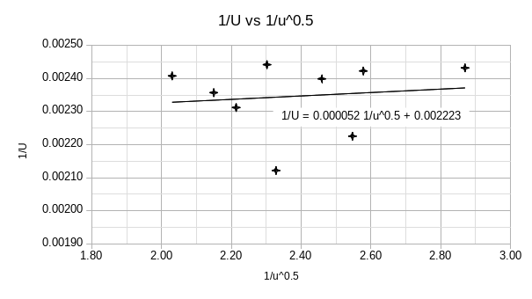
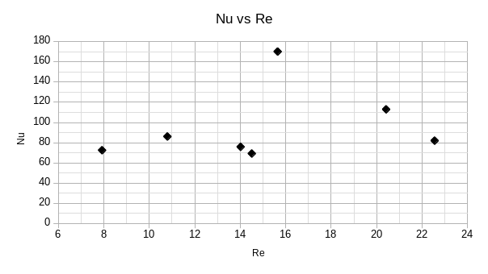
16D170027

