TIME SCALE FOR EVOLUTION OF EUKARYOTES
Mid-Sem Project Report

By Prabhat Ranjan
(16D170027)

OBJECTIVE

To find the time scale of evolution of Eukaryotes from Prokaryotes

INTRODUCTION

The origin of Eukaryotes was a major singular step in evolution. The origin of life on earth goes back to around 4 billion year and life forms were morphologically similar for ~2 billion year. This change in structure and complexity happens with the sudden evolution of Eukaryotic cells. Very less is known about the intermediate steps in the course of evolution. Eukaryotic cells are fundamentally different from those of bacteria and archaea at almost every level of organization, starting with their physical size. The earliest common Eukaryotic ancestor already have most of the modern Eukaryotic features as nucleus and other endomembrane system organelles.
The most widely accepted hypothesis is of Endosymbiosis, in which a bacteria is engulfed by an Archaea. They formed a symbiotic relationship in which host Archaea provide a stable environment and food for bacteria while bacteria provides energy to the symbiotic system. It latter evolved into an eukaryotic cell where bacteria assumes the role of mitochondria and Archaea becomes the cell. This transition from a symbiotic relation to complete eukaryotic cell happened in a series of evolutionary steps. Since there are no intermediates or fossils, which suggests this transition had happened very quickly in evolutionary time scale.
The objective of this project is to find out that time scale.

STEPS INVOLVED:

This project will look at the time interval elapsed between the engulfment of bacteria and formation of Nucleus inside the cell.

- Archaea engulfing a bacteria
- Number of bacteria grows inside the archaea host
- Bacteria started to shed its genes to host genome.
- Parasitic genes from Bacteria bombarded the host genome
- Formation of split genes and spliceosome
- Development of nucleus

STEP 1. Archaea engulfing a bacteria

Modern eukaryotic cell have proteins which are present in both Archaea and bacteria exclusively which suggest a chimeric origin of Eukaryote. It could be explained with the symbiotic relation between bacteria inside an Archaeal host. This is believed completely accidental.

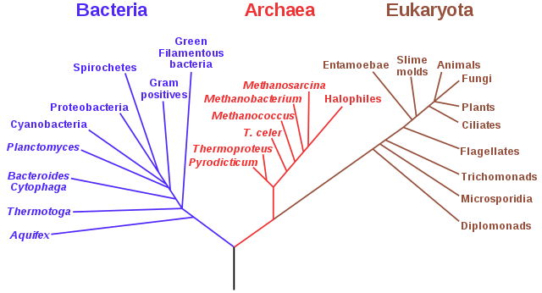

STEP 2. Number of bacteria grows inside the Archaeal host cell:

Since the bacteria found itself in a relatively stable environment the number of bacterial cell per host began to increase rapidly which is only stopped by the amount of food material archaea could supply to the bacteria.

STEP 3. Bacteria started to shed its genes:

Since the bacteria has a relatively stable environment now it could easily discard many genes which are no longer needed into the cytoplasm of host.
Many of these genes would be picked by the host genome and the size of genome began to increase.
Further many of the common genes which are not needed for the urgent operation of the bacterial cell were also incorporated to the host genome and the size of the host genome continues to grow while the genetic size of bacteria continues to decrease.
The bacteria started to rely upon the host proteins and machinery for most of its function.

STEP 4. The Parasitic DNA attacks the host genome:

The parasitic DNA molecules from the bacteria started to incorporate itself in host genome in multiple copies which increase the genetic load of the host cells. But this load of coping more genetic material can be balanced due to extra energy generated by individual bacterial cells which now has more energy per gene.

STEP 5. Formation of Split Genes and spliceosome:

The bombardment of parasitic DNA resulted into the formation of split genes which require spliceosome to form the correct mRNA and form correct protein.

STEP 6. Formation of nucleus:

The speed of spliceosome to cut and paste the RNA is much slower than the speed of translation by ribosomes hence there is a need for the separate compartmentalization inside the cell where spicing of an mRNA could be done in absence of Ribosomes. Hence it provided a path for formation of nucleus, which separated the mRNA from cytoplasm.

Approach:

The main idea is to look at the rate of individual step and figure out the slowest step of them, to have an idea of the time scale on which evolution has happened.

1. The difference between genetic size of a representative plant cell and representative animal cell should give the rate of incorporation of bacterial gene in the host genome, since plant cell have both mitochondria and chloroplast which were once the engulfed bacteria.

The problem however with this approach is, the chloroplast containing bacteria were acquired after the formation of nucleus which will affect the rate of incorporation of genetic material in host genome.

2. Cell could be modelled as CSTR (continuous stirred tank reactor) for the nutrient molecule. The amount of food that can be inserted inside an archaea is directly proportional to it surface area. The nutrient that will be inflow will be used by both bacteria and the archaea, As the size of host cell grow it will influx more nutrient and more bacterial cell could survive inside the cell. The competition between the size of host cell and the number of bacteria will eventually stop at an optimum size of host cell and an optimum number of bacterial cell.

REFERENCES

- Lane, N., 2015. The vital question: energy, evolution, and the origins of complex life. WW Norton & Company.
- Irimia, M. and Roy, S.W., 2014. Origin of spliceosomal introns and alternative splicing. Cold Spring Harbor perspectives in biology, 6(6), p.a016071.
- https://evolution.berkeley.edu/evolibrary/article/endosymbiosis_01

