|  |
| --- |
| Department of Chemical Engineering |
| Indian Institute of Technology – Bombay |
| CL717 Evolutionary Dynamics 2018-2019 |
| Submitted by - 150020057 |
| Project Report |

**FRAMEWORK FOR RESEARCH IN EVOLUTIONARY PSYCHOLOGY**

**INTRODUCTION**

"The goal of research in evolutionary psychology is to discover and understand the design of the human mind. Evolutionary psychology is an *approach* to psychology, in which knowledge and principles from evolutionary biology are put to use in research on the structure of the human mind." (Cosmides & Tooby).   
It began with Darwin himself when he wrote on *Origin of Species* that "In the distant future I see open fields for far more important researches. Psychology will be based on a new foundation, that of the necessary acquirement of each mental power and capacity

by gradation.". Since then, psychology and theory of evolution by natural selection, both, have advanced and taken up variety of forms.   
My current goal is to develop an understanding of the basic principles of evolutionary biology in the context of psychology that forms a coherent framework set to study different topics in evolutionary psychology.

**THE MIND & THE BRAIN**

The brain is seen as just an organ among the many others such as kidney, heart, etc. Hence, psychology is seen as a branch of biology only. Just as all the other organs have their defined functions in the human body, the brain also has its defined function. The function of the brain falls under the description of information-processing, and behaviour is its visible component. The mind and the brain are seen as two faces of the same coin in Evolutionary Psychology. While the brain is that part of the system being studied which deals in terms of *physical properties*, the mind comes into the picture when it is being dealt in terms of information-processing *operations.*

**LEVELS OF EXPLAINATION IN EVOLUTIONARY PSYCHOLOGY**

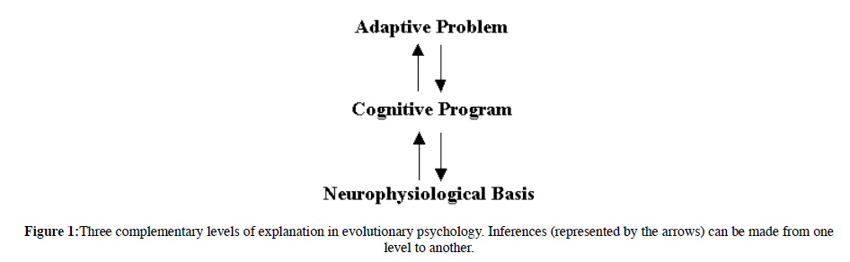

Source: Evolutionary Psychology Primer by Leda Cosmides and John Tooby

**Adaptive Problems -** It is those set of problems which were faced by a species again and again during their evolutionary history and whose solution affects the reproduction of individual members of the species. This differential reproduction thus occuring drives natural selection. In our context, the adaptive problems are those which our ancestors faced in the Environment of Evolutionary Adaptedness, most of which is the environment of an individual living in hunter-gatherer societies.

**Cognitive Program -** It is the function which is mapping the environment variables of the adaptive program to a particular set of reactionary behaviour.

**Neurophysiological basis** is the foundation bricks of the programs in the brain chemistry, that is the neural circuitry which execute the cognitive programs.

These three are interlinked : an adaptive problem identified leads in discovering the cognitive program which is a solution to the particular adaptive problem, and the existence of the specific cognitive programs guides in the search of its neural basis.

**Basic Principles of evolutionary biology applied to psychology as identified by Cosmides and Tooby**

1. The brain bridges the gap between environmental circumstances and corresponding behaviour. All the neural circuits in the brain has a basis in the laws of physics and chemistry operating at fundamental levesl.

2. Environment variables pass through a complex set of neural circuitry which produce behaviour. These neural circuitries are designed by evolutionary processes. The specific neural circuitries which exist could be explained by natural selection of that circuitry among others, or as a byproduct of some other selection process, or simply as noise(chance event).

3. Most of the execution of the neural circuitry in place occurs unconsciously, giving the person, the illusion that the circuitry is much simpler than it is. Hence, conscious experience of the world and self cannot be the sole basis for understanding of the cognitive functions.

4. The functions of the brain are specialized and not general. These functions are solving different evolutionary problems, seen as modules. The brain can be viewed as a collection of dedicated modules whose operations are functionally integrated.

5. Most of the evolution of the psychology occured in the environment of hunter-gatherer socieites. Hence, Evolutionary Psychologists reject the notion that one has explained a behavior pattern by showing that it promotes fitness under modern conditions.

**References:**

Cosmides, Leda, and John Tooby. "Evolutionary psychology: A primer." (1997).

Barkow, Jerome H., Leda Cosmides, and John Tooby, eds. *The adapted mind: Evolutionary psychology and the generation of culture*. Oxford University Press, USA, 1995.