**Q.no 1.**

#include <stdio.h>

int main()

{

int num1, num2;

int sum, sub, mult, mod;

float div;

printf("Input any two numbers separated by comma : ");

scanf("%d,%d", &num1, &num2);

/* Performs all arithmetic operations */

sum = num1 + num2;

sub = num1 - num2;

mult = num1 * num2;

div = (float)num1 / num2;

mod = num1 % num2;

/* Prints the result of all arithmetic operations */

printf("The sum of the given numbers : %d\n", sum);

printf("The difference of the given numbers : %d\n", sub);

printf("The product of the given numbers : %d\n", mult);

printf("The quotient of the given numbers : %f\n", div);

printf("MODULUS = %d\n", mod);

return 0;

}

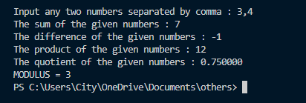

**Q no 2.**

#include <stdio.h>

int main()

{

int a[10], b[10], n1, n2;

printf("Enter size of set A\n");

scanf("%d", &n1);

printf("Enter element of set A\n");

for (int i = 0; i < n1; i++)

scanf("%d", &a[i]);

printf("Enter size of set B\n");

scanf("%d", &n2);

printf("Enter element of set B\n");

for (int i = 0; i < n2; i++)

scanf("%d", &b[i]);

printf("{");

for (int i = 0; i < n1; i++) {

for (int j = 0; j < n2; j++) {

printf(" (%d %d) ", a[i], b[j]);

}

}

printf("}");

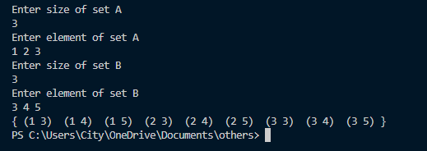 return 0;

}

**Q no 3.**

#include<stdio.h>

int main(){

int a[10],b[10],c[10],d[10],m=0,k=0,n1,n2,l,i,j;

printf("Enter size of set A\n");

scanf("%d",&n1);

printf("Enter element of set\n");

for( i=0;i<n1;i++)

scanf("%d",&a[i]); printf("Enter size of set B\n");

scanf("%d",&n2);

printf("Enter element of set\n");

for( i=0;i<n2;i++)

scanf("%d",&b[i]);

for( i=0;i<n1;i++){

for(j=0;j<n2;j++) {

if(b[j]==a[i])

break; }

if(j==n2) {

for(l=0;l<k;l++) {

if(c[l]==a[i])

break; }

if(l==k) {

c[k]=a[i];

k++; }} }

for( i=0;i<n2;i++){

for(j=0;j<n1;j++){

if(b[i]==a[j])

break; }

if(j==n1){

for(l=0;l<m;l++)

{

if(d[l]==b[i])

break; }

if(l==m)

{

d[m]=b[i];

m++;

} } }

printf("Difference of A-B is:-\n");

for(i=0;i<k;i++)

{

printf("%d",c[i]);

}

printf("\n");

printf("Difference of B-A is:-\n");

for(i=0;i<m;i++)

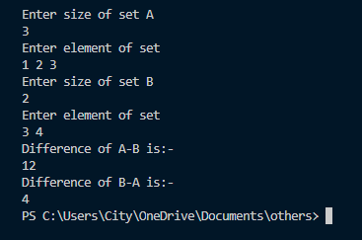 {

printf("%d",d[i]);

}

return 0;

}

**Q no 4.**

#include <stdio.h>

#include <math.h>

int main()

{

float val;

float fVal, cVal;

printf("Enter a float value: ");

scanf("%f", &val);

fVal = floor(val);

cVal = ceil(val);

printf("floor value:%f \nceil value:%f\n", fVal, cVal);

return 0;

}

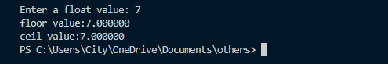

**Q no 5.**

#include<stdio.h>

int main() {

int a[100],b[100],c[100],n1,n2,n,k=0,i,j;

printf("Enter number of element of set A\n");

scanf("%d",&n1); printf("Enter elements of set A\n");

for(i=0;i<n1;i++)

scanf("%d",&a[i]);

printf("Enter number of element of set B\n");

scanf("%d",&n2);

printf("Enter elements of set B\n");

for(i=0;i<n2;i++)

scanf("%d",&b[i]);

for(i=0;i<n1;i++){

for(j=0;j<n2;j++){

if(a[i]==b[j]){

c[k]=a[i];

k++;

}} }

printf("intersection of set A and set B is:-\n");

for(i=0;i<k;i++)

printf("%d ",c[i]);

return 0;

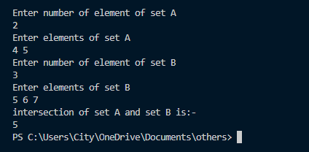}

**Q no 6.**

#include <stdio.h>

#include <conio.h>

int fact(int);

int main(){

int NPR,N,R,M,i;

NPR=0;

M=0;

M= N-R;

printf("Enter value for N and R:");

scanf("%d %d",&N,&R);

NPR = fact(N)/fact(M);

for(i=0;i<45;i++)

printf("_");printf("\n\n");

printf("Number of %d-permutation of %d object = %dn",R,N,NPR);

for(i=0;i<45;i++)

printf("_");printf("\n\n");

system("PAUSE");

return 0;}

int fact(m){

int i,fact=1;

for(i=1;i<=m;i++){

fact=fact*i;}

return(fact);

}



Q no 7.

#include<stdio.h>

#include<conio.h>

void main()

{

int a[10],b[10],i,c[10],j,k=0,n1,n2;

printf("Enter number of element of set A\n");

scanf("%d",&n1);

printf("Enter the element of set A \n");

for(i=0;i<n1;i++)

scanf("%d",&a[i]);

printf("Enter number of element of set B\n");

scanf("%d",&n2); printf("Enter the element of set B \n");

for(i=0;i<n2;i++)

scanf("%d",&b[i]); for(i=0;i<n1;i++)

{

for(j=0;j<k;j++)

{

if(c[j]==a[i])

break;}

if(j==k)

{

c[k]=a[i];

k++;

}

}

for(i=0;i<n2;i++)

{

for(j=0;j<k;j++)

{

if(c[j]==b[i])

break;

}

if(j==k)

{

c[k]=b[i];

k++;

}

}

printf("Union of set A and B is:-\n");

for(i=0;i<k;i++)

printf("%d ",c[i]);

}