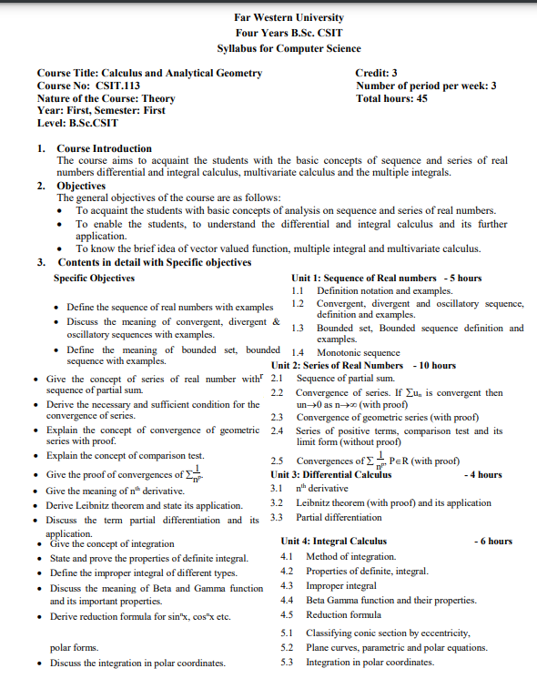

|  |  |
| --- | --- |
| A picture of a winding road and trees  Calculus and analytical geometry | Abstract  ***This is book is created by Sagilonotepeadia for students of BSc.CSIT. This book contains all the topics and articles which in the syllabus of BSc.CSIT. This book is combo of all books: Differential calculus, Integral calculus, Real analysis, Thomas and Finney Calculus and Analytica-2***  By SAGILONOTEPEADIA |



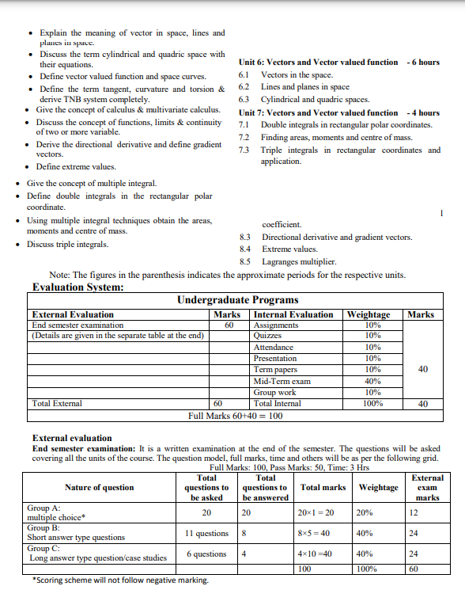

***Contents***

Unit 1: Sequence of Real numbers - 5 hours

1.1 Definition notation and examples.

1.2 Convergent, divergent and oscillatory sequence, definition and examples.

1.3 Bounded set, Bounded sequence definition and examples.

1.4 Monotonic sequence ­­­

Unit 2: Series of Real Numbers - 10 hours

2.1 Sequence of partial sum.

2.2 Convergence of series. If ∑un is convergent then un→0 as n→∞ (with proof)

2.3 Convergence of geometric series (with proof)

2.4 Series of positive terms, comparison test and its limit form (without proof) 1

2.5 Convergences of ∑ n p, P∈R (with proof)

Unit 3: Differential Calculus - 4 hours

3.1 nth derivative

3.2 Leibnitz theorem (with proof) and its application

3.3 Partial differentiation

Unit 4: Integral Calculus - 6 hours

4.1 Method of integration.

4.2 Properties of definite, integral.

4.3 Improper integral

4.4 Beta Gamma function and their properties.

4.5 Reduction formula

5.1 Classifying conic section by eccentricity,

5.2 Plane curves, parametric and polar equations.

5.3 Integration in polar coordinates

Unit 6: Vectors and Vector valued function - 6 hours

6.1 Vectors in the space.

6.2 Lines and planes in space

6.3 Cylindrical and quadric spaces

Unit 7: Vectors and Vector valued function - 4 hours

7.1 Double integrals in rectangular polar coordinates.

7.2 Finding areas, moments and center of mass.

7.3 Triple integrals in rectangular coordinates and application.

8.3 Directional derivative and gradient vectors.

8.4 Extreme values.

8.5 Lagranges multiplier.

Formulas and model set

***Unit 3: Differential Calculus***

**3.1 nth derivative (Derivative of higher order)**

  Higher-order derivative*refers to the repeated process of taking derivatives of derivatives. Higher-order derivatives are applied to sketch curves, motion problems, and other applications.*

Notation for higher-order derivatives:

1st Derivative 2nd Derivative 3rd Derivative 4th Derivative 5th Derivative

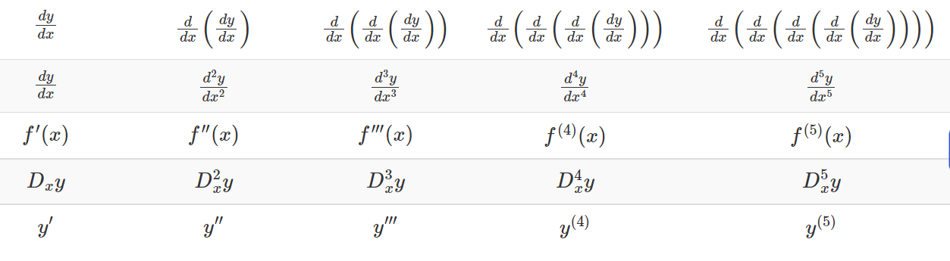

**Example 1:** Find the first, second, and third derivatives of f( x) = 5 x 4 − 3x 3 + 7x 2 − 9x + 2.

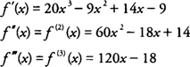

**3.1.1 Successive derivative of some typical function**

**If , then if m be a positive integer.**

Here,

In general,

**=**

Putting n=m,

ym = m(m-1)(m-2)………..3.2.1 = m!

and ym+1 and higher order derivatives are all zero.

**Generalization :** If , where m is positive integer then

, if n<m.

**3.1.2 Derivative of sin(ax + b) 3.1.3 Derivative of**

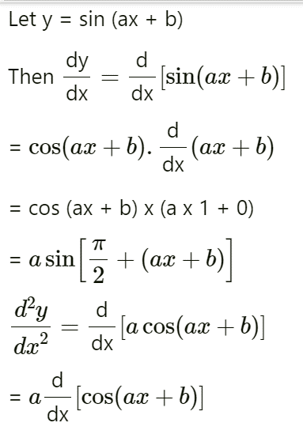

Let y =

Then y1=)

Put a = r cosθ , b = r sinθ , so that

then

∴ y1 = , and

Y2 = , and so on

In General,

Yn =

=

Similarly,

If y =

Yn==

**3.1.4 nth derivative of**

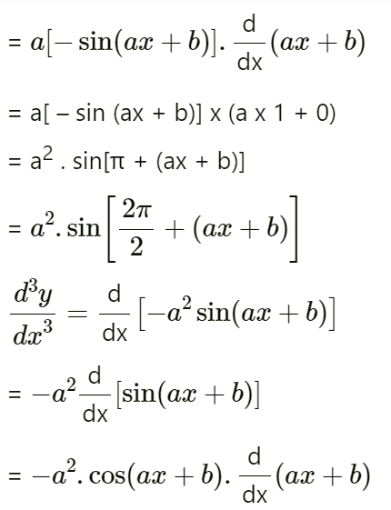

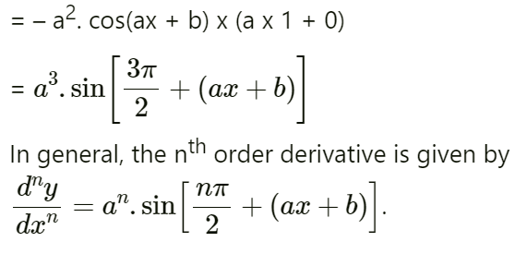

Similarly,

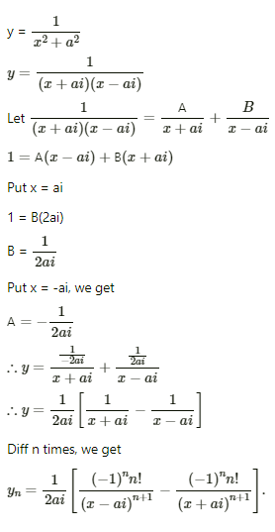**3.1.5 nth  derivative of**

The above result can be used to write down the nth  derivative of tan-1x as follows

**Some worked out examples**

1. Find y2 if y = tan(x+y)

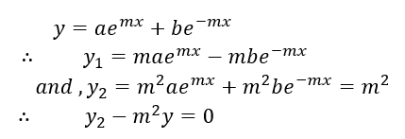

Again differentiating on both sides

1. 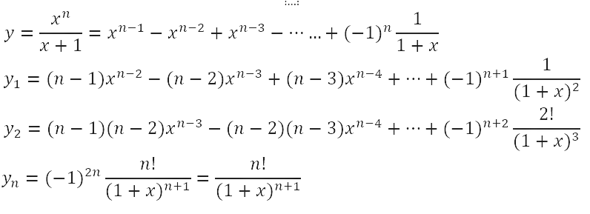If , find

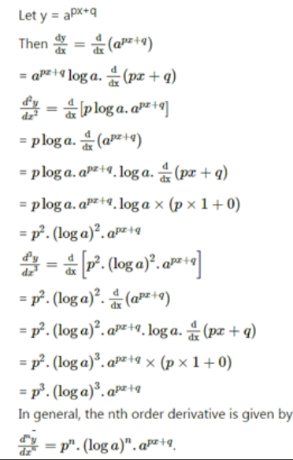5.Find the nth derivative of the following : 6.Find the nth derivative of

**7.Find nth derivative of**

**EXERCISE**

1.Find yn in the following

2. Find the nth derivative of the following functions

.

**ANSWERS**

2.

**3.2 Leibnitz theorem and its application**

***Leibnitz’s Theorem:***

***Proof:***

Differentiating,

This shows that if the theorem is true for n = m, it is also true for n = m+1. But the theorem is true for n = 2 and 3, hence it is true for n = 4 and so for 5, and so on. The theorem is, therefore, true for all values of n.

**Worked out Examples**

Solution

Now, by **Leibnitz** theorem,

Solution,

Differentiating n time by using Leibnitz theorem,

Solution,

Again, diff. on both sides

Solution,

……….. (i)

diff. n times the relation (i)

……….(ii)

From (i) we have, y1(0)=1, putting x = 0;

From (ii) y2(0) = 0

Generalizing, yn(0)=0 if n is even

**Exercise**

1. Find if y is

**Answers**

**3.3 Partial Differentiation**

Suppose, we have a function f(x, y), which depends on two variables x and y, where x and y are independent of each other. Then we say that the function f partially depends on x and y. Now, if we calculate the derivative of f, then that derivative is known as the partial derivative of f. If we differentiate the function f with respect to x, then take y as a constant and if we differentiate f with respect to y, then take x as a constant.

The notation for higher derivatives is similar. fxxyx is what you get by taking a partial derivative of ff with respect to x, then again with respect to x, then with respect to y, and finally with respect to x

**3.3.1 Geometry of partial derivatives**

**To understand partial derivatives geometrically, we need to interpret the algebraic idea of fixing all but one variable geometrically. This is equivalent to slicing a surface by a plane to produce a curve in space.**

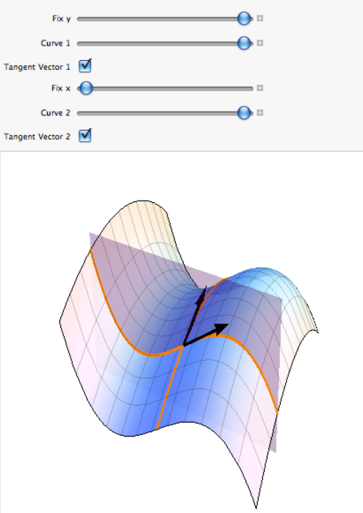Start with,

Whose graph shown right then

To exploit interactivity, fix y=−1y=−1 and use the 'Fix yy'-slider to intersect the graph of ff by the plane y=−1y=−1. The cubic curve of intersection shown in orange is the graph of the vector function

The tangent vector to this orange curve is

**Worked Out Examples**

**Example 1: Determine the partial derivative of the function: f (x,y) = 3x + 4y.**

**Solution:**

**Solution:**

When we keep y as constant cos y becomes a constant so its derivative becomes zero.

Similarly, finding fy

**Solution:**

Similarly,

**Solution:**

So,

Similarly,

Using product rule,

Similarly,

Solution,