2.`16:

Code in python:

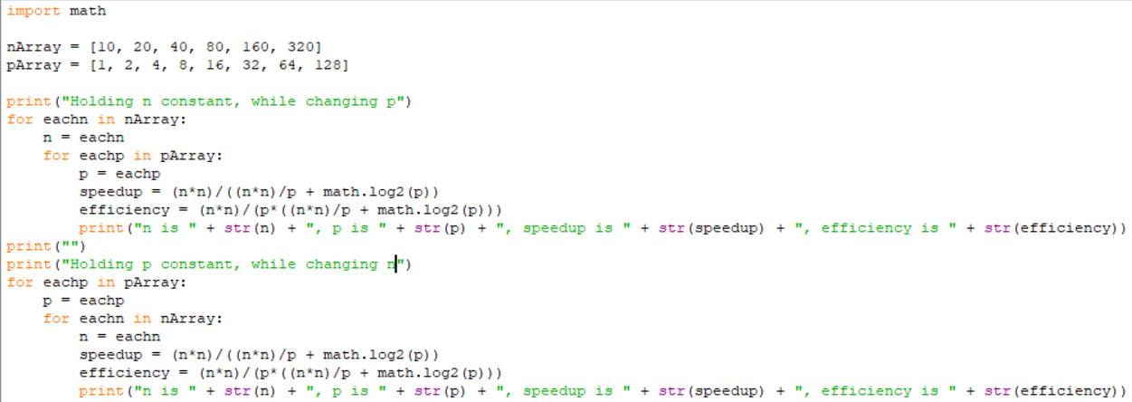

Output:

Holding n constant, while changing p

n is 10, p is 1, speedup is 1.0, efficiency is 1.0

n is 10, p is 2, speedup is 1.9607843137254901, efficiency is 0.9803921568627451

n is 10, p is 4, speedup is 3.7037037037037037, efficiency is 0.9259259259259259

n is 10, p is 8, speedup is 6.451612903225806, efficiency is 0.8064516129032258

n is 10, p is 16, speedup is 9.75609756097561, efficiency is 0.6097560975609756

n is 10, p is 32, speedup is 12.307692307692308, efficiency is 0.38461538461538464

n is 10, p is 64, speedup is 13.223140495867769, efficiency is 0.2066115702479339

n is 10, p is 128, speedup is 12.85140562248996, efficiency is 0.10040160642570281

n is 20, p is 1, speedup is 1.0, efficiency is 1.0

n is 20, p is 2, speedup is 1.9900497512437811, efficiency is 0.9950248756218906

n is 20, p is 4, speedup is 3.9215686274509802, efficiency is 0.9803921568627451

n is 20, p is 8, speedup is 7.547169811320755, efficiency is 0.9433962264150944

n is 20, p is 16, speedup is 13.793103448275861, efficiency is 0.8620689655172413

n is 20, p is 32, speedup is 22.857142857142858, efficiency is 0.7142857142857143

n is 20, p is 64, speedup is 32.6530612244898, efficiency is 0.5102040816326531

n is 20, p is 128, speedup is 39.50617283950617, efficiency is 0.30864197530864196

n is 40, p is 1, speedup is 1.0, efficiency is 1.0

n is 40, p is 2, speedup is 1.9975031210986267, efficiency is 0.9987515605493134

n is 40, p is 4, speedup is 3.9800995024875623, efficiency is 0.9950248756218906

n is 40, p is 8, speedup is 7.8817733990147785, efficiency is 0.9852216748768473

n is 40, p is 16, speedup is 15.384615384615385, efficiency is 0.9615384615384616

n is 40, p is 32, speedup is 29.09090909090909, efficiency is 0.9090909090909091

n is 40, p is 64, speedup is 51.61290322580645, efficiency is 0.8064516129032258

n is 40, p is 128, speedup is 82.05128205128206, efficiency is 0.6410256410256411

n is 80, p is 1, speedup is 1.0, efficiency is 1.0

n is 80, p is 2, speedup is 1.999375195251484, efficiency is 0.999687597625742

n is 80, p is 4, speedup is 3.9950062421972534, efficiency is 0.9987515605493134

n is 80, p is 8, speedup is 7.970112079701121, efficiency is 0.9962640099626401

n is 80, p is 16, speedup is 15.841584158415841, efficiency is 0.9900990099009901

n is 80, p is 32, speedup is 31.21951219512195, efficiency is 0.975609756097561

n is 80, p is 64, speedup is 60.37735849056604, efficiency is 0.9433962264150944

n is 80, p is 128, speedup is 112.28070175438596, efficiency is 0.8771929824561403

n is 160, p is 1, speedup is 1.0, efficiency is 1.0

n is 160, p is 2, speedup is 1.9998437622060776, efficiency is 0.9999218811030388

n is 160, p is 4, speedup is 3.998750390502968, efficiency is 0.999687597625742

n is 160, p is 8, speedup is 7.992507024664377, efficiency is 0.9990633780830471

n is 160, p is 16, speedup is 15.960099750623442, efficiency is 0.9975062344139651

n is 160, p is 32, speedup is 31.801242236024844, efficiency is 0.9937888198757764

n is 160, p is 64, speedup is 63.05418719211823, efficiency is 0.9852216748768473

n is 160, p is 128, speedup is 123.67149758454106, efficiency is 0.966183574879227

n is 320, p is 1, speedup is 1.0, efficiency is 1.0

n is 320, p is 2, speedup is 1.9999609382629246, efficiency is 0.9999804691314623

n is 320, p is 4, speedup is 3.9996875244121552, efficiency is 0.9999218811030388

n is 320, p is 8, speedup is 7.998125439350153, efficiency is 0.9997656799187691

n is 320, p is 16, speedup is 15.99000624609619, efficiency is 0.9993753903810119

n is 320, p is 32, speedup is 31.950078003120126, efficiency is 0.9984399375975039

n is 320, p is 64, speedup is 63.760896637608965, efficiency is 0.9962640099626401

n is 320, p is 128, speedup is 126.88971499380422, efficiency is 0.9913258983890955

Holding p constant, while changing n

n is 10, p is 1, speedup is 1.0, efficiency is 1.0

n is 20, p is 1, speedup is 1.0, efficiency is 1.0

n is 40, p is 1, speedup is 1.0, efficiency is 1.0

n is 80, p is 1, speedup is 1.0, efficiency is 1.0

n is 160, p is 1, speedup is 1.0, efficiency is 1.0

n is 320, p is 1, speedup is 1.0, efficiency is 1.0

n is 10, p is 2, speedup is 1.9607843137254901, efficiency is 0.9803921568627451

n is 20, p is 2, speedup is 1.9900497512437811, efficiency is 0.9950248756218906

n is 40, p is 2, speedup is 1.9975031210986267, efficiency is 0.9987515605493134

n is 80, p is 2, speedup is 1.999375195251484, efficiency is 0.999687597625742

n is 160, p is 2, speedup is 1.9998437622060776, efficiency is 0.9999218811030388

n is 320, p is 2, speedup is 1.9999609382629246, efficiency is 0.9999804691314623

n is 10, p is 4, speedup is 3.7037037037037037, efficiency is 0.9259259259259259

n is 20, p is 4, speedup is 3.9215686274509802, efficiency is 0.9803921568627451

n is 40, p is 4, speedup is 3.9800995024875623, efficiency is 0.9950248756218906

n is 80, p is 4, speedup is 3.9950062421972534, efficiency is 0.9987515605493134

n is 160, p is 4, speedup is 3.998750390502968, efficiency is 0.999687597625742

n is 320, p is 4, speedup is 3.9996875244121552, efficiency is 0.9999218811030388

n is 10, p is 8, speedup is 6.451612903225806, efficiency is 0.8064516129032258

n is 20, p is 8, speedup is 7.547169811320755, efficiency is 0.9433962264150944

n is 40, p is 8, speedup is 7.8817733990147785, efficiency is 0.9852216748768473

n is 80, p is 8, speedup is 7.970112079701121, efficiency is 0.9962640099626401

n is 160, p is 8, speedup is 7.992507024664377, efficiency is 0.9990633780830471

n is 320, p is 8, speedup is 7.998125439350153, efficiency is 0.9997656799187691

n is 10, p is 16, speedup is 9.75609756097561, efficiency is 0.6097560975609756

n is 20, p is 16, speedup is 13.793103448275861, efficiency is 0.8620689655172413

n is 40, p is 16, speedup is 15.384615384615385, efficiency is 0.9615384615384616

n is 80, p is 16, speedup is 15.841584158415841, efficiency is 0.9900990099009901

n is 160, p is 16, speedup is 15.960099750623442, efficiency is 0.9975062344139651

n is 320, p is 16, speedup is 15.99000624609619, efficiency is 0.9993753903810119

n is 10, p is 32, speedup is 12.307692307692308, efficiency is 0.38461538461538464

n is 20, p is 32, speedup is 22.857142857142858, efficiency is 0.7142857142857143

n is 40, p is 32, speedup is 29.09090909090909, efficiency is 0.9090909090909091

n is 80, p is 32, speedup is 31.21951219512195, efficiency is 0.975609756097561

n is 160, p is 32, speedup is 31.801242236024844, efficiency is 0.9937888198757764

n is 320, p is 32, speedup is 31.950078003120126, efficiency is 0.9984399375975039

n is 10, p is 64, speedup is 13.223140495867769, efficiency is 0.2066115702479339

n is 20, p is 64, speedup is 32.6530612244898, efficiency is 0.5102040816326531

n is 40, p is 64, speedup is 51.61290322580645, efficiency is 0.8064516129032258

n is 80, p is 64, speedup is 60.37735849056604, efficiency is 0.9433962264150944

n is 160, p is 64, speedup is 63.05418719211823, efficiency is 0.9852216748768473

n is 320, p is 64, speedup is 63.760896637608965, efficiency is 0.9962640099626401

n is 10, p is 128, speedup is 12.85140562248996, efficiency is 0.10040160642570281

n is 20, p is 128, speedup is 39.50617283950617, efficiency is 0.30864197530864196

n is 40, p is 128, speedup is 82.05128205128206, efficiency is 0.6410256410256411

n is 80, p is 128, speedup is 112.28070175438596, efficiency is 0.8771929824561403

n is 160, p is 128, speedup is 123.67149758454106, efficiency is 0.966183574879227

n is 320, p is 128, speedup is 126.88971499380422, efficiency is 0.9913258983890955