Ex 3.1 pg. 140

If strlen(greeting) is used instead of strlen(greeting) + 1, then the output of the program becomes:  
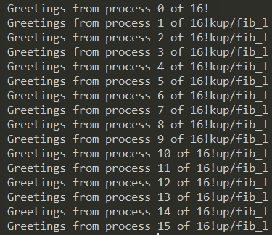

Because strlen(greeting) does not include the null character “\0” and therefore this is not sent. If MAX_STRING is used instead of strlen(greeting) then the output becomes:

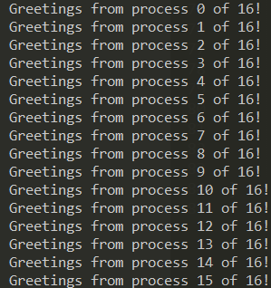

This is because now, the entire size of the greeting message can be sent.

Ex 3.2 pg. 140

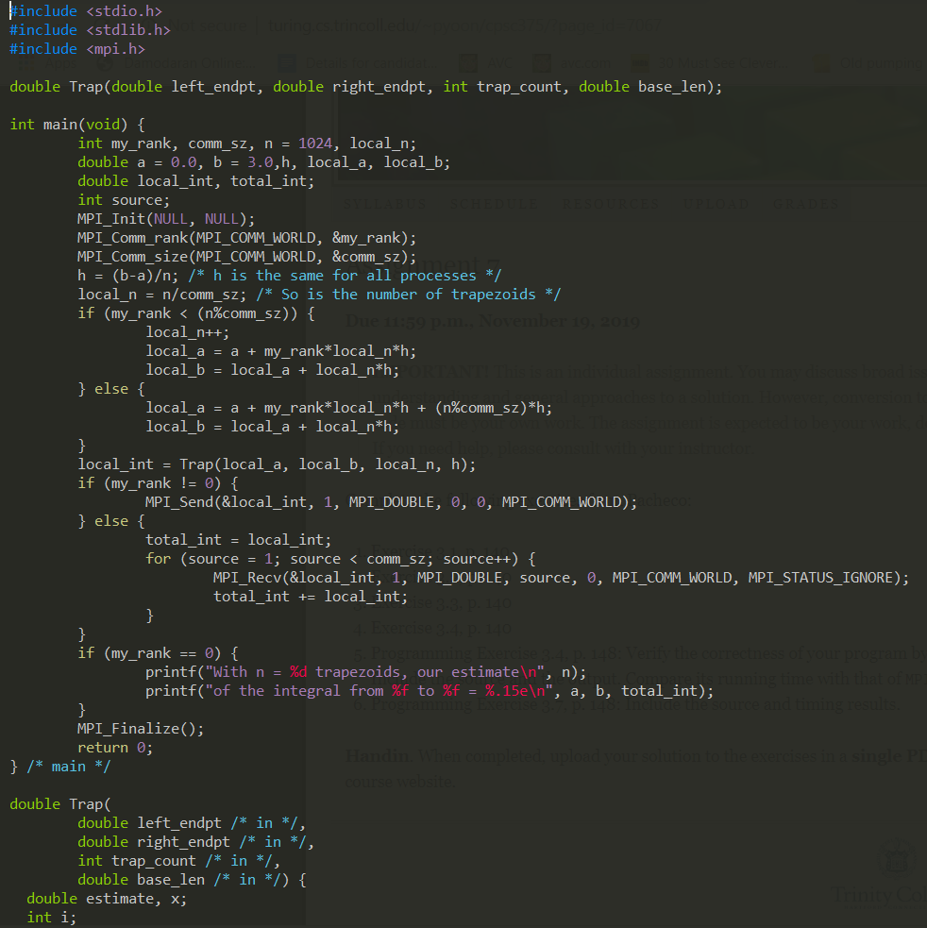

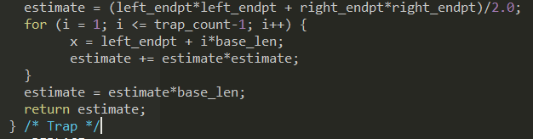

Ex 3.3 pg. 140

In the trapezoidal rule program, the variables my_rank, local_n, local_a, local_b, local_int, total_int are local variables since their values are can be different for each process. On the other hand, the variables comm_sz, n, a, b and h are all global variables as they have constant values across all processes.

Ex 3.4 pg. 140

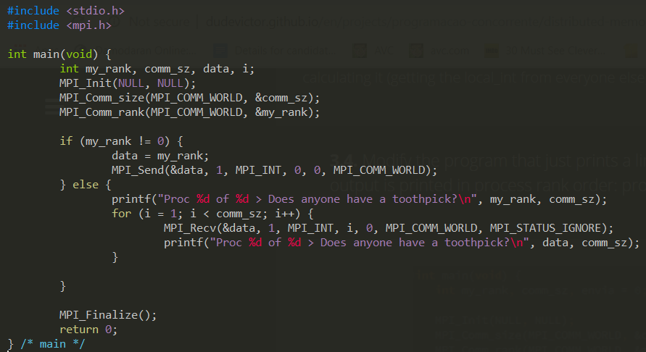

Programming Exercise 3.4, p. 148

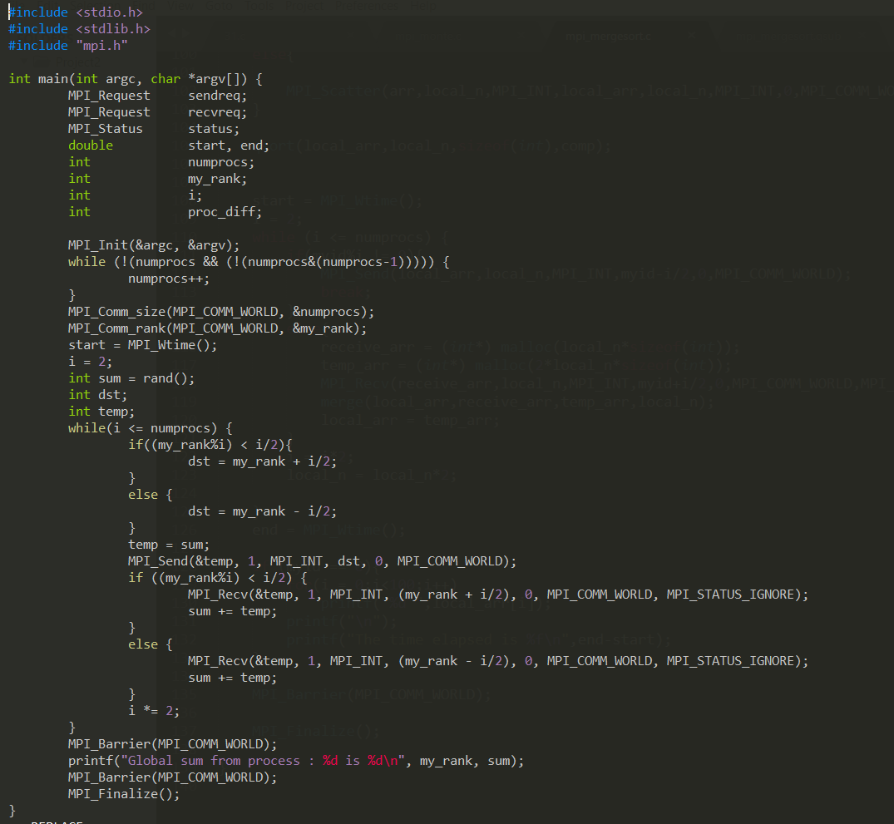

Output for test cases:

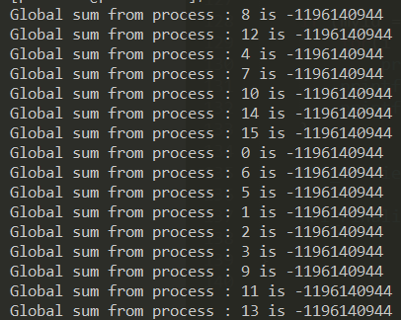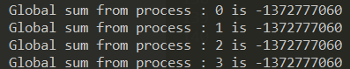

Programming Exercise 3.7, p. 148

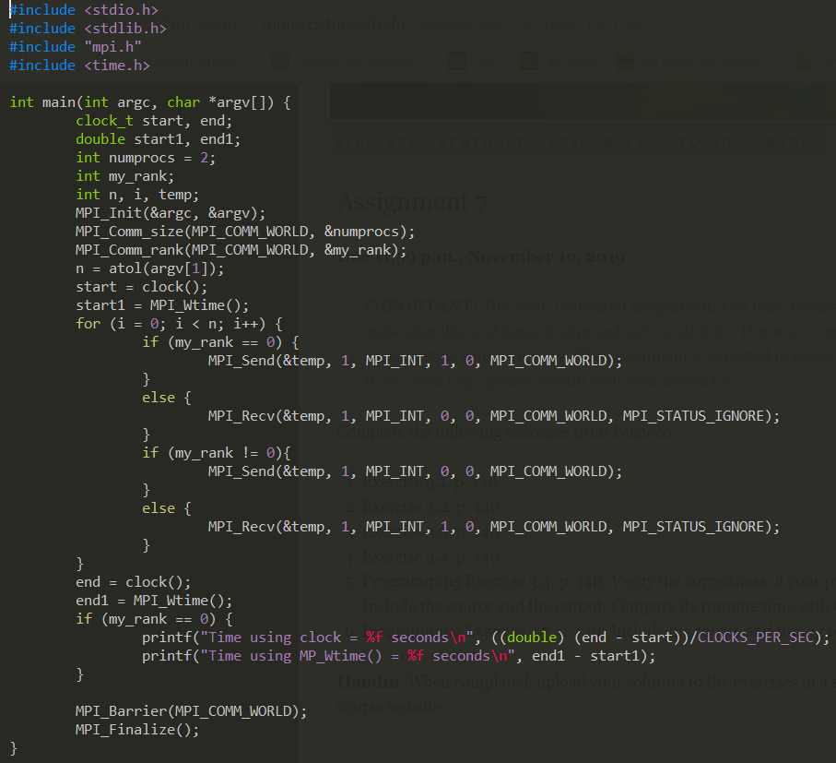

Output for various test runs:

|  |  |  |
| --- | --- | --- |
| Block size | Clock time (s) | MPI_Wtime (s) |
| 1000 | 0.000000 | 0.002141 |
| 10000 | 0.010000 | 0.015582 |
| 100000 | 0.150000 | 0.149632 |
| 1000000 | 1.100000 | 1.102033 |

Times with clock time seem to be slightly smaller than or approximately equal to times with MPI_Wtime().