***LEARNING MANAGEMENT SYSTEM***

Submitted by:

Gorav Hazarika, Ritesh Verma, Sharat Chetia

Under the guidance of

**Mr. Prabhat Das**

(PGT-IP)



**ARMY PUBLIC SCHOOL JORHAT**

**CHARAIBAHI, MILITARY STATION**

**Assam-785616**

**CERTIFICATE BY PRINCIPAL**

This is to certify that this project report entitled “**Learning Management System**” submitted by **Gorav Hazarika, Ritesh Verma, Sharat Chetia**

to Army Public School Jorhat has been examined and evaluated.

The report has been prepared as per the regulations of CBSE and qualifies to be accepted.

Date:

Place:

Mrs. Firdausi Sultana Hazarika

(Principal)

Army Public School, Jorhat

**CERTIFICATE BY EXAMINERS**

This is to certify that this project report entitled “**Learning Management System**” is the bonafide work of who carried out the project work under my supervision and guidance.

To the best of my knowledge, the matter embodied in the report has not been submitted to any other institute for the award of any other degree.

Date:

Place:

External Examiner Mr. Prabhat Das (Internal Examiner)

**ACKNOWLEDGEMENT**

I take this opportunity to extend my heart full gratitude to Army Public School Jorhat for providing me the opportunity.

I am highly grateful to my guide Mr. Prabhat Das, PGT-IP, Army Public School Jorhat for giving us the opportunity to work under him and providing us an ample guidance and support through the project.

Lastly, I would also like to thank the authors whose publications guided us regarding our project.

**DECLARATION**

I admit that this report is of my own work and all the sources of the information used in this report have fully acknowledged.

I hereby declare that the dissertation work entitled “**Learning Management System**” submitted to the Army Public School Jorhat, is prepared by me and was not submitted to any other institution for award of any other degree.

Date:

Place:

Signature

**ABSTRACT**

In the era of today’s world, where the globe is increasing it’s fecundity monumentally, the introduction of computers has contributed to a boundless scale to this everlasting race. The invention of computers and mechanisation has eased the human difficulties, where one had to store all the data in the form of physical means, adding to the efforts, space and expenditure.

With the introduction of databases, one can store a colossal data in the form of bytes and bits in a single computer, compared to the earlier times where one had to keep a raw data in the form of files, folders, cupboards, etc., which had to get themselves put in a huge amount of effort. All the schools in today’s era have the use of databases as their primary mode of storage.

**CONTENTS**

* Tools and Library 1
* Introduction 5
* Project overview 6
* Source code 15
* Commands in SQL 39
* Conclusion and Future work 40
* References 41

**LIST OF FIGURES**

**Figures Page no.**

* Fig 1.User information table 6
* Fig 2.1 Login Procedure for new users 6
* Fig 2.2 Login for registered users 6
* Fig 3. Main menu 7
* Fig4. Output for option 1 7
* Fig5. Output for option 2 7
* Fig6. Output for option 3 8
* Fig 7. Output for option 4 8
* Fig 8.Output for option 5 8
* Fig 9. Output for option 6 9
* Fig 9.1 Output for option 6(1) 9
* Fig 9.2 Output for option 6(1) 10
* Fig 9.3. Output for option 6(2) 10
* Fig 9.4. Output for option 6(2) 11
* Fig 10. Output for option 7 11
* Fig 10.1. Output for option 7(1) 12
* Fig 10.2. Output for option 7(2) 12
* Fig 11. Output for option 8 13
* Fig 11.1. Output for option 8(4) 13
* Fig 11.2. Output for option 8(4) Chapter1 13
* Fig 12. Logout 14
* Fig 12.1.Output for option 9 14

**TOOLS AND LIBRARIES USED**

**MySQL**

MySQL is the world's most used relational [database management system](https://www.limswiki.org/index.php?title=Database_management_system&action=edit&redlink=1) (RDBMS) that runs as a server providing multi-user access to a number of databases. It is named after developer Michael Widenius' daughter, My. The phrase "SQL" stands for "structured query language."

[Open source projects](https://www.limswiki.org/index.php/Category:Open-source_software) that require a full-featured database management system often use MySQL. Applications which use MySQL databases include:

[TYPO3](https://www.limswiki.org/index.php/TYPO3), [Joomla](https://www.limswiki.org/index.php/Joomla), [WordPress](https://www.limswiki.org/index.php/WordPress), [phpBB](https://www.limswiki.org/index.php/PhpBB), [Drupal](https://www.limswiki.org/index.php/Drupal), and other software built on the LAMP software stack. MySQL is also used in many high-profile, large-scale Web products, including Wikipedia, Google (though not for searches), Facebook, and Twitter.

The free open-source version of MySQL is commonly referred to as the MySQL Community Edition. For commercial use, several paid editions are also available, offering additional functionality.[1]

**PyCharm**

PyCharm is an [integrated development environment](https://en.wikipedia.org/wiki/Integrated_development_environment) (IDE) used in [computer programming](https://en.wikipedia.org/wiki/Computer_programming), specifically for the [Python](https://en.wikipedia.org/wiki/Python_(programming_language)) language. It is developed by the [Czech](https://en.wikipedia.org/wiki/Czech_Republic) company [JetBrains](https://en.wikipedia.org/wiki/JetBrains).[[5]](https://en.wikipedia.org/wiki/PyCharm#cite_note-5) It provides code analysis, a graphical debugger, an integrated unit tester, integration with [version control systems](https://en.wikipedia.org/wiki/Revision_control) (VCSes), and supports web development with [Django](https://en.wikipedia.org/wiki/Django_(web_framework)) as well as [data science](https://en.wikipedia.org/wiki/Data_science) with [Anaconda](https://en.wikipedia.org/wiki/Anaconda_(Python_distribution)).

PyCharm is [cross-platform](https://en.wikipedia.org/wiki/Cross-platform), with [Windows](https://en.wikipedia.org/wiki/Windows), [macOS](https://en.wikipedia.org/wiki/MacOS) and [Linux](https://en.wikipedia.org/wiki/Linux) versions. The Community Edition is released under the [Apache License](https://en.wikipedia.org/wiki/Apache_License), and there is also Professional Edition with extra features – released under a [proprietary license](https://en.wikipedia.org/wiki/Proprietary_software). [2]

**Pandas**

In [computer programming](https://en.wikipedia.org/wiki/Computer_programming), pandas is a [software library](https://en.wikipedia.org/wiki/Software_library) written for the [Python programming language](https://en.wikipedia.org/wiki/Python_(programming_language)) for data manipulation and analysis. In particular, it offers data structures and operations for manipulating numerical tables and [time series](https://en.wikipedia.org/wiki/Time_series). It is [free software](https://en.wikipedia.org/wiki/Free_software) released under the [three-clause BSD license](https://en.wikipedia.org/wiki/3-clause_BSD_license). The name is derived from the term "[panel data](https://en.wikipedia.org/wiki/Panel_data)", an [econometrics](https://en.wikipedia.org/wiki/Econometrics) term for data sets that include observations over multiple time periods for the same individuals. Its name is a play on the phrase "Python data analysis" itself. [Wes McKinney](https://en.wikipedia.org/wiki/Wes_McKinney) started building what would become pandas at [AQR Capital](https://en.wikipedia.org/wiki/AQR_Capital) while he was a researcher there from 2007 to 2010. [3]

**Numpy**

NumPy is a library for the [Python programming language](https://en.wikipedia.org/wiki/Python_(programming_language)), adding support for large, multi-dimensional [arrays](https://en.wikipedia.org/wiki/Array_data_structure) and [matrices](https://en.wikipedia.org/wiki/Matrix_(math)), along with a large collection of [high-level](https://en.wikipedia.org/wiki/High-level_programming_language) [mathematical](https://en.wikipedia.org/wiki/Mathematics) [functions](https://en.wikipedia.org/wiki/Function_(mathematics)) to operate on these arrays. The ancestor of NumPy, Numeric, was originally created by [Jim Hugunin](https://en.wikipedia.org/wiki/Jim_Hugunin) with contributions from several other developers. In 2005, [Travis Oliphant](https://en.wikipedia.org/wiki/Travis_Oliphant) created NumPy by incorporating features of the competing Numarray into Numeric, with extensive modifications. NumPy is [open-source software](https://en.wikipedia.org/wiki/Open-source_software) and has many contributors. [[4]](https://en.wikipedia.org/wiki/NumPy#cite_note-Nature-5)

**Matplotlib**

Matplotlib is a [plotting](https://en.wikipedia.org/wiki/Plotter) [library](https://en.wikipedia.org/wiki/Library_(computer_science)) for the [Python](https://en.wikipedia.org/wiki/Python_(programming_language)) programming language and its numerical mathematics extension [NumPy](https://en.wikipedia.org/wiki/NumPy). It provides an [object-oriented](https://en.wikipedia.org/wiki/Object-oriented_programming) [API](https://en.wikipedia.org/wiki/API) for embedding plots into applications using general-purpose [GUI toolkits](https://en.wikipedia.org/wiki/GUI_toolkit) like [Tkinter](https://en.wikipedia.org/wiki/Tkinter), [wxPython](https://en.wikipedia.org/wiki/WxPython), [Qt](https://en.wikipedia.org/wiki/Qt_(software)), or [GTK+](https://en.wikipedia.org/wiki/GTK%2B). There is also a [procedural](https://en.wikipedia.org/wiki/Procedural_programming) "pylab" interface based on a [state machine](https://en.wikipedia.org/wiki/State_machine) (like [OpenGL](https://en.wikipedia.org/wiki/OpenGL)), designed to closely resemble that of [MATLAB](https://en.wikipedia.org/wiki/MATLAB), though its use is discouraged. [SciPy](https://en.wikipedia.org/wiki/SciPy) makes use of Matplotlib.

Matplotlib was originally written by [John D. Hunter](https://en.wikipedia.org/wiki/John_D._Hunter). Since then it has an active development community and is distributed under a [BSD-style license](https://en.wikipedia.org/wiki/BSD_licenses). Michael Droettboom was nominated as matplotlib's lead developer shortly before John Hunter's death in August 2012 and was further joined by Thomas Caswell.[[5]](https://en.wikipedia.org/wiki/Matplotlib#cite_note-6)

**Mysql.connector**

MySQL Connector/Python enables Python programs to access MySQL databases, using an API that is compliant with the Python Database API Specification v2.0 (PEP 249).

For notes detailing the changes in each release of Connector/Python, see MySQL Connector/Python Release Notes.

MySQL Connector/Python includes support for:

1. Almost all features provided by MySQL Server up to and including MySQL Server version 8.0.
2. Connector/Python 8.0 also supports X DevAPI. For documentation of the concepts and the usage of MySQL Connector/Python with X DevAPI, see X DevAPI User Guide.
3. Converting parameter values back and forth between Python and MySQL data types, for example Python datetime and MySQL DATETIME. You can turn automatic conversion on for convenience, or off for optimal performance.
4. All MySQL extensions to standard SQL syntax.
5. Protocol compression, which enables compressing the data stream between the client and server.
6. Connections using TCP/IP sockets and on Unix using Unix sockets.
7. Secure TCP/IP connections using SSL.
8. Self-contained driver. Connector/Python does not require the MySQL client library or any Python modules outside the standard library.[6]

**Pywhatkit**

Python offers numerous inbuilt libraries to ease our work. Among them pywhatkit is a Python library for sending WhatsApp messages at a certain time, it has several other features too.

Following are some features of pywhatkit module:

1. Send WhatsApp messages.
2. Play a YouTube video.
3. Perform a Google Search.
4. Get information on a particular topic.

The pywhatkit module can also be used for converting text into handwritten text images.[7]

**Webrowser**

The webbrowser module is a convenient web browser controller in the Python programming language. This module offers a high-level interface that enables showing the documents based on the web. Under most circumstances, we can call the open() function from the webbrowser module to perform the right thing.

We can use the webbrowser module as a Command-Line Interface (CLI) tool. This module accepts a URL as the parameter. It accepts the following optional parameters:

1. -n: This parameter allows us to open the URL in a new browser window, if possible.
2. -t: This parameter allows us to open the URL in a new browser page ("tab").

The options are, naturally, mutually exclusive.[8]

**Smtplib**

Python offers a ` library to send emails- “SMTP lib”. “smtplib” creates a Simple Mail Transfer Protocol client session object which is used to send emails to any valid email id on the internet. The Port number used here is ‘587’ if you want to send mail using a website other than Gmail.[9]

**Random**

Python Random module is an in-built module of Python which is used to generate random numbers. These are pseudo-random numbers means these are not truly random. This module can be used to perform random actions such as generating random numbers, print random a value for a list or string, etc.[10]

**INTRODUCTION**

The theme of our project is ‘**LEARNING MANAGEMENT SYSTEM’**. This project is fine thought to make complex procedure of student analysis in an easy manner which is systematic, modular designed, selective menu based user display. The modular design and constructed is very much user oriented in which user can easily understand the tools and can do edit of his own choice. The system possesses many applications but it is made by focusing on maintaining record of student’s data in a computerized rather than time taking and cumbersome manual system.

The program is very user friendly. The interface can be easily operated by people with less computer knowledge without an error.

**PROJECT OVERVIEW**

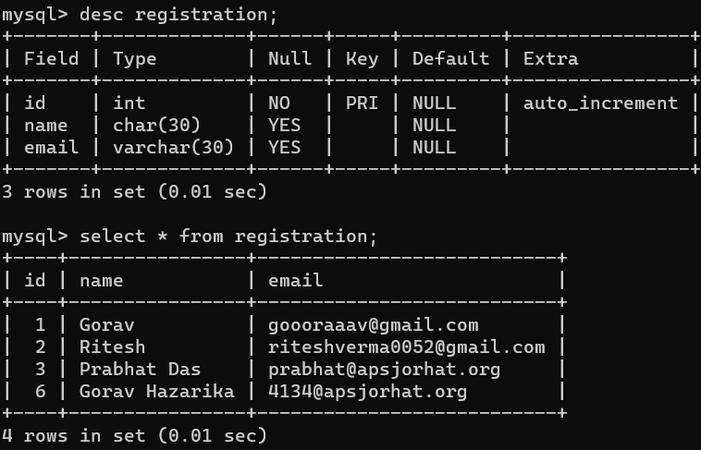

**Figure 1:All the information regarding the users are stored in this table**

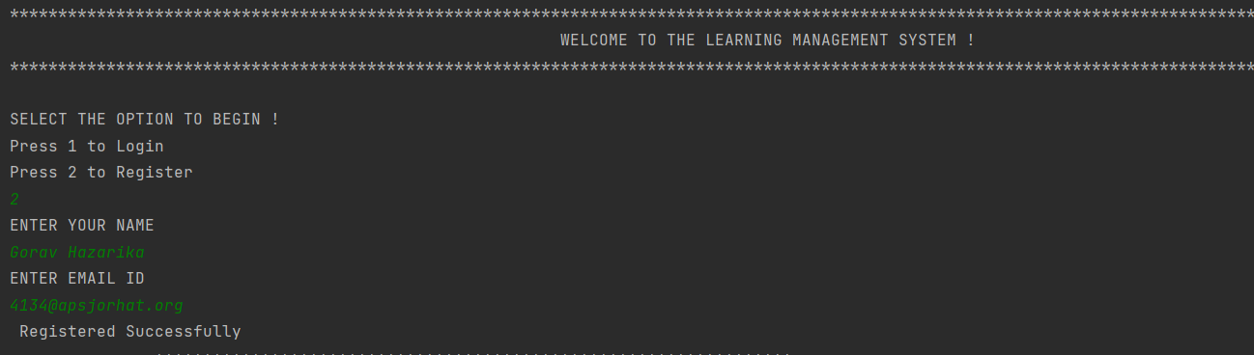

**Figure 2.1: Login procedures for new users**

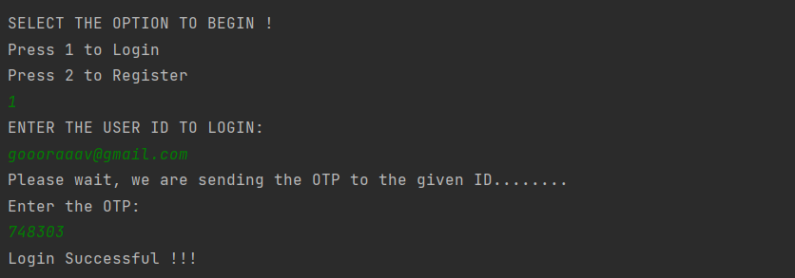**Figure 2.2 : When the user chooses option 1 the program asks for his/her email address, on entering the email id, if the email id exists then the login procedure is completed.**

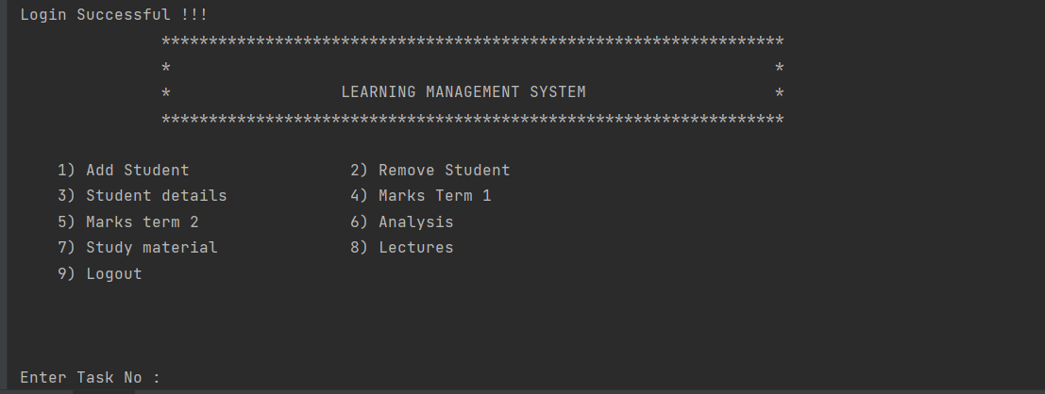

**Figure 3: After the login procedure is completed, the user is presented with the following list of options.**

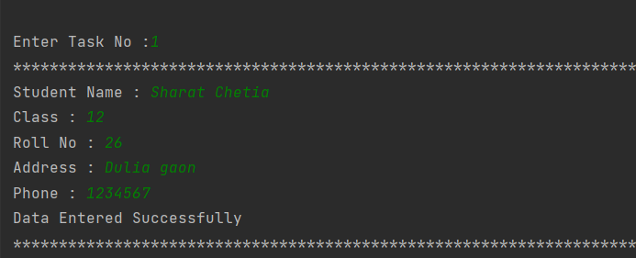

**Figure 4: Output for option 1(Add Student)**

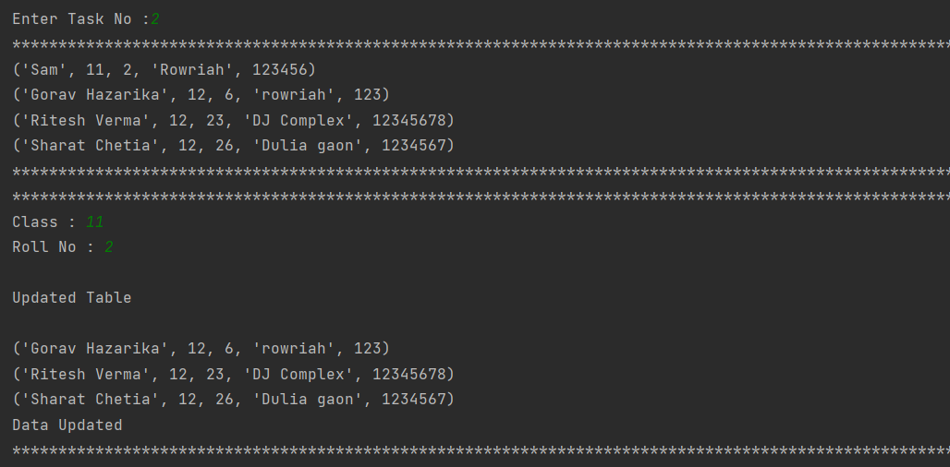

**Figure 5: Output for option 2 (Remove Student)**

**It will ask for Class and roll no of student whose details you want to remove**

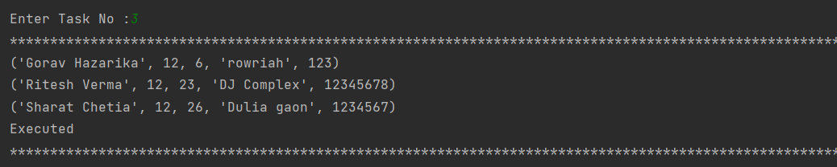

**Figure 6: Output for option 3 (Student Details)**

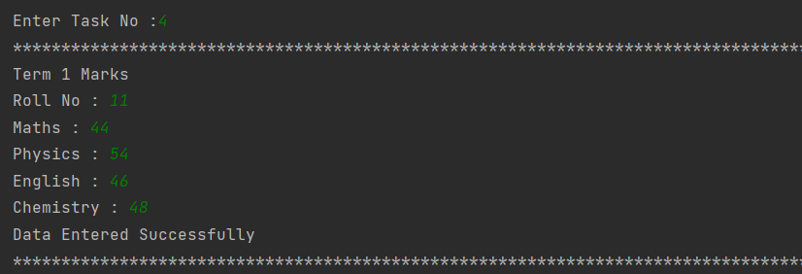

**Figure 7: Output for option 4(Term 1 Marks of Students)**

**Enter The Term 1 Marks Of The Student With The Roll no Entered**

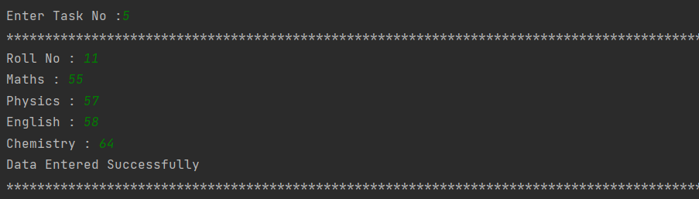

**Figure 8: Output for option 5(Term 2 Marks of Students)**

**Enter The Term 2 Marks Of The Student With The Roll no Entered**

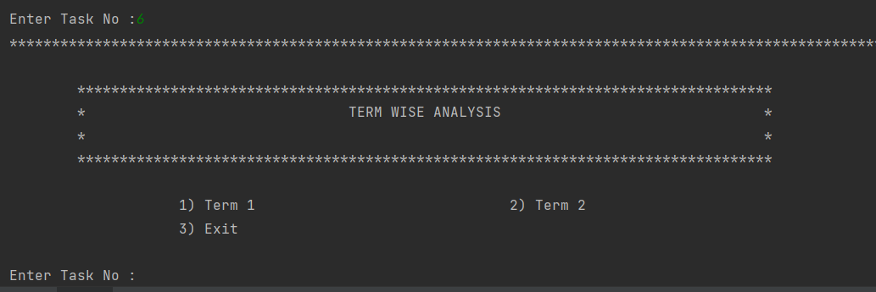

**Figure 9:Output for option 6:(Term Wise Analysis)**

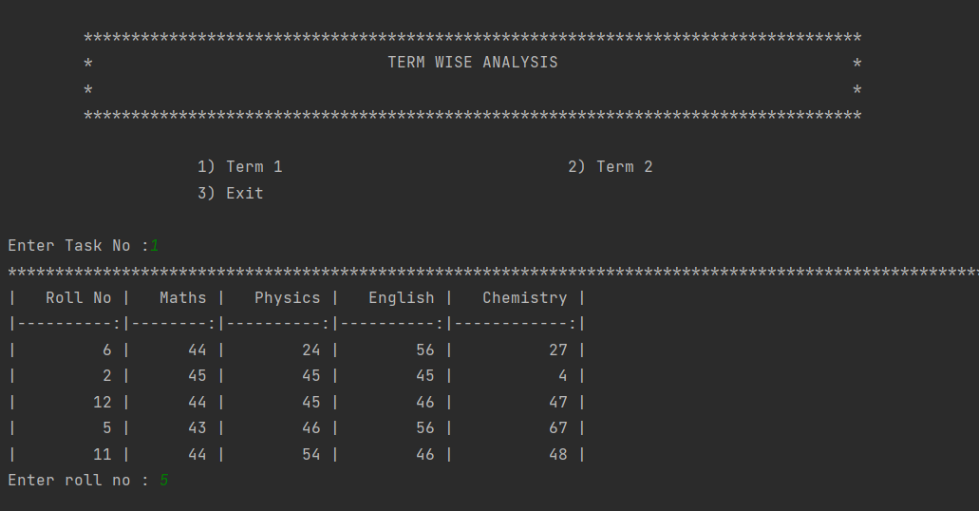

**Figure 9.1:Output for option 6 (1) :(Term 1 Marks)**

**Enter The Roll No Whose Term 1 Marks You Want To Be Displayed**

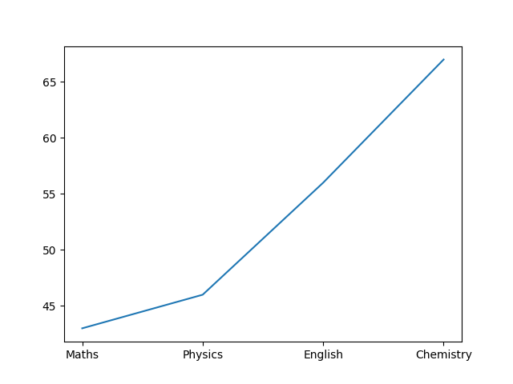

**Figure 9.2:Output for option 6 (1) :(Term 1 Marks)**

**Graphical representation**

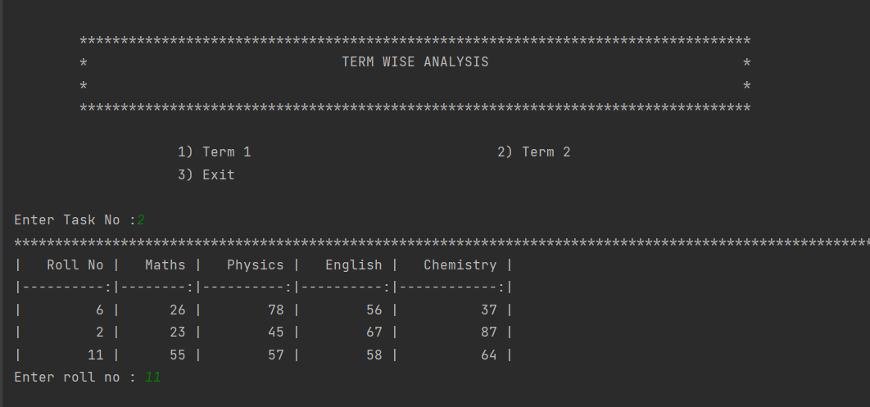

**Figure 9.3:Output for option 6 (2) :(Term 2 Marks)**

**Enter The Roll No Whose Term 2 Marks You Want To Be Displayed**

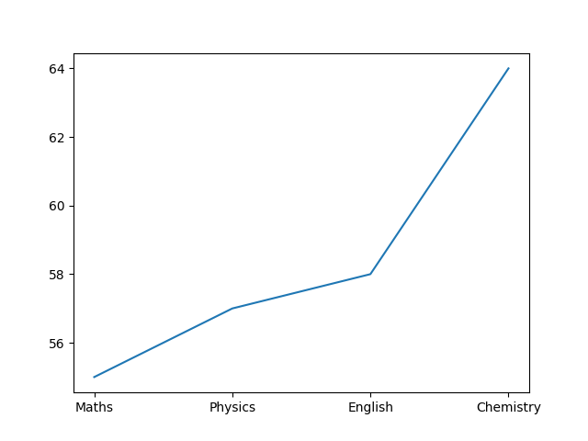

**Figure 9.4:Output for option 6 (2) :(Term 2 Marks)**

**Graphical representation**

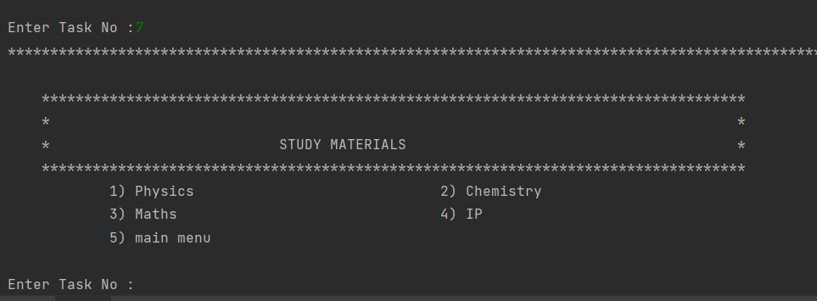

**Figure 10:Output for option 7 (Study materials)**

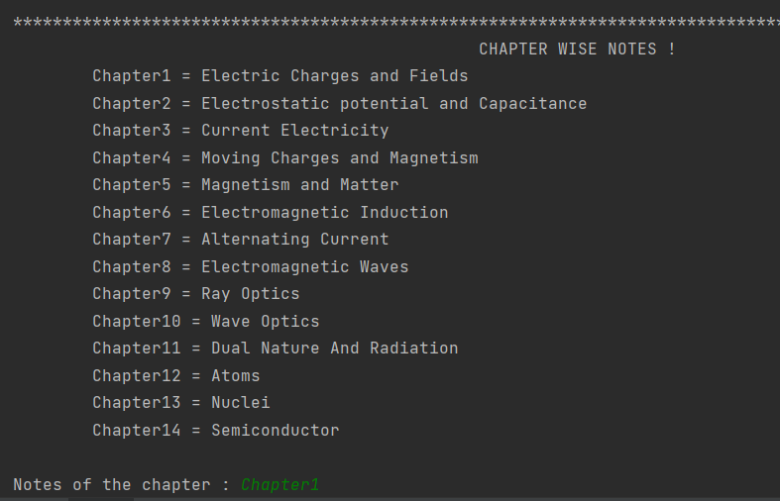

**Figure 10.1:Output for option 7(1) (Chapter Wise Notes of Physics)**

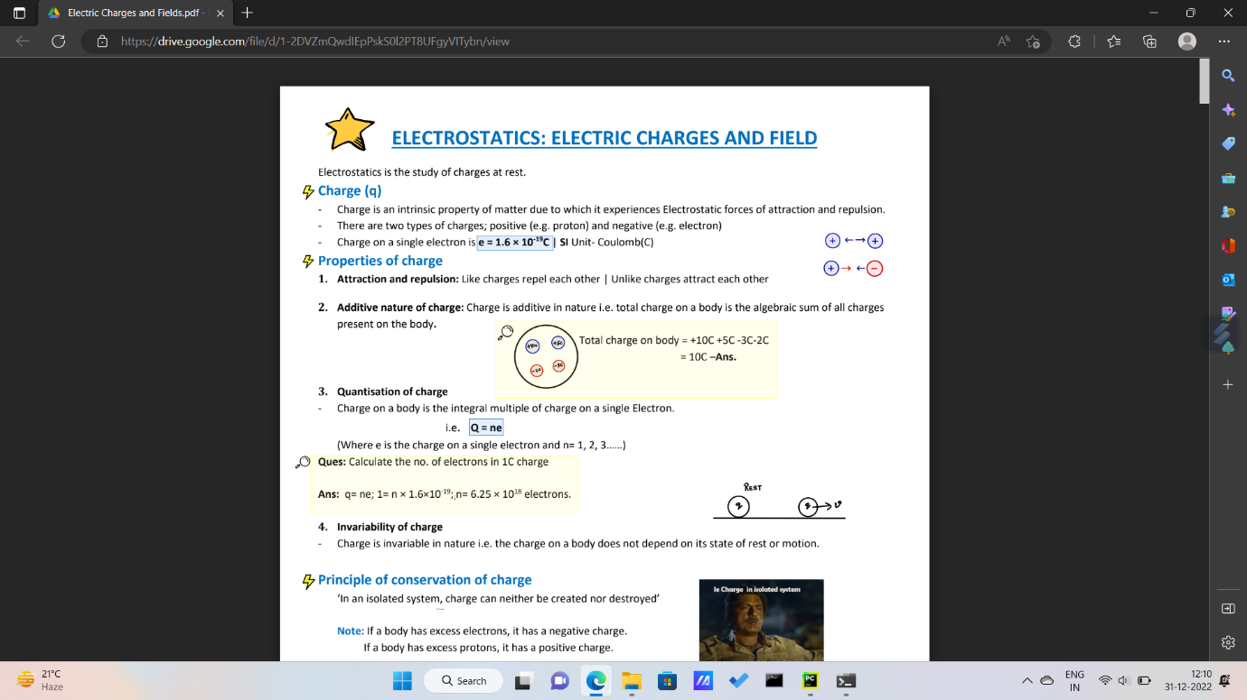

**Figure 10.2: Output For (Chapter1) Notes**

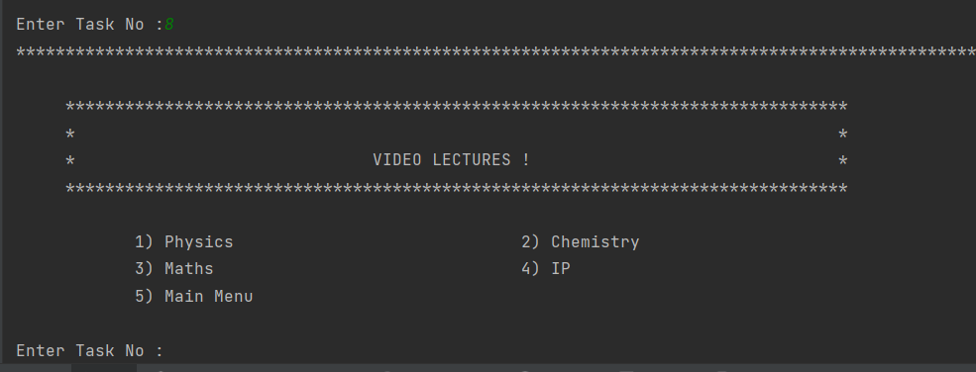

**Figure 11: Output For option 8 (Video Lectures)**

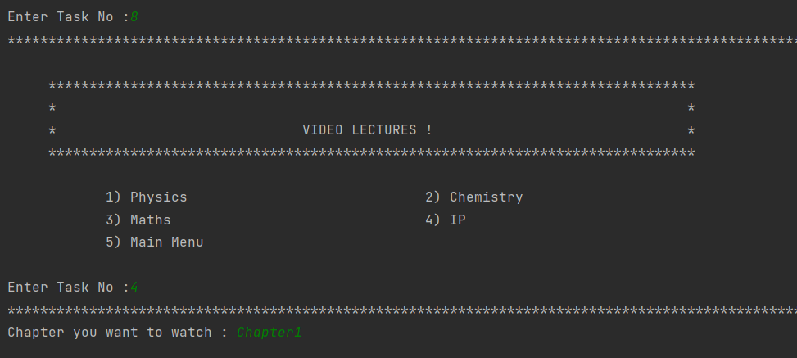

**Figure 11.1: Choose The Subject and Chapter Number Whose Video Lectures You want to access**

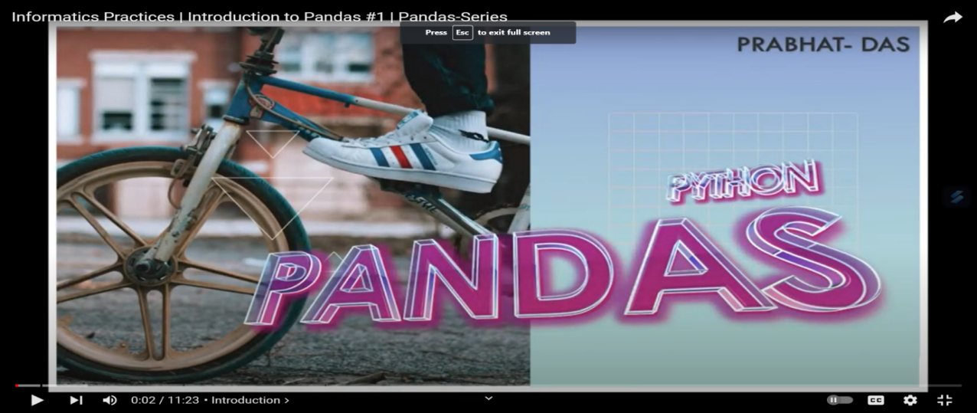

**Figure 11.2: Output for option 8(4) Chapter**

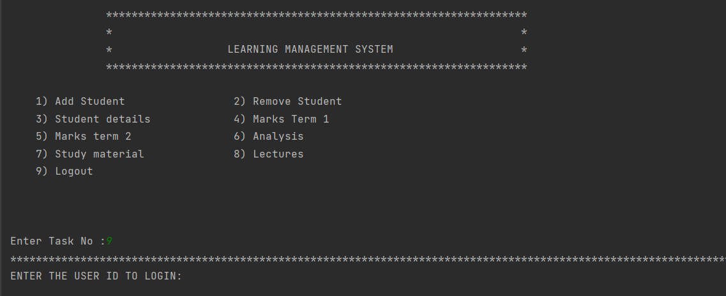

**Figure 12: Enter 9 to Logout**

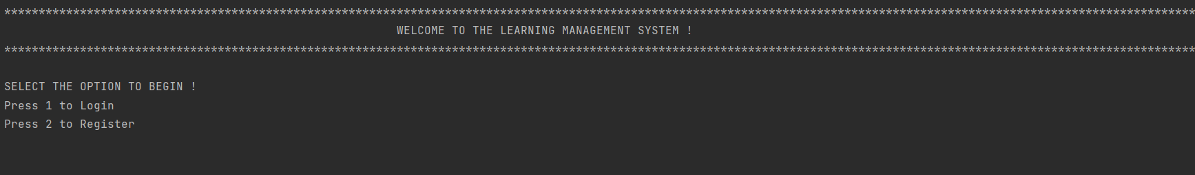

**Figure 12.1: Output for option 9 : Takes you to the login page**

**SOURCE CODE**

**Main**

**import connector as con**

**import auth**

**def registration():**

**print("ENTER YOUR NAME")**

**name=input()**

**print("ENTER EMAIL ID")**

**email=input()**

**query="insert into registration(name,email) values" +"('"+name+"','"+email+"');"**

**print(" Registered Successfully ")**

**con.cursor.execute(query)**

**con.dbc.commit()**

**def login():**

**print("ENTER THE USER ID TO LOGIN: ")**

**user_id = input()**

**fetch_query = "select * from registration;"**

**con.cursor.execute(fetch_query)**

**count = 0**

**for i in con.cursor:**

**if user_id == i[2]:**

**count = count + 1**

**print("Please wait, we are sending the OTP to the given ID........")**

**auth.auth(user_id)**

**if count == 0:**

**print("USER NOT REGISTERED !")**

**registration()**

**print("*"*176)**

**print(" WELCOME TO THE LEARNING MANAGEMENT SYSTEM !")**

**print("*"*176)**

**print(" "*176)**

**print("SELECT THE OPTION TO BEGIN !")**

**print("Press 1 to Login")**

**print("Press 2 to Register")**

**user_input=int(input())**

**if user_input==1:**

**login()**

**elif user_input==2:**

**registration()**

**import menu**

**menu.main()**

**menu.ast()**

**menu.pswd()**

**menu.rst()**

**menu.ast()**

**menu.dtails()**

**menu.mk1()**

**menu.mk2()**

**menu.Ana()**

**menu.phy()**

**menu.chem()**

**menu.meth()**

**menu.ip()**

**menu.Anan()**

**menu.main3()**

**menu.me()**

**menu.ch()**

**menu.IP()**

**menu.ph()**

**Authentication**

**import smtplib**

**import random**

**def auth(email):**

**s = smtplib.SMTP('smtp.gmail.com', 587)**

**s.starttls()**

**s.login('group2@apsjorhat.org', 'apsj#12345678')**

**otp = random.randint(111111, 999999)**

**message = str(otp)**

**s.sendmail("group2@apsjorhat.org", email, message)**

**s.quit()**

**print("Enter the OTP: ")**

**val = int(input())**

**if val == otp:**

**print("Login Successful !!!")**

**else:**

**print("Incorrect OTP !!!")**

**Connector**

**import mysql.connector as mc**

**try:**

**dbc = mc.connect(host="localhost", user="root", passwd="root", database="lms")**

**cursor = dbc.cursor()**

**except Exception as e:**

**print(e)**

**OTP Sender**

**import smtplib**

**import random**

**def auth(email):**

**s = smtplib.SMTP('smtp.gmail.com', 587)**

**s.starttls()**

**s.login('group2@apsjorhat.org', 'apsj#12345678')**

**otp = random.randint(111111, 999999)**

**message = str(otp)**

**s.sendmail("group2@apsjorhat.org", email, message)**

**s.quit()**

**print("Enter the OTP: ")**

**val = int(input())**

**if val == otp:**

**print("Login Successful !!!")**

**else:**

**print("Incorrect OTP !!!")**

**Menu**

**import mysql.connector as a**

**import matplotlib.pyplot as plt**

**import pywhatkit as kit**

**import webbrowser**

**import pandas as pd**

**con = a.connect(host="localhost", user="root", password="root")**

**c = con.cursor()**

**c.execute("use lms")**

**def ast():**

**n = input("Student Name : ")**

**c = input("Class : ")**

**r = input("Roll No : ")**

**a = input("Address : ")**

**p = input("Phone : ")**

**data = (n, c, r, a, p)**

**sql = "insert into student values(%s,%s,%s,%s,%s);"**

**c = con.cursor()**

**c.execute(sql, data)**

**con.commit()**

**print("Data Entered Successfully")**

**print("*" * 176)**

**main()**

**def rst():**

**sql="select * from student"**

**c=con.cursor()**

**c.execute(sql)**

**myresult = c.fetchall()**

**for row in myresult:**

**print(row)**

**print("*"*176)**

**print("*" * 176)**

**c = input("Class : ")**

**r = input("Roll No : ")**

**data = (c, r)**

**sql = "delete from student where Class = %s and roll_no = %s"**

**c = con.cursor()**

**c.execute(sql, data)**

**con.commit()**

**print(" "*176)**

**print("Updated Table")**

**print(" "*176)**

**sql = "select * from student"**

**c = con.cursor()**

**c.execute(sql)**

**myresult = c.fetchall()**

**for row in myresult:**

**print(row)**

**print("Data Updated")**

**print('*' * 176)**

**main()**

**def dtails():**

**sql = "select * from student"**

**c.execute(sql)**

**myresult = c.fetchall()**

**for row in myresult:**

**print(row)**

**print("Executed")**

**print("*" * 176)**

**main()**

**def mk1():**

**print("Term 1 Marks")**

**n = input("Roll No : ")**

**c = input("Maths : ")**

**r = input("Physics : ")**

**a = input("English : ")**

**p = input("Chemistry : ")**

**data = (n, c, r, a, p)**

**sql = "insert into marks values(%s,%s,%s,%s,%s);"**

**c = con.cursor()**

**c.execute(sql, data)**

**con.commit()**

**print("Data Entered Successfully")**

**print("*" * 176)**

**main()**

**def mk2():**

**n = input("Roll No : ")**

**c = input("Maths : ")**

**r = input("Physics : ")**

**a = input("English : ")**

**p = input("Chemistry : ")**

**data = (n, c, r, a, p)**

**sql = "insert into marks2 values(%s,%s,%s,%s,%s);"**

**c = con.cursor()**

**c.execute(sql, data)**

**con.commit()**

**print("Data Entered Successfully")**

**print("*" * 176)**

**main()**

**def Ana():**

**def term1():**

**sql = "select * from marks"**

**c = con.cursor()**

**c.execute(sql)**

**myresult = c.fetchall()**

**data=[]**

**for row in myresult:**

**data.append(row) #Copy this for Term 2**

**df=pd.DataFrame(data,columns=['Roll No','Maths','Physics','English','Chemistry'])**

**print(df.to_markdown(index=False))**

**roll = input("Enter roll no : ")**

**sql = "select maths,Physics,English,Chemistry from marks where roll_no = " + roll + ";"**

**c = con.cursor()**

**d = c.execute(sql)**

**for i in c:**

**marks = list(i)**

**subjects = ["Maths", "Physics", "English", "Chemistry"]**

**plt.plot(subjects, marks)**

**plt.show()**

**print("*" * 176)**

**Anan()**

**def term2():**

**sql = "select * from marks2"**

**c = con.cursor()**

**c.execute(sql)**

**myresult = c.fetchall()**

**data=[]**

**for row in myresult:**

**data.append(row) # Copy this for Term 2**

**df = pd.DataFrame(data, columns=['Roll No', 'Maths', 'Physics', 'English', 'Chemistry'])**

**print(df.to_markdown(index=False))**

**roll = input("Enter roll no : ")**

**sql = "select maths,Physics,English,Chemistry from marks2 where roll_no = " + roll + ";"**

**c = con.cursor()**

**d = c.execute(sql)**

**for i in c:**

**marks = list(i)**

**subjects = ["Maths", "Physics", "English", "Chemistry"]**

**plt.plot(subjects, marks)**

**plt.show()**

**print("*" * 176)**

**Anan()**

**def Anan():**

**print("""**

**\*\*\*\*\*\*\*\*\*\*\*\*\*\*\*\*\*\*\*\*\*\*\*\*\*\*\*\*\*\*\*\*\*\*\*\*\*\*\*\*\*\*\*\*\*\*\*\*\*\*\*\*\*\*\*\*\*\*\*\*\*\*\*\*\*\*\*\*\*\*\*\***

**TERM WISE ANALYSIS**

**\*\*\*\*\*\*\*\*\*\*\*\*\*\*\*\*\*\*\*\*\*\*\*\*\*\*\*\*\*\*\*\*\*\*\*\*\*\*\*\*\*\*\*\*\*\*\*\*\*\*\*\*\*\*\*\*\*\*\*\*\*\*\*\*\*\*\*\*\*\*\*\*\*\*\***

**1) Term 1 2) Term 2**

**3) Exit**

**""")**

**choice = input("Enter Task No :")**

**print("*" * 176)**

**if (choice == "1"):**

**term1()**

**elif (choice == "2"):**

**term2()**

**elif (choice == "3"):**

**main()**

**else:**

**print("Wrong Choice")**

**main()**

**Anan()**

**def phy():**

**Physics={"Chapter1": "https://www.youtube.com/watch?v=zHxYZJpb5G0",**

**"Chapter2" : "https://www.youtube.com/watch?v=ueqMlm8UPQA",**

**"Chapter3" : "https://www.youtube.com/watch?v=A2qXSSYL9lM",**

**"Chapter4" : "https://www.youtube.com/watch?v=QUPXVv-ZhiE",**

**"Chapter5" : "https://www.youtube.com/watch?v=-RfdFKa2Jgc",**

**"Chapter6" : "https://www.youtube.com/watch?v=qPVoaN0Mxkg",**

**"Chapter7" : "https://www.youtube.com/watch?v=t_2V7-gN6Fw",**

**"Chapter8" : "https://www.youtube.com/watch?v=CE3-X02W7AU",**

**"Chapter9" : "https://www.youtube.com/watch?v=9dopYMCpdJQ",**

**"Chapter10" : "https://www.youtube.com/watch?v=EqtkqcPJpyE",**

**"Chapter11" : "https://www.youtube.com/watch?v=xbd75rGqiWU",**

**"Chapter12" : "https://www.youtube.com/watch?v=3ahItMZDKO0",**

**"Chapter13" : "https://www.youtube.com/watch?v=ef6DR5eA4x4",**

**"Chapter14" : 'https://www.youtube.com/watch?v=F5IpIHzBvLQ',**

**}**

**for i in Physics:**

**a=input("Chapter you want to watch : ")**

**b=Physics[a]**

**kit.playonyt(b)**

**main2()**

**def chem():**

**Chemistry={"Chapter1": "https://www.youtube.com/watch?v=e8cPTtEueC0",**

**"Chapter2" : "https://www.youtube.com/watch?v=NZ9djVzSqQE",**

**"Chapter3" : "https://www.youtube.com/watch?v=UOGMqrkJYlM",**

**"Chapter4" : "https://www.youtube.com/watch?v=WIOhOF14udA",**

**"Chapter5" : "https://www.youtube.com/watch?v=PpuPUMfr91Y",**

**"Chapter6" : "https://www.youtube.com/watch?v=PPKkaT4ThEk",**

**"Chapter7" : "https://www.youtube.com/watch?v=WxZLrSY0dRE",**

**"Chapter8" : "https://www.youtube.com/watch?v=nwgktpWVSeI",**

**"Chapter9" : "https://www.youtube.com/watch?v=vwS4wO3W4eg",**

**"Chapter10" : "https://www.youtube.com/watch?v=gle54Yb1Q34"**

**}**

**for i in Chemistry:**

**a=input("Chapter you want to watch : ")**

**b=Chemistry[a]**

**kit.playonyt(b)**

**main2()**

**def meth():**

**maths={"Chapter1": "https://youtu.be/805ElUjEJ1I",**

**"Chapter2" : "https://youtu.be/nf2id-6PrQY",**

**"Chapter3" : "https://youtu.be/hyhktV5pxrE",**

**"Chapter4" : "https://youtu.be/U4j8Pw4hV5U",**

**"Chapter5" : "https://youtu.be/3v--OCXUgYY",**

**"Chapter6" : "https://www.youtube.com/watch?v=6Nk8YoHgnss",**

**"Chapter7" : "https://www.youtube.com/watch?v=hXOrQ0Ao4UE",**

**"Chapter8" : "https://www.youtube.com/watch?v=qEU2oKUNosA",**

**"Chapter9" : "https://www.youtube.com/watch?v=HzUPPCfcw64",**

**"Chapter10" : "https://www.youtube.com/watch?v=NEj70xMyRIk",**

**"Chapter11" : "https://www.youtube.com/watch?v=jCluGlqH70M",**

**"Chapter12" : "https://www.youtube.com/watch?v=9T3HfRnvpo8",**

**"Chapter13" : "https://www.youtube.com/watch?v=vO9zVl0fXZA",**

**}**

**for i in maths:**

**a=input("Chapter you want to watch : ")**

**b=maths[a]**

**kit.playonyt(b)**

**main2()**

**def ip():**

**ip={"Chapter1": "https://youtu.be/Caun35Wc82s",**

**"Chapter2" : "https://www.youtube.com/watch?v=Oj-vA63nsBI&list=PLF_7kfnwLFCFnjki8KSeTQHyJ7OkdBdNA",**

**"Chapter3" : "https://www.youtube.com/watch?v=TOXF8LXEFJw&list=PLF_7kfnwLFCFW27SD2cKamlTUde0OurJS",**

**"Chapter4" : "https://www.youtube.com/watch?v=daPAcFFSFdY&list=PLF_7kfnwLFCGzzyaPRyNjSXRRR7W_qmny",**

**"Chapter5" : "https://www.youtube.com/watch?v=zQwBW0HqEQA&list=PLYxMlXeOofIVFzJybpSfAM5pbbhUwxYrn",**

**}**

**for i in ip:**

**a=input("Chapter you want to watch : ")**

**b=ip[a]**

**kit.playonyt(b)**

**main2()**

**#Notes of physics**

**def ph():**

**Physics={"Chapter1": "https://drive.google.com/file/d/1-2DVZmQwdIEpPskS0l2PT8UFgyVITybn/view",**

**"Chapter2" : "https://drive.google.com/file/d/1f10LrgSw9uxFG0o8k9fzDF2K3aPGPbpM/view",**

**"Chapter3" : "https://drive.google.com/file/d/1z35mqk4zHD1GHVp1Drdo5gAK5YknH6yP/view",**

**"Chapter4" : "https://drive.google.com/file/d/16rex-dJUGyZlQQC76myU0VTtPGVmb44S/view",**

**"Chapter5" : "https://drive.google.com/file/d/1EJEOrlk8JMn6Nll5a8dSlWi_GfhmSlkk/view",**

**"Chapter6" : "https://drive.google.com/file/d/16e2eCkGuk3zAOFdPZQb2Ux9RsoE4Ghyq/view",**

**"Chapter7" : "https://drive.google.com/file/d/1-9h2P2MyM3fyijpQx4li-YxSun1uWkUJ/view",**

**"Chapter8" : "https://drive.google.com/file/d/1SG3kseUoplzTKNrc42aKLHGGBy4SeIRV/view",**

**"Chapter9" : "https://drive.google.com/file/d/1WpEYNFeml_oYklO7MgThHLJW2jEykHQ6/view",**

**"Chapter10" : "https://mycbseguide.com/blog/wave-optics-class-12-notes-physics/",**

**"Chapter11" : "https://drive.google.com/file/d/15QtAgAClibib3Mlm8_ZrF3wuZpnqibKv/view",**

**"Chapter12" : "https://drive.google.com/file/d/1irbay09SxjDtbs81tEJr_3Id1s1Mg30o/view",**

**"Chapter13" : "https://www.ndjtuition.com/2019/03/atom-and-nuclei-class-12th-handmade.html",**

**"Chapter14" : "https://www.vedantu.com/revision-notes/cbse-class-12-physics-notes-chapter-14-semiconductor-electronic-material-devices-and-simple-circuits"**

**}**

**for i in Physics:**

**print(""" CHAPTER WISE NOTES !**

**Chapter1 = Electric Charges and Fields**

**Chapter2 = Electrostatic potential and Capacitance**

**Chapter3 = Current Electricity**

**Chapter4 = Moving Charges and Magnetism**

**Chapter5 = Magnetism and Matter**

**Chapter6 = Electromagnetic Induction**

**Chapter7 = Alternating Current**

**Chapter8 = Electromagnetic Waves**

**Chapter9 = Ray Optics**

**Chapter10 = Wave Optics**

**Chapter11 = Dual Nature And Radiation**

**Chapter12 = Atoms**

**Chapter13 = Nuclei**

**Chapter14 = Semiconductor**

**""")**

**a=input("Notes of the chapter : ")**

**b=Physics[a]**

**webbrowser.open_new(b)**

**main3()**

**#Notes of Chemistry**

**def ch():**

**Chemistry={"Chapter1": "https://drive.google.com/file/d/1c0sQfgKbWJOewMJOV71stPWzTetYxD9n/view",**

**"Chapter2" :"https://drive.google.com/file/d/1gzD0ILpI2cOetL01TQ6kdyjRRW3tpkt4/view",**

**"Chapter3" :"https://drive.google.com/file/d/1ckA6tBheTLSEaouKhq72Cfq09c6onvbx/view",**

**"Chapter4" :"https://drive.google.com/file/d/1uaKhkW4d1uReROMGeJOPW5I6dIzNf6WU/view",**

**"Chapter5" :"https://drive.google.com/file/d/1J-ggGgBaG1ENG0AbF-rrQisht6a8WsDt/view",**

**"Chapter6" :"https://drive.google.com/file/d/1oybh2Rprjj6R3SJTqEbWDZkN4E841YAp/view",**

**"Chapter7" :"https://drive.google.com/file/d/1qbXJsLjqiMD8rIfP_a-kM8xDZ0ql0eZ7/view",**

**"Chapter8" :"https://drive.google.com/file/d/1m6jszPpfbktB5AoxPMpECjgRmwFvI7Go/view",**

**"Chapter9" :"https://drive.google.com/file/d/1AG6342oOQ2bPB-4STHCTEQLRmRLQwg3S/view",**

**"Chapter10" :"https://drive.google.com/file/d/1si4aFTFUotEHDtKxORr9-Dhp6TL3t-cj/view"**

**}**

**for i in Chemistry:**

**print(""" CHAPTER WISE NOTES !**

**Chapter1 = Solutions**

**Chapter2 = Electrochemistry**

**Chapter3 = Chemical Kinetics**

**Chapter4 = d- and f-Block Elements**

**Chapter5 = Coordination Compounds**

**Chapter6 = Haloalkanes and Haloarenes**

**Chapter7 = Alcohols, Phenols and Ethers**

**Chapter8 = Aldehydes, Ketones and Carboxylic Acid**

**Chapter9 = Amines**

**Chapter10 = Biomolecules**

**""")**

**a=input("Notes of the Chapter : ")**

**b=Chemistry[a]**

**webbrowser.open_new(b)**

**main3()**

**def me():**

**maths={"Chapter1": "https://www.learncbse.in/relations-and-functions-class-12-notes/",**

**"Chapter2" :"https://www.learncbse.in/relations-and-functions-class-12-notes/",**

**"Chapter3" :"https://www.learncbse.in/matrices-class-12-notes/",**

**"Chapter4" :"https://www.learncbse.in/determinants-class-12-notes/",**

**"Chapter5" :"https://www.learncbse.in/continuity-and-differentiability-class-12-notes/",**

**"Chapter6" :"https://www.learncbse.in/application-of-derivatives-class-12-notes/",**

**"Chapter7" :"https://www.learncbse.in/integrals-class-12-notes/",**

**"Chapter8" :"https://byjus.com/ncert-solutions-class-12-maths/chapter-8-application-of-integrals/",**

**"Chapter9" :"https://www.learncbse.in/differential-equations-class-12-notes/",**

**"Chapter10" :"https://www.learncbse.in/vector-algebra-class-12-notes/",**

**"Chapter11" :"https://www.learncbse.in/three-dimensional-geometry-class-12-notes/",**

**"Chapter12" :"https://www.learncbse.in/linear-programming-class-12-notes/",**

**"Chapter13" :"https://www.learncbse.in/probability-class-12-notes/"**

**}**

**for i in maths:**

**print(""" CHAPTER WISE NOTES !**

**Chapter1 = Relations and Functions**

**Chapter2 = Inverse trigonometric functions**

**Chapter3 = Matrices**

**Chapter4 = Determinants**

**Chapter5 = Continuity and Differentiability**

**Chapter6 = Application of Derivatives**

**Chapter7 = Integrals**

**Chapter8 = Application of Integrals**

**Chapter9 = Differential Equations**

**Chapter10 = Vector Algebra**

**Chapter11 = 3-D Geometry**

**Chapter12 = Linear Progamming**

**Chapter13 = Probability**

**""")**

**a=input("Notes of the Chapter : ")**

**b=maths[a]**

**webbrowser.open_new(b)**

**main3()**

**def IP():**

**ip={"Chapter1": "http://python.mykvs.in/presentation/presentation2023/class%20xii/informatics%20practices/Python%20Pandas1.pdf",**

**"Chapter2" : "http://python.mykvs.in/presentation/presentation2023/class%20xii/informatics%20practices/Data%20visualization2.pdf",**

**"Chapter3" : "http://python.mykvs.in/presentation/presentation2023/class%20xii/informatics%20practices/sql%20functions3.pdf",**

**"Chapter4" : "http://python.mykvs.in/presentation/presentation2023/class%20xii/informatics%20practices/sql%20relations4.pdf",**

**"Chapter5" : "http://python.mykvs.in/presentation/presentation2023/class%20xii/informatics%20practices/sql%20relations4.pdf",**

**"Chapter6" : "http://python.mykvs.in/presentation/presentation2023/class%20xii/informatics%20practices/internet%20and%20www6.pdf",**

**"Chapter7" : "http://python.mykvs.in/presentation/presentation2023/class%20xii/informatics%20practices/website%20concepts7.pdf",**

**"Chapter8" : "http://python.mykvs.in/presentation/presentation2023/class%20xii/informatics%20practices/web%20browser8.pdf",**

**"Chapter9" : "http://python.mykvs.in/presentation/presentation2023/class%20xii/informatics%20practices/societal%20impacts9.pdf",**

**"Chapter10" : "http://python.mykvs.in/presentation/presentation2023/class%20xii/informatics%20practices/societal%20impacts10.pdf",**

**}**

**for i in ip:**

**a=input("Notes Of The Chapter : ")**

**b=ip[a]**

**webbrowser.open_new(b)**

**main3()**

**def main3():**

**print("""**

**\*\*\*\*\*\*\*\*\*\*\*\*\*\*\*\*\*\*\*\*\*\*\*\*\*\*\*\*\*\*\*\*\*\*\*\*\*\*\*\*\*\*\*\*\*\*\*\*\*\*\*\*\*\*\*\*\*\*\*\*\*\*\*\*\*\*\*\*\*\*\*\*\*\*\***

**STUDY MATERIALS**

**\*\*\*\*\*\*\*\*\*\*\*\*\*\*\*\*\*\*\*\*\*\*\*\*\*\*\*\*\*\*\*\*\*\*\*\*\*\*\*\*\*\*\*\*\*\*\*\*\*\*\*\*\*\*\*\*\*\*\*\*\*\*\*\*\*\*\*\*\*\*\*\*\*\*\***

**1) Physics 2) Chemistry**

**3) Maths 4) IP**

**5) main menu**

**""")**

**choice = input("Enter Task No :")**

**print("*" * 176)**

**if (choice == "1"):**

**ph()**

**elif (choice == "2"):**

**ch()**

**elif (choice == "3"):**

**me()**

**elif (choice == "4"):**

**IP()**

**elif (choice == "5"):**

**main()**

**else:**

**print("Wrong Choice")**

**main3()**

**def main2():**

**print("""**

**\*\*\*\*\*\*\*\*\*\*\*\*\*\*\*\*\*\*\*\*\*\*\*\*\*\*\*\*\*\*\*\*\*\*\*\*\*\*\*\*\*\*\*\*\*\*\*\*\*\*\*\*\*\*\*\*\*\*\*\*\*\*\*\*\*\*\*\*\*\*\*\*\*\*\***

**VIDEO LECTURES !**

**\*\*\*\*\*\*\*\*\*\*\*\*\*\*\*\*\*\*\*\*\*\*\*\*\*\*\*\*\*\*\*\*\*\*\*\*\*\*\*\*\*\*\*\*\*\*\*\*\*\*\*\*\*\*\*\*\*\*\*\*\*\*\*\*\*\*\*\*\*\*\*\*\*\*\***

**1) Physics 2) Chemistry**

**3) Maths 4) IP**

**5) Main Menu**

**""")**

**choice = input("Enter Task No :")**

**print("*" * 176)**

**if (choice == "1"):**

**phy()**

**elif (choice == "2"):**

**chem()**

**elif (choice == "3"):**

**meth()**

**elif (choice == "4"):**

**ip()**

**elif (choice == "5"):**

**main()**

**else:**

**print("Wrong Choice")**

**main2()**

**def main():**

**print("""**

**\*\*\*\*\*\*\*\*\*\*\*\*\*\*\*\*\*\*\*\*\*\*\*\*\*\*\*\*\*\*\*\*\*\*\*\*\*\*\*\*\*\*\*\*\*\*\*\*\*\*\*\*\*\*\*\*\*\*\*\*\*\*\*\*\*\*\*\*\*\*\*\*\*\*\***

**LEARNING MANAGEMENT SYSTEM**

**\*\*\*\*\*\*\*\*\*\*\*\*\*\*\*\*\*\*\*\*\*\*\*\*\*\*\*\*\*\*\*\*\*\*\*\*\*\*\*\*\*\*\*\*\*\*\*\*\*\*\*\*\*\*\*\*\*\*\*\*\*\*\*\*\*\*\*\*\*\*\*\*\*\*\***

**1) Add Student 2) Remove Student**

**3) Student details 4) Marks Term 1**

**5) Marks term 2 6) Analysis**

**7) Study material 8) Lectures**

**9) Logout**

**""")**

**choice = input("Enter Task No :")**

**print("*" * 176)**

**if (choice == "1"):**

**ast()**

**elif (choice == "2"):**

**rst()**

**elif (choice == "3"):**

**dtails()**

**elif (choice == "4"):**

**mk1()**

**elif (choice == "5"):**

**mk2()**

**elif (choice == "6"):**

**Ana()**

**elif (choice == "7"):**

**main3()**

**elif (choice == "8"):**

**main2()**

**elif (choice == "9"):**

**from main import login**

**login()**

**else:**

**print("Wrong Choice")**

**main()**

**main()**

**COMMANDS USED IN MySQL**

**Creating Database**

Create database lms;

**Using Database**

Use lms;

**Creating Table and Inserting Values**

Create table registration(id int(10) primary key auto_increment ,name varchar(30) ,email varchar(30) unique);

**Desc table**

Desc registration;

**Inserting values**

Insert into registration values(1, “Gorav”,”goooraaav@gmail.com”),(2,”Ritesh”,”riteshverma0052@gmail.com”),(3,”prabhat das”,”prabhat@apsjorhat.org”)

**To Fetch All Values**

Select * from registration;

**CONCLUSION AND FUTURE WORK**

By making this program project, we have successfully shown an example of a useful database, the kind that is used by the companies to extract information. Here we have successfully completed the task of making a database of LEARNING MANAGEMENT SYSTEM and presenting it in front of the user.

The functions performed by this project program are in accordance to our assumptions for further upgradation like desktop or mobile application. This project can also be scaled to analyse global data in real time.

**REFERENCES**

[1] <https://www.limswiki.org/index.php/MySQL>

[2] <https://en.wikipedia.org/wiki/PyCharm>

[3]<https://en.wikipedia.org/wiki/Pandas_(software)>

[4]<https://en.wikipedia.org/wiki/NumPy>

[5]<https://en.wikipedia.org/wiki/Matplotlib>

[6] <https://dev.mysql.com/doc/connector-python/en/connector-python-introduction.html>

[7] <https://www.geeksforgeeks.org/introduction-to-pywhatkit-module/>

[8] <https://www.geeksforgeeks.org/python-launch-a-web-browser-using-webbrowser-module/>

[9] <https://www.geeksforgeeks.org/send-mail-gmail-account-using-python/>

[10] <https://www.geeksforgeeks.org/python-random-module/>