**<dcase@nwmissouri.edu>**

**Mapper out put:**

**[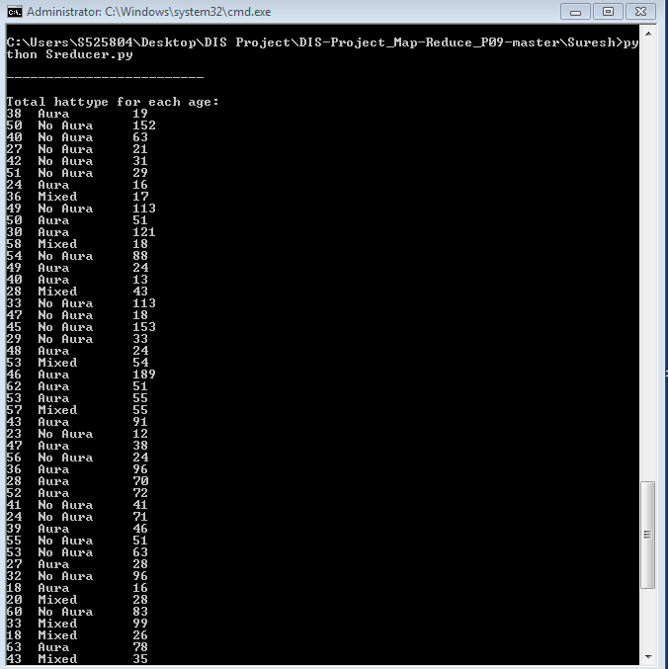](mapper)**

**Reducer output**:

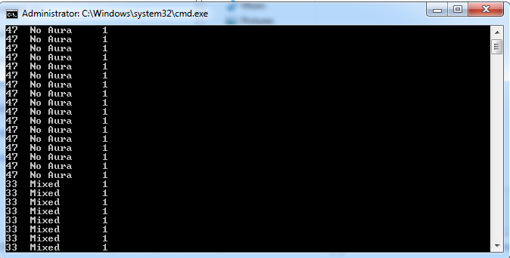

**Final results**