Submitted by –

Vaibhav Varshney(MT17065)

INFORMATION RETRIEVAL

**aSSIGNMENT 3**

# Dataset

* The dataset consist of five folders namely, “comp.graphics”, “rec.sport.hockey”, “sci.med”, “sci.space”, “talk.politics.misc”.
* The index of the folder names is considered as their labelled class.
* Each folder consist of 1000 files each.

# Assumption

* It is assumed that the distribution followed for the conditional probability is binomial distribution. Hence the decision function for classification followed will be:

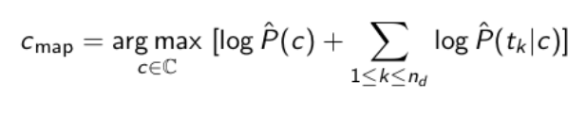

* It is assumed that all the classes are equally probable.
* The test data doesn’t contains numerical terms.

# Methodology

1. Preprocessing

Preprocessing is done in the following sequence:

* Punctuation removal
* Tokenization
* Stop words removal
* Stemming(using Porter Stemmer Algorithm)

1. Feature Selection

For optimization of the performance of the model, the following heuristic is implemented. I have calculated the tf-idf values of all the words of the complete corpus. Further, on the basis certain percentage, I have selected the words with high tf-idf value from each document. Taking the union of all the words, a feature vector has been selected.

1. Smoothing

During the training phase, the conditional probabilities are calculated of the tokens present in the train data. If some unknown token arrives then it is handled using the **“Laplace Smoothing”.**

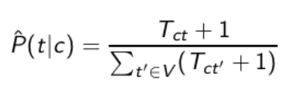

1. Splitting of the Data

For the splitting of the dataset, “train_test_split” function has been used from the sklearn’s library. It provides the split into train size and test size as provided input by the user.

# Analysis

**Without Feature Selection**- Following accuracies have been observed at different train-test split of the dataset.

|  |  |
| --- | --- |
| Split ratio | Test Accuracy |
| 90:10 | 0.94 |
| 80:20 | 0.952 |
| 70:30 | 0.9534 |
| 50:50 | 0.9376 |

**With Feature Selection**- Following accuracies have been observed at different train-test split of the dataset.

|  |  |  |
| --- | --- | --- |
| Split ratio | Feature selection %age | Test Accuracy |
| 90:10 | 10% | 0.66 |
| 30% | 0.848 |
| 50% | 0.91 |
| 90% | 0.94 |

|  |  |  |
| --- | --- | --- |
| 80:20 | 10% | 0.617 |
| 30% | 0.854 |
| 50% | 0.924 |
| 90% | 0.956 |

|  |  |  |
| --- | --- | --- |
| 70:30 | 10% | 0.53 |
| 30% | 0.9146 |
| 50% | 0.922 |
| 90% | 0.961 |

|  |  |  |
| --- | --- | --- |
| 50:50 | 10% | 0.734 |
| 30% | 0.908 |
| 50% | 0.894 |
| 90% | 0.943 |

# Observations

The following facts have been observed by seeing the results of the experiment:

* In different split ratios of train and test data, it has been observed that on increasing the training data size, an increase in the test data’s accuracy.
* Further, on performing grid search the percentage of feature selection (i.e., selecting ‘x%’ of tokens based on tf-idf values), a trend is observed. On increasing the feature selection, the accuracies are increasing for each of the split.

# Inference

* By seeing the accuracies of the test data at different split ratios, it can be stated that the model is best fitting at 70:30 ratio of train-test split data.
* It can be stated that the model is overfitting for 80:20 and 90:10 split ratios. (Refer to graphs)
* In terms of **calculation time,** with performing feature selection, the calculation is taking way more time as compared to without feature selection.

# Graphical Results

(1) Confusion Matrix

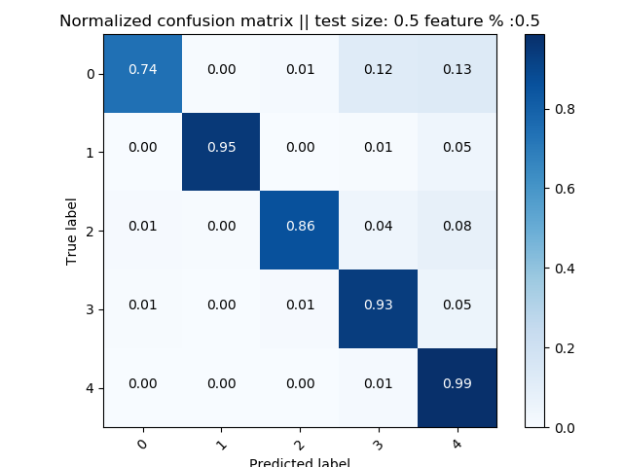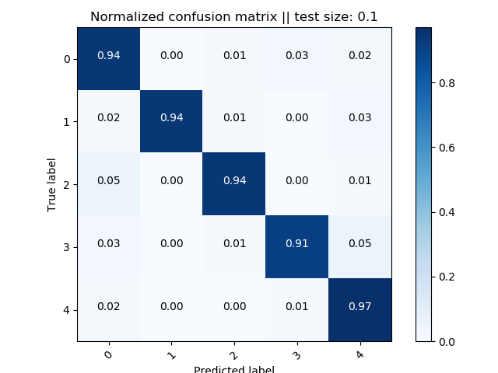

**Fig: with feature selection(left) and without feature selection(right)**

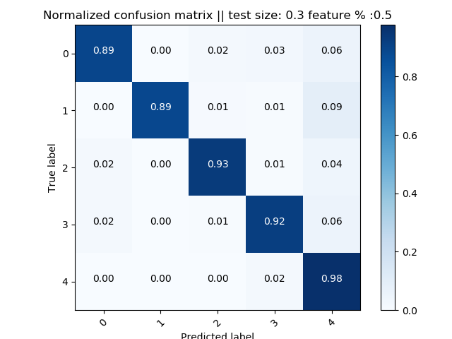

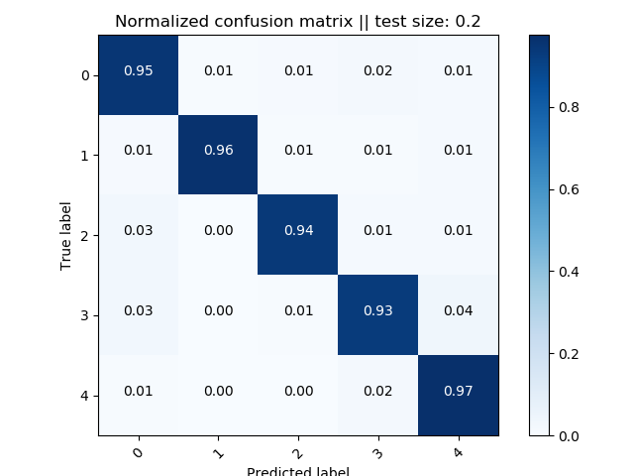

**Fig: with feature selection(left) and without feature selection(right)**

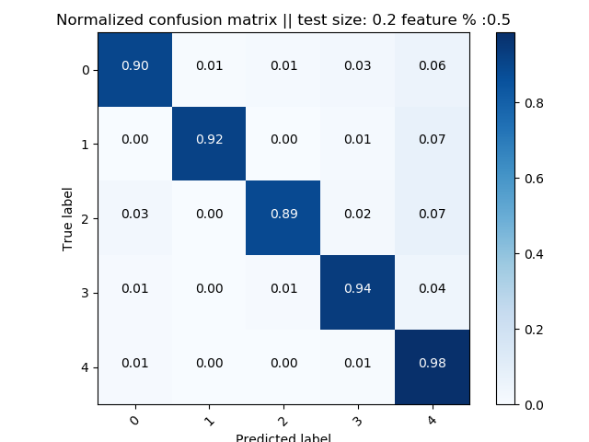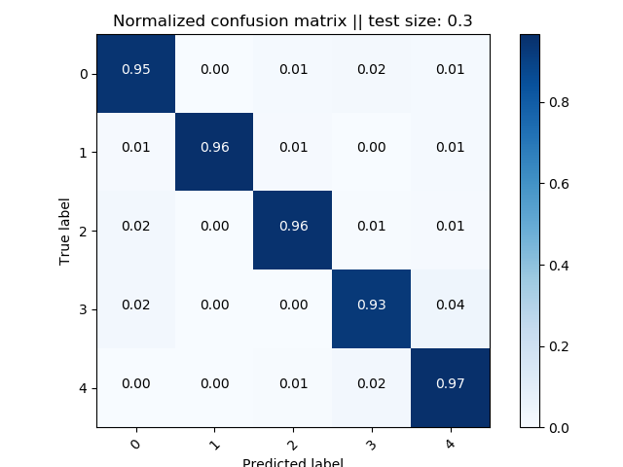

**Fig: with feature selection(left) and without feature selection(right)**

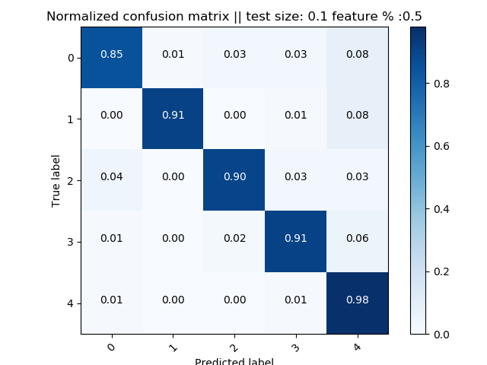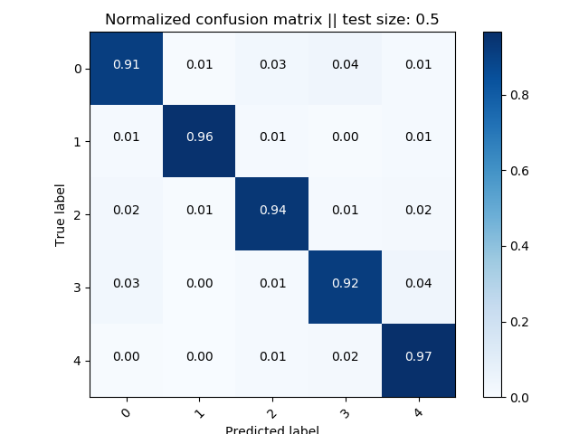

**Fig: with feature selection(left) and without feature selection(right)**

(2) Line Graphs for accuracies

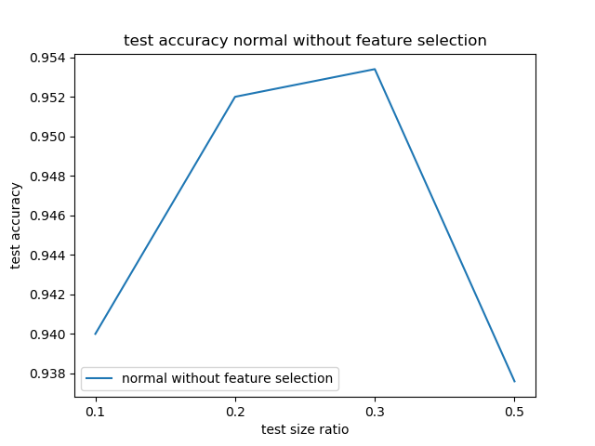

**Fig: Without feature selection**

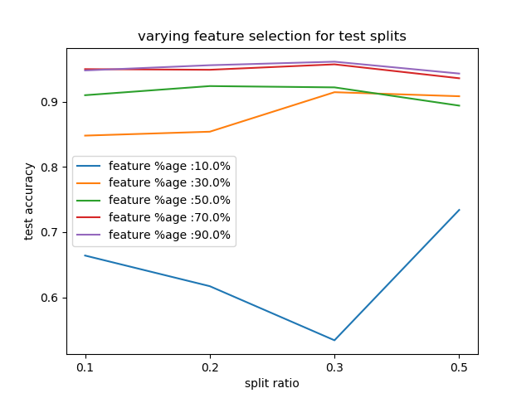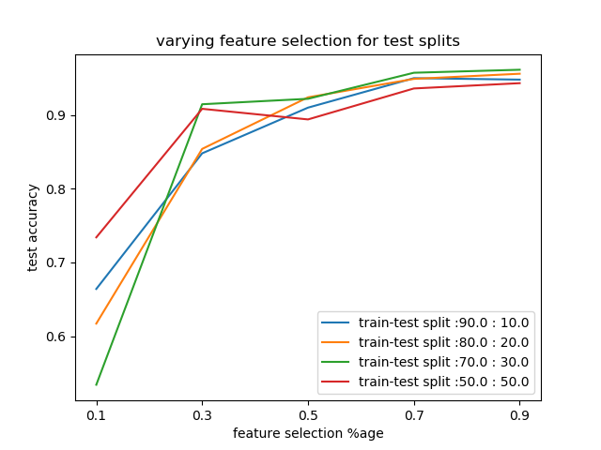

**Fig: With feature selection**

-------------------