Submitted by –

Vaibhav Varshney(MT17065)

INFORMATION RETRIEVAL

**aSSIGNMENT 5**

# Dataset

* The graph network taken is “Collaboration network of Arxiv General Relativity”.
* It is undirected graph originally consisting of 5242 nodes and 14, 496 edges.

# Methodology

* The graph is converted into an adjacency matrix with 1000 nodes only.

# Analysis

* **Degree Distribution-** In the study of graphs and networks, the degree of a node in a network is the number of connections it has to other nodes and the degree distribution is the probability distribution of these degrees over the whole network.

**The degree distribution obtained in this graph is as shown below:**

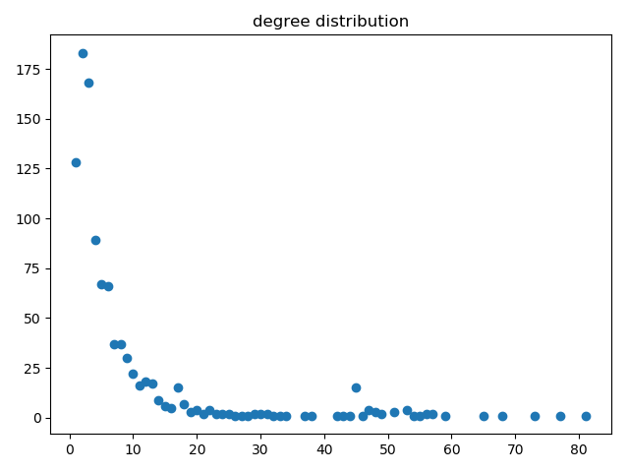

* **Cluster Coefficient-** The local clustering coefficient of a vertex (node) in a graph quantifies how close its neighbours are to being a clique (complete graph).



**Average clustering coefficient in this graph is: 0.529**

* **Closeness centrality-** Closeness Centrality indicates how close a node is to all other nodes in the network. Calculated as the average of the shortest path length from the node to every other node in the network.
* **Betweenness centrality-**

# Observations and Inferences

The following facts have been observed by seeing the results of the experiment:

* It has been observed that the average degree is around 30.
* Average clustering coefficient is 0.539 over the 1000 nodes.
* The closeness centrality is around 19 for most of the nodes but for some exceptional cases it is around 980.
* Betweenness centrality is around 0.01 average.

-------------------