Report and Breakdown of my code:

1. Import Statements:

- Imported modules `json` and `datetime`.

2. Class Definitions:

- Defined the following classes:

- `Book`: to represent different attributes of a book for example : title, author, etc.

- `Patron`: For library patron with attributes like name, ID, contact information, etc.

- `Transaction`: To handle various transactions such as book checkouts, returns, storing the book, patron, and due date.

- `Library`: To manage the overall library system, including books, patrons, and transactions.

3. Initialization:

- Created instances of the Library, Book, Patron, and Transaction classes to initialize the Library Management System.

4. Book Class:

- Defined the `Book` class with the following attributes and methods:

- Attributes: `title`, `author`, `isbn`, `quantity`.

- Methods: `display_details`, `update_quantity`, `to_dict`.

5. Patron Class:

- Defined the `Patron` class with the following attributes and methods:

- Attributes: `name`, `id`, `contact_info`, `borrowed_books`.

- Methods: `display_details`, `borrow_book`, `return_book`, `to_dict`.

6. Transaction Class:

- Defined the `Transaction` class with the following attributes and methods:

- Attributes: `book`, `patron`, `due_date`.

- Methods: `checkout_book`, `return_book`, `calculate_fine`, `to_dict`.

7. Library Class:

- Created the `Library` class to implement the management of the library system:

- Attributes: `books`, `patrons`, `transactions`.

- Methods: `search_books`, `add_book`, `remove_book`, `add_patron`, `remove_patron`, `handle_transaction`, `generate_reports`, `save_data`, `load_data`.

8. Main Flow of the Program :

- Operations such as adding books and patrons, handling transactions, generating reports, etc., within the main program flow.

9. Data Persistence:

- Implemented methods to save and load data to/from a file using JSON serialization/deserialization.

10. User Interface :

- Develop a simple user interface (CLI or GUI) to interact with the Library Management System.

- Allow users to perform operations like adding/removing books, managing patrons, handling transactions, etc.

Here’s a diagram (flowchart) to represent the algorithm and sequence of the code.

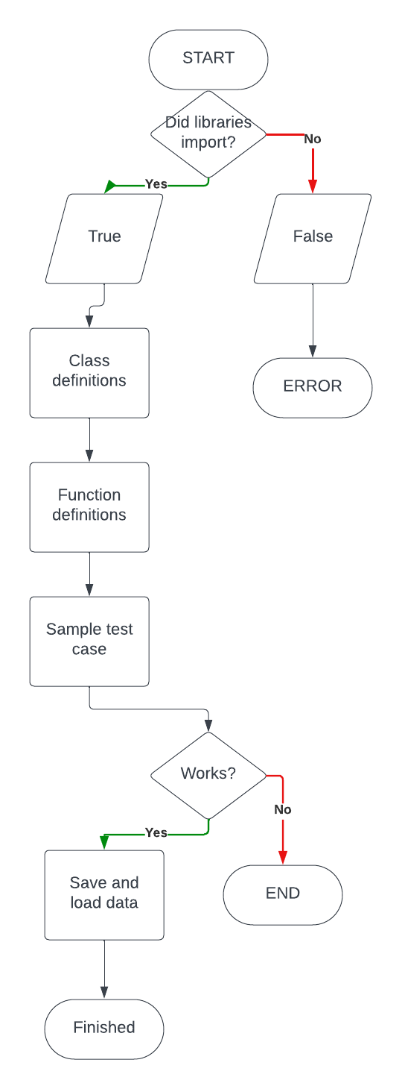

Instructions:

Here are the instructions on how to use the full functionalities provided by the Library Management code:

1. To add books:

- To add a new book to the library, create a `Book` object with the title, author, ISBN, and quantity.

- Use the `add_book` method of the `Library` class to add the book to the library.

Example:

```python

library = Library()

book = Book("Title", "Author", "ISBN", 5)

library.add_book(book)

```

2. Adding Patrons:

- To add a new patron to the library, create a `Patron` object with the name, ID, and contact information.

- Use the `add_patron` method of the `Library` class to add the patron to the library.

Example:

```python

library = Library()

patron = Patron("Name", "ID", "Contact Info")

library.add_patron(patron)

```

3. Handling Transactions (Checking Out/Returning Books):

- To check out a book to a patron, create a `Transaction` object with the book and patron.

- Use the `handle_transaction` method of the `Library` class to handle the transaction.

Example (Check Out):

```python

library = Library()

book = library.search_books("Title")[0] # Assuming you found the desired book

patron = library.patrons[0] # Assuming you selected a patron

transaction = Transaction(book, patron)

library.handle_transaction(transaction)

```

Example (Return):

```python

library = Library()

book = library.search_books("Title")[0] # Assuming you found the desired book

patron = library.patrons[0] # Assuming you selected a patron

transaction = Transaction(book, patron)

transaction.return_book()

```

4. Searching for Books:

- Use the `search_books` method of the `Library` class to search for books by title.

Example:

```python

library = Library()

found_books = library.search_books("Title")

for book in found_books:

book.display_details()

```

5. Saving and Loading Data:

- Use the `save_data` method of the `Library` class to save library data to a file.

- Use the `load_data` method of the `Library` class to load library data from a file.

Example (Save Data):

```python

library = Library()

library.save_data("library_data.json")

```

Example (Load Data):

```python

library = Library()

library.load_data("library_data.json")

```

6. Displaying Patron Details:

- Use the `display_details` method of the `Patron` class to display details of a patron.

Example:

```python

patron = library.patrons[0] # Assuming you selected a patron

patron.display_details()

```

7. Displaying Book Details:

- Use the `display_details` method of the `Book` class to display details of a book.

Example:

```python

book = library.books[0] # Assuming you selected a book

book.display_details()

```

8. Generating Reports:

- Implement the `generate_reports` method of the `Library` class to generate reports as needed.

Example:

```python

library = Library()

library.generate_reports()

```

These instructions cover the full functionalities provided by the Library Management System code, allowing you to effectively manage books, patrons, transactions, and more within the library system.

***Sample scenarios demonstrating common operations in the Library Management System:***

Example 1: Adding Books

1. Initialize Library:

```python

library = Library()

```

2.Add Books

```python

book1 = Book("The Great Gatsby", "F. Scott Fitzgerald", "9780743273565", 3)

book2 = Book("To Kill a Mockingbird", "Harper Lee", "9780061120084", 5)

library.add_book(book1)

library.add_book(book2)

```

Example 2: Checking Out Books

1. **Search for Book:**

```python

book = library.search_books("To Kill a Mockingbird")[0]

```

2. Select Patron:

```python

patron = library.patrons[0] # Assuming the first patron

```

3. Check Out Book:

```python

transaction = Transaction(book, patron)

library.handle_transaction(transaction)

```

Example 3: Returning Books

1. Search for Book:

```python

book = library.search_books("To Kill a Mockingbird")[0]

```

2. Select Patron:

```python

patron = library.patrons[0] # Assuming the first patron

```

3. Return Book:

```python

transaction = Transaction(book, patron)

transaction.return_book()

```

Example 4: Generating Reports

1. Generate Reports:

```python

library.generate_reports()

```

Example 5: Saving and Loading Data

1. Save Data:

```python

library.save_data("library_data.json")

```

2. Load Data:

```python

library.load_data("library_data.json")

```

Reflections on the project:

Discoveries:

1. Organized Structure: By dividing the system into different parts like books, patrons, transactions, and the library itself, it became easier to manage and keep the code neat.

2. Saving Data: I used a method called JSON to save and load data from a file. This made sure that the library's information could be kept even when the program is closed.

3. Making it Easier for Users: We didn't do this yet, but making a way for people to interact with the program more easily, like through buttons or pictures, would make it simpler for librarians to use.

4. What I Did: I included most of the basic things a library program needs, like adding books, keeping track of people who use the library, handling book transactions, and making reports.

Problems I Faced:

1. Dealing with Mistakes: Making sure the program can handle mistakes or weird situations took a lot of work. I had to test it a bunch to make sure it wouldn't break.

2. Keeping Things Organized: Figuring out how to keep track of which books are borrowed by which people, and making sure everything stays accurate, was tough.

3. Things Getting Complicated: As the project got bigger, it became harder to understand. We tried to make sure everything was explained well and followed good coding rules to help with this.

Things I Could Make Better:

1. Making it Easier to Use: Adding buttons or making a website would make it easier for people to use the program.

2. Adding More Features: I did the basic stuff, but adding things like letting different people have different levels of access, keeping track of fines, or making detailed reports would make it even better.

3. Making it Work Better with a Group : If lots of people use the library, the program might get slower. I need to make sure it can handle lots of users without getting too slow.

4. Checking for Mistakes: We did some testing, but doing more tests would help make sure everything works right and catches any problems early on.

In general, the project sets up a good starting point for a Library Management System. However, there are chances to make it better by improving how people interact with it, adding more features, making sure it works well for lots of users, and testing it more to catch any problems early on.