Birla Institute of Technology & Science, Pilani
Work-Integrated Learning Programmes Division
Mid-Semester Test (EC2R)

Course No. : MBA CC ZG501
Course Title : Business Statistics
Weightage : 30%
Duration : 2 Hours
Date of Exam :

- Describe and Compare- a) Conditional, Marginal and Joint probabilities, and b) Range, Standard deviation and Inter-Quartile Range. [Important: Describe means describe in detail, draw charts, give examples, applications, etc. Compare means compare in a table with rows and columns, compare several characteristics, etc.] [5]

- The bank balance in thousand Rupees of the customers who applied for a housing loan last week are: 22, 6000, 780, 1020, 52, 180, 120, 74, 92, 10, 620, and 1100. A) Draw a big, neat and well-labelled Boxplot chart. B) Which central tendency measure will be appropriate for this data- justify your answer, and C) Identify the outliers. [Important: Show every calculation/working]. [5]

- In a large IT company, every applicant for the entry-level jobs undergoes two rounds of the selection process- a written test and an interview round. Historical data shows the probability that a candidate passes the written test is 50% and the probability that a candidate passes the interview round is 60%. The data also shows that the probability a candidate passes both the written test and the interview round is 40%. A) If a candidate has passed the interview round, what is the probability that he also passed the written test? and B) Are the written test and interview round independent- justify your answer. [Important: Show every calculation/working]. [5]

- A stock market trader has categorized its customers into three segments (Optimistic, Cautious, and Pessimistic) based on past buy/sell behavior. The summary table is as follows- [5]

 | Gender
Segment | Male | Female
Optimistic | 26 | 16
Cautious | 41 | 43
Pessimistic | 33 | 41

If a customer is selected at random, what is the probability the customer is (provide the answers as fractions (1/3) and not as decimals (0.33)-
- Classified as Optimistic or Cautious?
- Is a Male or is classified as Pessimistic?
- Is a Male and is classified as Optimistic?
- Given the customer is female, what is the probability that she is classified as optimistic?

- A passenger car manufacturer buys car batteries from two suppliers, Supplier-A and Supplier-B. Supplier-A supplies 65% of the batteries and Supplier-B fulfils the remaining requirement.

The quality of batteries differs between the two suppliers. Quality inspection reports show that 99% of batteries supplied by Supplier-A were of Good quality and 2% were of Bad quality. For Supplier-B, 95% of the batteries were of Good quality and 5% were of Bad quality.

The batteries supplied by the two suppliers are stocked in the same store. If a battery is selected at random,
- What is the probability that it of Good quality?
- What is the probability that the battery has been supplied by Supplier-A given that it is of Good quality?
- What is the probability that the battery has been supplied by Supplier-B given that it is of Bad quality?

[Show all calculations/procedure/approach/formula]. [5]

- The result given by AI Google for a query is given below-

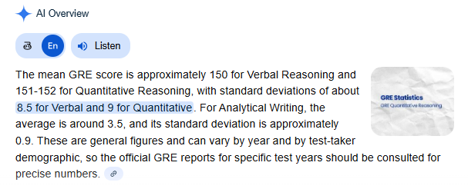

If the GRE scores for Verbal Reasoning are Normal distributed, then a) What percentage of the people who have taken the GRE test have Verbal Reasoning less than 140, b) What percentage have Verbal Reasoning scores between 145 and 160, and c) What is the Verbal Reasoning score below which 70% of the people have scored? [Important: Show every calculation/working and underline/ highlight the final answer]. [5]




