**1. Cluster Setup**

**Managed Kubernetes Service**: Amazon EKS

**Cluster Configuration**:

* **Number of Nodes**: 3
* **Node Specifications**:
  + Instance Type: t2.medium
  + vCPUs: 2
  + Memory: 8 GB
  + Storage: 20 GB EBS

**2. Namespace Creation**

**Namespaces**:

* Frontend Namespace: frontend
* Backend Namespace: backend
* Database Namespace: database

**3 & 4 : Shared the code in Kubernetes-Manifests-file**

**5. Scaling and HA Implementation**

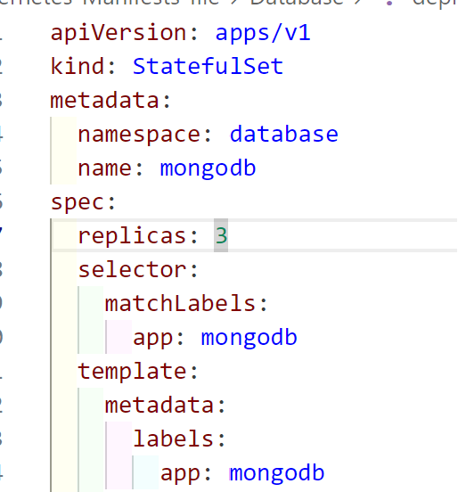

**6 : Shared the code in Kubernetes-Manifests-file**

**7. Rolling Updates and Rollbacks**

**Rolling Update**:

1. Update the deployment with a new image:

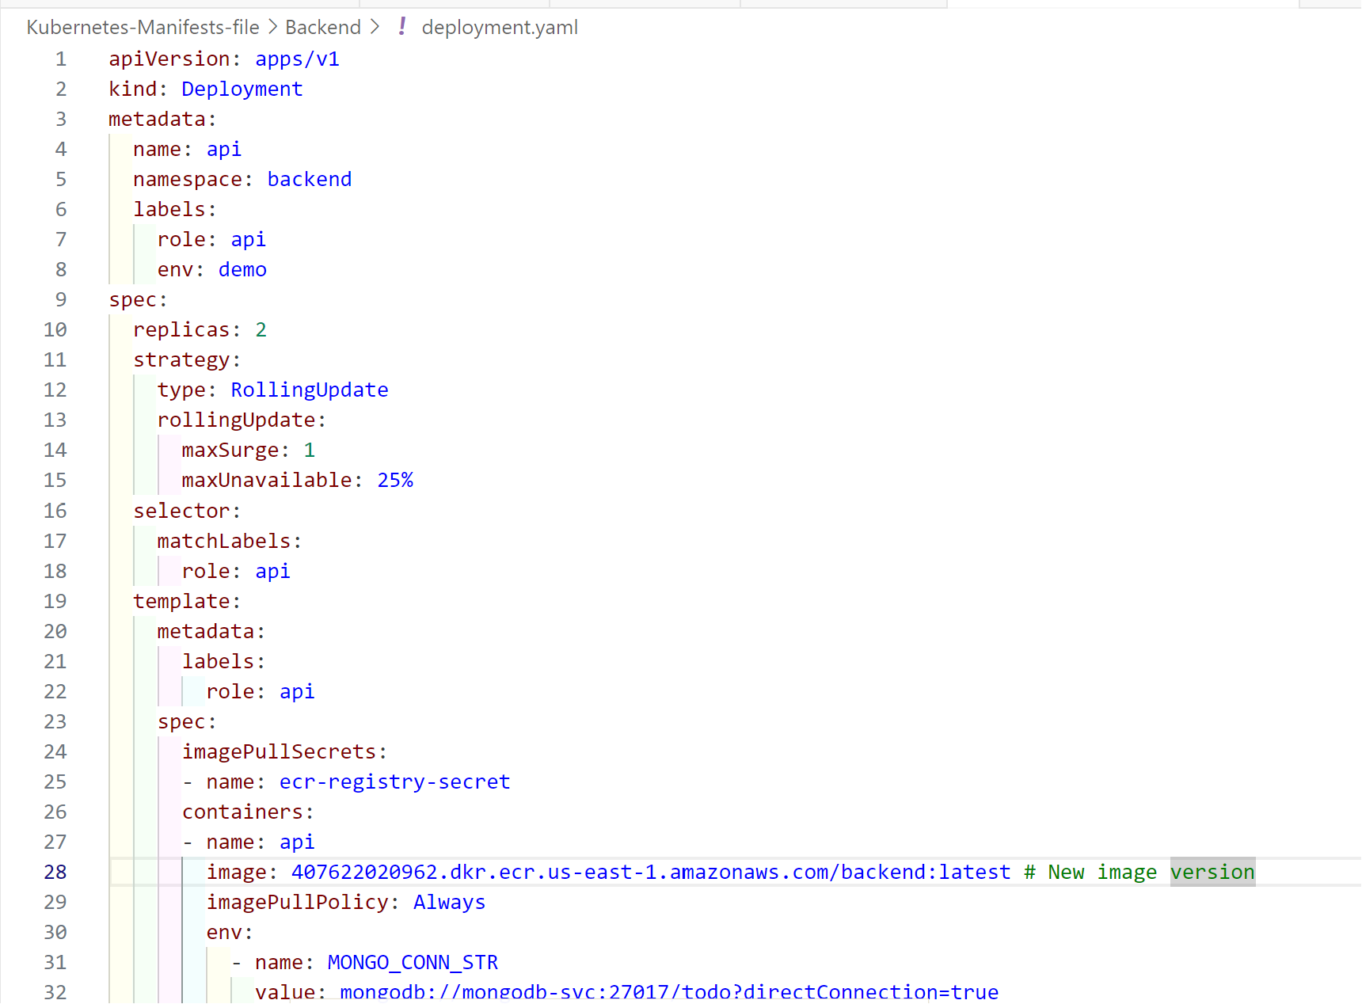

**Apply the update:**

**Command :** kubectl apply -f backend/deployment.yaml

**Rollback:**

**Check the rollout history:**

**Command :** kubectl rollout history backend/api -n backend

**Rollback to a previous revision:**

**Command :** kubectl rollout undo backend/api -n backend