 PROJECT ID: MCA2022-24PID007 
Project Report
on
DEVELOPMENT OF E-BHARAT: ESSENTIAL VOTING SYSTEM
Submitted in the partial fulfillment of the requirements for the award of
Degree
of
MASTER OF COMPUTER APPLICATIONS
SUBMITTED BY
SANJAY SAINI (2202900140037)
PRABHAT SINGH CHAUHAN (2202900140027)
PRASHANT KUMAR (2202900140030)
PRANJUL AWASTHI (2202900140028)
PRATEEK YADAV (2202900140031)

Under the guidance of
MRS. DEEPSHIKHA RAI
(ASSISTANT PROFESSOR)
DEPARTMENT OF MCA
ABES INSTITUE OF TECHNOLOGY, GHAZIABAD
AFFILIATED TO
DR.A.P.J. ABDUL KALAM TECHNICAL UNIVERSITY, LUCKNOW, UTTAR PRADESH
CERTIFICATE

This is to Certify that Sanjay Saini (Roll no. 2202900140037), Prabhat Singh Chauhan (Roll no. 2202900140027), Pranjul Awasthi (Roll no. 2202900140028), Prateek Yadav (2202900140031), Prashant Chauhan (Roll no. 2202900140030) has carried out the research work presented in this thesis entitled “Development of E-Bharat: Essential Voting System” for the award of Master of Computer Applications from Dr. APJ Abdul Kalam Technical University, Lucknow under our supervision. The report embodies result of original work, and studies are carried out by the student themselves and the contents of the thesis do not form the basis for the award of any other degree to the candidate or to anybody else from this or any other University/Institution.

Supervisor Signature Signature
Mrs. Deepshikha Rai Dr. Sheelesh Kumar Sharma
Assistant Professor Head of Department (MCA)
ABES Institute of Technology ABES Institute of Technology
Ghaziabad Ghaziabad

Date:

ACKNOWLEDGEMENT
With deep gratitude we express my earnest thanks to my esteemed supervisor Mrs. Deepshikha Rai, Assistant Professor, Department of Master of Computer Application for her constant involvement, energetic efforts and proficient guidance, which gave me direction and body to work, respond here. Without her counsel and encouragement, it would have been impossible to complete the thesis work in this manner.
We wish to express my gratitude to the Director, Dean Academics and Head of Department (MCA) of ABESIT for their support, guidance and advice throughout this work. We are thankful to all the faculty members of the MCA Department for their intellectual support during my research work.
We also want to thank my friends for their valuable support whenever needed. We would like to thank all those people who have helped me some way or the other in my thesis work.
Lastly, and most importantly, we thank our parents for their moral support and encouragement towards completing my thesis successfully. In the last, we want to thanks Almighty God.

Sanjay Saini
MCA (Final Year)
Roll No:2202900140037
Date: Department of MCA
Place: Ghaziabad ABES Institute of Technology, Ghaziabad

Prabhat Singh Chauhan
MCA (Final Year)
Roll No:2202900140027
Date: Department of MCA
Place: Ghaziabad ABES Institute of Technology, Ghaziabad

Pranjul Awasthi
MCA (Final Year)
Roll No:2202900140028
Date: Department of MCA
Place: Ghaziabad ABES Institute of Technology, Ghaziabad

Prateek Yadav
MCA (Final Year)
Roll No:2202900140031
Date: Department of MCA
Place: Ghaziabad ABES Institute of Technology, Ghaziabad

Prashant Chauhan
MCA (Final Year)
Roll No:2202900140030
Date: Department of MCA
Place: Ghaziabad ABES Institute of Technology, Ghaziabad

DECLARATION

We here by declare that the work presented in this report entitled “Development of E-Bharat: Essential Voting System”, was carried out by us. We have not submitted the matter embodied in this report for the award for any other degree or diploma of any other university or institute. We have given due credit to the original authors/sources for all the word, ideas, diagrams, graphics, computer programs, experiments, results that are not our original contribution. We have used quotation marks to identify verbatim sentences and giving credit to the original authors/sources.
We affirm that no portion of my work is plagiarized, and the experiments and results reported in the report are not manipulated. In the event of a complaint of plagiarism and the manipulation of the experiments and results, we shall be fully responsible and answerable.

Name : Sanjay Saini
Roll No.: 2202900140037
Master of Computer Application (Candidate Signature)

Name : Prabhat Singh Chauhan
Roll No.: 2202900140027
Master of Computer Application (Candidate Signature)

Name : Pranjul Awasthi
Roll No.: 2202900140028
Master of Computer Application (Candidate Signature)

Name : Prashant Chauhan
Roll No.: 2202900140030
Master of Computer Application (Candidate Signature)

Name : Prateek Yadav
Roll No.: 2202900140031
Master of Computer Application (Candidate Signature)

ABSTRACT

The Online Voting System is a web-based application. The system has a centralized database to keep records of all the Voters and Candidates and Final Results. This web-based system is time saving, work load reduced information available at time and it provide security for the data. During the election, the election commission of India has introduced a new method of polling by online voting system (OVS). The election commission will maintain this website. This is a simple, safe and secure method that takes minimum of time.
The word VOTE means to choose from a list, to elect or to determine. The main goal of voting (in a scenario involving the citizens of a given country) is to come up with leaders of the people’s choice. Most countries, India not an exception have problems when it comes to voting. Some of the problems involved include ridging votes during election, insecure or inaccessible polling stations, inadequate polling materials and also inexperienced personnel.
The Online Voting System (OVS) is a digital platform designed to facilitate the electoral process, making it more accessible, secure, and efficient. This system aims to overcome the limitations of traditional voting methods by leveraging modern technology to streamline the entire voting process. The key features of the Online Voting System include user authentication, ballot creation, secure transmission of votes, and result tabulation.
The ballot creation module allows election administrators to design and customize electronic ballots, ensuring accuracy and clarity in presenting candidates or issues to the voters. Additionally, the system incorporates advanced security measures to prevent tampering or manipulation of the ballot content.
Overall, the Online Voting System represents a significant advancement in the democratic process, promoting inclusivity, efficiency, and security. While addressing challenges associated with traditional voting methods, the system adheres to the highest standards of cybersecurity to instill confidence in both voters and election authorities.

LIST OF FIGURES

DESCRIPTION PAGE NO.
3.2.1 VOTER FLOWCHART…………………………....................................06
3.2.2 ADMIN FLOWCHART…………………………………………………07
3.3.1 USE CASE DIAGRAM…………………………………………………08
3.4.1 DFD LEVEL 0…………………………………………………………..09
3.4.2 DFD LEVEL 1…………………………………………………………..10
3.4.3 DFD LEVEL 2…………………………………………………………..11
3.5.1 ER DIAGRAM………………………………………………………….12
10.1 Home Page……………………………………………………………….68
10.2 About Page……………………………………………………………….68
10.3 Contact Us………………………………………………………………..69
10.4 Voter Dashboard………………………………………………………….69
10.5 Candidate Dashboard…………………………………………………….70
10.6 Voter Registration………………………………………………………...70
10.7 Add Candidate…………………………………………………………….71
10.8 Candidate Registration……………………………………………………71
10.9 Ballot Page………………………………………………………………..72
10.10 Voter Login……………………………………………………………...72
10.11 Logout Page……………………………………………………………..73

TABLE OF CONTENTS

DESCRIPTION PAGE NO.
1. INTRODUCTION…………………………..................................................1
2. ANALYSIS………………………………………………………………….2
2.1 SYSTEM ANALYSIS……………………………………………...2
2.1.1 Project Aim………………………………………………2
2.1.2 Existing system…………………………………………..2
2.1.3 Drawbacks of Existing System…………………………..2
2.1.4 Objective…………………………………………………3
2.1.5 Proposed System…………………………………………3
2.1.6 Drawbacks of Proposed System………………………….4
2.2 SYSTEM SPECIFICATION……………………………………….4
2.2.1 Hardware Requirements………………………………….4
2.2.2 Software Requirements…………………………………..4
3. DESIGN APPROACH………………………………………………………5
3.1 INTRODUCTION TO DESIGN…………………………………...5
3.1.1 Design Overview…………………………………………5
3.1.2 Module Description………………………………………5
3.2 FLOWCHART……………………………………………………5-7
3.3 USE CASE DIAGRAM……………………………………………8
3.4 DATA FLOW DIAGRAM…………………………………………9
3.4.1 Context Level Diagram…………………………………..9
3.4.2 Data Flow Diagram Level 1…………………………….10
3.4.3 Data Flow Diagram Level 2…………………………….11
3.5 ENTITY RELATION DIAGRAM………………………………..12
4. PROJECT MODULES………………………………………………….13-14
5. TECHNOLOGY USED………………....................................................15-18

6. IMPLEMENTATION………………………………………………………19
6.1 GENERAL OVERVIEW…………………………………………19
6.2 SYSTEM DEVELOPMENT TOOLS…………………………19-21
6.3 TESTING……………………………………………………....21-23
6.4 MAINTENANCE AND ENVIRONMENT………………………23
6.4.1 Corrective Maintenance……………………………...23-24
6.4.2 Adaptive Maintenance……………………………….24-25
6.4.3 Perfective Maintenance……………………....................25
6.4.4 Preventive Maintenance……………………………..25-26
7. TESTING……………………………………………………………………27
7.1 INTRODUCTION TO TESTING…………………………………27
7.2 TEST CASES……………………………………………………...27
7.2.1 Test Case User Authentication…………………………..28
7.2.2 Test Case User Registration……………………………..29
8. CODING………………………………………………………………...30-67
9. OUTPUT SCREENS…….……………………………………………....68-73
10. CONCLUSION……………………………………………………………74
11. FUTURE ENHANCEMENT……………………………………………...75
BIBLIOGRAPHY

1.INTRODUCTION

The Online voting system (OVS) also known as e-voting is a term encompassing several different types of voting embracing both electronic means of counting votes. Electronic voting technology can include punched cards, optical scan voting systems and specialized voting kiosks (including self contained direct-recording electronic voting systems or DRE). It can also involve transmission of ballots and votes via telephones, private computer networks, or the internet.
Online voting is an electronic way of choosing leaders via a web driven application. The advantage of online voting over the common “queue method” is that the voters have the choice of voting at their own free time and there is reduced congestion. It also minimizes on errors of vote counting. The individual votes are submitted in a database which can be queried to find out who of the aspirants for a given post has the highest number of votes.
This system is geared towards increasing the voting percentage in Nepal since it has been noted that with the old voting method {the Queue System}, the voter turnout has been a wanting case. With system in place also, if high security is applied, cases of false votes shall be reduced.
With the “ONLINE VOTING SYSTEM”, a voter can use his\her voting right online without any difficulty. He\She has to register as a voter first before being authorized to vote. The registration should be done prior to the voting date to enable data update in the database.
However, not just anybody can vote. For one to participate in the elections, he/she must have the requirements. For instance, he/she must be a registered citizen i.e. must be 18 and above years old. As already stated, the project ‘Online Voting' provides means for fast and convenient voting and access to this system is limited only to registered voters.
Internet voting systems are appealing for several reasons which include; People are getting more used to work with computers to do all sorts of things, namely sensitive operations such as shopping and home banking and they allow people to vote far from where they usually live, helping to reduce absenteeism rate.

2. ANALYSIS

2.1 System Analysis
2.1.1 Project Aim
Our aim is to create a Web based Voting System that acts as an interface between the users who are looking for a channel to give the excess things without wasting it. It enables us to cast the vote anytime from anywhere. The required users claim the notification.
It will be a web-based system that can be accessible from everywhere. To provide an easy method so that anyone can easily use.

2.1.2 Existing System
An electronic voting system which is used nowadays provide some characteristic different from the traditional voting technique, and also it provides improved features of voting system over traditional voting system such as accuracy, convenience, flexibility, privacy, verifiability and mobility.
The existing manual Voting system consumes more time for Vote Casting. Voter has to wait for vote polling station to vote for a right candidate. The election officers has to be check the voter, this voter can vote in this booth then check voter ID present in voters list of booth those are information will be present then the voter can vote in that booth. The voter had to stand in the queue to cast his vote. All the work is done in paper ballot so it is very hard to locate a particular candidate, some voters cast their votes for all candidates. To overcome of all these problem we have to implement a web application, which is helpful for Voting from anywhere.
But Electronic voting systems suffers from various drawbacks such as time consuming, consumes large volume of paper work, no direct role for the higher officials, damage of machines due to lack of attention, mass update doesn’t allow users to update and edit many item simultaneously etc.

2.1.3 Drawbacks of Existing System
The problems of the existing manual system of voting include among others the following:
1. Expensive and Time Consuming:
The process of collecting data and entering this data into the database takes too much time and is expensive to conduct, for example, time and money is spent in printing data capture forms, in preparing registration stations together with human resources, and there after advertising the days set for registration process including sensitizing voters on the need for registration, as well as time spent on entering this data to the database.
2. Too much paper work:
The process involves too much paper work and paper storage which is difficult as papers become bulky with the population size.
3. Error during data entry:
Errors are part of all human beings; it is very unlikely for humans to be 100 percent efficiency in data entry.
4. Loss of Registration Forms:
Sometimes, registration forms get lost after being filled in with voter’s details, in most cases these are difficult to follow-up and therefore many remain unregistered even though they are voting age nationals and interested in exercising their right to vote.
5. Short time provided to view the voter register:
This is very big problem since not all people have free time during the given short period of time to check and update the voter register.

2.1.4 Objective
The specific objectives of the project include:
- Reviewing the existing/current voting process or approach.
- Coming up with an automated voting system.
- Implementing a an automated/online voting system.
- Validating the system to ensure that only legible voters are allowed to vote.
- Eliminate the practice of multiple casting of vote.

2.1.5 Proposed System
As we are looking at the existing system, they are just providing online voting. As we knew that Government of India contain multiple elections. So we are implementing our system such that voter can select election and submit their vote region/ward wise. After studying existing system we observed that they are not providing state wise, region wise voting facility. So its difficult to vote because there is no restriction, so voter can also cast his/her vote to those candidate who is not belonging from his/her area. In proposed system we are implementing that voter can cast his/her vote only those candidate who’s belonging from his/her region/ward. We will display only those candidate who are belonging from that particular voters ward. So it will also help to conduct small election such as Gram Panchayat Election or Nagar Sevak Election. We are making our voting system user friendly.

2.1.6 Drawbacks of Proposed System
Accessing this application always requires an internet connection. Wrong information will affect the project.

2.2 SYSTEM SPECIFICATION
2.2.1 Hardware Requirements
- Processor: Intel Pentium 1.2 GHz or AMD Athlon 1.1 GHz or Above
- RAM: 256 MB RAM or Above
- Storage: HDD/SDD 128 GB or Above

2.2.2 Software Requirements
- Operating System: Windows 7 and Above
- Browser: Chrome, Firefox and Explorer
- Front-End: HTML, CSS and JavaScript
- Back-End: PHP and MySQL
- Database: phpMyAdmin
- Web Server: Localhost Apache

3. DESIGN APPROACH

3.1 INTRODUCTION TO DESIGN
3.1.1 Design Overview
Design is the first step in the development phase for any techniques and principles for the purpose of defining a device, a process or system in sufficient detail to permit its physical realization.
Once the software requirements have been analyzed and specified the software design involves three technical activities - design, coding, implementation and testing that are required to build and verify the software.
The design activities are of main importance in this phase, because in this activity, decisions ultimately affecting the success of the software implementation and its ease of maintenance are made. These decisions have the final bearing upon reliability and maintainability of the system. Design is the only way to accurately translate the customer’s requirements into finished software or a system.
Design is the place where quality is fostered in development. Software design is a process through which requirements are translated into a representation of software. Software design is conducted in two steps. Preliminary design is concerned with the transformation of requirements into data.

3.1.2 Module Description
We have separated the software into different modules like admin, voters, these all modules have different tasks in the system.
- Admin module will handle all the process of registration, login, validation, role checking of the system. This module will interact with the user table of the database.
- Voter module is for people to cast their vote. This module will interact with the donation table and address table of the database.

3.2 FLOWCHART
A flowchart is a visual representation of a process or algorithm using various shapes, symbols, and arrows to illustrate the sequence of steps or actions. It provides a clear and concise way to depict the flow of information, decision points, and the order of operations within a system or procedure. Flowcharts are widely used in various fields such as software development, business processes, project planning, and problem-solving. They serve as a valuable tool for understanding, documenting, and communicating complex processes in a easily understandable and systematic manner.

Flowchart of Voter Panel:

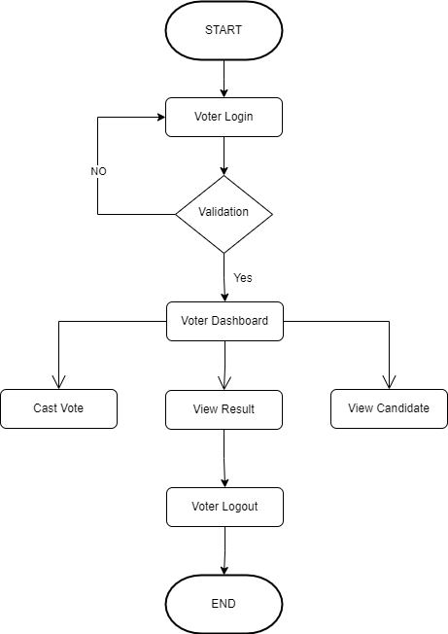:
Fig 3.2.1: Flowchart Voter

Flowchart of Admin Panel:

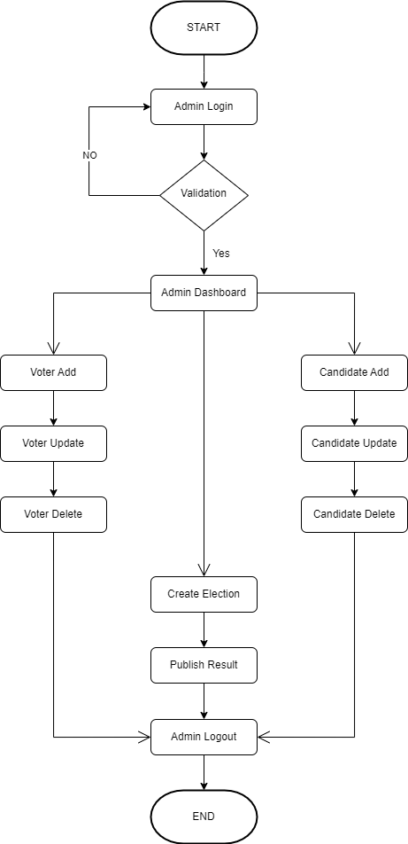
Fig 3.2.2: Flowchart Admin

3.3 USE CASE DIAGRAM
A use case diagram is a graphical representation that illustrates how a system interacts with external entities (actors) and showcases the various ways these entities can interact with the system. The primary purpose of a use case diagram is to capture and communicate the functional requirements of a system in a clear and visual manner.

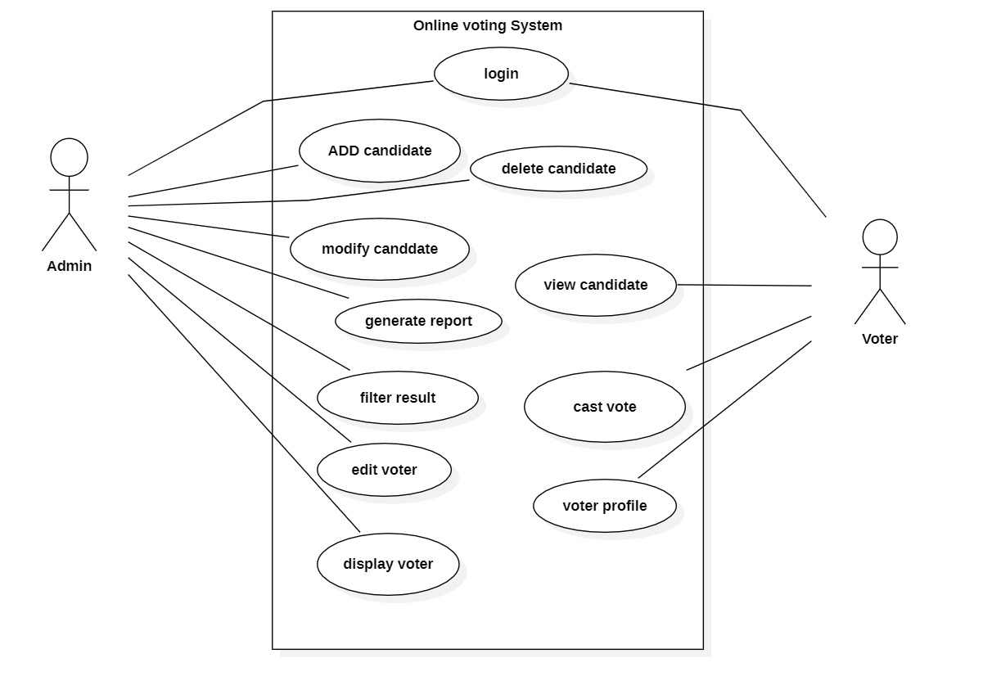
Fig 3.3.1 Use Case of Online Voting System

3.4 DATA FLOW DIAGRAM
A data flow diagram (DFD) is a diagram that describes the flow of data and the process that change data throughout a system It's a structured analysis and design tool that can be used for flow charting in place of or in association with information. The DFD reviews the current system, prepare input and output specification, specifies the implementation plan etc. Using any convention's DFD rules or guidelines, the symbols depict the four components of data flow diagrams.

3.4.1 Context Level Diagram (0 Level)
A Level 0 Data Flow Diagram (DFD), also known as a Context Diagram, provides a high-level view of a system by illustrating the interactions between the system and external entities. It represents the system as a single process and showcases the flow of data between the system and its external entities. The primary purpose of a Level 0 DFD is to offer a concise and easily understandable overview of the system's scope and boundaries.

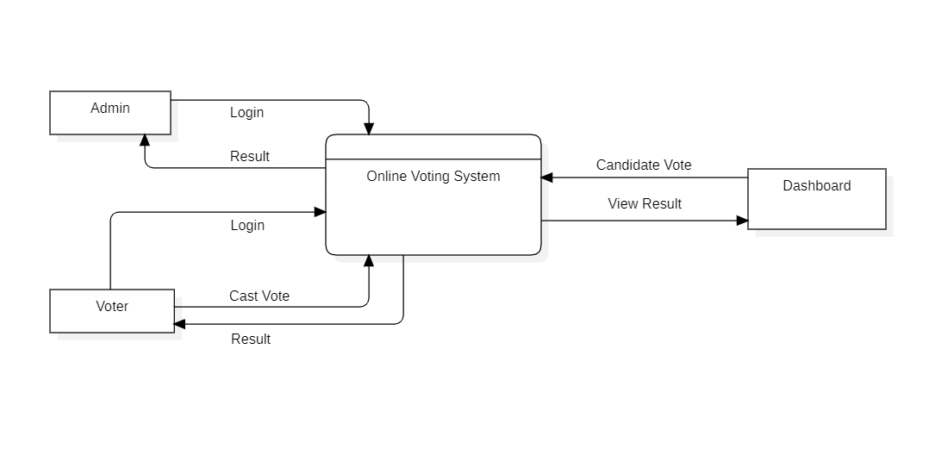
Fig 3.4.1: DFD Level 0

3.4.2 Data Flow Diagram (1 Level)
A Level 1 Data Flow Diagram (DFD) is a visual representation that provides a more detailed view of the processes and data flows within a system compared to a Level 0 DFD. At Level 1, the diagram expands on the processes identified in the Level 0 DFD and decomposes them into sub processes, offering a more granular depiction of the system's functionality.
The Level 1 DFD acts as an intermediary step between the high-level overview of the Level 0 DFD and the more detailed representations that might follow in subsequent levels. It helps in breaking down complex processes into manageable components, making it easier for analysts and stakeholders to understand the system's inner workings.

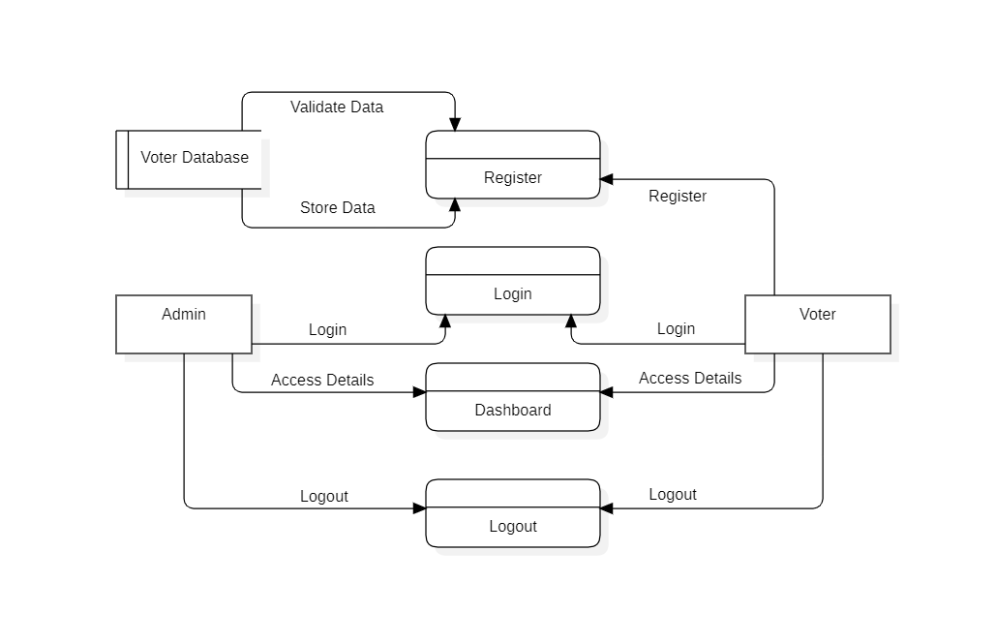
Fig 3.4.2: DFD Level 1

3.4.3 Data Flow Diagram (Level 2)
A Level 2 Data Flow Diagram (DFD) is a more detailed version of the Level 1 DFD, providing a deeper insight into the processes, data stores, and data flows within a system. It expands on the high-level view presented in Level 1 by breaking down processes into sub-processes and illustrating the detailed data flows between them.
The Level 2 DFD is valuable for project teams, analysts, and stakeholders as it provides a detailed understanding of the system's internal workings. It serves as a blueprint for system design and development, offering a more comprehensive guide for system implementation based on the insights gained from the higher-level diagrams. The Level 2 DFD is particularly useful for developers and system architects as they work on the detailed design and implementation phases of a project.

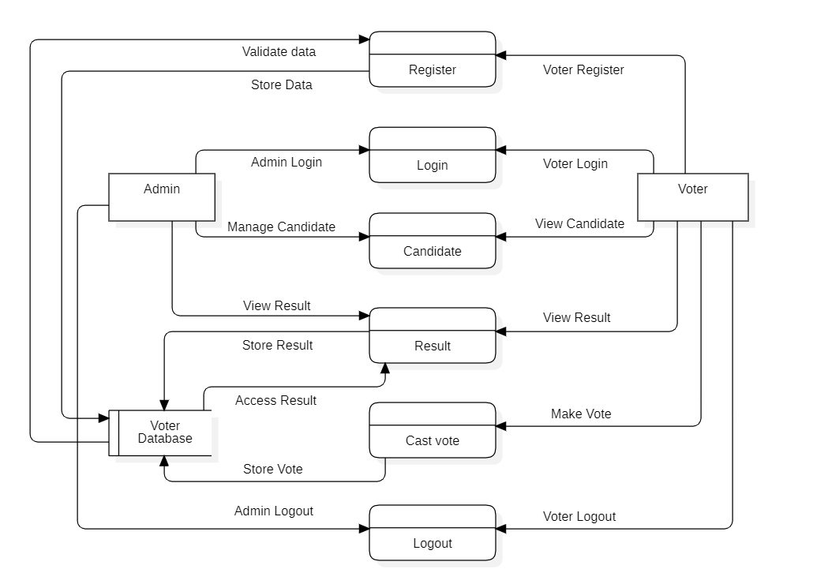
Fig 3.4.3: DFD Level 2

3.5 ENTITY RELATION DIAGRAM
An Entity-Relationship (ER) diagram is a visual representation of the data model that depicts the relationships among entities within a database. It illustrates how different entities in a system are related to each other and helps in designing a database schema. In an ER diagram:
Entities: Entities are objects, concepts, or things in the real world that can be uniquely identified and have data associated with them. In the diagram, entities are represented by rectangles.
Attributes: Attributes are the properties or characteristics of entities. They are depicted as ovals connected to the respective entity rectangles.
Relationships: Relationships describe how entities are connected or associated with each other. They are typically represented by diamond shapes and lines connecting the related entities.

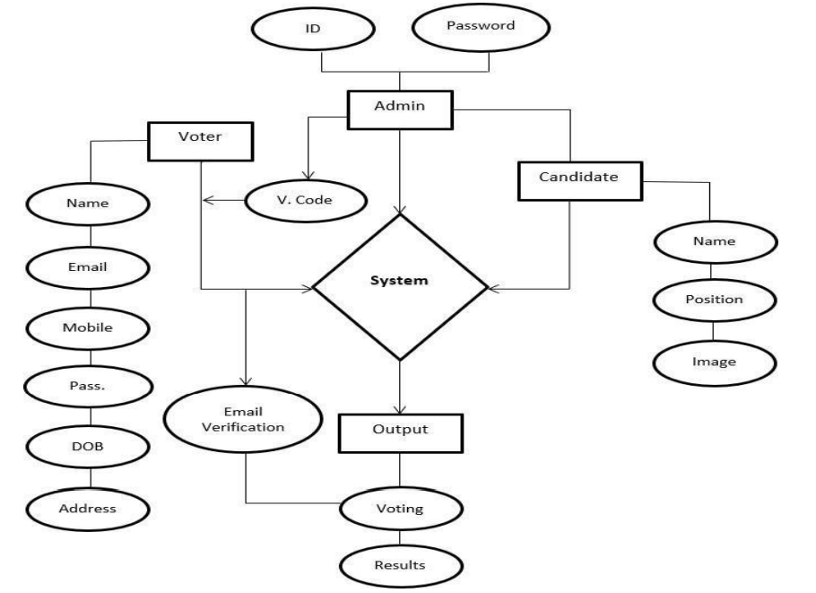

Fig 3.5: E-R Diagram

4. PROJECT MODULES

MODULES:
- ADMIN MODULE
- VOTER MODULE

1. ADMIN MODULE:
- LOGIN
- ADD CANDIDATE
- UPDATE CANDIDATE
- DELETE CANDIDATE
- ADD VOTER
- UPDATE VOTER
- DELETE VOTER
- MAKE ELECTON
- GENERATE RESULT
- LOGOUT
1. LOGIN: The registered Admins are allowed to manage their inner details in his/her dashboard.
2. ADD CANDIDATE: Admin will be able to add multiple legible candidates manually.
3. UPDATE CANDIDATE: Admin will be able to update the information or details of existing candidate.
4. DELETE CANDIDATE: Admin will be able to delete particular candidate.
5. ADD VOTER: Admin will be able to add multiple legible voters manually.
6. UPDATE VOTER: Admin will be able to update the information or details of existing voters.
7. DELETE VOTER: Admin will be able to delete particular voter.
8. MAKE ELECTION: Admin will create an election that the admin wanted to conduct.
9. GENERATE RESULT: Admin will publish the result of conducted election and announces the name of winner participant/group.
10. LOGOUT: Admin will logout from his/her dashboard and will be redirected to website home page.

2. USER MODULE:
- REGISTER
- LOGIN
- VIEW PROFILE
- CAST VOTE
- VIEW CANDIDATE
- VIEW RESULT
- LOGOUT

1. REGISTER: Here the voter is verified and creates an account.
2. LOGIN: The registered voter are allowed to manage their inner details in his/her dashboard and cast their votes.
3. VIEW PROFIL E: The voters will be able to manage and view their profile details.
4. CAST VOTE: The voter be able to cast the vote to their favourable candidate.
5. UPDATE PROFILE: The voters will be able to update their details/information.
6. VIEW CANDIDATE: Voters will be able to see how many candidates are available in the row.
7. LOGOUT: Voter will logout from his/her dashboard and will be redirected to website home page.

5. TECHNOLOGY USED
HTML:
HTML, or Hyper Text Markup Language, is a standard markup language used to create and structure the content on the World Wide Web. It provides a set of elements or tags that define the structure of a web page, indicating how different pieces of content should be displayed in a web browser. HTML is a foundational technology for web development and works in conjunction with other technologies like CSS (Cascading Style Sheets) and JavaScript.
Web Page Structure: HTML is the backbone of web pages, providing the structural framework for content. It defines the layout, headings, paragraphs, images, links, and other elements on a page.
Cross-Browser Compatibility: HTML ensures that web content is displayed consistently across different web browsers, allowing users to access and interact with the same information regardless of the browser they use.
In summary, HTML is a fundamental language for building and structuring content on the web. Its simplicity, versatility, and compatibility make it an essential tool for web developers and designers.

CSS:
CSS, or Cascading Style Sheets, is a style sheet language used to describe the presentation of a document written in HTML or XML. CSS defines how elements should be displayed on a web page, including their layout, colors, fonts, spacing, and other visual aspects. The primary uses of CSS are as follows:
Consistent Styling: CSS enables the consistent styling of web pages across an entire website. By defining styles in a central stylesheet, you can ensure that elements like headings, paragraphs, and links have a consistent appearance throughout the site, providing a cohesive and professional look.
Animations and Transitions: CSS supports animations and transitions, allowing developers to create visually appealing effects without relying on JavaScript. This includes transitions for hover effects, as well as keyframe animations for more complex motion effects.
In summary, CSS is a fundamental technology in web development, providing a flexible and efficient way to control the visual presentation of web pages across different devices and screen sizes. It enhances the aesthetics, usability, and maintainability of websites.

JavaScript:
JavaScript is a high-level, versatile, and widely-used programming language that is primarily known for its ability to create dynamic content on the web. It is an essential technology for building interactive and user-friendly websites. Here are key aspects of JavaScript and its uses:
Client-Side Scripting: JavaScript is mainly employed as a client-side scripting language, meaning it runs in the user's web browser. It enables dynamic interactions with the user interface, such as form validation, animations, and updating content without requiring a full page reload.
Asynchronous Programming: JavaScript supports asynchronous programming through features like callbacks, promises, and async/await. This allows developers to create responsive and efficient applications that can handle tasks such as fetching data from servers without blocking the user interface.
JavaScript's versatility and widespread adoption make it a fundamental technology for web development, and its expanding role in other domains ensures its continued relevance in the broader software development landscape.

Bootstrap:
Bootstrap is a popular open-source front-end framework that simplifies the process of designing and developing responsive and mobile-first web applications. It was originally created by Twitter and is now maintained by a community of developers. Bootstrap provides a set of pre-designed HTML, CSS, and JavaScript components, along with a responsive grid system, which makes it easier for developers to create consistent and visually appealing user interfaces.
Responsive Design: Bootstrap is built on a responsive grid system that automatically adjusts the layout of the web page based on the screen size and device. This ensures that web applications look good and function well on various devices, such as desktops, tablets, and smartphones.
Customization: While Bootstrap provides a default set of styles and components, it is highly customizable. Developers can easily customize the look and feel by modifying variables, utilizing themes, or even selectively including specific components to suit the project's needs.
In summary, Bootstrap is a versatile framework that simplifies front-end development by providing a set of tools and components for creating responsive, consistent, and visually appealing web applications. It is widely used in the industry and is suitable for projects of varying sizes and complexities.

PHP:
PHP, which stands for Hypertext Preprocessor, is a server-side scripting language designed for web development. It is a widely-used open-source scripting language and is embedded within HTML. PHP code is executed on the server, generating dynamic content that is then sent to the client's web browser.
Server-Side Scripting: PHP is primarily a server-side scripting language, meaning that the PHP code is executed on the web server, and the results are sent to the client's browser. This allows for dynamic content generation based on user input, database queries, or other server-side processes.
Database Connectivity: PHP is frequently used for interacting with databases. It provides built-in support for various database management systems like MySQL, PostgreSQL, SQLite, and others. This enables developers to perform tasks such as database queries and updates dynamically.
Cross-Platform Compatibility: PHP is platform-independent, meaning that PHP code can run on various operating systems such as Windows, Linux, macOS, etc. This flexibility makes it easy to deploy PHP applications across different environments.
In summary, PHP is a versatile and widely-used scripting language for server-side web development, known for its ease of integration, database connectivity, and support for dynamic content generation. It remains a popular choice for web developers building a variety of applications and websites.

MySQL:
MySQL is an open-source relational database management system (RDBMS) that is widely used for building and managing databases. It is a key component of the LAMP (Linux, Apache, MySQL, PHP/Perl/Python) and MEAN (MongoDB, Express.js, AngularJS, Node.js) stacks, which are popular for web development. Here's an overview of MySQL:
Relational Database Management System (RDBMS): MySQL is a relational database system, meaning it organizes data into tables with predefined relationships between them. It adheres to the principles of the relational model, providing a structured and efficient way to store and retrieve data.
Data Security: MySQL provides robust security features, including user authentication, access control, and encryption. It helps protect sensitive data and ensures that only authorized users have access to specific parts of the database.
In summary, MySQL is a versatile and powerful relational database management system that is widely used for building and managing databases in a variety of applications and industries.

VS Code:
Visual Studio Code (VS Code) is a free and open-source source code editor developed by Microsoft. It has gained widespread popularity among developers for its lightweight design, extensive customization options, and powerful features. VS Code supports a wide range of programming languages, offering syntax highlighting, IntelliSense code completion, and built-in Git integration. Its versatile extensions marketplace allows developers to enhance functionality for various frameworks and languages. With a user-friendly interface and cross-platform compatibility (Windows, macOS, Linux), Visual Studio Code has become a preferred choice for developers seeking a fast, efficient, and extensible code editing environment.

7. IMPLEMENTATION
7.1 GENERAL OVERVIEW
After completing the design phase, implementation phase is carried out according to the output of the previous phase using the selected design tools and techniques. This is a very important phase in SDLC because the output of this phase is the system itself. As per the design architecture, the system is divided into modules and developed individually. After that one by one, each module is integrated accordingly. In this chapter, major code segments of the system, tools, and techniques used for development and the implementation environment are discussed.
This chapter is the part that puts a planned system into action and examine in details the analysis and design of the Online Voting System. The present chapter discusses the implementation of the system, highlighting the testing exercise and describing some of the main components of the system's Graphical User Interface. It will give an output from programming language and other tools used to develop our system. According to this plan, the activities are to be carried out, discussions made regarding the equipment and resources and the additional equipment has to be acquired to implement the new system.

7.2 SYSTEM DEVELOPMENT TOOLS
Development and implementation of this application is carried out using some software as seen below;
- Visual Studio Code
- phpMyAdmin SQL Command Editor
- Web Browser (Chrome, Firefox and others.)
- XAMPP Control Panel
- Live Server (Localhost Apache Configuration)

Visual Studio Code
Visual Studio Code (VS Code) is a free and open-source source code editor developed by Microsoft. It has gained widespread popularity among developers for its lightweight design, extensive customization options, and powerful features. VS Code supports a wide range of programming languages, offering syntax highlighting, IntelliSense code completion, and built-in Git integration. Its versatile extensions marketplace allows developers to enhance functionality for various frameworks and languages. With a user-friendly interface and cross-platform compatibility (Windows, macOS, Linux), Visual Studio Code has become a preferred choice for developers seeking a fast, efficient, and extensible code editing environment.

phpMyAdmin MySQL
phpMyAdmin is an open-source, web-based administration tool for managing MySQL and MariaDB databases. Developed in PHP, it provides a user-friendly interface for database administrators and developers to interact with their databases without the need for extensive command-line knowledge.
Database Management: Administrators can create, modify, and delete databases and tables effortlessly. The tool allows for the import and export of data, making it convenient for handling large datasets.
SQL Query Execution: Users can run SQL queries directly through the web interface, facilitating database operations such as SELECT, INSERT, UPDATE, and DELETE with ease.
User Account Management: phpMyAdmin enables the administration of MySQL user accounts, including the assignment of privileges and permissions at various levels, ensuring secure and controlled access.

Web Browser
A web browser is a software application that allows users to access and navigate the World Wide Web. It interprets and displays web content, comprising text, images, videos, and other multimedia elements, by fetching and rendering data from web servers. Users interact with the browser through a graphical user interface, which typically includes features such as a URL bar for entering website addresses, navigation buttons for moving backward and forward through pages, and bookmarks for saving frequently visited sites. Additionally, modern web browsers often support extensions and plugins, enabling users to customize their browsing experience. Security features, such as sandboxing and private browsing modes, aim to protect users from malicious websites and enhance privacy. Popular examples of web browsers include Google Chrome, Mozilla Firefox, Microsoft Edge, Safari, and Opera.

XAMPP Control Panel
XAMPP Control is a graphical user interface (GUI) application that serves as the central management tool for XAMPP (Cross-Platform, Apache, MySQL, PHP, and Perl). Developed by Apache Friends, XAMPP is a free and open-source web server solution that simplifies the installation and configuration of essential components for web development.
This tool is particularly valuable for developers, students, and professionals working on web projects locally. It streamlines the setup process, allowing users to create a development environment quickly without the complexities of manual configuration. XAMPP Control enhances the user experience by providing a unified interface for controlling and overseeing the essential components of the XAMPP server stack.

Apache Live Server
The Apache HTTP Server, commonly referred to as Apache, is an open-source web server software developed and maintained by the Apache Software Foundation. Renowned for its robustness, flexibility, and scalability, Apache is one of the most widely used web servers globally.
Key features of Apache include high performance, thanks to its efficient handling of concurrent connections, and extensive configurability through its comprehensive configuration files. Additionally, Apache's open-source nature fosters a vibrant community that continually contributes to its development, ensuring security updates and enhancements.

7.3 TESTING
Having comprehensive testing documentation is essential for project management, quality assurance, and collaboration among team members. It facilitates communication, enables traceability between requirements and test cases, and ensures that the software meets the specified criteria for functionality, performance, and reliability.
Test Cases:
Purpose: Provides detailed instructions for executing tests to ensure that specific functionalities or requirements are met.
Contents: Test case identifier, test case description, preconditions, input data, expected results, actual results, and status.
Test Data:
Purpose: Specifies the data used in testing to ensure that the system behaves correctly under various conditions.
Contents: Sample data, input values, and expected outcomes for each test case.
Test Summary Report:
Purpose: Summarizes the results of testing, providing an overall assessment of the quality of the project deliverables.
Contents: Introduction, objectives achieved, summary of test execution, issues and resolutions, recommendations, and conclusion.
Some of the related testing types are:
Testing is a crucial phase in the software development life cycle to ensure the quality, functionality, and reliability of a software product. There are various types of testing, each serving a specific purpose. Here are some common types of testing:
Unit Testing:
Purpose: To test individual units or components of a system in isolation.
Scope: Focuses on the smallest parts of the software, such as functions or methods

Integration Testing:
Purpose: To verify the interactions between different components or systems.
Scope: Ensures that integrated components work as expected.
Approaches: Top-down, bottom-up, and incremental integration testing.

Functional Testing:
Purpose: To ensure that the software functions as intended and meets specified requirements.
Scope: Involves testing various functionalities of the system.
Examples: Smoke testing, sanity testing, and regression testing.

System Testing:
Purpose: To evaluate the complete and integrated software product.
Scope: Tests the entire system against specified requirements.
Activities: Performance testing, security testing, and usability testing.

Acceptance Testing:
Purpose: To determine if the software meets the acceptance criteria and is ready for deployment.
Scope: Involves both alpha testing (internal acceptance) and beta testing (external acceptance by end-users).

Regression Testing:
Purpose: To ensure that new code changes do not negatively impact existing functionalities.
Scope: Re-running previously executed tests after code changes.

Performance Testing:
Purpose: To assess the speed, responsiveness, and stability of a software application under various conditions.

Security Testing:
Purpose: To identify vulnerabilities and ensure that the system is secure from unauthorized access and attacks.

These testing types can be conducted manually or through automated testing tools, depending on the nature of the testing and the project requirements. It's common for multiple testing types to be used in conjunction to ensure comprehensive coverage.

7.4 MAINTENANCE AND ENVIRONMENT
Software maintenance is a critical phase in the software development life cycle (SDLC) aimed at preserving and enhancing the value of a software system over time. It involves the processes of modifying, updating, and optimizing the software to address evolving needs, fix bugs, and improve performance.
- Corrective Maintenance
- Adaptive Maintenance
- Perfective Maintenance
- Preventive Maintenance
In essence, software maintenance is a proactive and ongoing process that fosters the sustainability and relevance of a software product, ensuring it continues to meet user expectations and business requirements.
7.4.1 Corrective Maintenance
This corrective maintenance report addresses identified issues and proposes solutions. The goal is to ensure the system's functionality, security, and user experience.
Identified Issues:
1. Security Vulnerability:
Description: A potential security vulnerability was identified in the voter authentication module, allowing unauthorized access.
Impact: Risk of unauthorized access to sensitive voter information.
Resolution: Implement a patch to address the vulnerability, enforce stronger authentication measures, and conduct a thorough security audit.
3.Slow System Response:
Description: Users have reported slow system response times during peak hours, affecting the overall user experience.
Impact: Reduced efficiency and frustration among users.
Resolution: Conduct performance analysis, optimize database queries, and consider server infrastructure upgrades to enhance system responsiveness.
3.Action Plan:
Security Enhancement:
Develop and deploy a security patch to address the identified vulnerability.
Implement multi-factor authentication for voter accounts.
Conduct a comprehensive security audit to identify and address potential vulnerabilities.
Performance Optimization:
Analyze system performance during peak hours to identify bottlenecks.
Optimize database queries and server configurations to improve response times.
Consider infrastructure upgrades or scaling options to accommodate increased user load.

7.4.2 Adaptive Maintenance
Adaptive maintenance for the Online Voting System involves continuous adjustments and updates to ensure the system remains responsive to the dynamic needs of the conducting the election, the regulatory landscape, and technological advancements.
Technological Updates:
Stay abreast of advancements in web technologies and security protocols.
Implement updates to maintain compatibility with the latest browsers, databases, and server environments.
Integration with External Systems:
Ensure smooth data exchange and interoperability with external platforms.
Security Measures:
Regularly assess and update security protocols to safeguard voter information.
Implement encryption and authentication enhancements as needed.
Identify areas that require adaptation based on the changing environment.

7.4.3 Perfective Maintenance
Feature Enhancement:
Identify areas within the system that can be enhanced to provide additional functionality or improve existing features.
Example: Enhance the reporting module to allow customizable financial reports for better analysis and transparency.
Security Enhancements:
Conduct a security audit to identify and address potential vulnerabilities in the system.
Example: Implement additional security measures such as multi-factor authentication for admin accounts to enhance access control.
Integration with External Systems: Explore opportunities for integrating the online voting system with other relevant tools or platforms to improve overall functionality.

7.4.4 Preventive Maintenance
Preventive maintenance for a charity management system involves proactive measures to minimize the risk of system failures, ensure optimal performance, and safeguard data integrity. Here's a list of preventive maintenance tasks for Online Voting System:
Regular Data Backups:
Schedule regular backups of the E-Bharat data, including voter information, candidate records, and operational data.
Verify the integrity of backup files and store them securely in an offsite location.
Performance Monitoring:
Implement monitoring tools to track system performance, resource usage, and response times.
Set up alerts for any abnormal behaviour or performance degradation, allowing for timely intervention.
Database Maintenance:
Regularly optimize and clean the database to remove redundant or obsolete data.
Monitor database performance and apply tuning strategies as needed to maintain efficiency.
Access Controls and Permissions Review:
Regularly review user access controls and permissions to ensure that users have the necessary privileges for their roles.
Remove access for users who no longer require it and update roles as needed.

8. TESTING
8.1 INTRODUCTION TO TESTING
Software Testing is a method to check whether the actual software product matches expected requirements and to ensure that the software product is Defect free). It is a process of evaluating and verifying that a software product or application does what it is supposed to do. The benefits of testing include
- Preventing bugs
- Reducing development costs
- Improve customer satisfaction
- Improve product quality
- Improve security
- Improving performance etc.
Testing is an important phase in SDLC that need to carry out during the implementation phase. The testing phase can be divided into two sub-segments. Testing phase and evaluation phase. Testing is carried out during the implementation phase and evaluation can be conducted after implementing the system or a prototype of the system.

8.2 TEST CASES
This section describes the system test cases carried out when doing the manual testing of each module and its functionality. The system is developed and tested module by module to reduce the complexity of both development and testing. Following are some of the test cases and their corresponding results which are carried out for the major system modules.

8.2.1 Test Case for User Authentication
Test Case ID | Description | Testing Steps | Expected Outputs | Actual Result | Pass/Fail
SC01 | Check user login with valid data | - Go to the website User Login page  - Enter the Username  - Enter the Password  - Click submit button | - The user should be able to log into the system.  - If the user is a registered voter, voter dashboard page should be displayed.  - If the user is an administrative staff, admin dashboard page should be displayed | As Expected | Pass
SC02 | Check user login with an invalid email address | - Go to the website login page  - Enter the Username  - Enter the Password  - Click submit button | - The user should not be able to log into the system | As Expected | Pass
SC03 | Check user login with an invalid password | - Enter the Username  - Enter the Password  - Click submit button | - The user should not be able to log into the system | As Expected | Pass
SC04 | Check user login with null data | - Go to the website login page  - Click submit button | - The user should not be able to log into the system | As Expected | Pass
Table 8.2.1: User Authentication Test Case
8.2.2 Test Case for User Registration
Test Case ID | Description | Testing Steps | Expected Outputs | Actual Result | Pass/Fail
SC01 | Register the user with a valid username | - Go to the website signup page  - First validate the Aadhaar details.  - Enter the Username  - Enter the Password  - Click on the Register button | - The user should be able to registered into the system. | As Expected | Pass
SC02 | Register user without filling all fields | - Go to the website signup page  - Click the Sign up button | - The user should not be able to registered into to the system. | As Expected | Pass

Table 8.2.2: User Registration Test Case

9. CODING
HOME PAGE:
<!DOCTYPE html>
<html lang="en">
<head>
<meta charset="UTF-8">
<meta name="viewport" content="width=device-width, initial-scale=1.0">
<title>E-Bharat Voting System</title>
<link href="https://cdn.jsdelivr.net/npm/bootstrap@5.3.2/dist/css/bootstrap.min.css" rel="stylesheet" integrity="sha384-T3c6CoIi6uLrA9TneNEoa7RxnatzjcDSCmG1MXxSR1GAsXEV/Dwwykc2MPK8M2HN" crossorigin="anonymous">

<link rel="stylesheet" href="css/index.css">
<link rel="stylesheet" href="https://fonts.googleapis.com/icon?family=Material+Icons">
</head>
<body>
<!------------- NAVIGATION BAR ------------->
<nav class="navbar">
<div class="navbar-container container">
<input type="checkbox" name="" id="">
<div class="hamburger-lines">
<span class="line line1"></span>
<span class="line line2"></span>
<span class="line line3"></span>
</div>
<ul class="menu-items">
<li><a class="nav-link active" href="#hero">Home</a></li>
<li><a class="nav-link active" href="#about">About</a></li>
<li><a class="nav-link active" href="contact.html">Contact</a></li>
<li><a class="nav-link active" href="adminlogin.html">Admin</a></li>
<li class="nav-item dropdown">
<a class="nav-link dropdown-toggle" href="#" data-bs-toggle="dropdown">Voters</a>
<ul class="dropdown-menu">
<li><a class="dropdown-item" href="adminlogin.html">Login</a></li>
<li><a class="dropdown-item" href="adhaarno.html"> Sign Up </a></li>
</ul>
</li>
</ul>
<h1 class="logo">E-Bharat</h1>
</div>
</nav>

<!------------- HERO SECTION ------------->
<section id="hero">
<div id="hero-container">

<div id="bg">
<div id="color-overlay"></div>
</div>

<div class="sitetitle">
<h1 id="hero-title">Welcome to E-Bharat!</h1>
<p id="hero-content">
We are thrilled to have you as part of our democratic journey, where your voice matters. With E-Bharat, we have revolutionized the way we participate in elections by bringing the power of technology and convenience to your fingertips.
<br />
<br />
E-Bharat Voting System ensures the highest standards of security and privacy. We have implemented robust encryption protocols and advanced authentication mechanisms to safeguard your information and maintain the integrity of the voting process. Rest assured that your vote is anonymous, and your personal data remains confidential.
</p>
<br />
<br />
<a href="registration.html" class="hero-button">Vote Now!</a>
</div>
</div>
</section>

<!------------- ABOUT US SECTION ------------->
<section id="about">
<div class="main">
<img src="img/about.png" alt="Ballot box"
<div class="about-text">
<h1>Choose Wisely!</h1>
<p>Through E-Bharat, we strive to make the electoral process more inclusive and accessible to all. Whether you are a seasoned voter or a first-time participant, our user-friendly interface and intuitive design will guide you seamlessly through the voting journey. We prioritize transparency and have incorporated features that allow you to verify your vote, track the progress of the election, and witness the democratic process unfold in real-time.
<br />
<br />
Thank you for choosing E-Bharat as your trusted e-voting partner. Together, let us embark on this exciting digital voyage and create a future where every citizen's voice is heard and every vote matters.
</p>
<br />
<br />
<a href="registration.html" class="about-button">Vote Now!</a>
</div>
</div>
</section>

<!-------------FOOTER ------------->
<footer>
<p>Developed by Prabhat Singh Chauhan © 2023 | PSC</p>
</footer>
</body>
</html>

CONTACT PAGE:
<!DOCTYPE html>
<html lang="en">
<head>
<meta charset="UTF-8">
<meta name="viewport" content="width=device-width, initial-scale=1.0">
<title>Contact Us</title>
<link href="https://cdn.jsdelivr.net/npm/bootstrap@5.3.2/dist/css/bootstrap.min.css" rel="stylesheet"integrity="sha384T3c6CoIi6uLrA9TneNEoa7RxnatzjcDSCmG1MXxSR1GAsXEV/Dwwykc2MPK8M2HN" crossorigin="anonymous">

<link rel="stylesheet" href="css/index.css">
<link rel="stylesheet" href="https://fonts.googleapis.com/icon?family=Material+Icons">
</head>
<body>
<section id="contact">
<div class="section-header">
<div class="container">
<h2>Contact Us</h2>
<p>Lorem Ipsum is simply dummy text of the printing and typesetting industry. Lorem Ipsum has been the industry's standard dummy text ever since the 1500s, when an unknown printer took a galley of type and scrambled it to make a type specimen book.</p>
</div>
</div>

<div class="container">
<div class="row">

<div class="contact-info">
<div class="contact-info-item">
<div class="contact-info-icon">
<i class="material-icons">home</i>
</div>

<div class="contact-info-content">
<h4>Address</h4>
<p>ABES Institute of Technology<br/> Ghaziabad,Uttar Pradesh<br/></p>
</div>
</div>

<div class="contact-info-item">
<div class="contact-info-icon">
<i class="material-icons">phone</i>
</div>

<div class="contact-info-content">
<h4>Phone</h4>
<p>+91 94520-52586</p>
</div>
</div>

<div class="contact-info-item">
<div class="contact-info-icon">
<i class="material-icons">email</i>
</div>

<div class="contact-info-content">
<h4>Email</h4>
<p>prabhatsinghc00@gmail.com</p>
</div>
</div>
</div>

<div class="contact-form">
<form action="" id="contact-form">
<h2>Send Message</h2>
<div class="input-box">
<input type="text" required="true" name="">
<span>Full Name</span>
</div>

<div class="input-box">
<input type="email" required="true" name="">
<span>Email</span>
</div>

<div class="input-box">
<textarea required="true" name=""></textarea>
<span>Type your Message...</span>
</div>

<div class="input-box">
<input type="submit" value="Send" name="">
</div>
</form>
</div>

</div>
</div>
</section>
</body>
</html>
CODE FOR CSS:
@import url('https://fonts.googleapis.com/css2?family=Montserrat:wght@400;500;600;700&display=swap');

:root {
--color-bg: #FFFFFF;
--color-bg-variant: #E5E5E5;
--color-primary: #202020;
--color-primary-variant: #000000;
--color-accent: #FCA311;
--color-blue: #0085CF;
--color-blue-variant: #14213D;
--border: 2px solid var(--color-accent);
--border-radius: 15px;
}

*,
*::after,
*::before{
box-sizing: border-box;
padding: 0;
margin: 0;
font-family: 'Montserrat', sans-serif;
}

.html{
font-size: 62.5%;
scroll-behavior: smooth;
width: 100%;
}

/***************** NAVBAR SECTION ****************/

.navbar input[type="checkbox"],
.navbar .hamburger-lines{
display: none;
}

.container{
max-width: 1200px;
width: 90%;
margin: auto;
}

.navbar{
position: fixed;
width: 100%;
color: #000;
z-index: 100;
background-color: var(--color-primary);
}

.navbar-container{
display: flex;
justify-content: space-between;
height: 64px;
align-items: center;
}

.menu-items{
order: 2;
display: flex;
}
.logo{
order: 1;
font-size: 2rem;
color: #fff;
}

.menu-items li{
list-style: none;
margin-left: 1.5rem;
font-size: 1rem;
}

.navbar a{
color: var(--color-bg);
text-decoration: none;
font-weight: 300;
font-size: 1rem;
transition: color 0.3s ease-in-out;
}

.navbar a:hover{
color: var(--color-accent);
}

/***************** HERO SECTION ****************/

#hero-container {
width: 100%;
}

#bg {
background-image: url("../img/background.png");
background-repeat: no-repeat;
background-attachment: fixed;
background-size: cover;
height: 100vh;
width: 100%;
}

#color-overlay {
position: absolute;
top: 0;
left: 0;
width: 100%;
height: 100%;
background-color: var(--color-primary);
opacity: 0.8;
}

#hero-title {
font-family: Arial Narrow, sans-serif;
color: #FFF;
font-size: 3rem;
text-align: center;
text-shadow: 1px 1px #000;
text-transform: uppercase;
letter-spacing: 7px;
margin-bottom: 2rem;
}

.sitetitle {
position: absolute;
top: 50%;
left: 50%;
transform: translate(-50%, -50%);
display: flex;
align-items: center;
justify-content: center;
flex-wrap: wrap;
}

#hero-content {
color: var(--color-bg-variant);
text-align: center;
}

.hero-button {
border: var(--border);
padding: 1rem;
width: 200px;
font-size: 1.5rem;
color: var(--color-accent);
text-decoration: none;
border-radius: 50px;
margin-top: 2rem;
text-align: center;
}

.hero-button:hover {
background-color: var(--color-accent);
color: var(--color-primary-variant);
}

/***************** ABOUT SECTION ****************/

#about {
width: 100%;
height: 100vh;
padding: 78px 0;
background-color: var(--color-bg-variant);
display: flex;
align-items: center;
justify-content: space-around;
}

#about img {
height: auto;
width: 480px;
}

.about-text {
width: 500px;
}

.main {
width: 1130px;
max-width: 95%;
margin: 0 auto;
display: flex;
align-items: center;
justify-content: space-around;
}

.about-text h1 {
color: var(--color-primary-variant);
font-size: 3rem;
margin-bottom: 20px;
}

.about-text p {
color: var(--color-primary-variant);
letter-spacing: 1px;
line-height: 25px;
font-size: 1rem;
}

.about-button {
padding: 1rem;
width: 200px;
font-size: 1.5rem;
background-color: var(--color-accent);
color: var(--color-primary-variant);
text-decoration: none;
border-radius: 50px;
margin-top: 2rem;
text-align: center;
}

.about-button:hover {
background-color: transparent;
border: var(--border);
}

/***************** CONTACT SECTION ****************/

#contact {
position: relative;
z-index: 3;
padding-top: 50px;
padding-bottom: 50px;
background-color: var(--color-primary);
height: 100vh;
display: flex;
align-items: center;
justify-content: center;
flex-wrap: wrap;
}

#contact .container {
max-width: 1080px;
margin-left: auto;
margin-right: auto;
padding-left: 20px;
padding-right: 20px;
}

.section-header {
text-align: center;
margin-bottom: 2rem;
}

.section-header h2 {
color: #FFF;
font-weight: bold;
font-size: 3em;
margin-bottom: 20px;
}

.section-header p {
color: #FFF;
}

#contact .row {
display: flex;
flex-wrap: wrap;
align-items: center;
justify-content: space-between;
margin-top: 0%;
}

.contact-info {
width: 50%;
}

.contact-info-item {
display: flex;
margin-bottom: 30px;
}

.contact-info-icon {
height: 70px;
width: 70px;
background-color: #fff;
text-align: center;
border-radius: 50%;
}

.contact-info-icon i {
font-size: 30px;
line-height: 70px;
}

.contact-info-content {
margin-left: 20px;
}

.contact-info-content h4 {
color: var(--color-accent);
font-size: 1.4em;
margin-bottom: 5px;
}

.contact-info-content p {
color: #FFF;
font-size: 1em;
}

.contact-form {
background-color: #fff;
padding: 40px;
width: 45%;
padding-bottom: 20px;
padding-top: 20px;
}

.contact-form h2 {
font-weight: bold;
font-size: 2em;
margin-bottom: 10px;
color: #333;
}

.contact-form .input-box {
position: relative;
width: 100%;
margin-top: 10px;
}

.contact-form .input-box input,
.contact-form .input-box textarea{
width: 100%;
padding: 5px 0;
font-size: 16px;
margin: 10px 0;
border: none;
border-bottom: 2px solid #333;
outline: none;
resize: none;
}

.contact-form .input-box span {
position: absolute;
left: 0;
padding: 5px 0;
font-size: 16px;
margin: 10px 0;
pointer-events: none;
transition: 0.5s;
color: #666;
}

.contact-form .input-box input:focus ~ span,
.contact-form .input-box textarea:focus ~ span{
color: var(--color-accent);
font-size: 12px;
transform: translateY(-20px);
}

.contact-form .input-box input[type="submit"] {
width: 100%;
background: var(--color-accent);
color: #FFF;
border: none;
cursor: pointer;
padding: 10px;
font-size: 18px;
border: 1px solid var(--color-accent);
transition: 0.5s;
}

.contact-form .input-box input[type="submit"]:hover {
background: #FFF;
color: var(--color-primary-variant);
}

/***************** FOOTER ****************/

footer {
padding: 2rem;
text-align: center;
font-size: 1.2rem;
background-color: var(--color-bg-variant);
}

footer a {
text-decoration: none;
color: var(--color-blue);
}

footer a:hover {
text-decoration: none;
color: var(--color-accent);
}

/***************** MEDIA CONTROLS ****************/

@media (max-width: 991px) {

.sitetitle {
width: 80%;
}

#hero {
height: 100vh;
}

section {
padding-top: 50px;
padding-bottom: 50px;
}

.row {
flex-direction: column;
}

.contact-info {
margin-bottom: 40px;
width: 100%;
}

.contact-form {
width: 100%;
}

#contact {
height: 100%;
}

footer {
font-size: 1rem;
}
}

@media (max-width: 768px){

/***************** NAVBAR ****************/
.navbar{
opacity: 0.95;
}

.navbar-container input[type="checkbox"],
.navbar-container .hamburger-lines{
display: block;
}

.navbar-container{
display: block;
position: relative;
height: 64px;
}

.navbar-container input[type="checkbox"]{
position: absolute;
display: block;
height: 32px;
width: 30px;
top: 20px;
left: 20px;
z-index: 5;
opacity: 0;
cursor: pointer;
}

.navbar-container .hamburger-lines{
display: block;
height: 28px;
width: 35px;
position: absolute;
top: 20px;
left: 20px;
z-index: 2;
display: flex;
flex-direction: column;
justify-content: space-between;
}

.navbar-container .hamburger-lines .line{
display: block;
height: 4px;
width: 100%;
border-radius: 10px;
background: #fff;
}

.navbar-container .hamburger-lines .line1{
transform-origin: 0% 0%;
transition: transform 0.3s ease-in-out;
}

.navbar-container .hamburger-lines .line2{
transition: transform 0.2s ease-in-out;
}

.navbar-container .hamburger-lines .line3{
transform-origin: 0% 100%;
transition: transform 0.3s ease-in-out;
}

.navbar .menu-items{
padding-top: 100px;
background: var(--color-primary);
height: 100vh;
max-width: 300px;
transform: translate(-150%);
display: flex;
flex-direction: column;
margin-left: -40px;
padding-left: 40px;
transition: transform 0.5s ease-in-out;
overflow: scroll;
}

.navbar .menu-items li{
margin-bottom: 1.8rem;
font-size: 1.1rem;
font-weight: 500;
}

.logo{
position: absolute;
top: 10px;
right: 15px;
font-size: 2rem;
}

.navbar-container input[type="checkbox"]:checked ~ .menu-items{
transform: translateX(0);
}

.navbar-container input[type="checkbox"]:checked ~ .hamburger-lines .line1{
transform: rotate(45deg);
}

.navbar-container input[type="checkbox"]:checked ~ .hamburger-lines .line2{
transform: scaleY(0);
}

.navbar-container input[type="checkbox"]:checked ~ .hamburger-lines .line3{
transform: rotate(-45deg);
}

/***************** HERO ****************/

#hero-title {
font-size: 2.5rem;
}

#hero-content {
font-size: 1rem;
}

#hero {
height: 100vh;
}

.sitetitle {
width: 90%;
}

/***************** ABOUT US ****************/

#about {
height: 100%;
}

.main {
flex-direction: column;
}

#about img {
margin-bottom: 2rem;
width: 350px;
}

.about-text {
width: 100%;
text-align: center;
}

footer {
font-size: 0.8rem;
}

}

@media (max-width: 500px){
.navbar-container input[type="checkbox"]:checked ~ .logo{
display: none;
}
}

/* hvover for navbar of votres */
@media all and (min-width: 992px) {
.navbar .nav-item .dropdown-menu{ display:none; }
.navbar .nav-item:hover .nav-link{ color:var(--color-accent); }
.navbar .nav-item:hover .dropdown-menu{ display:contents;}
.navbar .nav-item .dropdown-menu{ margin-top:0; background-color: transparent; }
}

ADMIN DASHBOARD:
<!DOCTYPE html>
<html lang="en">

<head>
<meta charset="utf-8">
<meta http-equiv="X-UA-Compatible" content="IE=edge">
<meta name="viewport" content="width=device-width, initial-scale=1, shrink-to-fit=no">
<meta name="description" content="Responsive Admin &amp; Dashboard Template based on Bootstrap 5">
<meta name="author" content="AdminKit">
<meta name="keywords" content="adminkit, bootstrap, bootstrap 5, admin, dashboard, template, responsive, css, sass, html, theme, front-end, ui kit, web">

<link rel="preconnect" href="https://fonts.gstatic.com">
<link rel="shortcut icon" href="img/icon-48x48.png" />

<link rel="canonical" href="https://demo-basic.adminkit.io/"/>

<title>Admin Dashboard</title>

<link href="css/admin_dashboard.css" rel="stylesheet">
<link href="https://fonts.googleapis.com/css2?family=Inter:wght@300;400;600&display=swap" rel="stylesheet">
</head>

<body>
<div class="wrapper">
<nav id="sidebar" class="sidebar js-sidebar">
<div class="sidebar-content js-simplebar">
<a class="sidebar-brand" href="index.html">
<span class="align-middle">E-Bharat Admin</span>
</a>

<ul class="sidebar-nav">
<li class="sidebar-header">
Pages
</li>

<li class="sidebar-item active">
<a class="sidebar-link" href="admin_dashboard.html">
<i class="align-middle" data-feather="sliders"></i> <span class="align-middle">Dashboard</span>
</a>
</li>

<li class="sidebar-item">
<a class="sidebar-link" href="proceed.html">
<i class="align-middle" data-feather="user"></i> <span class="align-middle">Profile</span>
</a>
</li>

<li class="sidebar-item">
<a class="sidebar-link" href="candidate_admin.html">
<i class="align-middle" data-feather="log-in"></i> <span class="align-middle">Candidate</span>
</a>
</li>

<li class="sidebar-item">
<a class="sidebar-link" href="voters_admin.html">
<i class="align-middle" data-feather="user-plus"></i> <span class="align-middle">Voters</span>
</a>
</li>
<li class="sidebar-item">
<a class="sidebar-link" href="#">
<i class="align-middle" data-feather="book"></i> <span class="align-middle">Election</span>
</a>
</li>
</div>
</nav>

<div class="main">
<nav class="navbar navbar-expand navbar-light navbar-bg">
<a class="sidebar-toggle js-sidebar-toggle">
<i class="hamburger align-self-center"></i>
</a>
</nav>

<main class="content">
<div class="row">
<div class="col-12 col-lg-8 col-xxl-9 d-flex">
<div class="card flex-fill">
<div class="card-header">

<h5 class="card-title mb-0">Elections</h5>
</div>
<table class="table table-hover my-0">
<thead>
<tr>
<th>Name</th>
<th class="d-none d-xl-table-cell">Election Date</th>

<th>Status</th>
<th class="d-none d-md-table-cell">Winnig Party</th>
</tr>
</thead>
<tbody>
<tr>
<td>Project Apollo</td>
<td class="d-none d-xl-table-cell">01/01/2021</td>

<td><span class="badge bg-success">Done</span></td>
<td class="d-none d-md-table-cell">Vanessa Tucker</td>
</tr>
<tr>
<td>Project Fireball</td>
<td class="d-none d-xl-table-cell">01/01/2021</td>

<td><span class="badge bg-danger">Cancelled</span></td>
<td class="d-none d-md-table-cell">William Harris</td>
</tr>
<tr>
<td>Project Hades</td>
<td class="d-none d-xl-table-cell">01/01/2021</td>

<td><span class="badge bg-success">Done</span></td>
<td class="d-none d-md-table-cell">Sharon Lessman</td>
</tr>
<tr>
<td>Project Nitro</td>
<td class="d-none d-xl-table-cell">01/01/2021</td>

<td><span class="badge bg-warning">In progress</span></td>
<td class="d-none d-md-table-cell">Vanessa Tucker</td>
</tr>
<tr>
<td>Project Phoenix</td>
<td class="d-none d-xl-table-cell">01/01/2021</td>

<td><span class="badge bg-success">Done</span></td>
<td class="d-none d-md-table-cell">William Harris</td>
</tr>
<tr>
<td>Project X</td>
<td class="d-none d-xl-table-cell">01/01/2021</td>

<td><span class="badge bg-success">Done</span></td>
<td class="d-none d-md-table-cell">Sharon Lessman</td>
</tr>
<tr>
<td>Project Romeo</td>
<td class="d-none d-xl-table-cell">01/01/2021</td>

<td><span class="badge bg-success">Done</span></td>
<td class="d-none d-md-table-cell">Christina Mason</td>
</tr>
<tr>
<td>Project Wombat</td>
<td class="d-none d-xl-table-cell">01/01/2021</td>

<td><span class="badge bg-warning">In progress</span></td>
<td class="d-none d-md-table-cell">William Harris</td>
</tr>
</tbody>
</table>
</div>
</div>

</main>

<footer class="footer">
<div class="container-fluid">
<div class="row text-muted">
<div class="col-6 text-start">
<p class="mb-0">
<a class="text-muted" href="#" target="_blank"><strong>E-Bharat</strong></a> - <a class="text-muted" href="#" target="_blank"><strong>Prabhat Singh Chauhan</strong></a> &copy;
</p>
</div>
<div class="col-6 text-end">
<ul class="list-inline">
<li class="list-inline-item">
<a class="text-muted" href="#" target="_blank">Support</a>
</li>
<li class="list-inline-item">
<a class="text-muted" href="#" target="_blank">Help Center</a>
</li>
<li class="list-inline-item">
<a class="text-muted" href="#" target="_blank">Privacy</a>
</li>
<li class="list-inline-item">
<a class="text-muted" href="#" target="_blank">Terms</a>
</li>
</ul>
</div>
</div>
</div>
</footer>
</div>
</div>
<script src="js/app.js"></script>
</body>
</html>

LOGIN PAGE:
<!DOCTYPE html>
<html lang="en">
<head>
<meta charset="UTF-8">
<meta http-equiv="X-UA-Compatible" content="IE=edge">
<meta name="viewport" content="width=device-width, initial-scale=1.0">
<title>Login</title>
<link rel="stylesheet" href="css/style.css">
<link href=https://cdnjs.cloudflare.com/ajax/libs/font-awesome/6.4.2/css/all.min.css rel='stylesheet'>
</head>
<body style="background-image: url(../img/112.jpg);">
<div class="wrapper">
<form>
<h1>Login</h1>
<div class="inputbox">
<input type="text" placeholder="Username" required>
<i class="fa-solid fa-user" ></i>

</div>

<div class="inputbox">
<input type="password" placeholder="Password" id="myInput">
<input type="password" onclick="myFunction()">
<i class="fa-solid fa-lock" id="lock" aria-hidden="true" ></i>
</div>

<div class="remember-forget">
<div class="remember">
<input type="checkbox" id="remember">
<label for="remember">Remember Me </label>
</div>
<a href="adhaarno.html">Forget Password</a>
</div>

<a href="admin_dashboard.html"><button type="submit" class="btn">Login</button></a>

</form>
</div>

<script>

document.getElementById("lock").addEventListener("click",function() {
var x = document.getElementById("myInput");
if (x.type == "password") {
x.type = "text";
this.classList.add("fa-lock-open");
this.classList.remove("fa-lock");

} else {
x.type = "password";
this.classList.remove("fa-lock-open");
this.classList.add("fa-lock");
}
});
</script>
</body>
</html>

CODE FOR CSS:

*{
margin:0;
padding: 0;
box-sizing: border-box;
font-family:"Poppins",sans-serif;
}

body{
display: flex;
justify-content: center;
align-items: center;
min-height: 100vh;
background-image: url(img/112.jpg);
background-position: center;
background-size: 2160px 1080px;

}

.wrapper{
width: 420px;
background-color: transparent;
color:rgb(20, 16, 16);
border-radius: 20px;
padding: 30px;
border: 2px solid rgba(255, 255, 255, .2);
backdrop-filter: blur(50px);
font-weight: 600 ;
}
.wrapper h1{
text-align: center;
font-size: 36px;
}
.wrapper .inputbox{
position:relative;
width: 100%;
height: 50px;
margin: 30px 0;
}

.inputbox input{
width:100%;
height:100%;
background: transparent;
border: none;
outline:none;
border: 2px solid rgba(255, 255, 255, .2);
border-radius: 40px;
font-size: 16px;
color: rgb(17, 14, 14);
padding:20px 45px 20px 20px;

}

.inputbox input::placeholder{
color: rgb(14, 12, 12);
font-weight: 300;
}
.inputbox i{
position: absolute;
right: 20px;
top:30%;
transform:translate(-50%);
font-size: 20px;

}
.wrapper .remember-forget{
display: flex;
justify-content:space-between ;
font-size: 15px;
margin:15px

}
.remember-forget .remember{
text-align: left;
}
.remember-forget a{
text-decoration:none;
color: rgb(92, 83, 83);
}
.wrapper .btn{
width: 100% !important;
height: 45px;
border-radius: 40px;
cursor: pointer;
font-weight: 850;
margin-top: 10px;

}
.wrapper .reg{
text-align: center;
font-size: 15px;
margin-top: 20px;

}
.reg p a{
color: rgb(92, 83, 83);
text-decoration: none;
}

10. OUTPUT SCREENS

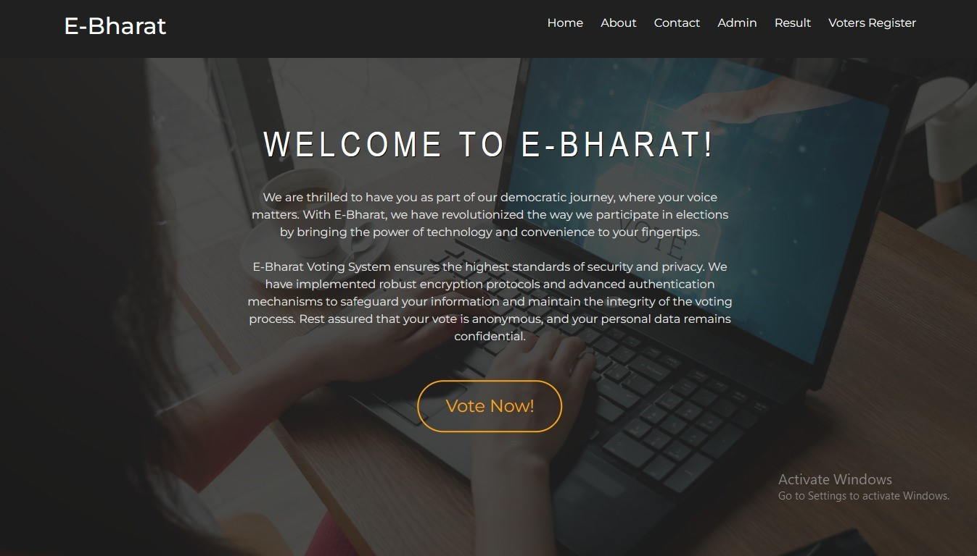
Fig 10.1: Home Page

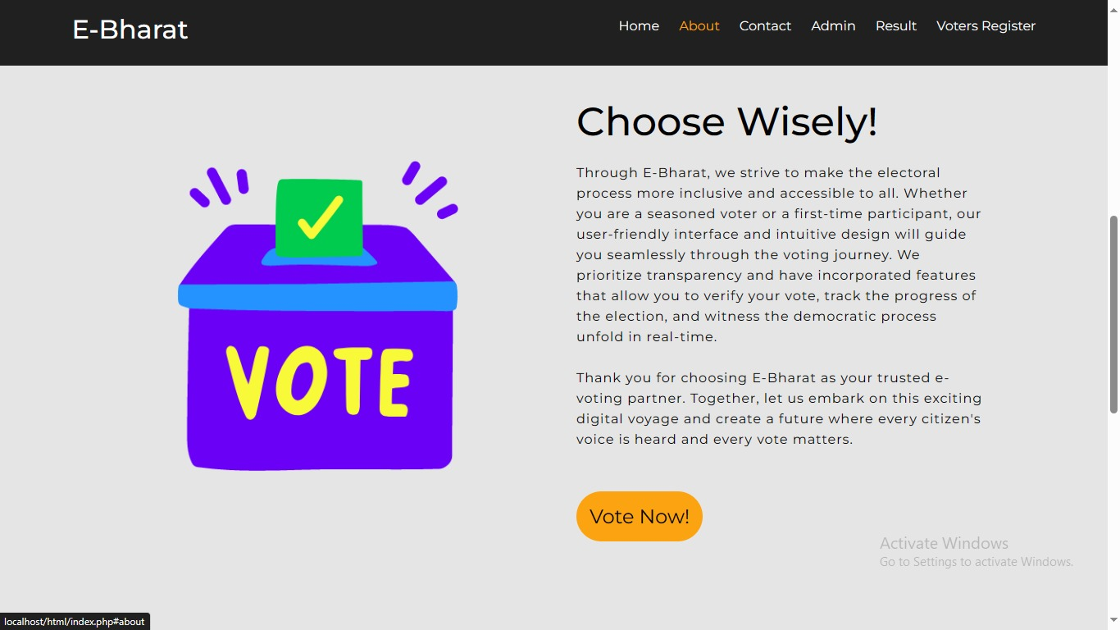

Fig 10.2: About Page
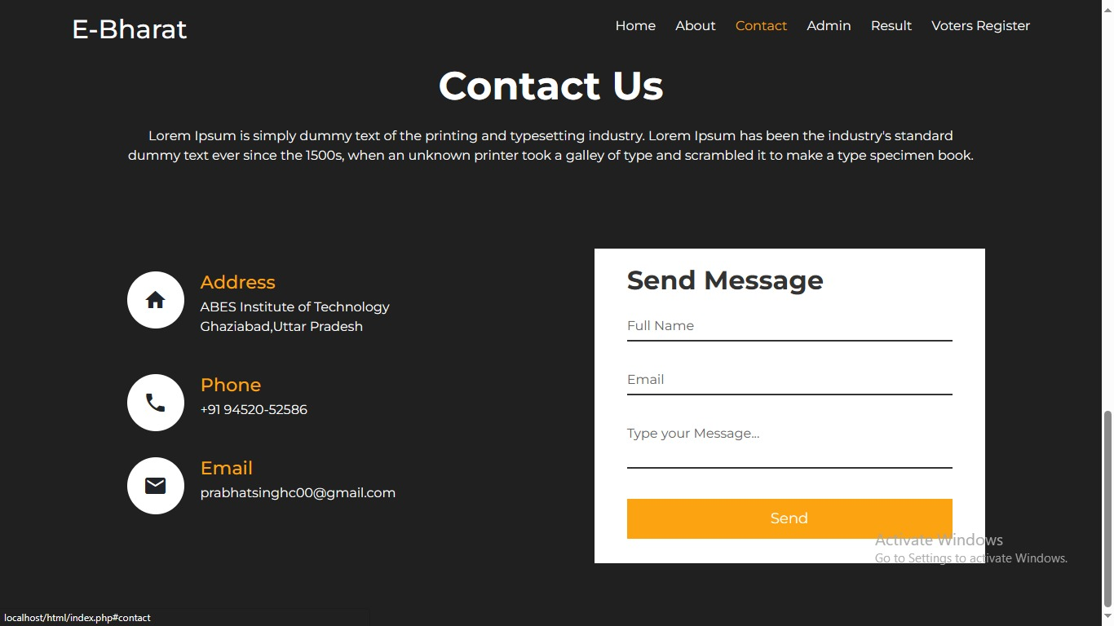

Fig 10.3: Contact Us

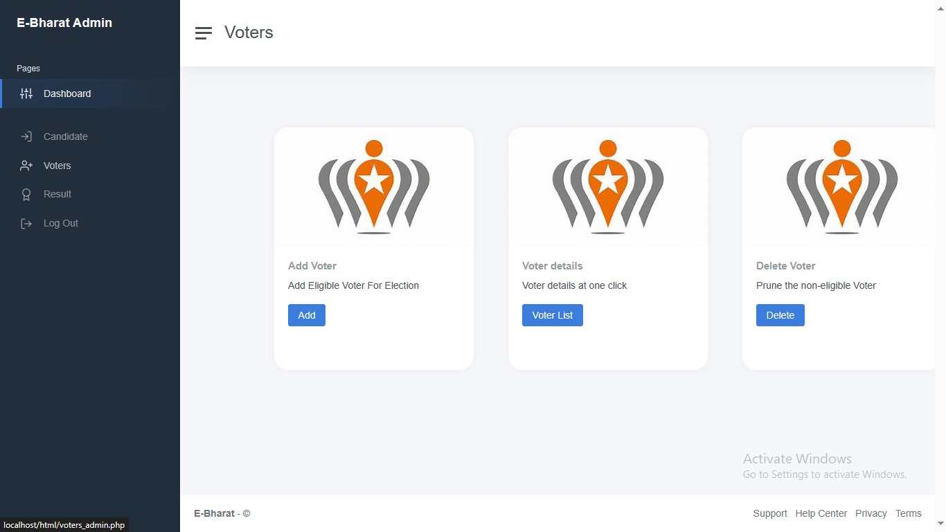

Fig 10.4: Voter Dashboard
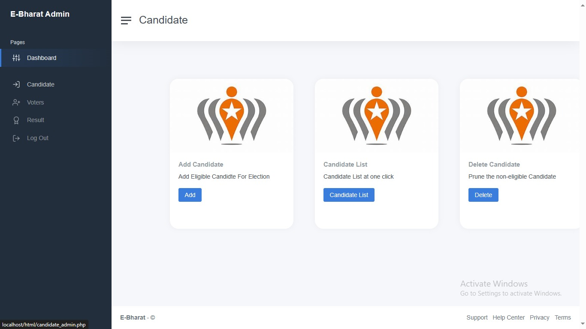

Fig 10.5: Candidate Dashboard

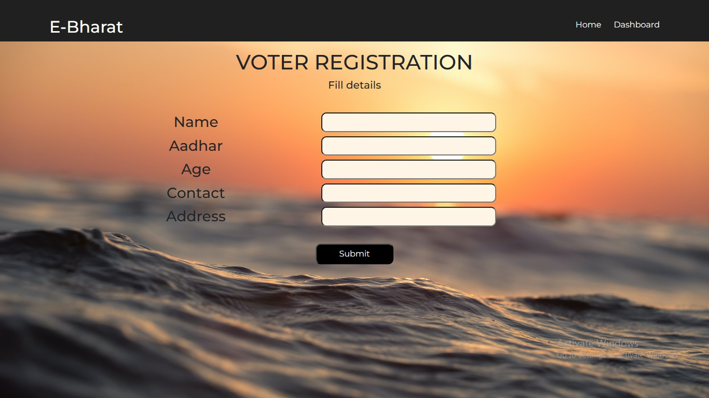

Fig 10.6: Voter Registration
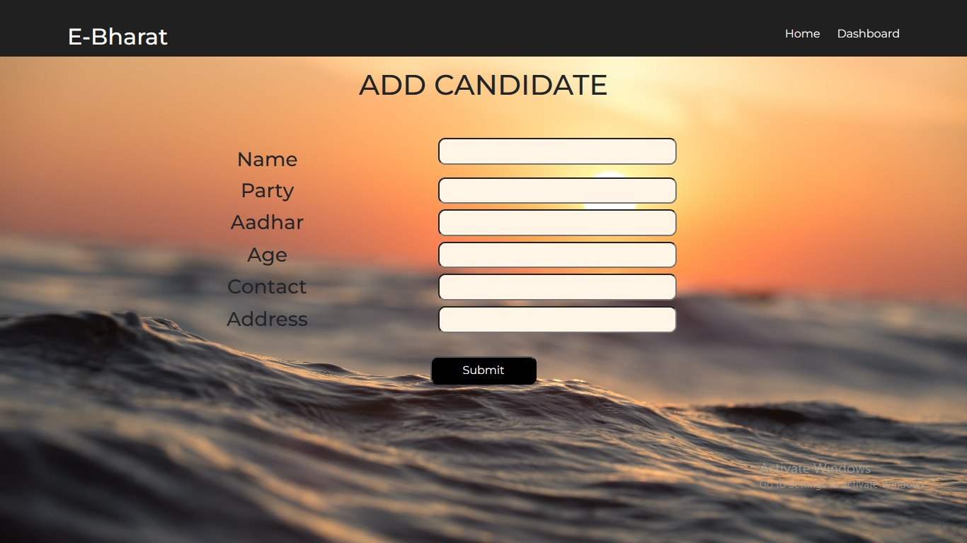

Fig 10.7: Candidate Registration

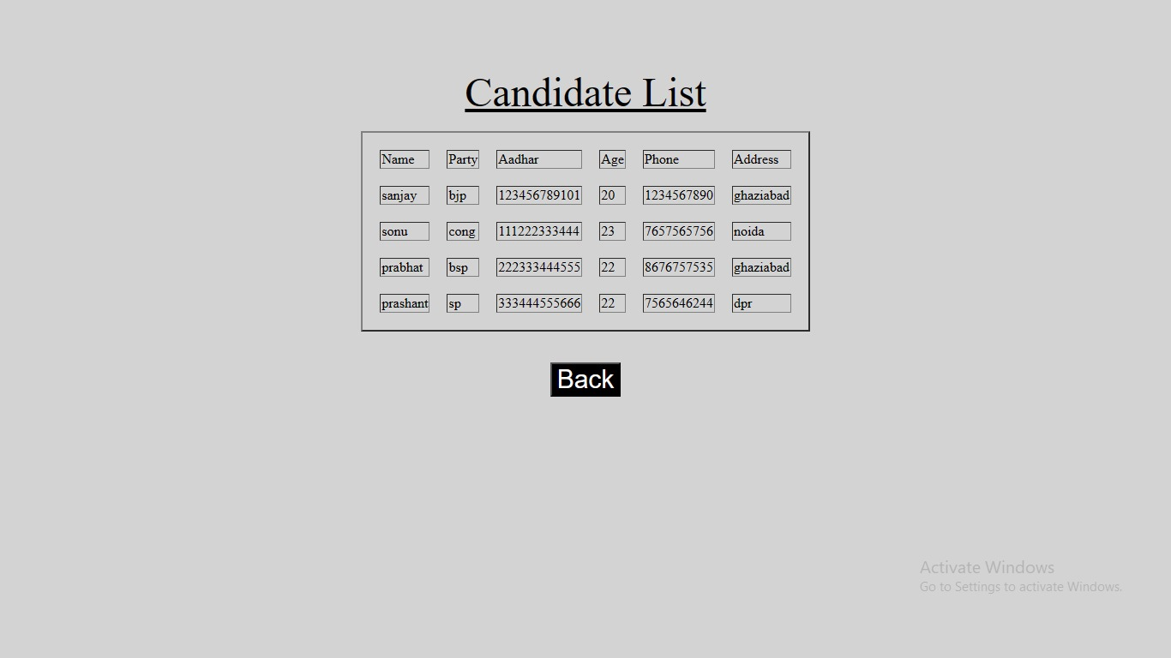

Fig 10.8: Candidate List

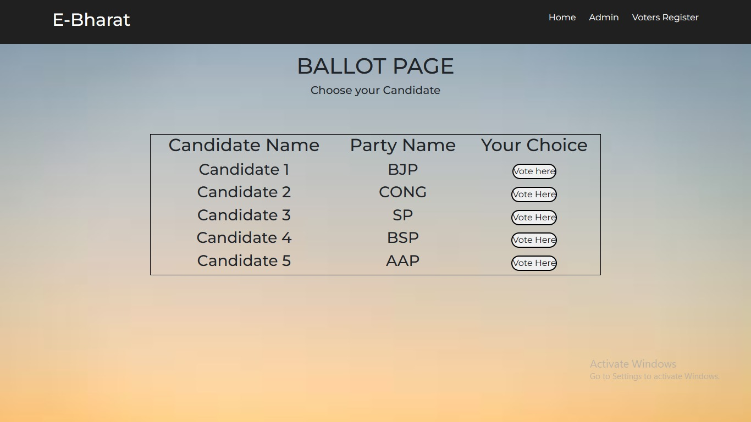

Fig 10.9: Ballot Page

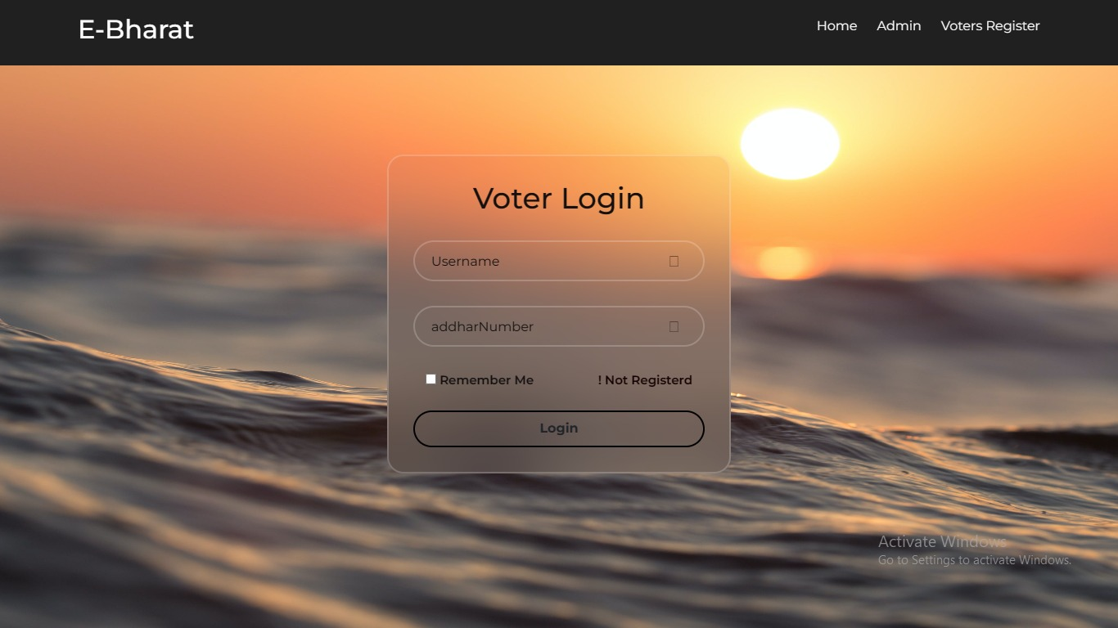

Fig 10.10: Voter Login

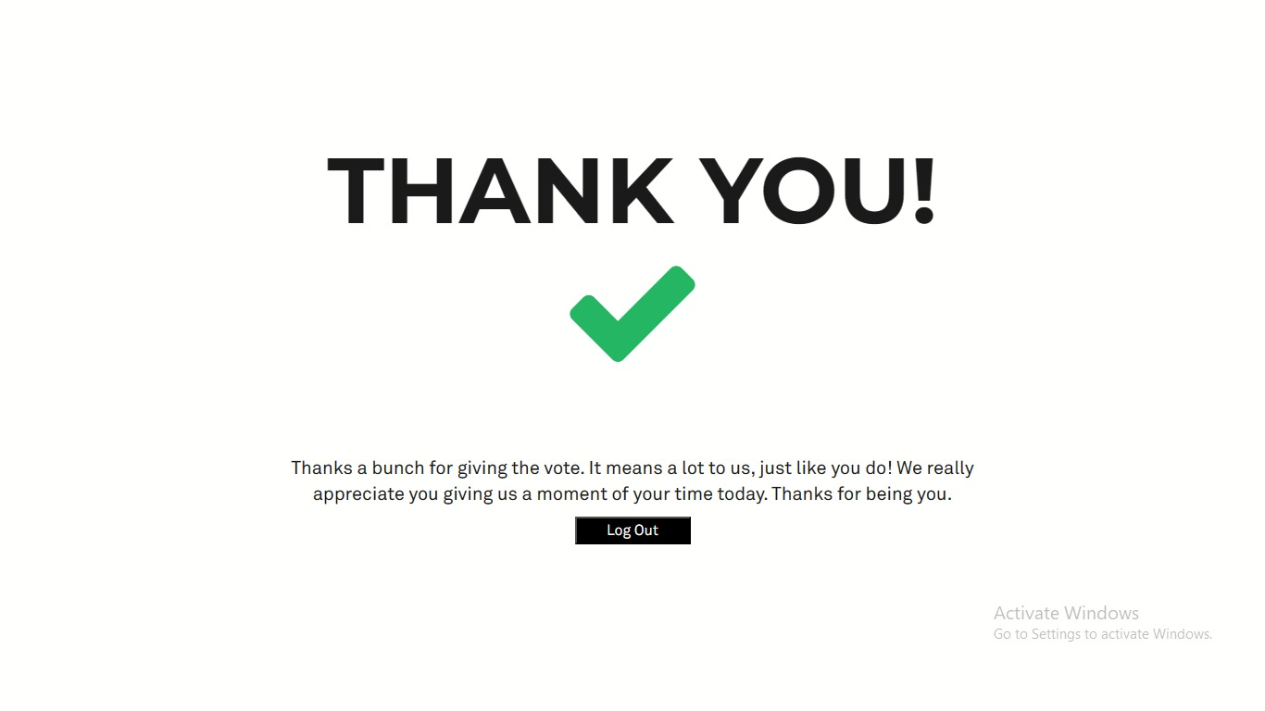
Fig 10.11: Logout Page After Casting Vote

11. CONCLUSION

This online Voting system will manage the Voter’s information by which voter can login and use his voting rights. The system will incorporate all features of voting system. It provides the tools for maintaining voter’s vote to every party and it count total no. of every party. There is a DATABASE which is maintained by the ELECTION COMMISION OF INDIA in which all the names of voter with complete information is stored.
The traditional method of manual voting system has few drawbacks. This method is obviously not efficient as it wastes the voter’s energy and quite slow in term of completion. This smart system involves the voters can cast their vote easily, and can be implemented to the entire India.
Data can be managed on cloud so that it will be secured and managed efficiently. We have developed the online system for only one particular booth, this should be extended to all the polling booths in India.

12. FUTURE ENHANCEMENT

In the current scenario, most of the countries of the world hold their elections using Electronic Voting Machines, where your vote gets registered electronically with the help of an Electronic Machine without using and wasting ballot paper to vote for elections.
As security is a major concern nowadays, ensuring that no person exercises the right to vote twice is the main aspect. We can resolve this issue by introducing Finger Print Based Voting, where a person can be authorized based on his Finger Print. This will put an end to fake voting. The domain of the project is the Internet of Things where we are building Fingerprint Based Biometric Voting Machine. We know that IoT is the system of interrelated computing devices, mechanical and digital machines, objects, and the ability to transfer data over a network without requiring human-to-human or human-to-computer interaction. Thus our Fingerprint online module is an application where the user is recognized by his finger pattern. As we know that the minutiae features on a finger of each human being are different, the voter can be easily authenticated.
The online system allows the voter to vote through his fingerprint. The fingerprint of the voter is used to uniquely and distinctively identify him/her using the fingerprint module. Also, the system promises the right to vote a candidate only once, thus not allowing the voter to vote for the second time. An admin is assigned to add all the candidates standing for the election. Only the admin has the right to add a candidate name and photo who are nominated.
The Admin will also register the voter's name by verifying voter's details. Admin will authenticate the voter by verifying the voter's identity and then admin will register the voter. Once the user has got the voters id and password from the admin the user can log in and vote for the candidates who were nominated. The system will allow the user to vote for only one candidate. In the end, the election result is published by using the election id. Even users can view the election result.

BIBLIOGRAPHY

[1] https://www.electionsonline.com/online-votingsystem/
[2] https://en.wikipedia.org/wiki/Electronic_voting
[3]. K. P. Kaliyamurthie, R. Udayakumar, D. Parameswari and S. N. Mugunthan, “Highly Secured Online Voting System over Network,” in Indian Journal of Science and Technology | Print ISSN: 0974-6846 | Online ISSN: 0974-5645
[4]. Ankit Anand, Pallavi Divya, An Efficient Online Voting System, Vol.2, Issue.4, July-Aug. 2019, pp2631-2634.
[5]. Drew Springall, Travis Finkenauer, Zakir Durumeric, Jason Kitcat, Harri Hursti Margaret MacAlpine J. Alex Halderman, November 3–7, 2021, “Security Analysis of the Estonian Internet Voting System,” in CCS‟14, Scottsdale, Arizona, USA. ACM 978-1-4503-2957-6/14/11.

