Software Requirements Specification
for
Online Voting System
Version 1.0 approved
Prepared by:
Prabhat Singh Chauhan
ABESIT
Date: 08-12-2023

Table of Contents
Table of Contents ii
Revision History ii
1. Introduction 1
1.1 Purpose 1
1.2 Intended Audience 1
1.3 Product Scope……………………………………………………………………………………1-2
1.4 References 3
2. Overall Description 3
2.1 Product Perspective 3
2.2 Product Functions 3
2.3 User Classes and Characteristics 4
2.4 Operating Environment 4
2.5 Design and Implementation Constraints 4
2.6 User Documentation 4
2.7 Assumptions and Dependencies 4
3. External Interface Requirements 4
3.1 User Interfaces 4
3.2 Hardware Interfaces 5
3.3 Software Interfaces 5
3.4 Communications Interfaces 5
4. System Features 5
4.1 System Feature 1 5-6
4.2 System Feature 2 6
5. Other Nonfunctional Requirements 6
5.1 Performance Requirements 6
5.2 Safety Requirements 6
5.3 Security Requirements 7
5.4 Software Quality Attributes 7-9
5.5 Business Rules 9
6. Other Requirements 9
Appendix A: Glossary 9
Appendix B: Analysis Models 10

Revision History
Name | Date | Reason For Changes | Version

Introduction

Purpose
The existing manual Voting system consumes more time for Vote Casting. Voter has to wait for vote polling station to vote for a right candidate. The election officers has to be check the voter, this voter can vote in this booth then check voter ID present in voters list of booth those are information will be present then the voter can vote in that booth. The voter had to stand in the queue to cast his vote. All the work is done in paper ballot so it is very hard to locate a particular candidate, some voters cast their votes for all candidates. To overcome of all these problem we have to implement a web application, which is helpful for Voting from anywhere.

Intended Audience
The intended readers of this document are the developers of the site, website owners, manager. This document is organized in such a way that any common people can understand and covers all the important components of the project. Readers are requested to read the whole document and can also refer any part of the document they want to with the help table contents. The contents of the document are arranged according to priority.

Product Scope
The scope of an online voting system is broad and encompasses various aspects related to the election process. Here are some key elements within the scope of an online voting system:

1.Accessibility:

1.1 Geographic Accessibility: Online voting systems can provide access to voters regardless of their physical location, enabling citizens to vote from anywhere with an internet connection.
1.2 Inclusivity: Online voting can potentially increase voter turnout by making it easier for people with disabilities or mobility issues to participate.

2.Security

2.1 Authentication: Ensuring secure and reliable methods for voter authentication to prevent unauthorized access.
2.2 Encryption: Implementing robust encryption protocols to protect the integrity and confidentiality of the voting process.
2.3 Voter Verification: Developing mechanisms to verify the identity of voters and prevent fraudulent activities.

3. Integrity:

3.1 Vote Tampering Prevention: Implementing measures to prevent tampering with votes and ensuring the integrity of the election results.
3.2 Audit Trails: Creating transparent and verifiable audit trails to track and verify each vote.

4. Usability:

4.1 User-Friendly Interface: Designing an intuitive and user-friendly interface to ensure that voters, including those with varying levels of technical proficiency, can easily navigate the system.
4.2 Accessibility Features: Incorporating features to accommodate voters with disabilities, such as screen readers and alternative input methods.

5. Scalability:

5.1 Capacity Planning: Ensuring that the online voting system can handle a large number of concurrent users during peak voting periods.
5.2 Infrastructure: Developing a scalable and reliable infrastructure to support the voting process.

6. Legal and Regulatory Compliance:

6.1 Compliance with Election Laws: Ensuring that the online voting system complies with existing election laws and regulations.
6.2 Data Privacy: Addressing concerns related to voter privacy and data protection.

7. Verification and Transparency:

7.1 Voter Verification: Providing a mechanism for voters to verify that their votes have been recorded accurately.
7.2 Result Transparency: Ensuring transparency in the counting and reporting of election results.

8. Contingency Planning:

8.1 Backup Systems: Implementing backup systems and contingency plans in case of technical failures or security breaches.
8.2 Disaster Recovery: Planning for the recovery of data and system functionality in the event of a disaster or unforeseen circumstance.

9. Education and Training:

9.1 Voter Education: Developing educational materials and campaigns to inform voters about the online voting process.
9.2 Training for Election Officials: Providing training for election officials to ensure they can effectively manage and oversee the online voting process.

10. Continuous Improvement:

10.1 Feedback Mechanisms: Implementing mechanisms to collect feedback from voters, election officials, and other stakeholders to continually improve the system.
10.2 Technological Updates: Keeping the system up-to-date with the latest technologies and security measures.

References
[1] https://en.wikipedia.org/wiki/Electronic_voting
[2]. K. P. Kaliyamurthie, R. Udayakumar, D. Parameswari and S. N. Mugunthan, “Highly Secured Online Voting System over Network,” in Indian Journal of Science and Technology | Print ISSN: 0974-6846 | Online ISSN: 0974-5645
[3]. Ankit Anand, Pallavi Divya, An Efficient Online Voting System, Vol.2, Issue.4, July-Aug. 2019, pp2631-2634.
[4]. Drew Springall, Travis Finkenauer, Zakir Durumeric, Jason Kitcat, Harri Hursti Margaret MacAlpine J. Alex Halderman, November 3–7, 2021, “Security Analysis of the Estonian Internet Voting System,” in CCS‟14, Scottsdale, Arizona, USA. ACM 978-1-4503-2957-6/14/11.

Overall Description

Product Perspective
An electronic voting system which is used nowadays provide some characteristic different from the traditional voting technique, and also it provides improved features of voting system over traditional voting system such as accuracy, convenience, flexibility, privacy, verifiability and mobility.

But Electronic voting systems suffers from various drawbacks such as time consuming, consumes large volume of paper work, no direct role for the higher officials, damage of machines due to lack of attention, mass update doesn’t allow users to update and edit many item simultaneously etc.

These drawbacks can overcome by Online Voting System. This is a voting system by which any voter can use his/her voting rights from anywhere in the country. Voter can cast their votes from anywhere in the country without visiting to voting booths, in highly secured way. That makes voting a fearless of violence and that increases the percentage of voting.

Product Functions
- Insert to database the details about voters.
- Insert to database the details about candidate.
- Also can get three kind of reports-add candidate, modify candidate, delete candidate.
- Voter can get report about election
- voter can details for about candidate by giving their state or city name.
- Insert voter details.
- Calculate total vote cast.
- Administrator can declare result.
- Handle all financial details and insert these details in to database.
- Administrator can get report about the voters and candidate.

User Classes and Characteristics
Manager who is the Major user of the Product consider as the Administrator, who use the System with All privilege levels have to Manager And the other users of the System known as voters.

Operating Environment
- Operating System supports all known operating systems, such as Windows, Linux
- Ubuntu. Desktop 512MB RAM + ROM, monitor with minimum resolution of 1024 * 768, keyboard and mouse.
- Hard Drive should be NTFS file system formatted with minimum 10GB of free space.
- A Laser Printer will need to be used to print these reports and notes.
- Software is designed to run on any platform above Microsoft Windows 7 (32 bit).
- Microsoft NET Frameworks 3.2 or above.

Design and Implementation Constraints
In order to maintain the reliability and durability of system, some design and implementation constraints are applied. System will need a minimum memory of 512MB but it is recommended to have a memory of 1GB. Considering the customer’s budget we decided to create those interfaces in simple realistic manner using affordable technology.

User Documentation
And user manual include contain both a written guide and the associated images. In the case of computer applications, it is usual to include Screenshots of how the program should look and hardware manuals often include clear, simplified diagrams. The language used is matched to the intended audience to a minimum or explained thoroughly. That situation there is no more online help for this product. The product will be compatible with our client computer requirements. The databases will be created in the MySQL server. Our contact information will include email address and Phone Numbers.

Assumptions and Dependencies
It is assumed that system developed will work perfectly that’s going to be developed under the Windows OS, and Apache Server with MySQL database. If in case of any difficulties, SRS should be flexible enough to change accordingly.

External Interface Requirements

User Interfaces
Home Page: This page involves all the additional pages. This is the front page that opens when a user uses this website.
Admin Login: This login page is for admin after that the admin enters in a admin dashboard where admin add, modify, and delete candidate and voters both.
Voter Sign In: This login page is for voter after that the voter enters in a voter dashboard where voter cast his/her vote.
Voter Sign Up: This login page is for voter after that the voter register himself/herself on this website by using his/her Aadhar card.

Hardware Interfaces
- Monitor – 1080x720p Display
- Processor – Intel Pentium / AMD Athlon 1.5GHz or Above
- RAM – 512 MB or Above
- Storage – 5GB or Above

Software Interfaces
- The system supports windows 7, windows XP, Linux.
- Net 4.0 will be installed and that will be the platform the particular software will be run.
- The database is MySQL Server.
- It supports browser opera, chrome etc.

Communications Interfaces
The entire communication interface is handled by the operating system. Example sockets are used for communication between MySQL server and pharmacy management system software.

System Features

System Feature 1
An online voting system incorporates various features to facilitate a secure, efficient, and user-friendly voting process. The specific features may vary based on the design and requirements of the system, but here are common features found in online voting systems:

1.User Authentication: Secure login mechanisms to ensure that only authorized individuals can access the system. Multi-factor authentication for an additional layer of security.

2. Voter Registration: Online voter registration to create a verified and eligible voter database.
Verification processes to confirm the identity and eligibility of voters.

3.Ballot Creation: Tools for creating electronic ballots that accurately represent the candidates or options in an election. Support for various types of elections (e.g., single-choice, multiple-choice).

4.Intuitive User Interface: User-friendly design to accommodate voters with varying levels of technical proficiency. Clear instructions and prompts to guide users through the voting process.
5.Accessibility Features: Support for accessibility features such as screen readers and alternative input methods. Design considerations for users with disabilities.

6.Security Measures: Robust encryption to protect the confidentiality and integrity of votes.
Measures to prevent unauthorized access and ensure the security of the voting platform
.
7. Audit Trail: Transparent and verifiable audit trail to track and verify each vote. Logging mechanisms to record activities and detect any irregularities.

System Feature 2
1.Voter Verification: Mechanisms for voters to verify that their votes have been accurately recorded. Confirmation messages or receipts sent to voters upon successful submission.

2.Results Reporting: Real-time or timely reporting of election results. Clear presentation of results to ensure transparency and understanding.

3.Data Privacy: Implementation of data protection measures to ensure the privacy of voter information. Compliance with relevant privacy regulations and laws.

4.Scalbility: Infrastructure that can handle a large number of concurrent users during peak voting periods. Capacity planning to ensure the system's scalability as the number of users increases.

5.Contingency Planning: Backup systems to handle technical failures or security breaches.
Disaster recovery plans to recover data and system functionality in case of unforeseen circumstances.

6.Feedback Mechanisms: Channels for voters to provide feedback on the voting process. Continuous improvement based on user feedback and lessons learned from previous elections.

Other Nonfunctional Requirements

Performance Requirements
In Our system we have several Graphical User Interfaces and In order to moving one GUI to another GUI no need to wait more than three seconds. In the case of printing requirements the printing hardware performance is out of the control of our system. The system will take no longer than 10 seconds for the system to initiate request to a printer. The system will take no longer than 5 seconds to calculate total amount of a bill. In this process the system need more memory usage more than minimum memory usage

Safety Requirements
Data handle is an important part of our system. We use one central database to store our system data. If any power failure, virus attack or data crash can lost all data of the database. Therefore we recommend taking the backup for database after doing any updating. And also recommend use separate power supply and install updating virus guard to the database machine.

Security Requirements
Ensuring the security of an online voting system is critical to maintaining the integrity and trustworthiness of the electoral process. Here are key security requirements that should be considered when designing and implementing an online voting system:

1.Authentication and Authorization:

1.1 Strong User Authentication: Implement robust authentication methods, such as username/password combinations or multi-factor authentication, to ensure that only authorized individuals can access the system.
1.2 Authorization Controls: Define and enforce access controls to limit user privileges based on their roles within the system.

2.Voter Registration Security:

2.1 Secure Registration Process: Ensure that the voter registration process is secure and includes verification mechanisms to confirm the identity and eligibility of voters.
2.2 Protection Against Duplicate Registrations: Implement measures to prevent individuals from registering multiple times.

3. Denial-of-Service (DoS) Protection:

3.1 DoS Mitigation Measures: Implement measures to protect the online voting system against denial-of-service attacks that could disrupt the voting process.

4.Backup and Recovery:

4.1 Regular Backups: Perform regular backups of the voting system data to ensure data integrity and availability.
4.2 Disaster Recovery Plan: Develop and maintain a comprehensive disaster recovery plan to recover the system in the event of a critical failure or cyberattack.

Software Quality Attributes
Software quality attributes are characteristics or properties of a software system that contribute to its overall quality. For an online voting system, ensuring a high level of software quality is essential to maintain the integrity, security, and usability of the electoral process. Here are some key software quality attributes relevant to an online voting system:

1.Security:

1.1 Authentication and Authorization: Ensure robust user authentication and authorization mechanisms to prevent unauthorized access to the system.
1.2 Data Encryption: Implement strong encryption protocols to protect sensitive data, including voter information and election results.
1.3 Secure Coding Practices: Adhere to secure coding practices to minimize vulnerabilities and protect against common security threats.

2.Reliability:

2.1 System Availability: Design the system to be highly available, minimizing downtime during peak voting periods.
2.2 Fault Tolerance: Implement measures to detect and recover from faults or failures, ensuring the system remains operational.

3.Usability:

3.1 User Interface Design: Develop an intuitive and user-friendly interface to accommodate voters with varying levels of technical proficiency.
3.2 Accessibility: Ensure that the system is accessible to users with disabilities, providing features such as screen readers and alternative input methods.

4.Performance:

4.1 Scalability: Design the system to handle a large number of concurrent users during peak voting times.
4.2 Response Time: Optimize the system's response time to provide a seamless and efficient voting experience.

5.Maintainability:

5.1 Modularity: Design the system with a modular architecture to facilitate easier maintenance and updates.
5.2 Code Documentation: Provide comprehensive documentation to assist developers and administrators in understanding and maintaining the system.

6.Portability:

6.1 Cross-Browser Compatibility: Ensure compatibility with various web browsers to accommodate a diverse range of users.
6.2 Platform Independence: Design the system to be platform-independent, allowing users to access it from different devices and operating systems.

7.Interoperabilty:

7.1 Integration with Election Systems: Ensure that the online voting system can integrate seamlessly with other election-related systems and databases.
7.2 Standard Data Formats: Use standardized data formats to enable interoperability with external systems and tools.

8.Auditability:

8.1 Transparent Logging: Implement comprehensive logging mechanisms to create a clear and tamper-evident audit trail.
8.2 Result Verification: Provide tools and mechanisms for independent verification of election results.

9.Privacy:
9.1 Data Protection: Implement measures to protect the privacy of voter information and ensure compliance with relevant privacy laws.
9.2 Anonymity: Ensure that the voting process maintains the anonymity of individual voters.

10.Compliance:

10.1 Legal Compliance: Adhere to election laws and regulations to ensure the legality and legitimacy of the voting process.
10.2 Standards Compliance: Follow industry standards and best practices to enhance the reliability and compatibility of the system.

11.Scalibility:

11.1 Capacity Planning: Plan for and manage the system's scalability to accommodate an increasing number of users and evolving requirements.

12. Feedback and Improvement:

12.1 User Feedback Mechanisms: Incorporate mechanisms for users to provide feedback on their voting experience.
12.2 Continuous Improvement: Regularly update and improve the system based on user feedback, evolving security threats, and changing technology landscapes.

Business Rules
System administrator can view each operation any time. If there are any changes the system is capable of handling such information.

Other Requirements
Appendix A: Glossary
HTTP - Hyper Text Transfer Protocol.

CSS - Cascading Style Sheet

SQL - Structured Query Language

GUI - Graphical User Interface

PHP - Hypertext Preprocessor

SRS – Software Requirement Specification
Appendix B: Analysis Models

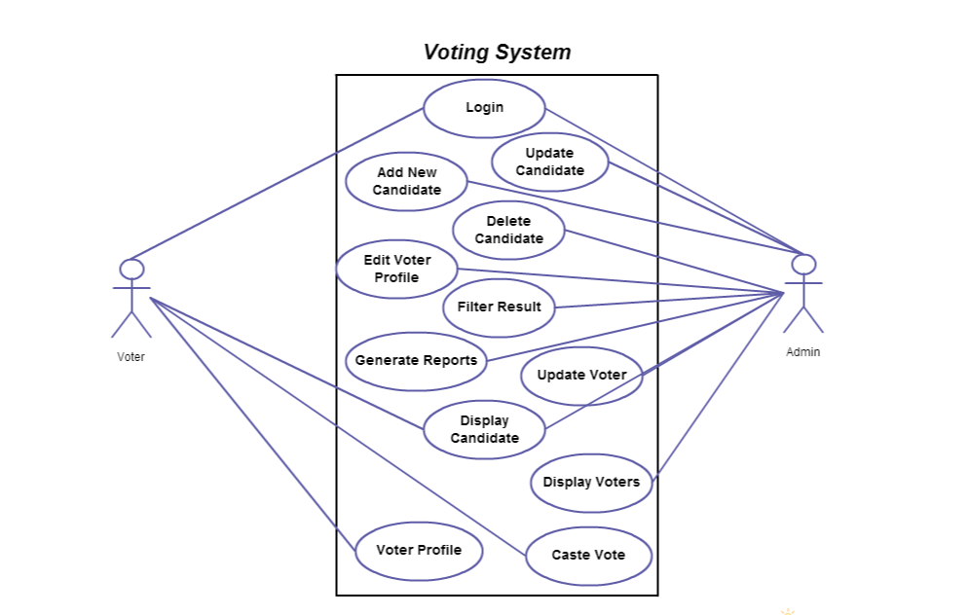
Use Case Diagram of Online Voting System

