Java bean validation 1
About 1
Annotations 1
Required jars 2
Usage 3
Custom annotation 4
Create your own annotation and registered it in validation api 4
Example of custom annotation applied on field constraint 4
Example of custom annotation applied on class level constraint 6
In springboot 7
Validate requestbody 7
Validation message with internationalization 8
Internationalization in springboot 9
Use application1.properties file instead of application.properties 10
Use company1_messages instead of message.properties 10

Java bean validation

About
Java bean validation : (JSR 380)
specification :
validation api
reference implementation of validation api
Hibernate validator

Annotations
@Pattern(message="", regex="")
for integer :
@Max(10)
@Min(2)
@Digits(integer=6, fraction=2)
for decimal:
@DecimalMax("30.2")
@DecimalMin("12.3")
@AssertFalse //value always false
@AssertTrue // value always true
@NotNull
@Null
@Size(min=2,max=6) // to calculate size of the field (field can be string or collection)
@Email
@Negative
@NegativeOrZero
@Positive
@PositiveOrZero
@Future //future date
@FutureOrPresent
@Past // past date
@PastOrPresent

Required jars

specification jar: validation-api
implementation jar: hibernate validator
compile time validation annotation jar: hibernate-validator-annotation-processor
expression language: el-api
expression language implementation: javax.el

<!-- Java bean validation API - Spec -->
<dependency>
<groupId>javax.validation</groupId>
<artifactId>validation-api</artifactId>
<version>2.0.1.Final</version>
</dependency>

<!-- Hibernate validator - Bean validation API Implementation -->
<dependency>
<groupId>org.hibernate</groupId>
<artifactId>hibernate-validator</artifactId>
<version>6.0.11.Final</version>
</dependency>

<!-- Verify validation annotations usage at compile time -->
<dependency>
<groupId>org.hibernate</groupId>
<artifactId>hibernate-validator-annotation-processor</artifactId>
<version>6.0.11.Final</version>
</dependency>

<!-- Unified Expression Language - Spec -->
<dependency>
<groupId>javax.el</groupId>
<artifactId>javax.el-api</artifactId>
<version>3.0.1-b06</version>
</dependency>

<!-- Unified Expression Language - Implementation -->
<dependency>
<groupId>org.glassfish.web</groupId>
<artifactId>javax.el</artifactId>
<version>2.2.6</version>
</dependency>

Note:
ValidationMessages.properties in classpath
//it automatically pick by the validation api

Usage

class User

@NotNull(message = "please enter name")
private String name;

@Size(min = 1, max = 3, message = "{user.age.invalid}")
private String age;

// @Min(value = 18)
// @Max(value = 150)
// private int age;

@Email(regexp = "^pv.*" )
private String email;

in main class

User user = new User();
user.age = "43423";
user.name = null;// "asdf";
user.email = "pvfadsfsf@gmail.com";

ValidatorFactory factory = Validation.buildDefaultValidatorFactory();
Validator validator = factory.getValidator();
Set<ConstraintViolation<User>> validate = validator.validate(user);
System.out.println("total errors" + validate.size());
for (ConstraintViolation<User> cv : validate) {
System.out.println(cv.getInvalidValue());
System.out.println(cv.getMessage());
}

Note:
if you want to use your own property file instead of ValidationMessages.properties
then,

AggregateResourceBundleLocator userResourceBundleLocator = new AggregateResourceBundleLocator( Arrays.asList("messages", "otherMessages"));
ResourceBundleMessageInterpolator interpolator = new ResourceBundleMessageInterpolator( userResourceBundleLocator);
ValidatorFactory factory = Validation.byDefaultProvider().configure().messageInterpolator(interpolator).buildValidatorFactory();

messages.properties
user.age.invalid= invalid age. it should be in range {min} and {max}

Custom annotation

Create your own annotation and registered it in validation api

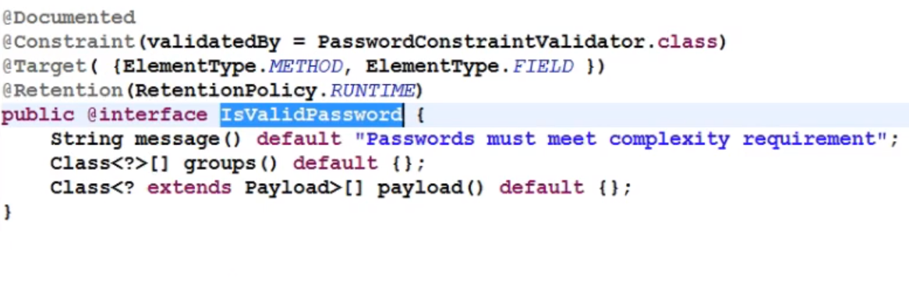

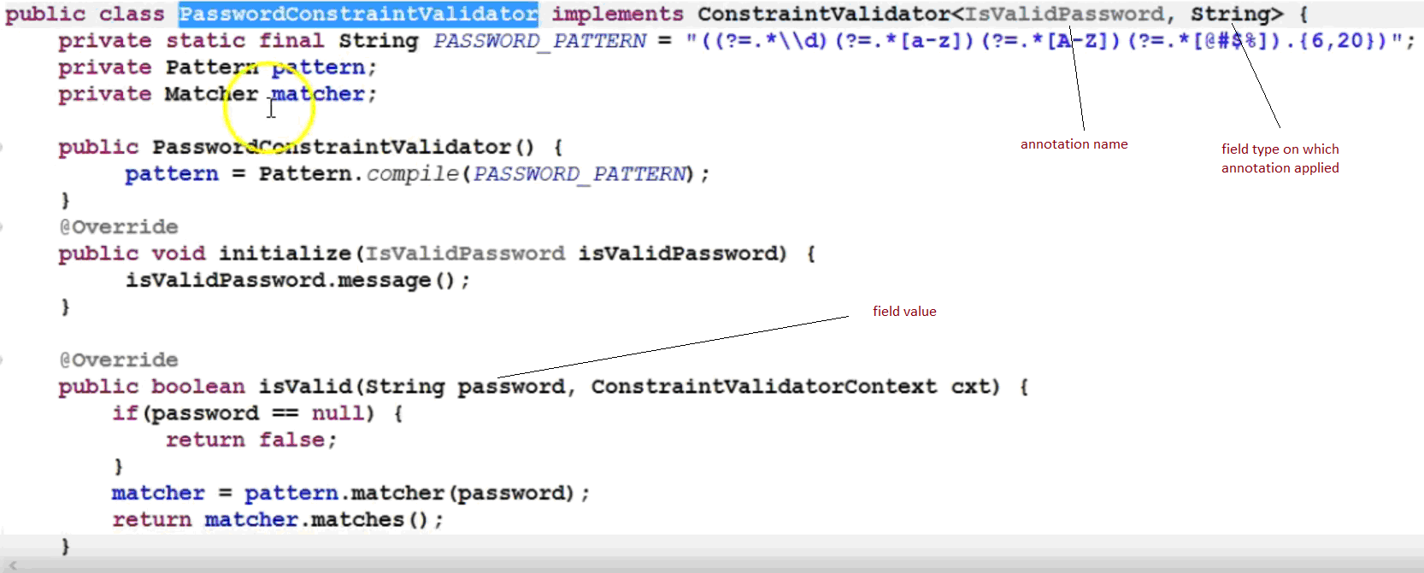

Example of custom annotation applied on field constraint

Account

public class Account {
@IsValidPassword(value = "testing")
private String password;
}

IsValidPasswordValidator

public class IsValidPasswordValidator implements ConstraintValidator<IsValidPassword, String> {
private String password;

@Override
public void initialize(IsValidPassword constraintAnnotation) {
this.password = constraintAnnotation.value();
}

@Override
public boolean isValid(String password, ConstraintValidatorContext constraintContext) {
if(password==null) return true;
boolean isValid = false;
isValid = Pattern.compile("(wonder)").matcher(password).matches();
// if (isValid) {
// constraintContext.getDefaultConstraintMessageTemplate();
// }
return isValid;
}
}

In ValidationMessages_en_CA.properties

account.password= invalid password {value} ca

In IsValidPassword

@Target({ FIELD, METHOD, PARAMETER, ANNOTATION_TYPE })
@Retention(RUNTIME)
@Constraint(validatedBy = IsValidPasswordValidator.class)
@Documented
public @interface IsValidPassword {
String message() default "{account.password}";
Class<?>[] groups() default {};
Class<? extends Payload>[] payload() default {};
String value();
}

Example of custom annotation applied on class level constraint

When to use class level constraint?
Lets have, Account class
Account
String accountNumber;
String txnNumber;
String txnAmount;
String creditAmount;
String accountType;
String paymentType;

And if accountType="F" and paymentType="H"only then it is a valid data
Then, we have to class level constraint here
Because we need to conclude valid based on the combination of two fields value

Example

In Account

@CheckType
public class Account {
@IsValidPassword(value = "testing")
private String password;
@CheckCase(CaseMode.UPPER)
private String licensePlate;
@NotBlank
@Range(min = 900002, max = 9999998, message = "{account.accountNumber}")
private String accountNumber;
private String txnNumber;
@NotBlank(message = "{account.amount}")
private String txnAmount;
@NotBlank
private String creditAmount;
private String phbkNumber;

private String accountType;
private String paymentType;
}

In CheckType

@Target({ TYPE })
@Retention(RUNTIME)
@Constraint(validatedBy = CheckTypeValidator.class)
@Documented
public @interface CheckType {
String message() default "{account.accountType}";
Class<?>[] groups() default {};
Class<? extends Payload>[] payload() default {};
// String[] value() default { "F", "H" };
}

In CheckTypeValidator

public class CheckTypeValidator implements ConstraintValidator<CheckType, Account> {
//private String[] values;
@Override
public void initialize(CheckType constraintAnnotation) {
// this.values = constraintAnnotation.value();
}

@Override
public boolean isValid(Account account, ConstraintValidatorContext constraintContext) {
if (account == null) {
return true;
}
boolean isValid;
if (account.getAccountType().equals("F") && account.getPaymentType().equals("H")) {
isValid = false;
} else {
isValid = true;
}
return isValid;
}
}

Example with full code



In springboot

Validate requestbody

In springboot
@RequestMapping(value = "/demo", method = RequestMethod.POST, consumes = "application/json", produces = "application/json")
@ResponseBody
ResponseEntity<List<String>> home(@RequestBody @Valid Account account, BindingResult result) {
List<ObjectError> allErrors = result.getAllErrors();
ResponseEntity<List<String>> responseEntity = null;
if (allErrors.isEmpty()) {
List<String> success=new ArrayList<>();
success.add("sayHelloHub() is called");
responseEntity = new ResponseEntity<List<String>>(success,HttpStatus.OK);
} else {
List<String> errorMessages = new ArrayList<>();
for (ObjectError objectError : allErrors) {
errorMessages.add(objectError.getDefaultMessage());
}
responseEntity = new ResponseEntity<List<String>>(errorMessages, HttpStatus.BAD_REQUEST);
}
return responseEntity;
}

Note:
you can use "Errors error" and errors.hasErrorss()
or
"BindingResult result"

in pom.xml
<version>1.4.3.RELEASE</version>
spring-boot-starter-web
hibernate-validator
validation-api
spring-boot-starter-tomcat
tomcat-embed-el

Validation message with internationalization

@Configuration
class Config implements WebMvcConfigurer{

@Bean
public LocaleResolver localeResolver() {
SessionLocaleResolver localeResolver = new SessionLocaleResolver();
localeResolver.setDefaultLocale(Locale.CANADA); //default locale
return localeResolver;
}

@Override
public void addInterceptors(InterceptorRegistry registry) {
LocaleChangeInterceptor localeChangeInterceptor = new LocaleChangeInterceptor();
localeChangeInterceptor.setParamName("language1");
// passing it as a queryString
registry.addInterceptor(localeChangeInterceptor);
}
}

create 3 property files:
ValidationMessages_en_CA.properties
ValidationMessages_fr_FR.properties
ValidationMessages.properties

From postman:
http://localhost:8085/demo?language1=fr
http://localhost:8085/demo?language1=fr_FR
http://localhost:8085/demo?language1=en
http://localhost:8085/demo?language1=en_US
http://localhost:8085/demo?language1=en_CA

Internationalization in springboot
1.
@Autowired
private MessageSource messageSource;

String message = messageSource.getMessage("hello.world",new Object[] {"one","two"}, LocaleContextHolder.getLocale());
//hello.world= hello world {0} {1} ca

2.
in src\main\resources
messages_en_CA.properties
hello.world= hello world {0} {1} ca
messages_fr_FR.properties
hello.world= hello world {0} {1} fr
messages.properties
hello.world= hello world {0} {1} en

3.
@Configuration
class Config implements WebMvcConfigurer{
@Bean
public LocaleResolver localeResolver() {
SessionLocaleResolver localeResolver = new SessionLocaleResolver();
localeResolver.setDefaultLocale(Locale.CANADA); //default locale
return localeResolver;
}

@Override
public void addInterceptors(InterceptorRegistry registry) {
LocaleChangeInterceptor localeChangeInterceptor = new LocaleChangeInterceptor();
localeChangeInterceptor.setParamName("language1"); // passing it as a queryString
registry.addInterceptor(localeChangeInterceptor);
}
}

Use application1.properties file instead of application.properties
new SpringApplicationBuilder(HelloWorld.class).properties("spring.config.name:application1").build().run(args);
// SpringApplication.run(HelloWorld.class, args);

Use company1_messages instead of message.properties
@Bean public MessageSource messageSource() {
ReloadableResourceBundleMessageSource messageSource = new
ReloadableResourceBundleMessageSource();
messageSource.setBasenames("classpath:company1_messages");
messageSource.setDefaultEncoding("UTF-8"); return messageSource; }

